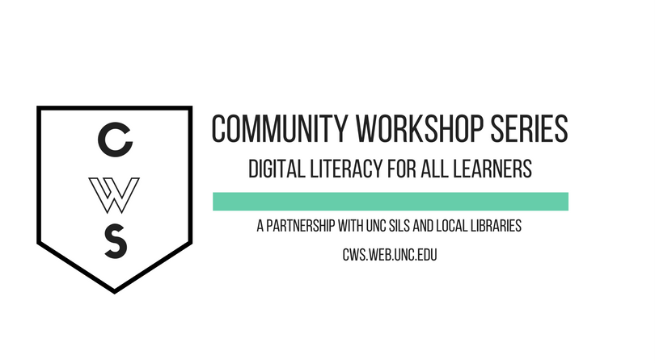

INTRODUCTION TO eBOOKS

GETTING STARTED PAGE 02
Prerequisites
What You Will Learn

INTRODUCTION PAGE 03
What is an eBook?
What is an eReader?

eBOOKS AT CHAPEL HILL PUBLIC LIBRARY PAGE 06
Lending Policies
Accessing Overdrive

NAVIGATING THE OVERDRIVE WEBSITE PAGE 09
Searching and Browsing
Understanding eBook Records
Using the Patron Account

DOWNLOADING eBOOKS PAGE 16
For Kindles
For iPad/iPod/iPhone, Android Phones & Tablets
For Nooks
For Sony Readers

OTHER SOURCES OF eBOOKS PAGE 2200

To view our full schedule, handouts, and additional tutorials, visit our website:
cws.web.unc.edu
WHAT YOU WILL LEARN

Prerequisites:

It is assumed for this class that the user is comfortable with basic computer operations as well as basic Internet experience.

- This workshop is intended for new eBook and eReader users and/or those who want to learn about eBooks available through the Chapel Hill Public Library via Overdrive.
- Please let the instructor know if you have any questions or concerns prior to starting class.

What You Will Learn

Familiarize you with eBooks | Learn about different eBook readers | Learn to search and use the Overdrive website | Download library eBooks to your eReader!
INTRODUCTION

What Are eBooks?
- Short for electronic book, a book-length publication in digital form
- Can be read on a computer or transferred to a device (Nook, Kindle, iPhone, etc.)

What Is an eBook Reader?

- Also known as eReaders, they come in many shapes and sizes.
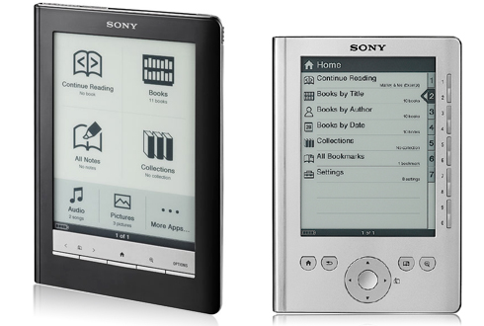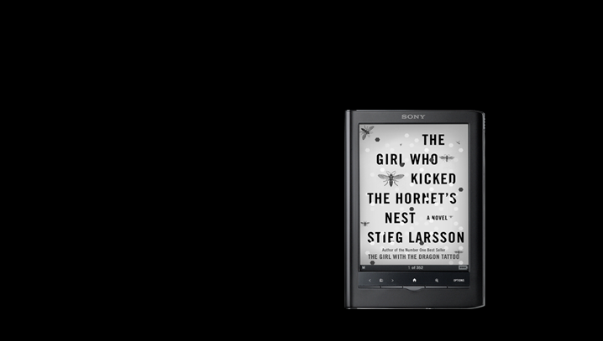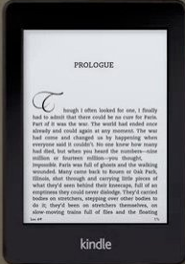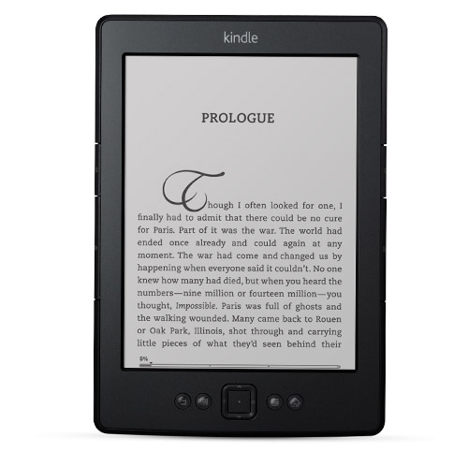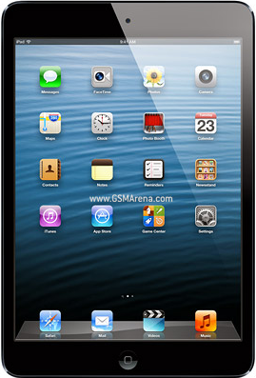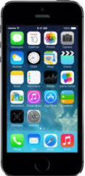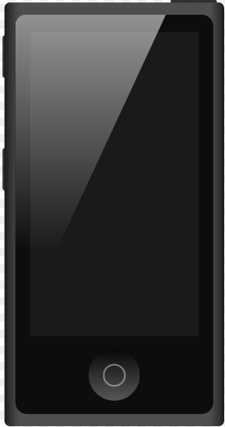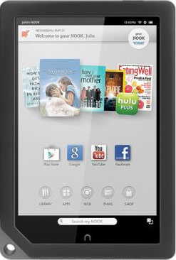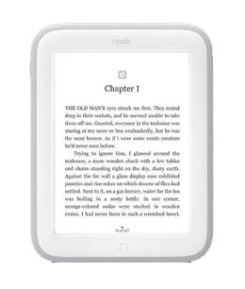
Features and Specifications to Consider:
Sony eReader
Apple iPod/iPhone/iPad
Amazon Kindle
Barnes & Noble Nook
- eInk vs. LCD
  - eInk looks like the page of a book and is not backlighted which makes it easier to read outside but requires a reading light to read in the dark. eInk text and images are displayed in black and white only.
  - LCD screens are like reading on a computer screen. They are backlighted which means you can read them in the dark but they are hard to read outside in sunlight. LCD screens can display full color.
- Buttons vs. Touch Screens
  - Buttons: some eReaders use buttons only to navigate through its functions and through the texts of the eBooks you are reading.
  - Touch Screens: other eReaders have a touch screen instead of buttons. With the touch screen you tap directly on the screen to select options and navigate.
  - Both: there are some eReaders that have a combination of both buttons and a touch screen that allow you to navigate in more than one way.
- Size
  - eReaders vary in size quite a bit. With a larger screen you can see more text at once however the device is larger and you may have more difficultly carrying it around.
- Weight
  - The weight of eReaders also varies. While there are some cases available that allow you to prop up the eReader, often people hold the eReader while using it, so weight is an important consideration.
- Battery Life
  - Generally eReaders with LCD screens have much shorter battery life than those with eInk. Tablet eReaders (Kindle Fire, Nook Tablet, or the iPad) do many other things besides display text which use up a lot of power.
- Wireless and 3G
  - Some eReaders have the capability to connect to the internet via Wi-Fi or 3G.
- File Format
  - Kindle Book: works with all Amazon Kindle devices. It will also work using the Kindle app on other devices like the iPad, iPhone and Android phones.
  - Adobe EPUB eBook: a file format developed specifically for eBooks, it features adjustable fonts. The ePUB format works on the iPad, Nook, Sony, and Kobo readers, but not the Kindle.
  - Adobe PDF: a common file format for digital documents, and can also be used for eBooks. PDF eBooks can be re-sized, but are much less customizable than ePUB eBooks. PDF format works on the iPad, Nook, Kindle, Sony, and Kobo readers, but not the Kindle.

Popular eReaders

Kindle by Amazon
- eInk
- Button navigation
- 6.5" x 4.5"
- 5.98 ounces
- Up to 1 month with Wi-Fi off
- Wi-Fi
- Kindle Book Format, PDF

Kindle Paperwhite (3G optional) by Amazon
- Paperwhite with built-in light
- Touch-Screen and. Button navigation
- 6.8" x 4.7"
- 7.5 ounces
- Up to 2 months with Wi-Fi off
- Wireless (or free 3G)
- Kindle Book Format, PDF

Kindle Fire Tablet by Amazon
- LCD
- Touch-Screen navigation
- 7.5" x 4.7"
- 14.1 ounces
- Up to 8 hours of reading or 7.5 hours video playback
- Wi-Fi
- Kindle Book Format, PDF

Nook Simple Touch by B&N
- eInk
- Touch-Screen and Button Navigation
- 6.5” x 5”
- 7.48 ounces
- Up to 2 months with wireless off
- Wi-Fi
- Adobe EPUB eBook Format, PDF

Nook GlowLight
- eInk
- Touch-Screen navigation
- Built-in reading light
- 6.5” x 5"
- 6.2 oz
- Up to 2 months with wireless off
- Wi-Fi
- Adobe EPUB eBook Format, PDF

Nook HD Tablet by B&N
- LCD
- Touch-Screen navigation
- 7.6” x 5”
- 11.1 ounces
- Up to 10.5 hours of reading or 9 hours of video playback
- Wi-Fi
- Adobe EPUB eBook Format, PDF
- Book lending and borrowing

Sony Reader Wi-Fi by Sony
- eInk
- Touch-Screen and Button navigation
- 6.8” x 4.75”
- 5.9 ounces
- Up to 2 months with Wi-Fi off
- Wi-Fi
- Adobe EPUB eBook Format, PDF
Kobo Touch by Kobo
- eInk
- Touch-Screen navigation
- 4.5” x 6.5”
- 6.5 ounces
- Up to 1 month with Wi-Fi off
- Adobe EPUB eBook Format, PDF, MOBI

iPad with Retina Display by Apple
- LCD
- Touch-Screen navigation
- 9.5” × 7.3”
- 22 ounces
- Up to 10 hours
- Wireless (or 3G for additional cost)
- PDF Format

iPad Mini by Apple
- LCD
- Touch-Screen navigation
- 7.8” x 5.4”
- 10.86 ounces
- Up to 10 hours
- Wireless (or 3G for additional cost)
- PDF Format

Reading eBooks on non-eReader devices

eBooks can also be read on devices that are not exclusively eReaders by downloading the Kindle, Nook or other reading apps. These apps are available for iPhones, iTouches, Androids, tablets, and computers.

eBooks - Digital Rights Management

The eBooks in Overdrive employ Digital Rights Management (DRM) to enforce copyright on titles in our library. Just like a print library book is not owned by a patron and must be returned to the library, eBooks are owned by publishers and must be returned at the end of their borrowing period. Library-loaned eBooks can only be copied to other devices owned by the same patron. For the Nook, for example, one library eBook can be copied to up to 6 authorized devices (computer, Mom’s Nook, Dad’s iPad, etc.).

eBOOKS AT CHAPEL HILL PUBLIC LIBRARY

Lending Policies
- 5 items may be checked out at a time
- Length of checkout: eBooks- 7, 14, or 21 days depending on your settings and the particular item, AudioBooks- 7 or 14 days
- 6 holds are allowed at a time and customers have 3 days to “pickup” the hold before it goes to the next person.
- Titles cannot be renewed, but you can check them out again after they expire if they are still available.
- When due, titles will be returned automatically which means you cannot acquire late fees on eBooks!
- Each copy may only be checked out by 1 person at a time – just like a physical book.
- Titles cannot be downloaded onto public library computers, to download a book you must use your own computer.

*Please note that these lending policies are different from those for physical books from CHPL.

The Chapel Hill Public Library also has Kindles for checkout. These Kindles come preloaded with selected titles that you may read but do not allow you to check out additional titles. This can be a great way to try out an eReader but does not give you access to the full range of titles available through the Overdrive website.

Accessing eBooks from the Chapel Hill Public Library website
- First things first: If you have never created a PIN number for your CHPL card, you will need to do that before you can check out eBooks! From the homepage, click on the link on the left under In Demand that says “Create/Reset your PIN.”
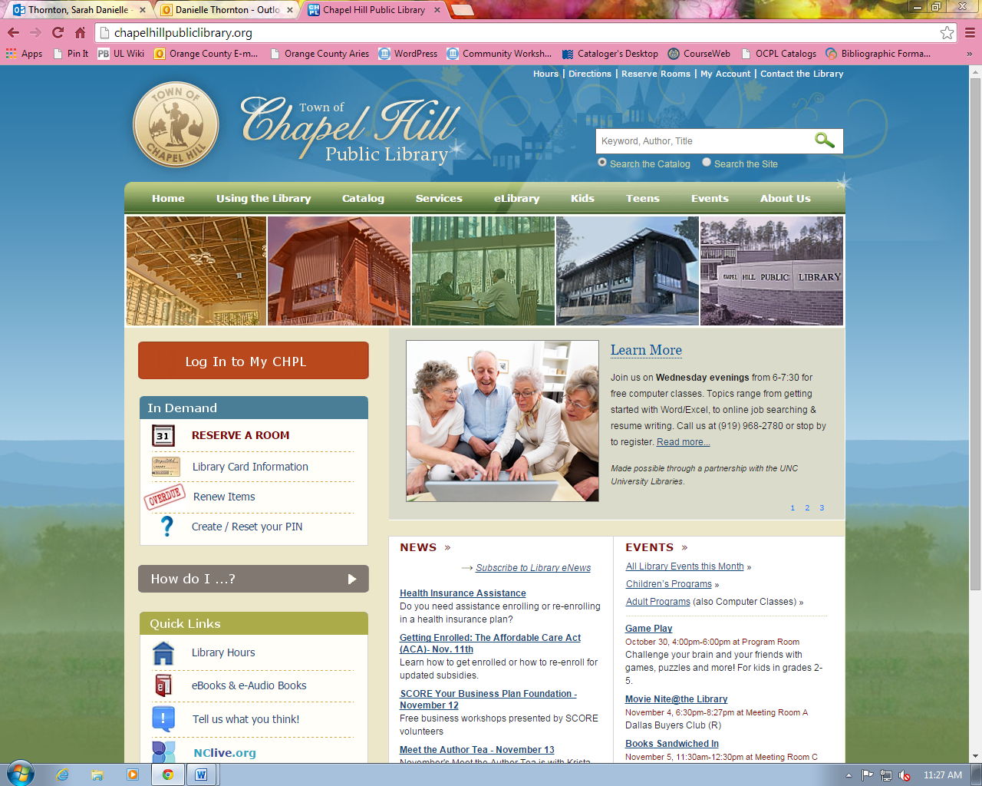

- This will take you to a PIN FAQs page. Follow the directions listed for creating a PIN, and you should be all set. Here are the instructions:
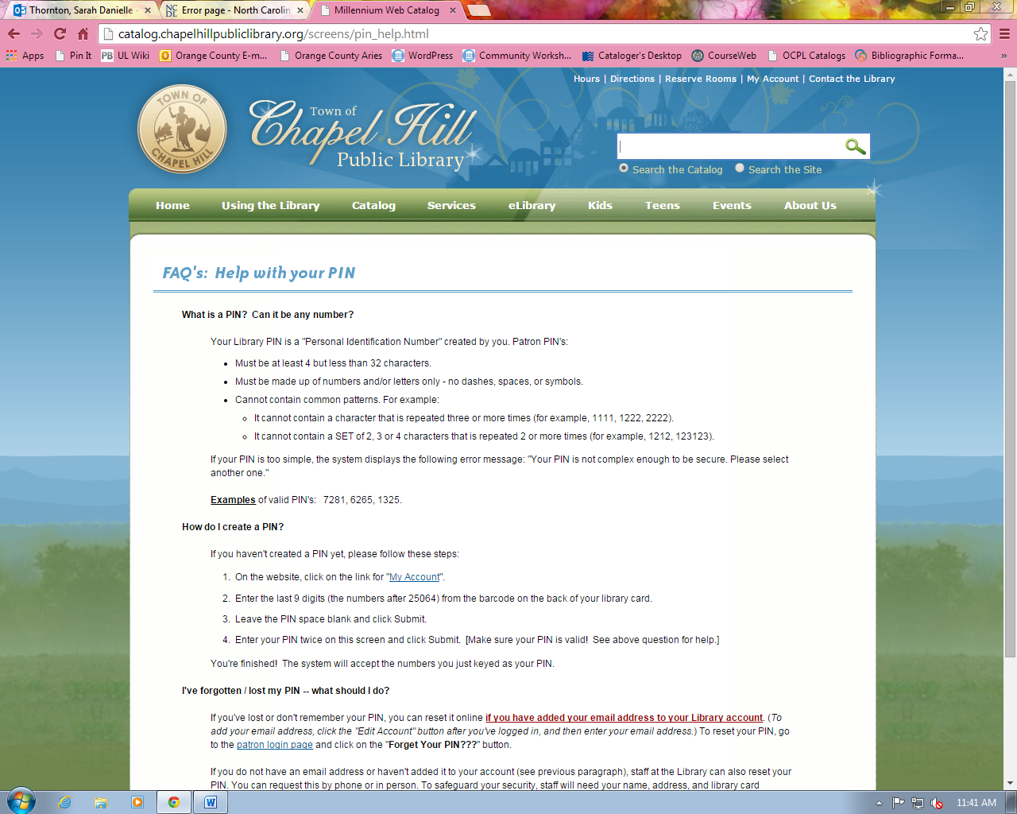
- eBooks cannot be located through the main library catalog. There is a separate website known as Overdrive that you can use to search and access eBooks. CHPL is a member of the NC Digital Library consortium, which means that there are more than just CHPL patrons who are checking out the same eBooks that you are.
- To begin using Overdrive to check out eBooks, visit chapelhillpubliclibrary.org and click on the “eLibrary” link.

- Once you have clicked on the eLibrary link, you can select either eBooks or eAudio Books to get started. (Both options will take you to the same page).

- Next, follow the NC Digital Library link:
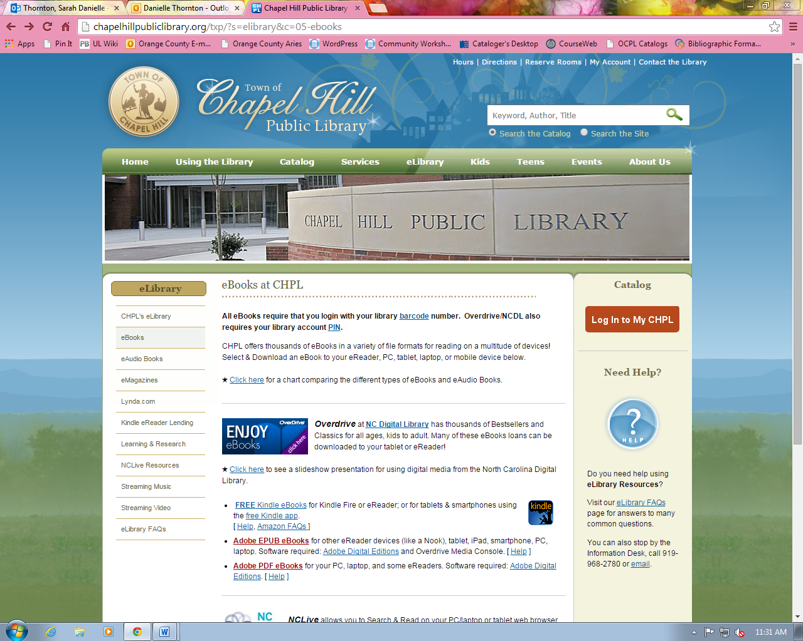

- You can also access this Overdrive site directly by entering the following URL in your address bar: http://ncdigital.lib.overdrive.com/

NAVIGATING THE OVERDRIVE WEBSITE

Below is the homepage you will see when you go navigate to the Overdrive website. *Note the Help option – this is available on every page in Overdrive.

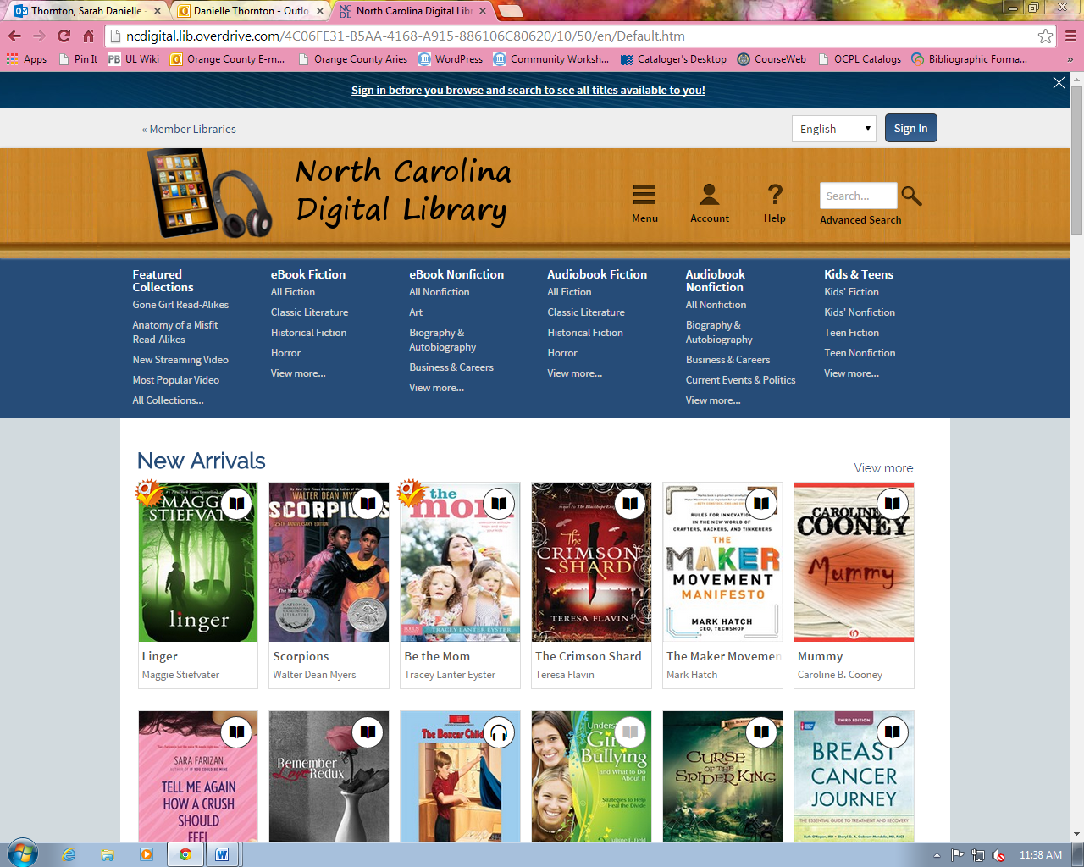

*Note: If you are not logged in while you are browsing, you may see titles that are unavailable to your library’s subscription.

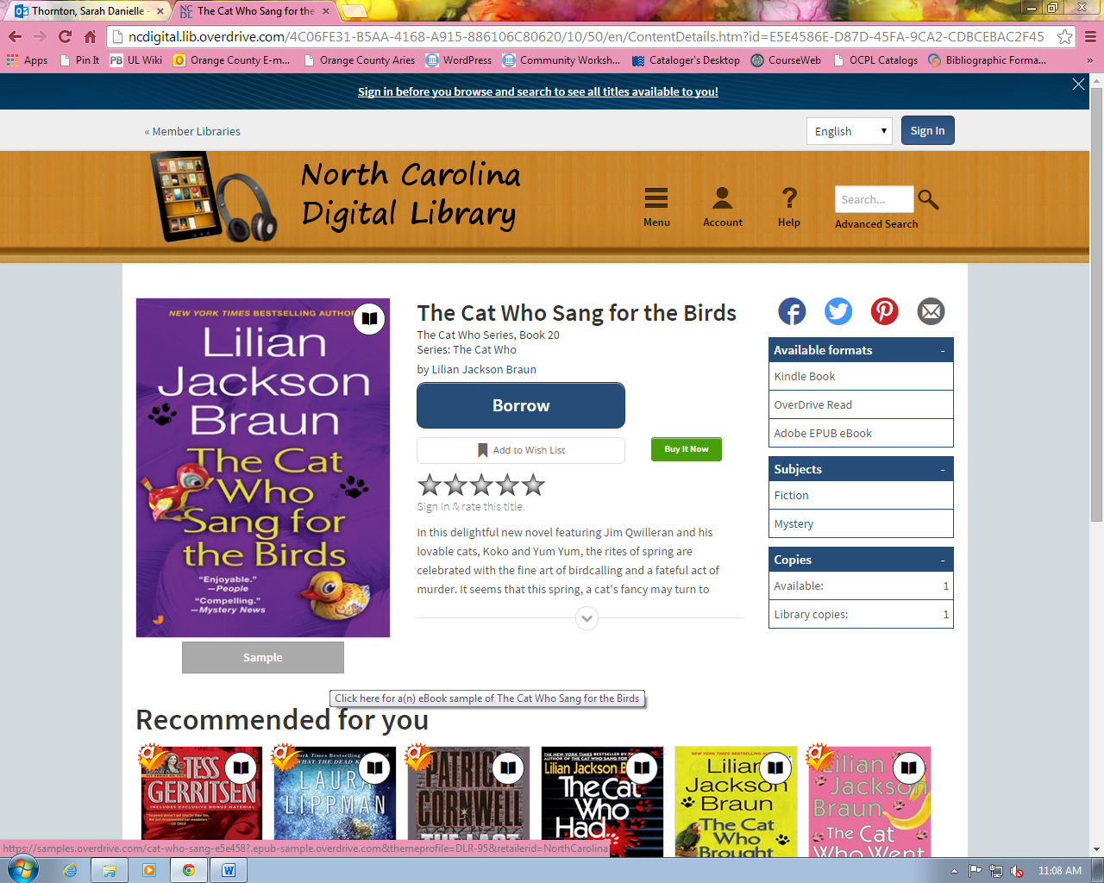

Some items allow you to preview a sample of them. Just like you would be able to flip through the pages of a book at a physical library, you can look at a brief sample of some of the NC Digital Library books. To do this, click on the sample option of a selected book.

Searching and Browsing
There are several ways to search for eBooks.

Keyword searching by author, title, or subject in the top search bar will yield results based on your search.
Once search results have been returned, you can click the button “Available Now” found on the left side of your screen to only see results that you will be able to check out.

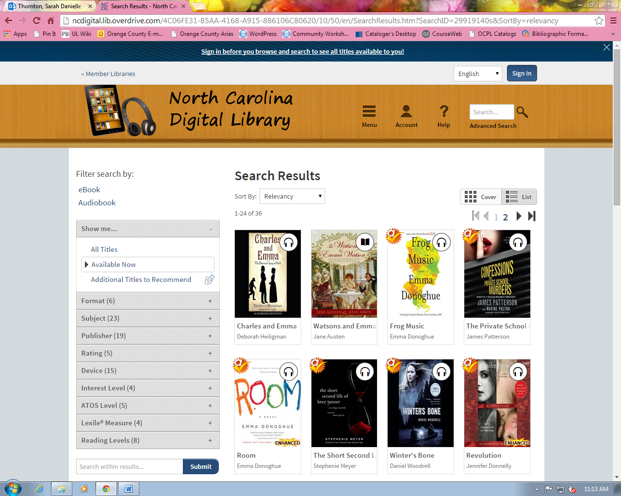

Advanced searching is available by clicking “Advanced Search” in the top search bar. You will get a lot of advanced searching options, but remember, you do not have to fill all of them out. One helpful option is to search by Format here - only showing Kindle Books, for example. To do this, click the arrow in the box that says for “all formats” and select Kindle Book.
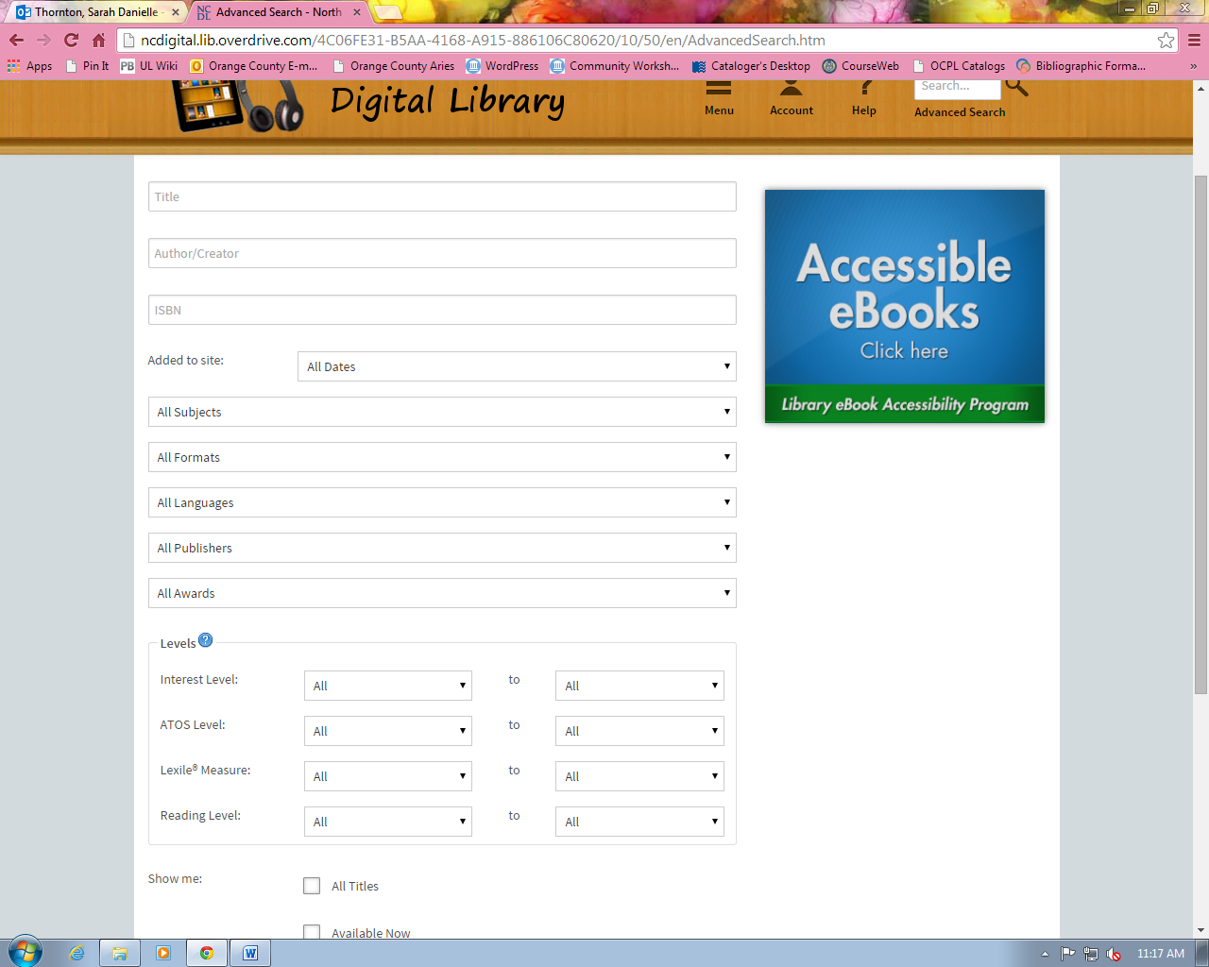

Browsing the Overdrive website can also be a useful way to discover books. You can browse within the major categories. If you do not see the browse menu, click the “Menu” icon at the top right of the screen. Then click on one of the options listed to browse. When you click on a category, the browse page will look the same as a search results page.
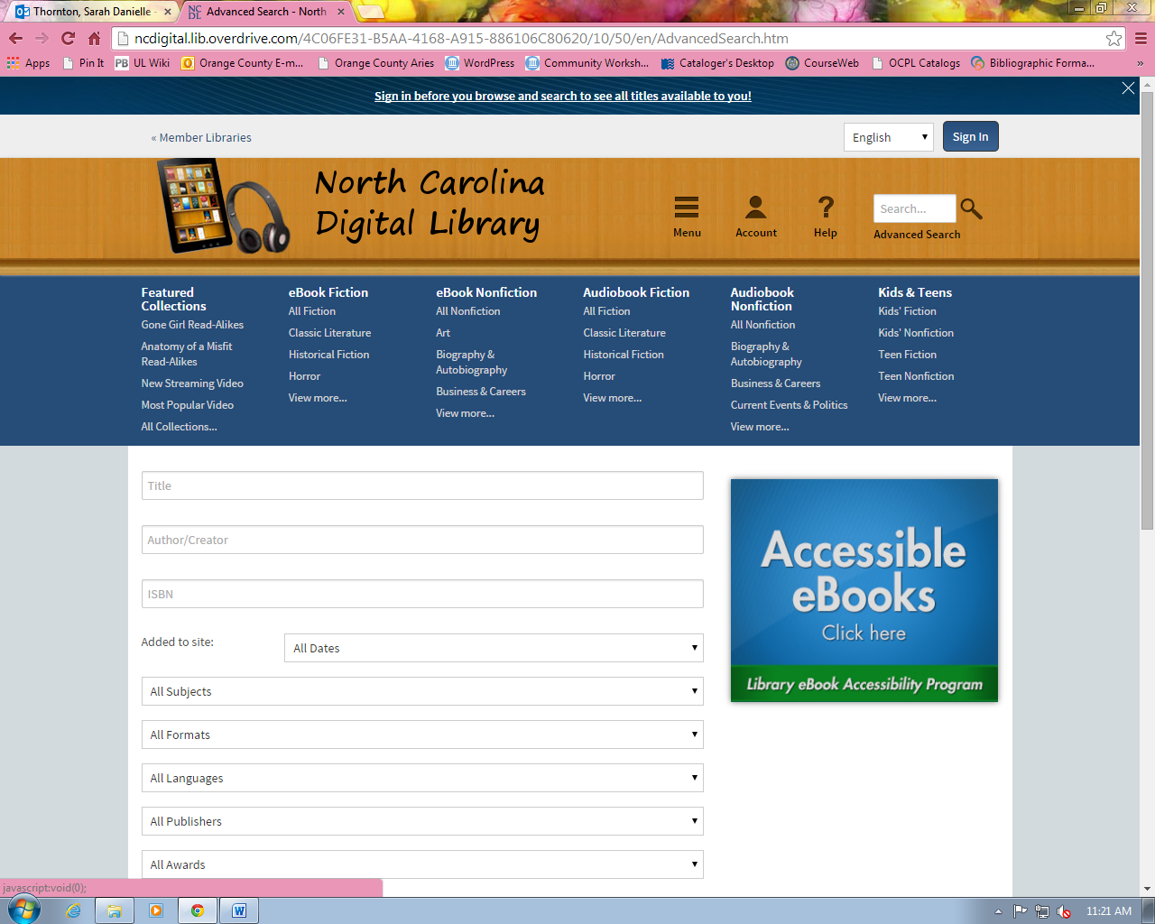

Understanding eBook Records

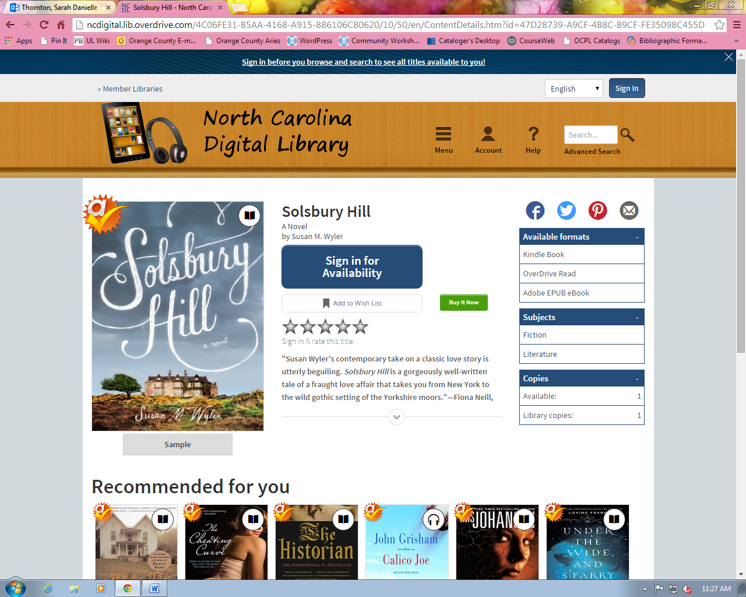

Above is an example of an eBook record on the Overdrive website. The important things to note when looking at a record are the available formats, number of available copies, and number of library copies.

Available formats give you the list of formats that this particular eBook is available to be checked out as. This example is available as a Kindle Book, and OverDrive Read book, and an Adobe EPUB eBook.

Available copies show the number of copies of the eBook available for checkout. If the number is 0, then all copies are checked out.

Library copies show the number of copies owned by the NC Digital Library consortium in total.

If you are already signed in, and a book has one or more available copies, you will see a “Borrow” button, which you can click on to check it out. If a book has 0 copies available, you will see a “Place a Hold” button instead. More details on placing holds are included below.

If you’re not signed in, you’ll see the button that says “Sign in for Availability.” If you’d like to check out the book, you should click there.

Using the Patron Account

To check out eBooks, you will need to login to your patron account.

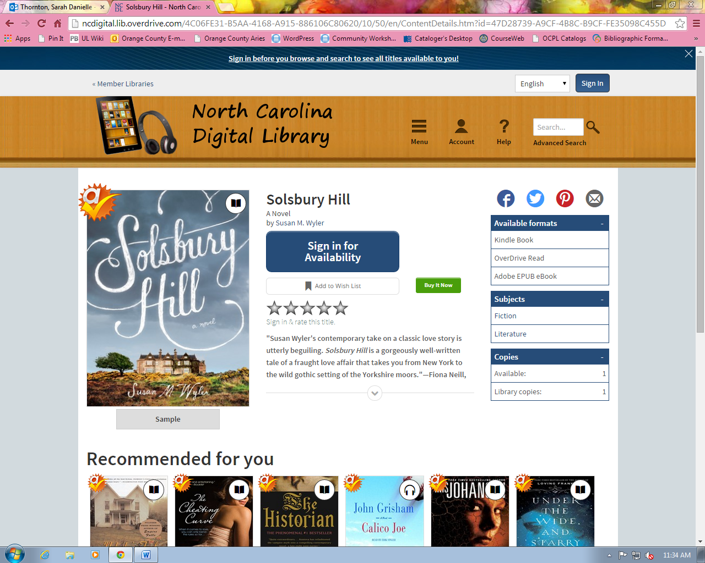

Click on “Sign In” in the top right corner. You will then need to select your library from the list, which of course is Chapel Hill Public Library. Once you have done that, click “Go” to sign in with your library card number and PIN. Since we went through how to set your PIN earlier, you should know what it is and be able to login.

After signing in, you will be able to access the “My Account” page with access to your Bookshelf, Holds, Lists, and Settings.
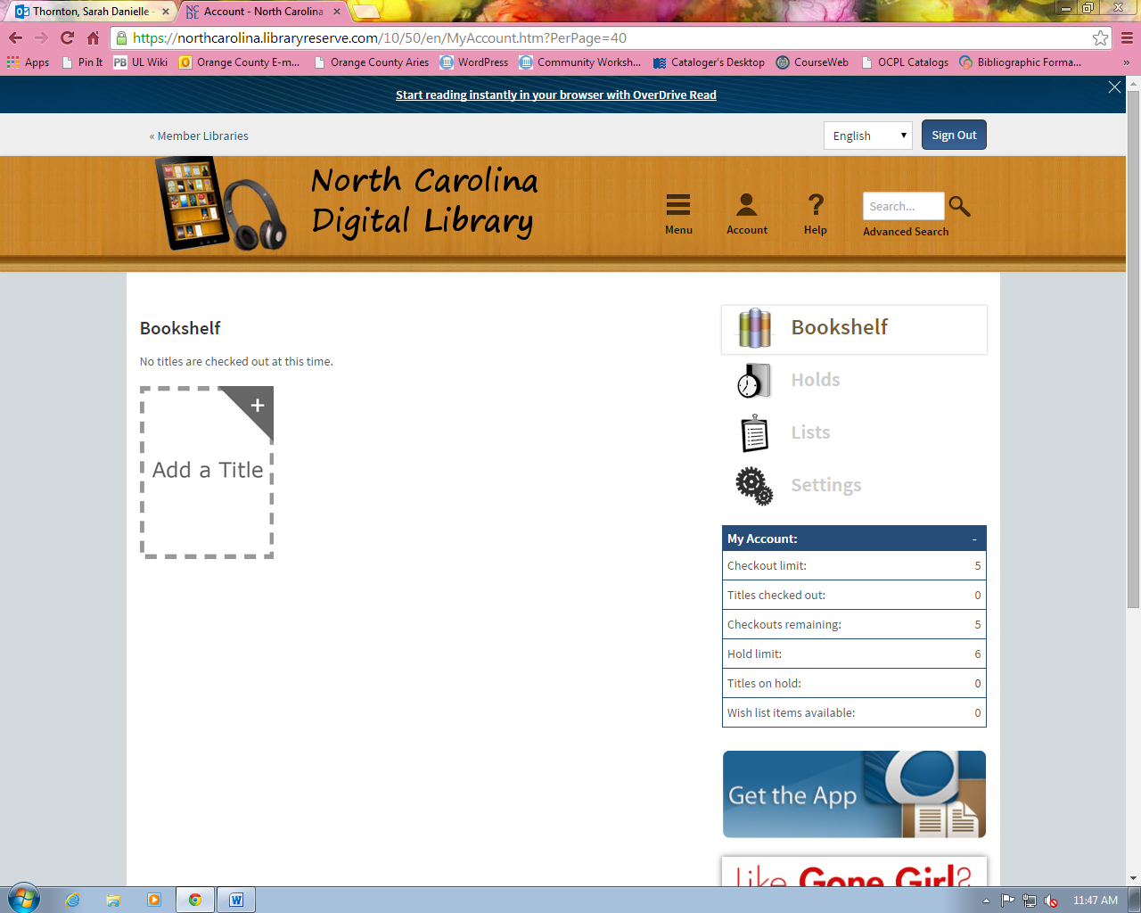

Bookshelf shows you what you have checked out; from here you can click the “Download” link to download it onto your personal computer or device in the correct format. If the OverDrive Read option is available as a format, you can click on that link to read the book in your browser.

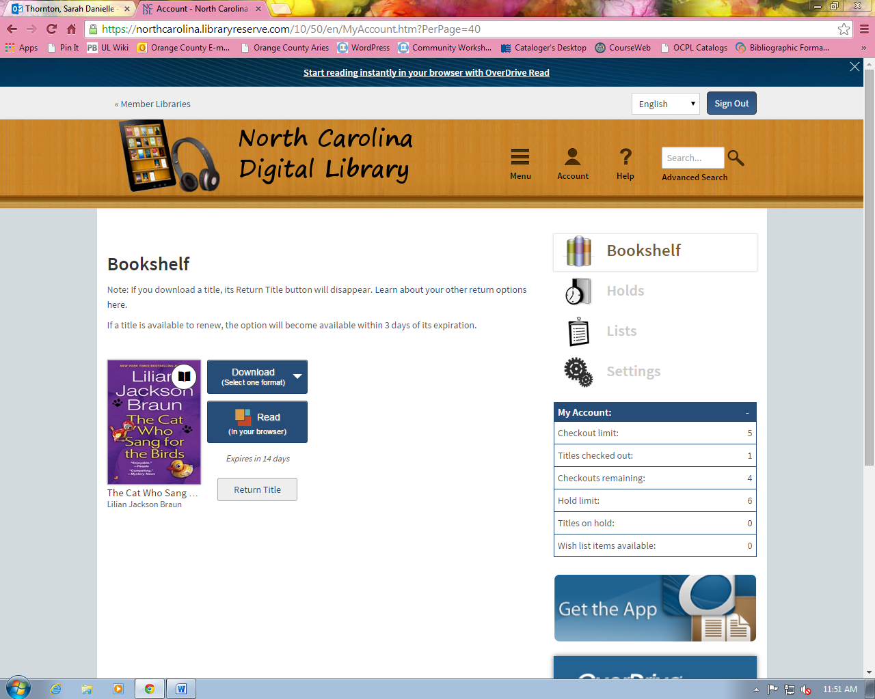

Once you’ve signed in to your account, you can also place holds.

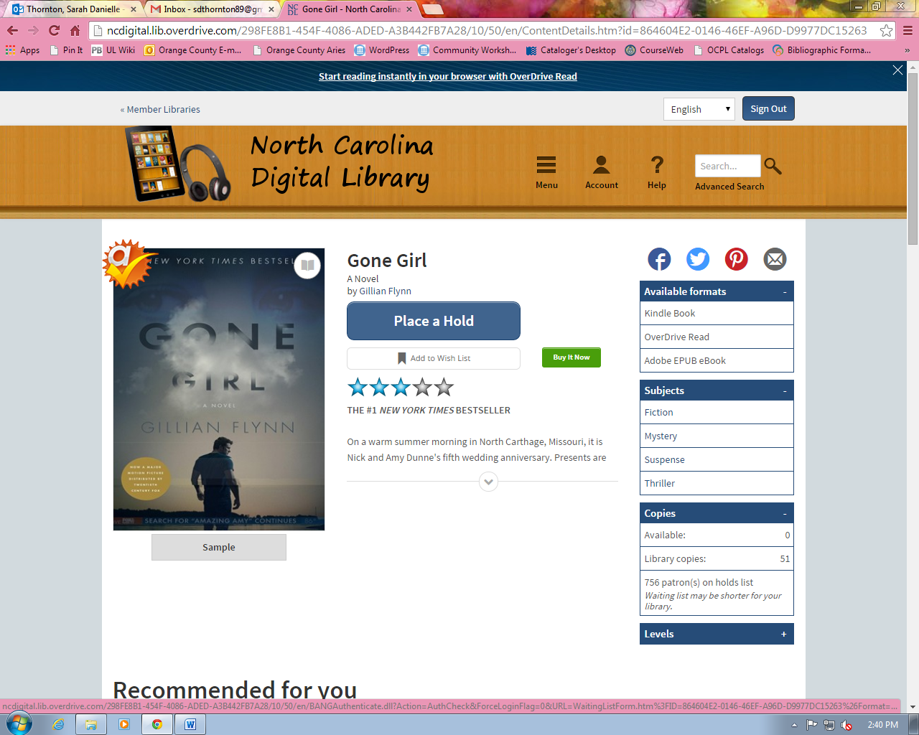

If you click on the “Place a Hold” link on a checked out book that you’d like to request, it will prompt you to enter your email address so that you can be notified via email when the title is available for you to checkout.

Holds (found under “Account”) will list the books you have placed on hold. A preview of each book will show you how many people are ahead of you on the hold list, how many copies your library has, where you will be notified by email when the book is available, and whether or not you have autocheckout on—autocheckout will automatically check out a book to you if you are on hold for it and it comes available.

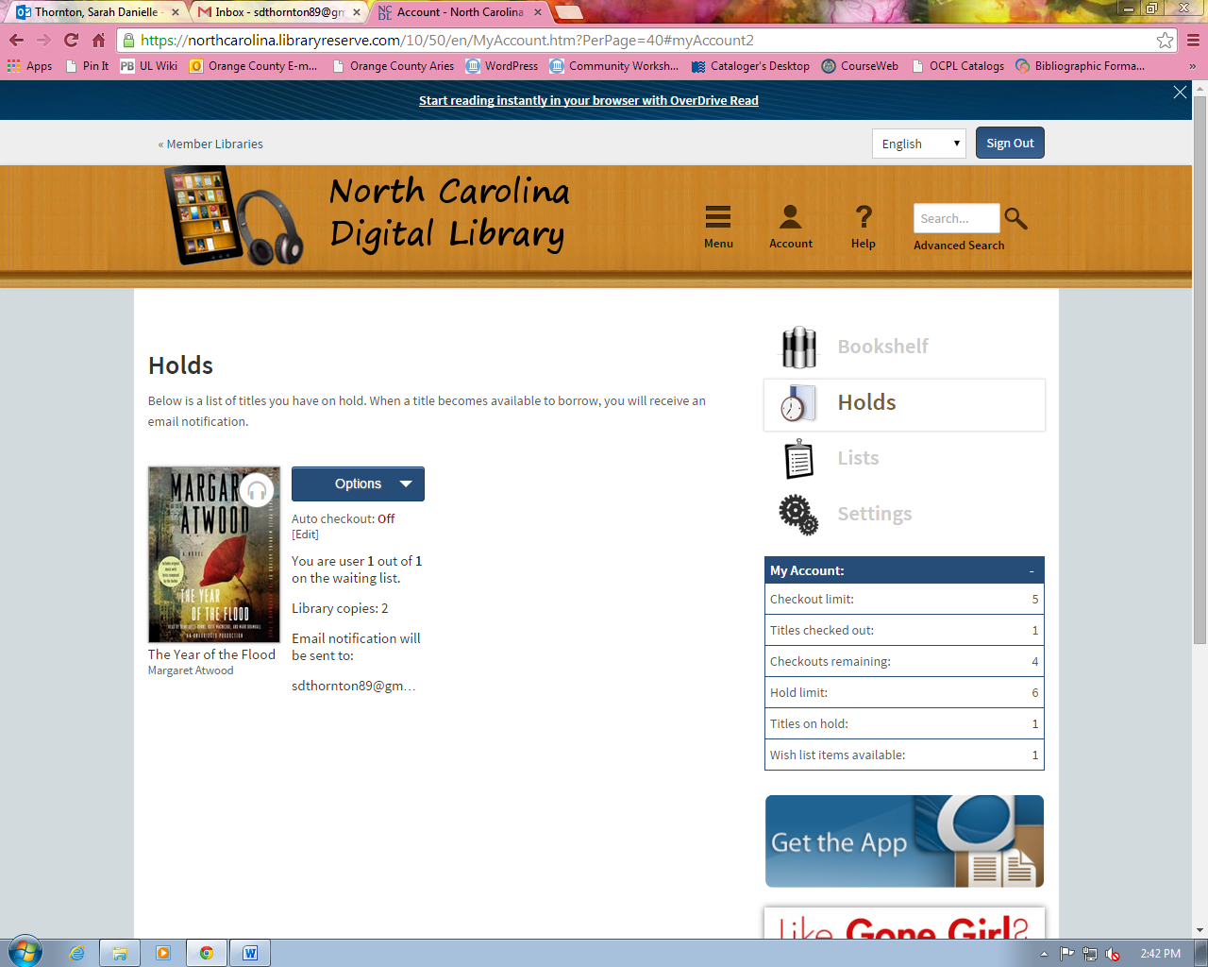

Lists include several different types of lists:

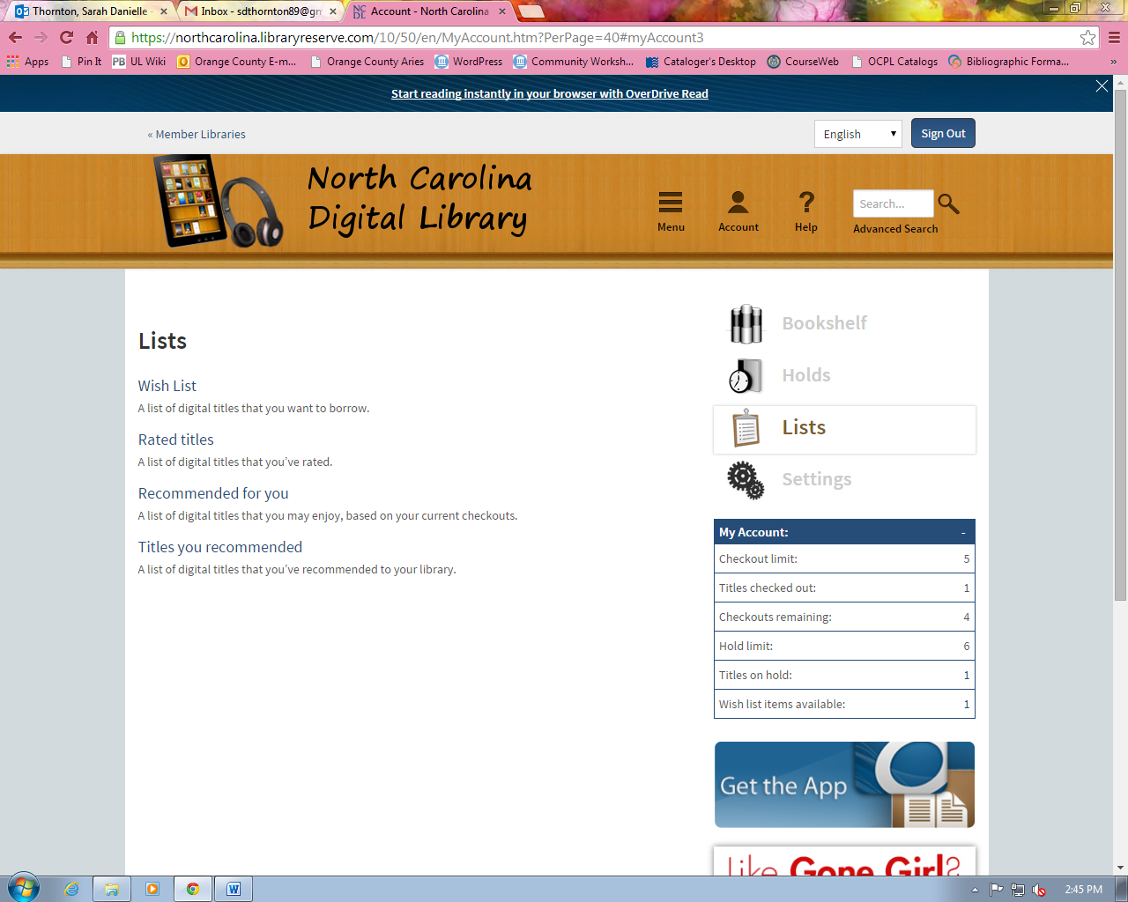

When you see a book that you’d like to read, but you’re not ready just yet, you can add it to your Wish List so that you can easily find it later. You can rate titles, recommend titles to your library for purchase, and you can view a list of recommended titles for you that is based on your previous checkouts.

Settings include a few options:

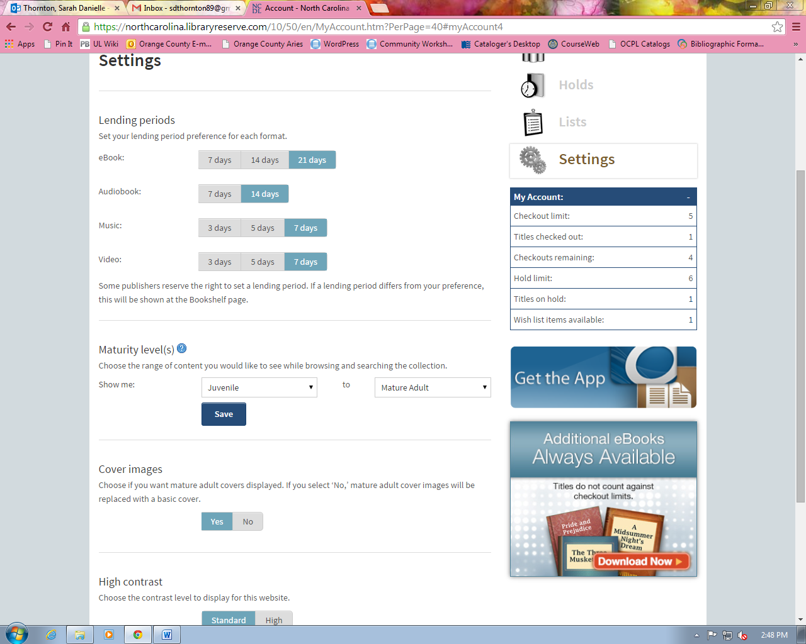

You can change your lending periods for different formats, and you can also set maturity levels. If you only want juvenile material to show up in your searches, then you can set that limiter. Also, you can change the contrast of the website—if you find it easier to read light colored text on a dark background, that is what this will change.

DOWNLOADING eBOOKS TO eREADERS

The process of downloading eBooks to devices differs significantly for each device. The following directions are a summary of the process.

Kindles

The download process for Kindle requires a computer and a Kindle. For the Kindle Fire, the entire process can be done on the device. No software is required for the process, so it can be done from any computer with an internet connection (including library terminals).

*There are some Kindle downloads which require you to download the book through a USB cable or onto a USB key due to publisher restrictions. If this is the case for a title you are checking out it will be noted on the checkout and download screens.

Once you have checked out a book, you will find it in your Bookshelf. From there, you will have the option to choose which format you’d like to download. Choose Kindle Book, then click “Confirm and Download.”

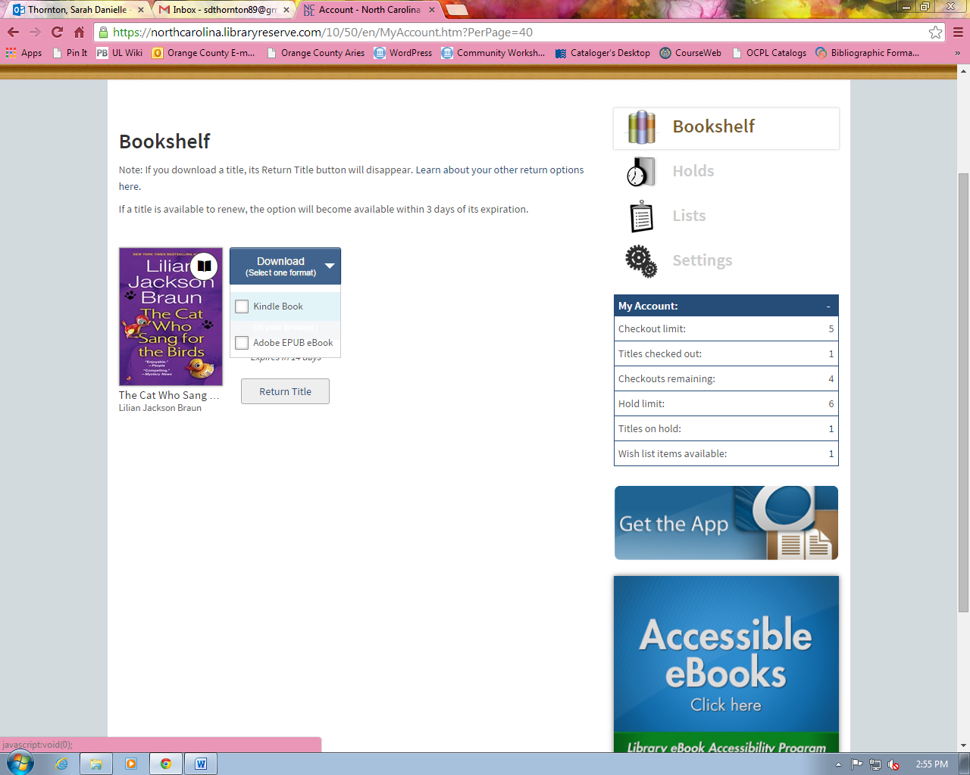

At this point, you will be automatically redirected to your Amazon account. Click the “Get library book” button. You will then be prompted to login and select the Kindle device or Kindle reading app that you will be using.

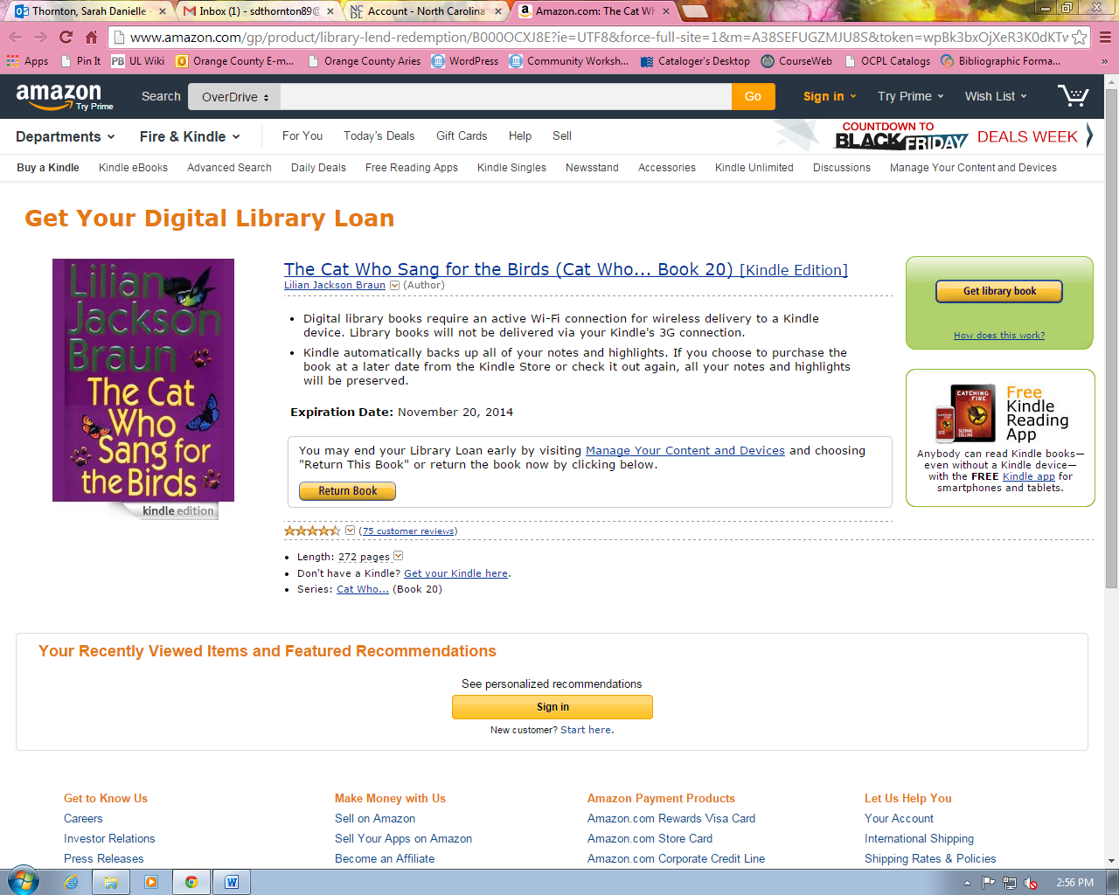

You should a confirmation that looks like this:

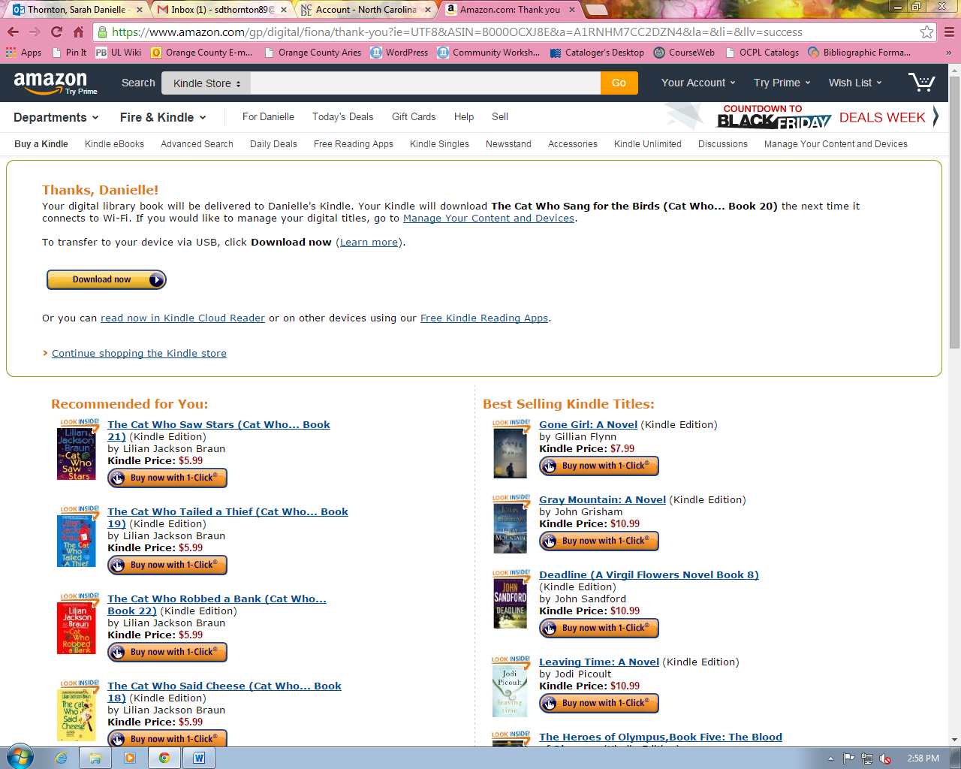

At this point, the process should be complete. The book has been delivered to your Kindle, but may not show up there if the Kindle is connected to 3G internet. The Kindle needs to be connected to wi-fi in order to get the library book. It may be necessary to disconnect from 3G (through the Kindle “settings” menu) and manually connect to a wi-fi network to do this.

Finally, first generation Kindles don’t have wi-fi, only 3G internet. For these Kindles, you’ll need to click the “Download Now” button to download the book and transfer it manually to your Kindle using the USB cable. Refer to Amazon’s instructions to do this: http://www.amazon.com/gp/help/customer/display.html?nodeId=200505520&#usb

To return a Kindle e-book before its expiration, go to "Manage Your Kindle" from Amazon's website. Select the "Actions" dropdown next to the title you want to return. Select "Return the book," and hit yes. The title will remain on your Kindle until you re-sync the Kindle with your Amazon account. Even after you return the book, its title will still display in your Kindle Library list, because Amazon likes to show you your reading history. To remove it from this list, select Actions again, and choose "Delete from library."

iPad/iPod/iPhone, Android Phones & Tablets

To download public library eBooks to an iPad (and other smartphones and Android tablets), you will need the device and a wi-fi or 3G connection.

First, download the free OverDrive Media Console App. You can do this by searching the Apple App Store (or equivalent app store for other devices) for “OverDrive Media Console”.

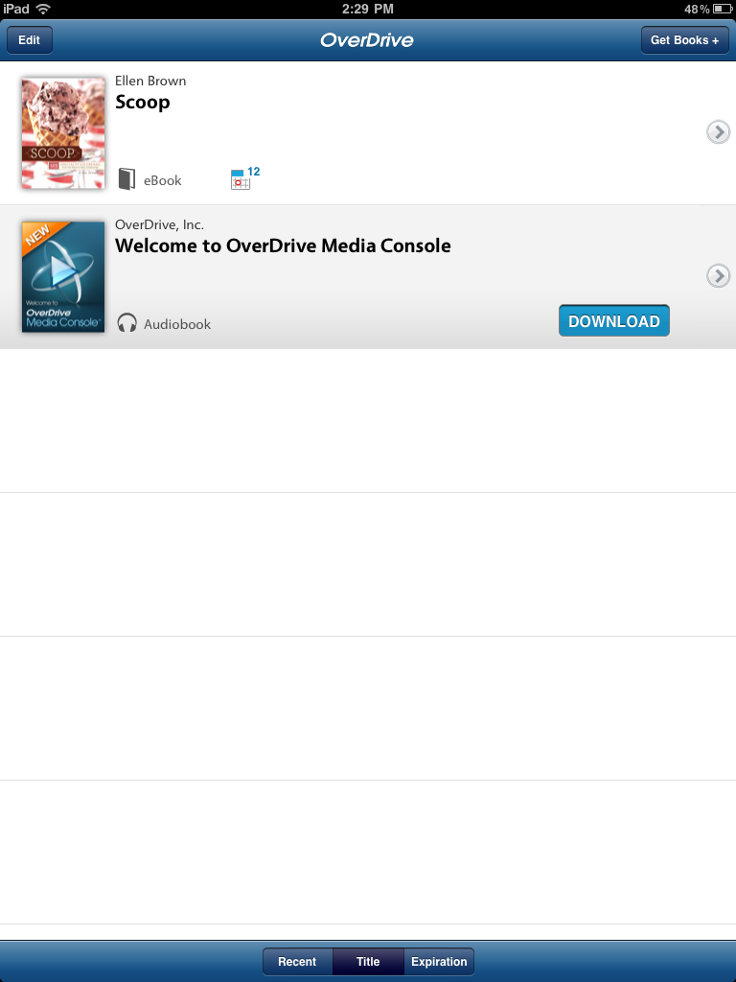
Open the app once it has downloaded. Select “Get Books” and then “Add Library”.

Search for “Chapel Hill Public Library” or “North Carolina Digital Library” and select the Chapel Hill Public Library. Click on the star to save the library to your “Get Books” list.

You will now be seeing the NC Digital Library Overdrive mobile website. Login, choose a title to download, and then add the ePUB format eBook to your Cart.

Check out, then download the eBook. You will be prompted to enter your Adobe ID (you will only have to do this once). Adobe IDs can be created for free at: https://www.adobe.com/cfusion/membership/index.cfm?loc=en%5Fus&nl=1&nf=1

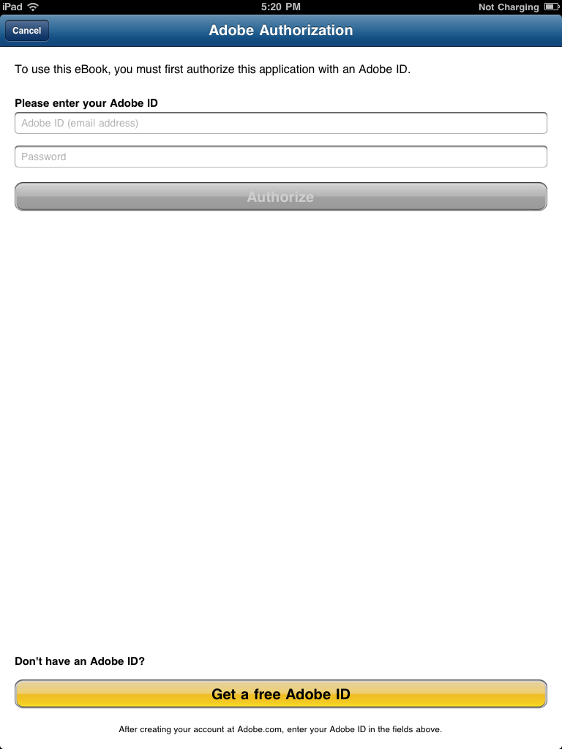

After entering your Adobe ID, the download process will begin and your book will be listed.

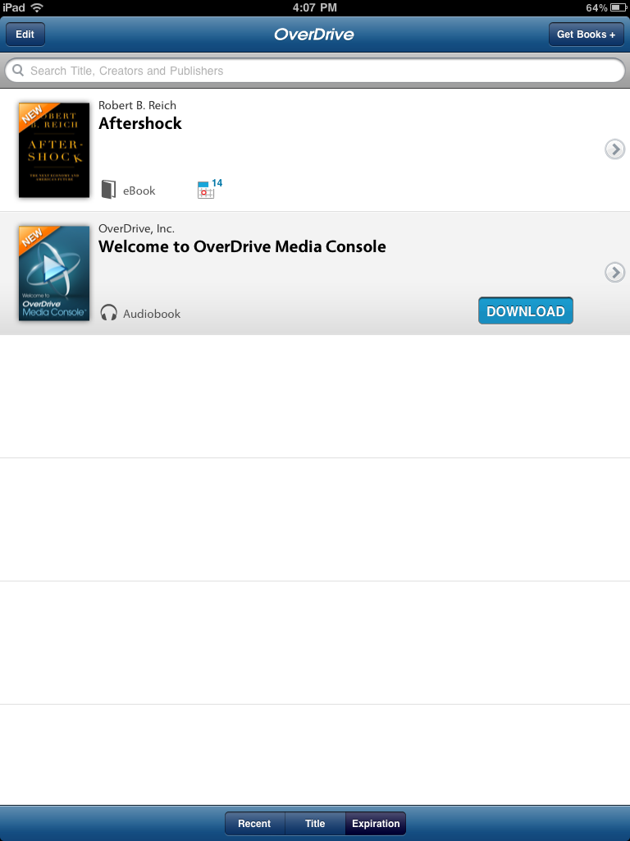

To return eBooks early, swipe across the title of the book (from left to right or right to left). You will see a dialog box like what you see below. Tap on “Return and Delete”.

Nooks

Downloading eBooks for the Nook readers requires a device and a computer (for the Nook Tablet the entire process can be done on the device, see above instructions). Please note that the complete process of downloading eBooks to Nook readers cannot be accomplished on public library computers, since it involves downloading software to the computer.

You will first need to download and install Adobe Digital Editions. On the Overdrive website, click on the Help button and choose “Applications” from the available options. Next, choose “Adobe Digital Editions.”

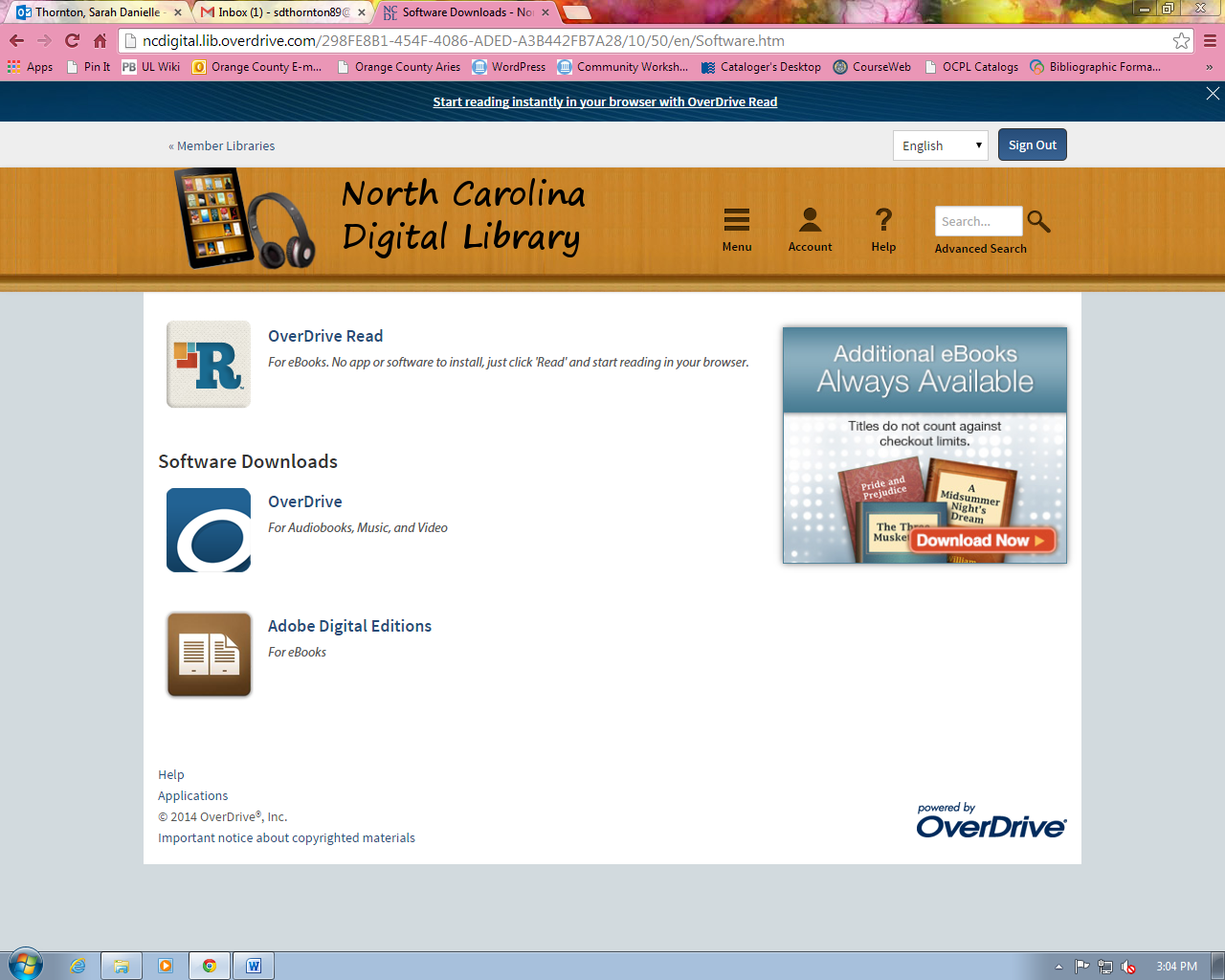

You will be redirected to the Adobe website. Download Adobe Digital Editions to install this program on your computer.
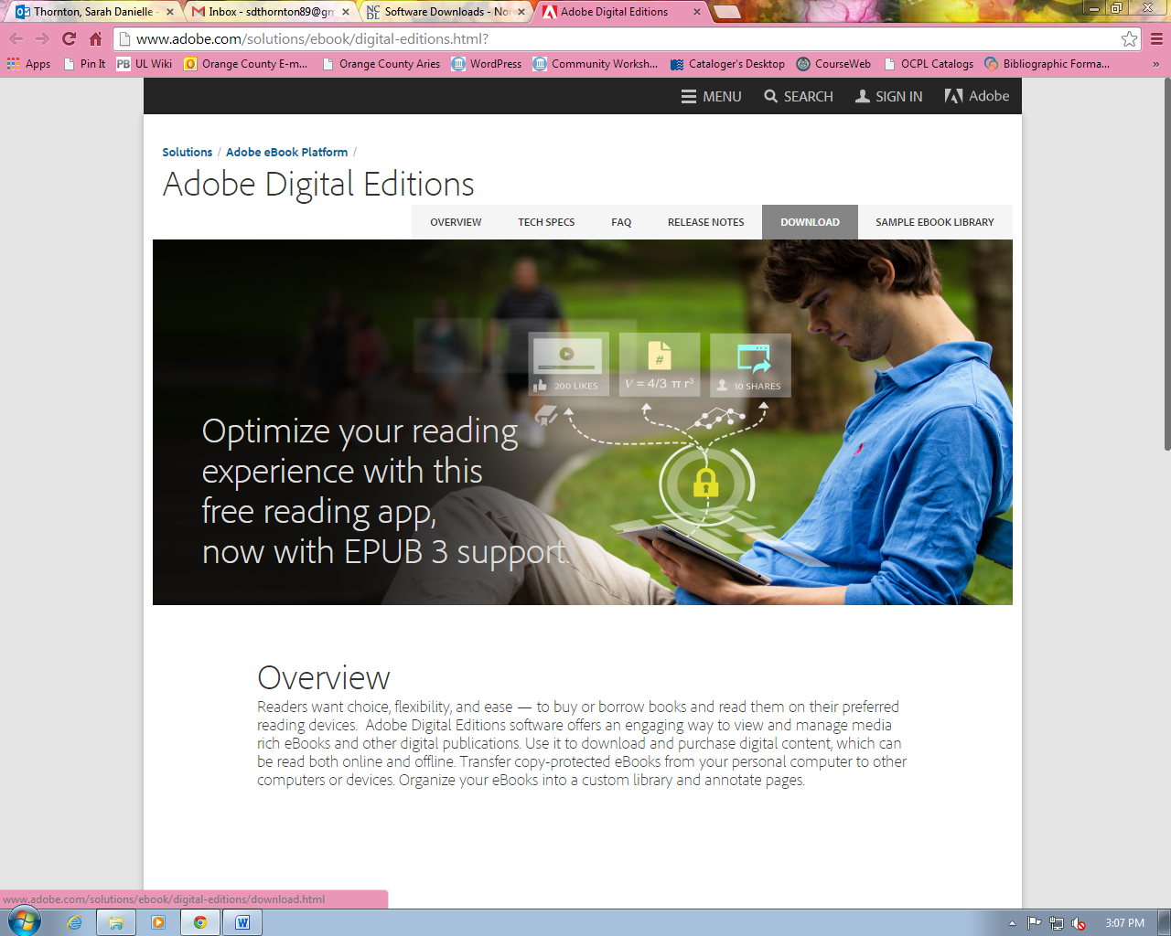

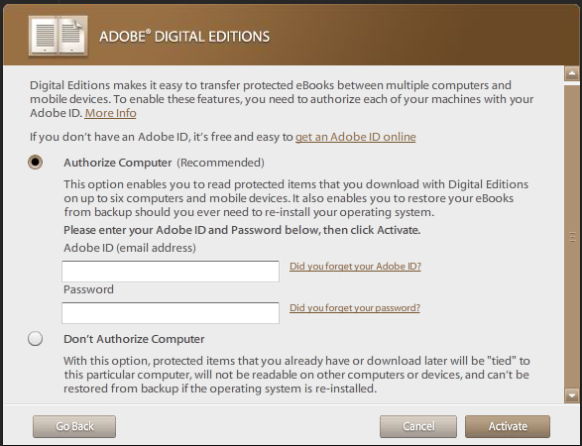Create an Adobe ID when prompted during the installation process. Without it, you will not be able to transfer eBooks to your Nook.

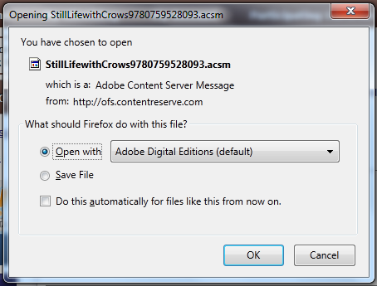
Check out and download an ePUB or PDF eBook from the Overdrive website. After clicking the download link, you will be prompted to open the eBook using Adobe Digital Editions.
Once the eBook has opened in Adobe Digital Editions, plug in your Nook. Adobe Digital Editions will detect the device and add it the left hand panel. Make sure you are in “Library View” (bookshelf icon in upper left-hand corner) to see your device. Drag and drop the eBook from the library to the device.

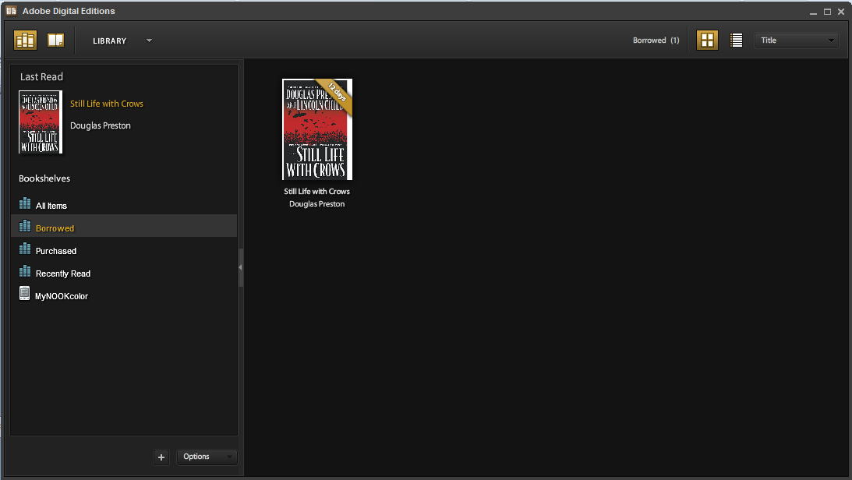

Eject and unplug your Nook. Your eBook will now be in your library on your Nook. If it is not appearing on the main Library screen, go to Library My Files Digital Editions to find it.

To return eBooks early, move your mouse over the eBook in Adobe Digital Editions on your computer. Click on the small arrow in the upper left-hand corner that appears. Then click “Return Borrowed Item”.
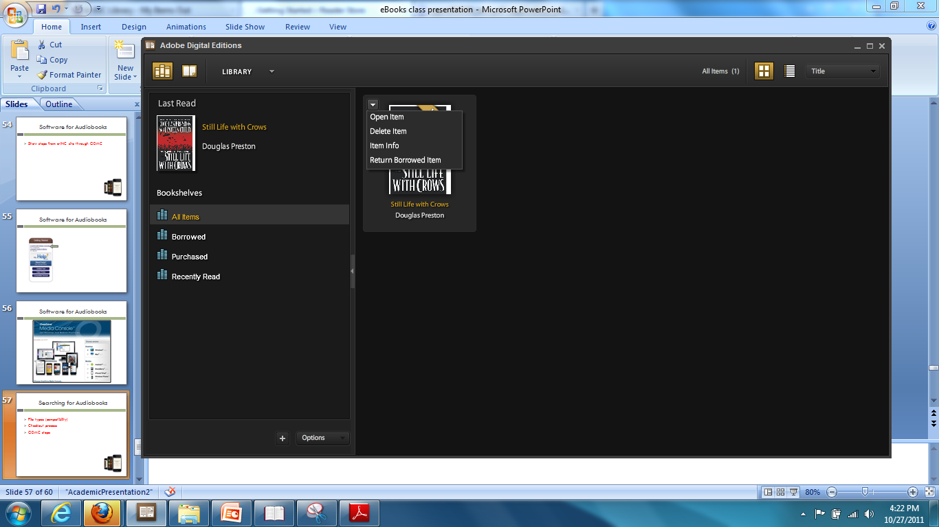

Sony Reader

Downloading eBook for the Sony Reader requires a device and a computer. Please note that the complete process of downloading eBooks to the Sony reader cannot be accomplished on public library computers. There are two methods of downloading eBooks to the Sony Reader: using Sony’s Reader Library software, and using Adobe Digital Editions.

Using Reader Library:

Plug in Sony Reader and run Reader Library Setup (if you don’t already have it).

Download an eBook from the Overdrive website. You will automatically be prompted to open it with Reader Library.
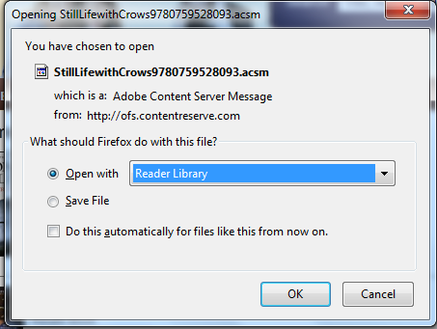

Connect the Sony Reader to your computer. Once the device appears in the left-hand panel, drag and drop the eBook to the device.

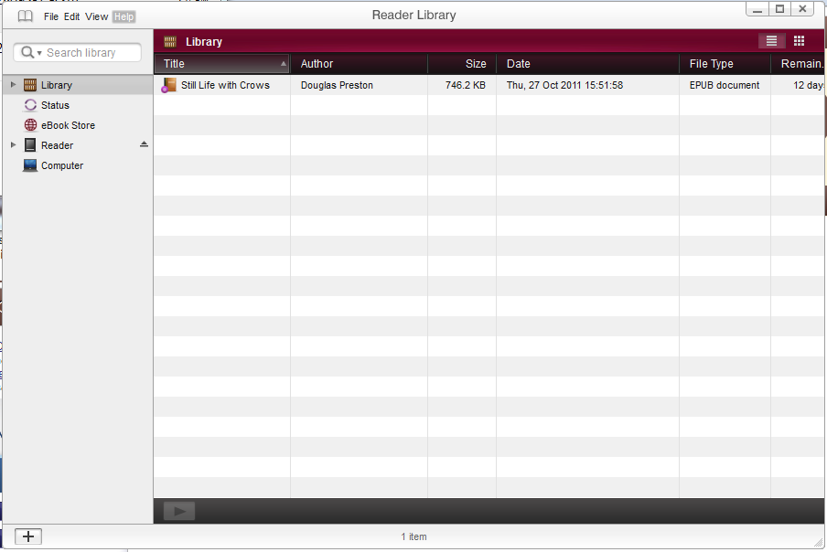

Eject and unplug the Sony Reader. Your eBook should appear on the screen.

Using Adobe Digital Editions:

Follow the directions for downloading eBooks for Nook readers. Drag and drop the eBook to the Sony Reader after plugging it in.

OTHER SOURCES OF eBOOKS

Project Gutenberg eBooks are books whose copyright has expired and are now in the public domain. The over 34,000 Project Gutenberg eBooks available through the Overdrive website includes many classics, most books published before 1923, as well as some more recent titles. These books are always available through the Overdrive website, and there are unlimited copies. Project Gutenberg eBooks also have no DRM attached to them, so they can be checked out indefinitely and copied freely.

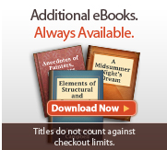

Clicking on the above link in the lower left side of the Overdrive website will allow you to search Project Gutenberg eBooks. Please note that these titles will not show up through the main search and must be accessed through the link shown above. Also note that Project Gutenberg eBooks are not available to the Kindle through the Overdrive website, although they can be accessed by Kindle users by going to Project Gutenberg’s website: http://www.gutenberg.org.

NCLIVE.org is a large collection of free online resources for North Carolinians. There are a large number of eBooks available for use through NC LIVE, but they must be read on a computer and cannot be transferred to eReaders. NC LIVE can be accessed by going directly to their website at nclive.org or via the Chapel Hill Public Library’s website under “eLibrary.” These eBooks can be accessed by selecting your library and entering your library card number.

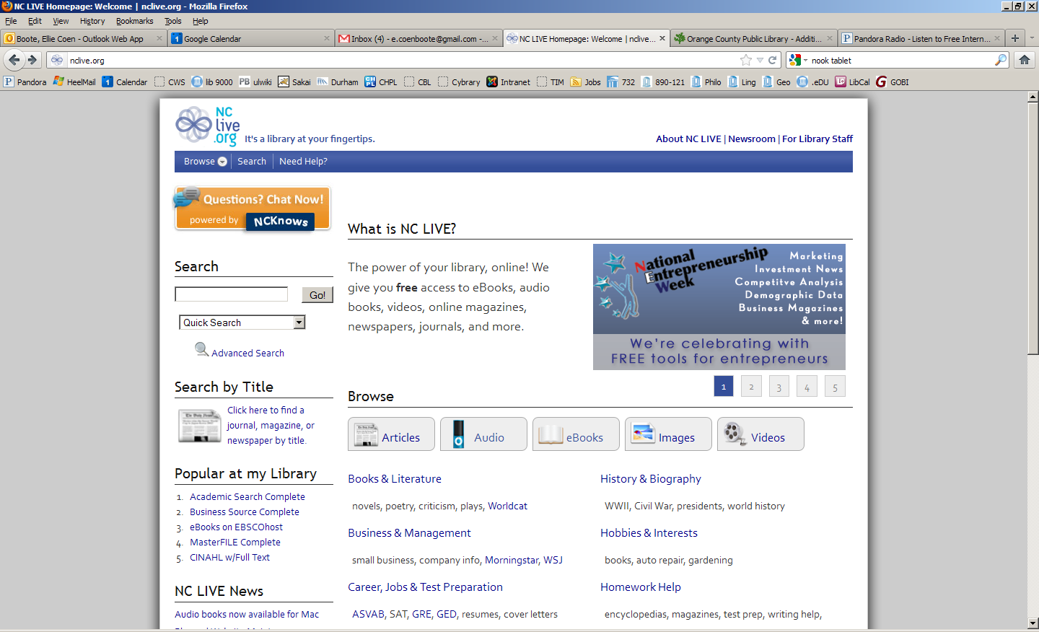

NOTE: Images and screen captures may differ from those seen on another system.

This work is licensed under a Creative Commons Attribution-NonCommercial 4.0 International License2.

