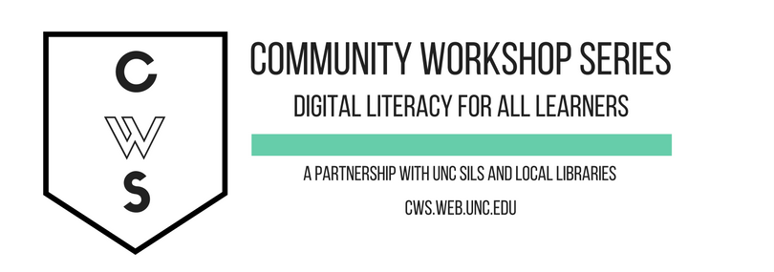
News & Media Literacy

Objectives:
- Understand the historical roots of misinformation & disinformation
- Learn how to fact check news sites and find credible information
- Learn how to identify misinformation on social media websites like Facebook and Twitter
- Understand bias, balance, and fairness in news
- Learn about the power and politics of information
- Understand “whose news” and “who decides what’s newsworthy”

To complete feedback forms, and to view our full schedule, handouts, and additional tutorials, visit our website:
cws.web.unc.edu

