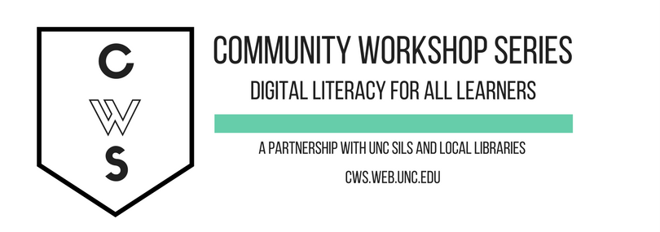
INTRODUCTION TO NC LIVE ONLINE RESOURCES

GETTING STARTED PAGE 02
Class Overview
What You Will Learn

The Basics PAGE 03
What Is NC LIVE?
What Is Available on NC LIVE?
How to Access NC LIVE
Navigating NC LIVE

Audiobooks PAGE 07
OneClick Digital

Videos PAGE 11
NC Live Video Collection

Health Resources PAGE 12
Medline Plus
ProQuest Family Health

Newspaper and Magazine Articles Page 15
ArticleFirst
Infotrac Newsstand
ProQuest Newsstand

Language learning PAGE 16
Pronunciator

Genealogy Resources PAGE 18
HeritageQuest

Business Resources Page 19
Morningstar Investment Research Center

Education Resources Page 20
Learning Express Library
CQ Researcher

To view our full schedule, handouts and tutorials, visit our website:
cws.web.unc.edu
Class Overview

This is a class for new users of NC LIVE. You will need to be comfortable with the basics of using a computer, including using the mouse and keyboard, opening a program, and turning the computer on and off. Additionally, you will need to know the basics of navigating the Internet.

Today, we will be exploring the wealth of resources that are available to North Carolina residents with a library card. These resources come from NC LIVE, a statewide online library available to public libraries and public universities. We’ll overview a few of the more commonly used and interesting resources, plus discuss how to find more NC LIVE resources that might fit your needs or interests.

Please let the instructor know if you have questions or concerns before the class, or as we go along.

You Will Learn How To:

Access the resources available on NC LIVE | Find a list of resources available on NC LIVE | Check out and download audiobooks
Stream PBS videos | Find consumer health information | Locate newspaper and magazine articles
Learn a language | Look up business and investment information | Find study guides and research tools
Discover more NC LIVE resources!

THE BASICS

What is NC LIVE?

NC LIVE is an online library service created and maintained by representatives from the NC Community Colleges, the NC Independent Colleges and Universities, the NC Public Library Directors Association, the University of North Carolina, and the State Library of North Carolina. It provides access to a wide variety of online databases, tools, and electronic books to public library users and students across the state. Resources range from career and business information to genealogical and ancestry information to automotive manuals and consumer reports. All of the resources available on NC LIVE are designed to be accessible from your home computer, but you can also use library computers to access them.

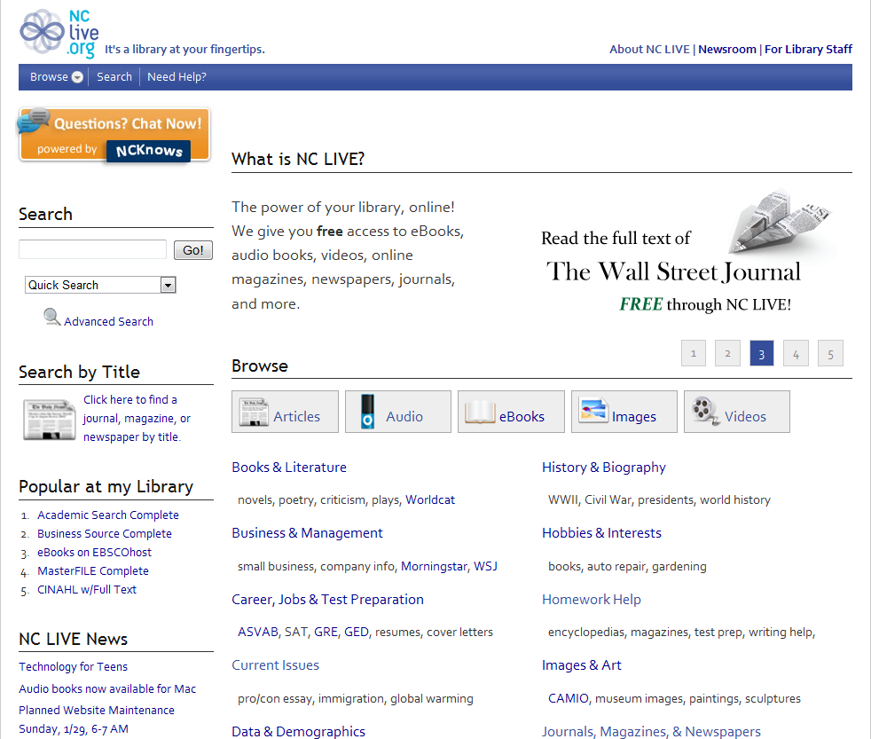

What Is Available on NC LIVE? (As of January 2015)

ABC-CLIO E-book Collection
ABI/INFORM Complete
AccessScience
African-American Poetry
American Poetry
American Slavery: A Composite Autobiography
Archive Grid
ArticleFirst
ArtNC
Bills from the NC General Assembly
Business Link North Carolina
CAMIO
Canadian Busines & Current Affairs Complete (CBCA)
Canadian Newsstand Complete
Centers for Disease Control and Prevention (CDC)
Centros para el Control y Prevención de Enfermedades
ClasePeriodica
CQ Researcher Online
CQ Weekly
Crime in North Carolina (Uniform Crime Report)
Criminal Justice Periodicals
DigitalNC
eBooks on EBSCOhost
ebrary Academic and Public Library Complete
Economic Development Information System
English Poetry
Faber Poetry Library
Films on Demand Video Collection
Gale Virtual Reference Library
Go Ask Alice
Government Employee Telephone Directory
GPO
HealthFinder
HealthFinder en Español
HeritageQuest
HIV InSite
Home Grown eBooks Collection
Hoover’s Company Profiles
Infotrac Newsstand
Job Openings
KidsHealth
Lab Tests Online
LawHelpNC
LearningExpress Library
Literature Resource Center
MayoClinic.com
MedlinePlus
MedlinePlus Drugs & Supplements
Merck Manual Home Edition
Morningstar Investment Research Center
MyiLibrary
National Cancer Institute
National Center for Complementary and Alternative Medicine
National Institute of Mental Health
Natural Standard
NC ECHO
NC Health Info
NC LIVE Video Collection
NC Public Schools Statistical Profile
NCPedia
New York Times
NIH Senior Health
North American Women’s Letters and Diaries
North Carolina Agricultural Statistics Service
North Carolina Curriculum
North Carolina Driver’s Manual
North Carolina Education Directory
North Carolina General Assembly
North Carolina Homepage
North Carolina Periodicals Index
North Carolina Public Health
North Carolina State Government Publications Collection
OAIster
Occupational Outlook Handbook
One Click Audio
One Click Ebooks
Open Library
Oxford Reference Online Premium
Pharmaceutical News Index
Pronunciator
ProQuest Accounting & Tax Database
ProQuest Asian Business and Reference
ProQuest Banking Information Source
ProQuest Biology Journals
ProQuest Career & Technical Education
ProQuest Central
ProQuest Computing
ProQuest Education Journals
ProQuest Entrepreneurship
ProQuest Environmental Science Package
ProQuest European Business
ProQuest Family Health
ProQuest Health & Medical Complete
ProQuest Health Management
ProQuest Military
ProQuest Newsstand
ProQuest Nursing & Allied Health Source
ProQuest Political Science
ProQuest Psychology Journals
ProQuest Religion
ProQuest Research Library
ProQuest Science Journals
ProQuest Social Science Journals
ProQuest Sociology
ProQuest Telecommunications
PubMed
ReferenceUSA
Regional Accounts Data – Local Area Personal Income
Sanborn Maps North Carolina
Science in Context
SimplyMap
SIRS Knowledge Source Package
Snapshots Series (market reports set)
State Center for Health Statistics
State Data Center
State Demographics
Statistical Abstract of the United States
Tax Forms via NC Department of Revenue
Teaching Positions in North Carolina
TOPICsearch
Twentieth Century African-American Poetry
Twentieth Century American Poetry
Twentieth Century English Poetry
Wall Street Journal
Women’s Health
WorldCat

How to Access NC LIVE

To access NC LIVE, visit www.nclive.org. You will be able to browse through the lists of available resources without having to sign in with your library card.

If you click on an NC LIVE resource, you will be taken to a log-in screen. First, you will be prompted to select your library:
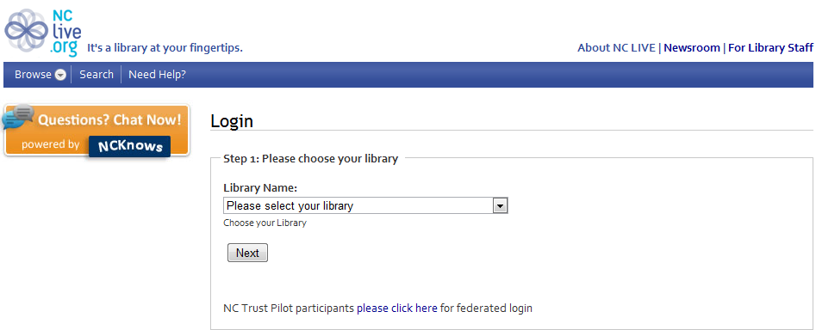
If you have a Durham County Library card, select Durham County. If you have Carrboro Cybrary card, then select Orange County. If you have a Chapel Hill Library card, choose Chapel Hill Public Library. Then click “Next.” This will take you to a page where you need to enter your library card number. After doing this and clicking “Login,” you should be able to access the resource.
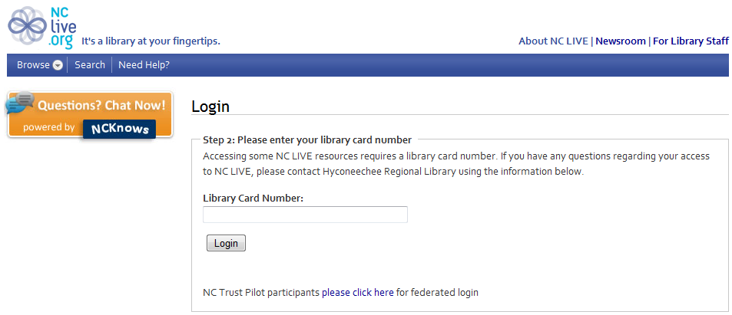
Depending on the library card required resource you select, you might see something like the following screen. Just enter your library card number and click the “Proceed” or “Submit” button!

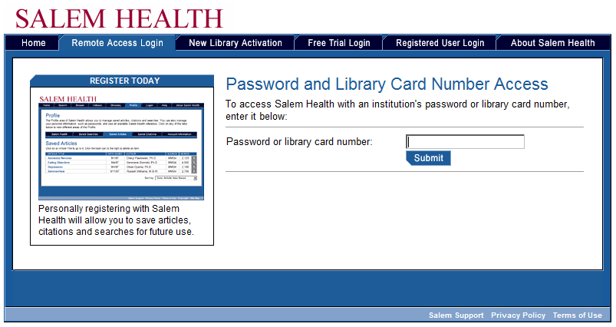

Navigating NC LIVE

The NC LIVE homepage is the best way to access all of the resources available through this great service. Though the library website links to some of the more commonly used resources, the NC LIVE homepage provides a much larger variety of resources at your fingertips. Let’s take a look at how we can find resources from the NC LIVE homepage.
Questions? Click here to chat with a librarian!
You can search by subject, database name, or title here.
Browse by type of resource by clicking on these icons.
Looking for a particular magazine? Click here to see what resources include that magazine or newspaper!
Browse by categories by clicking on these links.

AUDIOBOOKS

One of the newest resources available on NC LIVE allows you to check out and download audiobooks from the comfort of home!

You can access it from the NC LIVE homepage:
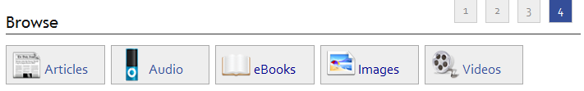

OneClick Digital

The service that provides audiobooks for checkout online through NC LIVE is called OneClick Digital. You can listen to audiobooks that you download from OneClick Digital on your PC or Mac, iPod, iPhone, iPad, Zen Digital Media Player, Sandisk MP3 player, or Sony Walkman. You can also listen to audiobooks on most MP3 or WMA players, but they are not explicitly supported by the OneClick Digital Media Manager (the program that will help transfer your audiobooks to your device).

When you click on a link to the OneClick Digital website, you’ll see this page:
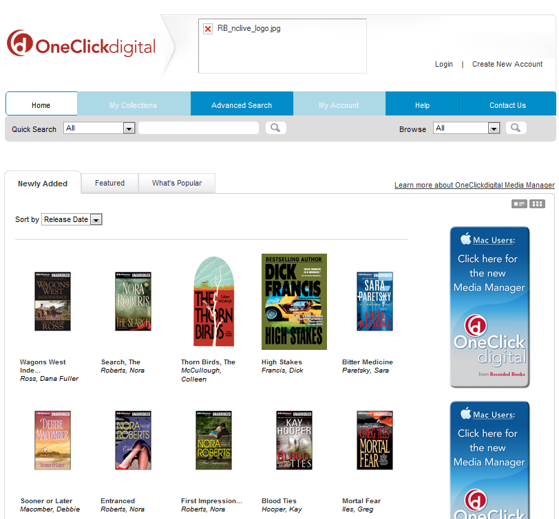

From here, you can see the newest audiobooks, perform a search for specific audiobooks, create an account, and download the OneClick Digital Media Manager, which will allow you to check out and download books onto your computer.
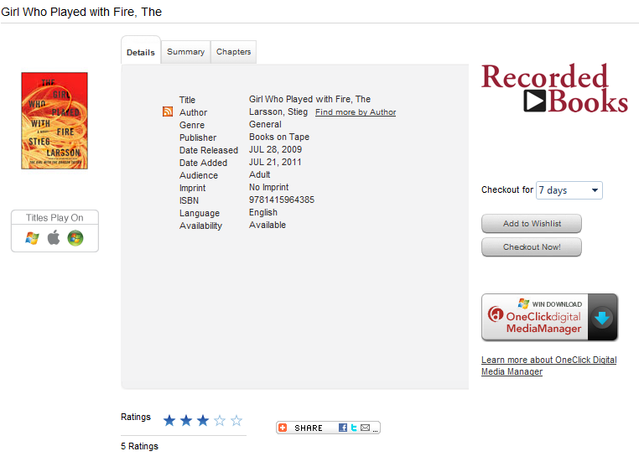
If you click on a title, you’ll be taken to a page with more information about the book:

The Details tab will give you general info, the Summary tab will tell you about the book’s content, and the Chapters tab displays the length in minutes of each chapter.

Under the image of the book cover, a list of platforms that this audiobook will play on is shown (in this case, both Windows and Apple are supported).

At the bottom of the page, you can see how other patrons have rated this audiobook, out of five stars.

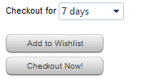
If an audiobook is available for check-out, there will be a dropdown menu and two buttons on the right side of the screen. You can select the amount of time you would like to check out the book for (7 days or less), then checkout the audiobook. If you’d like to save the book for later, click on “Add to Wishlist.”

If the book is currently checked out by someone else, the dropdown menu and the “Checkout Now!” button will not appear. The only option you will have is “Add to Wishlist”—this is the same as placing a hold, and you will receive an e-mail when the title is available to be checked out again. It will automatically be checked out to you at that point.

In order to check out an audiobook, you’ll need to create an account and download the OneClick Digital Media Manager. The first time you click “Checkout Now!” you will be prompted to create an account—choose a username and password that you’ll remember. Then, you will be taken to a page to download and install the Media Manager, which will allow you to download audiobooks now and in the future.

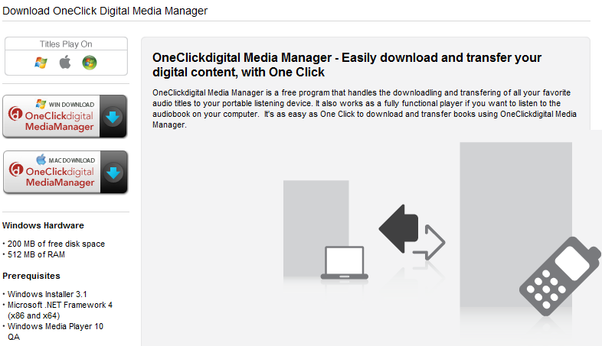
Follow the on-screen prompts to install the Media Manager on your computer.
The first time you open the program, you will need to log-in with your account information and choose your library.
The interface for the program will look something like this:
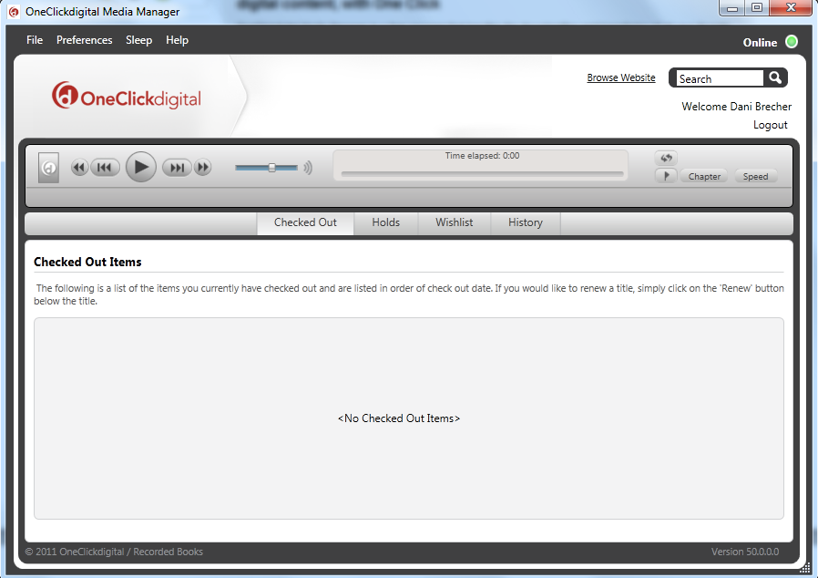
You can see all your checked out items from your home screen, which will also allow you to renew your audiobooks with one click. You can listen to the audiobooks right here, through the Media Manager on your computer, or transfer the items to a media device. If you are using an Apple product, you will do this through iTunes (it will automatically open alongside the Media Manager); if you are using another type of audio device, you can transfer directly from the Media Manager.
If you get stuck, OneClick Digital also offers a great set of video tutorials on how to get started downloading and listening to audiobooks!

VIDEOS
PBS Video Collection
NC LIVE also recently bought access to the PBS video collection, which means that you can stream a wide-variety of PBS programs and North Carolina videos on your home computer! To start, click on the Videos icon.

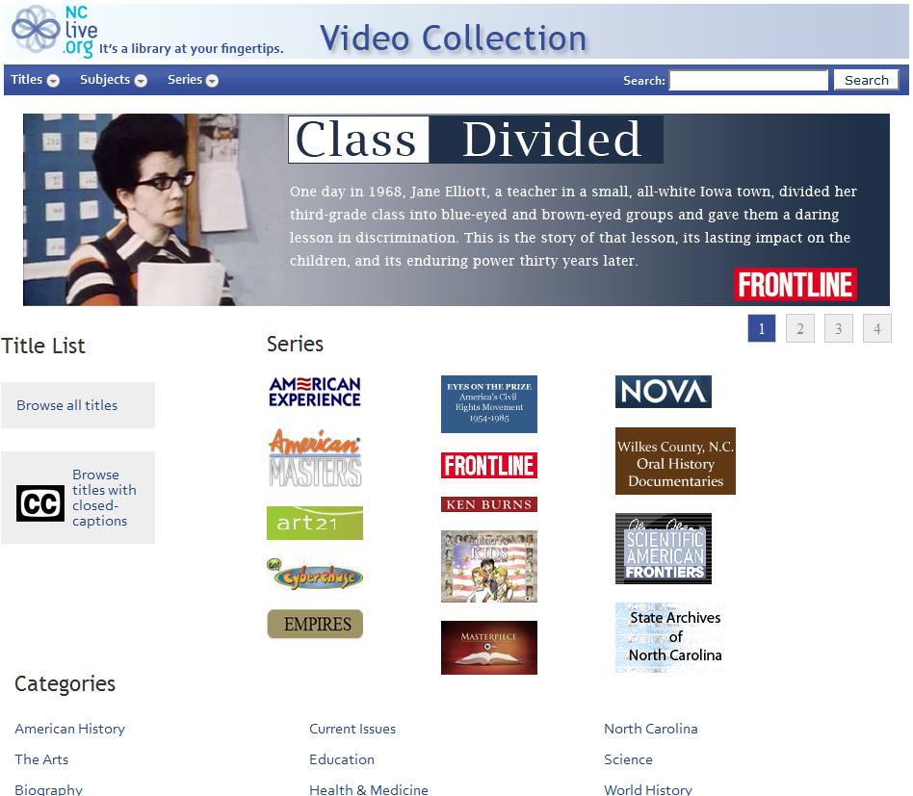
A few of the programs available to watch include: Masterpiece Theater, Frontline, a variety of Ken Burns films, NOVA, and American Experience.
You can look for specific series and shows that you know you want to watch, browse by category or genre, or look for only shows that offer closed-captioning.
HEALTH RESOURCES
Medline Plus

Medline Plus is a great website put out by the U.S. National Library of Medicine and the National Institutes of Health (NIH) to provide reliable and understandable health information to the general population.

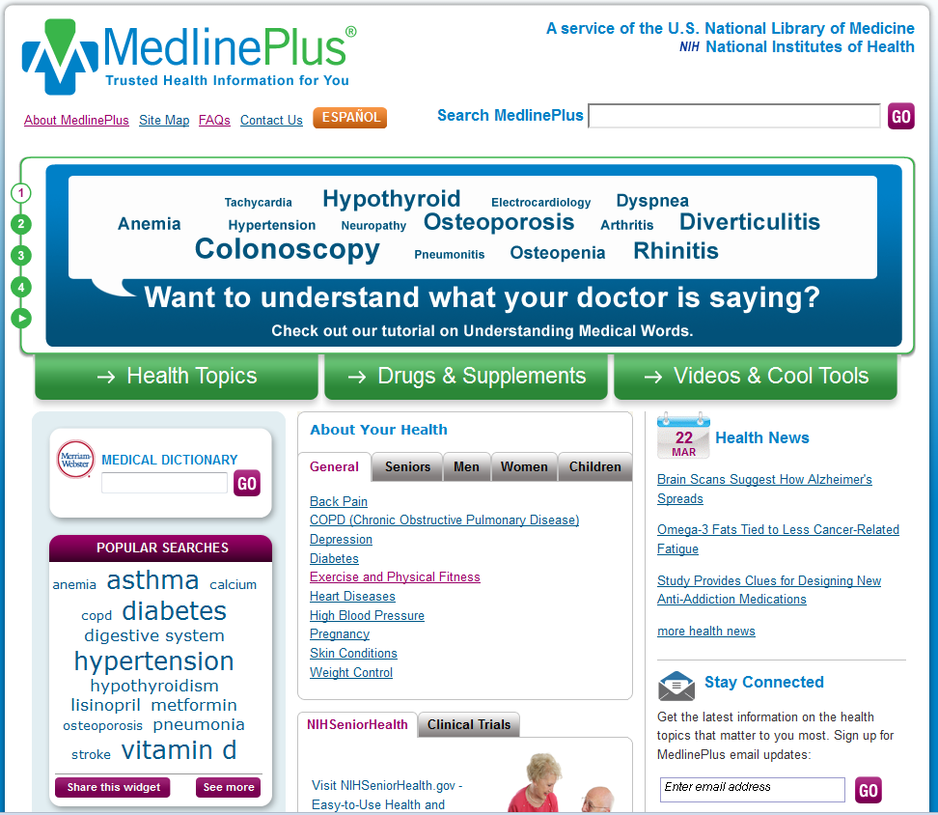

A few of the great features available on Medline Plus include:

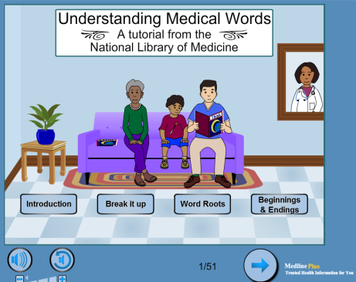
Tutorials on understanding medical words and other topics

The Merriam-Webster Medical Dictionary

News articles on recent health breakthroughs and developments

Comprehensive articles on a wide variety of health conditions (browse by name or part of the body affected)

Information about medical drugs, herbal supplements, and therapies

ProQuest Family Health

ProQuest Family Health provides a way for you to search through many trusted health publications to find particular articles that are of interest to you. ProQuest Family Health covers an enormous range of subjects of value in the public library context - from sports injuries to women's health, from food and nutrition to midwifery, from eye care to dentistry. It includes important general medical journals such as The Lancet and The New England Journal of Medicineas well as a strong selection of consumer and news magazines.
Other titles include:
- Men's Health
- Exceptional Children
- Diabetes
- Journal of Health and Social Behavior
- Journal of Youth and Adolescence
- Women's Health Weekly
- Pediatrics for Parents
- Occupational Health

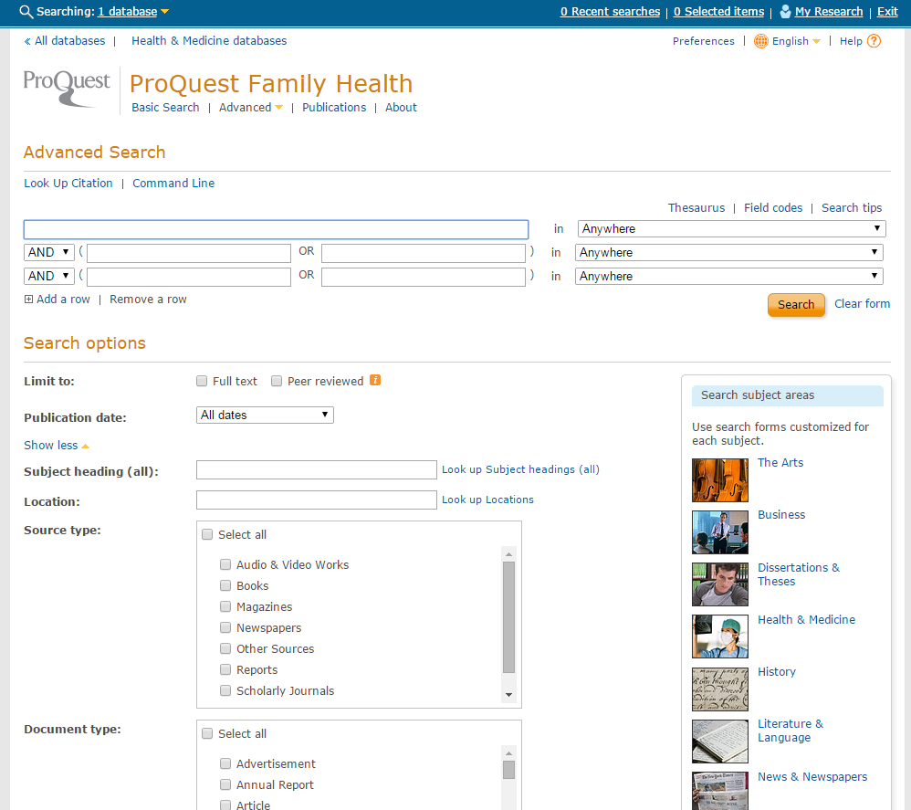
Boolean operators

Click on the dropdown arrows to see more options

Your screen will look like the image above, on page 13. This search in particular is an Advanced Search, and it will allow you to use more specific search methods in order to retrieve more relevant and useful results. To perform an advanced search, you can use as little or as much information as you like. Be aware that the more specific you are, the more specific your results will be. Steps to do an advanced search:

- Type a word or phrase into the first search box
- Specify where you would like the database to search for that word or phrase by clicking on the dropdown arrow in the box to the right of where you just typed. If you would like your word or phrase to be searched for in all parts of the articles/results, leave it set to anywhere. However, if you’d like to search in specific elements of the results, you can. Here are the options:

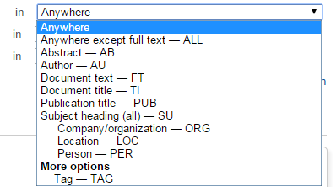

For example, if you are searching for articles written by a particular author, then you wouldn’t necessarily want the database to pull articles that had your author’s name in them. You would want to select the Author—AU option so that you will only get results whose author is the name you have searched.
- This step is optional, but you can make your search even more specific by using Boolean operators. Look at the second line of your search options. It should begin with a box that has a dropdown arrow and reads AND. If you click on that box, you will get the option to change the AND to OR or NOT. For example, if you want to search for skin diseases, but you are not interested in results on psoriasis, you can type “skin diseases” in the first line, then choose the NOT operator and type “psoriasis” for the second line. This will ensure that you do not have results about psoriasis.
- You can add as many additional search lines as you feel are necessary—but don’t get too specific. You could miss helpful results that way.
- You are now ready to perform your search, or you can specify more search options in the bottom section of the page.
- One option is publication date (not a specific date, but this is good if you do/don’t want results from a particular time period, or if you want only recent results).
- Other options are available, and they include subject heading, location, document type, document feature, language, and how you would like your search results sorted. If they’re sorted by “Relevance,” this means that the articles that match the most of your search criteria will be displayed first.

You also have the option to do a Basic Search. If you click on the “Basic Search” linked text at the top of your page, you will then be able to perform simple keyword searches. (Kind of like doing a Google search).

NEWSPAPER ARTICLES
InfoTrac Newsstand

“This innovative full-text newspaper resource allows users to search articles instantly by title, headline, date, author, newspaper section or other fields, eliminating random searching through newspaper archives. InfoTrac Newsstand provides access to more than 1,100 major U.S. regional, national and local newspapers as well as leading titles from around the world. It also includes thousands of images, radio and TV broadcasts and transcripts.”

InfoTrac Newsstand’s home page has a basic search box on it. You can use this simple search, or you can choose the advanced search option to do perform searches similar to the process we detailed on page 14 of this handout.

Additionally, the home page links to popular searches and popular articles in case you are just browsing.

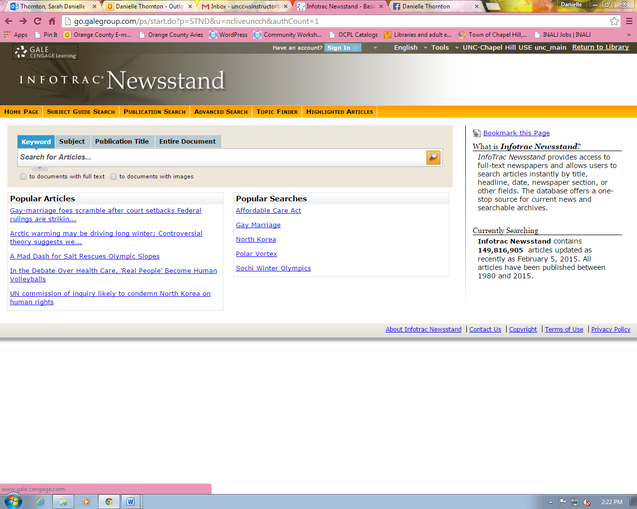

LANGUAGE LEARNING
Pronunciator

“Pronunciator is a fun and free way to learn any of 80 languages.” You can use your computer browser to follow the modules, or you can download an app to your mobile device.

The first time you use Pronunciator, you’ll need to register your email address. You’ll then receive a confirmation email containing instructions on how to log in. Once you’ve logged in, you’re ready to get started!

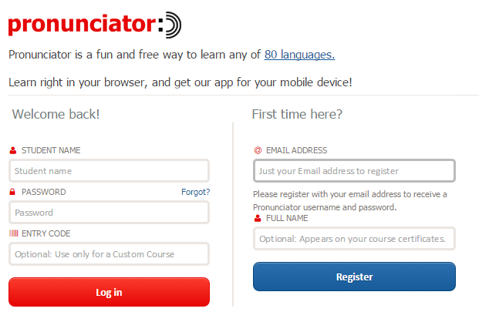
Pronunciator allows you to choose the language you speak, and the language you want to learn.
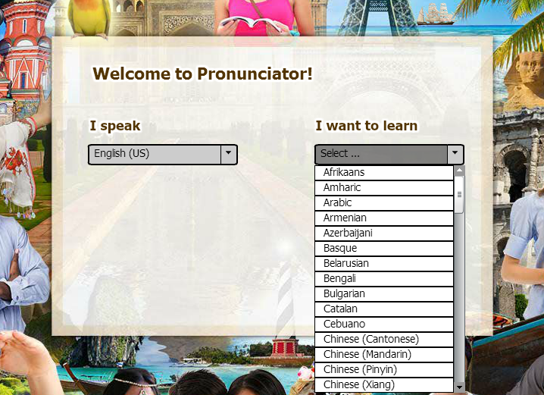
Below is an example of what options you have once you have chosen a language—you can choose a flexible “Main Course,” or you can choose specific learning guides dependent upon your skill level.
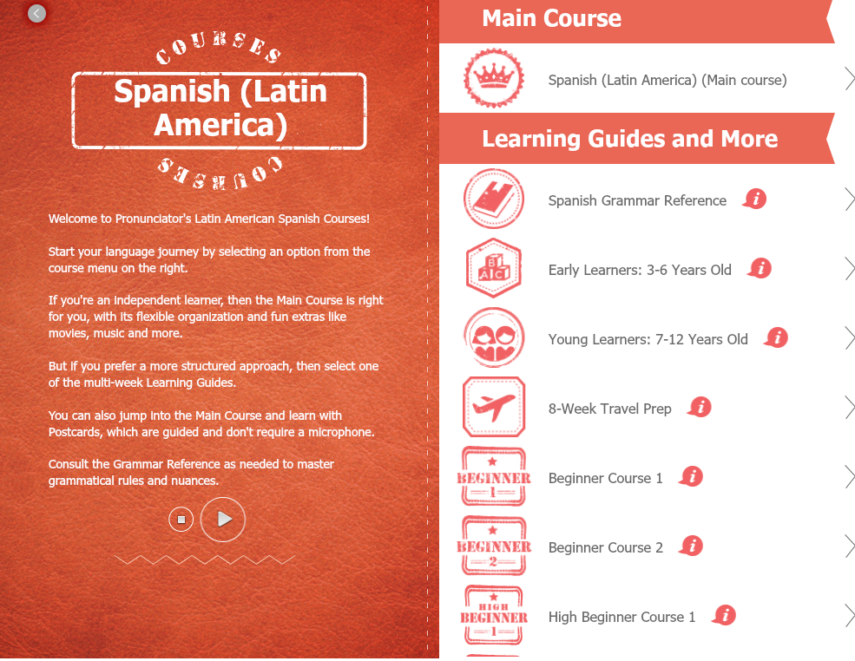

GENEALOGY RESOURCES
HeritageQuest

For those working on researching genealogy, HeritageQuest provides access to old Census records, books on local history around the U.S., and a variety of digitized records, including the Freedman’s Bank and Revolutionary War records.

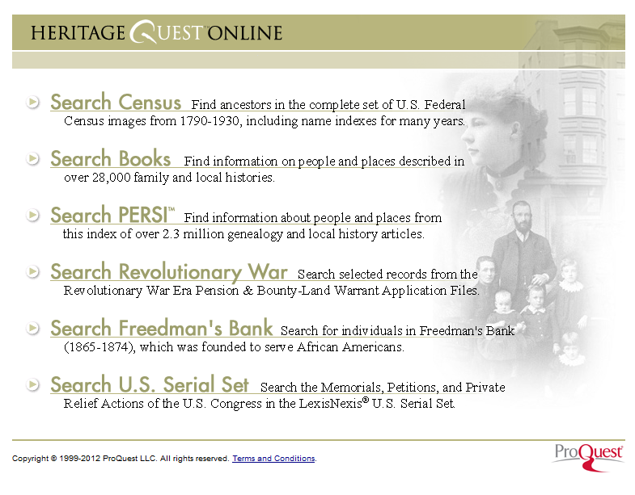
You can search by name, year, or geographical area for genealogical records.

BUSINESS RESOURCES
Morningstar Investment Research Center

Another great resource for investors is the Morningstar Investment Research Center. Morningstar rates stocks, bonds, and mutual funds.

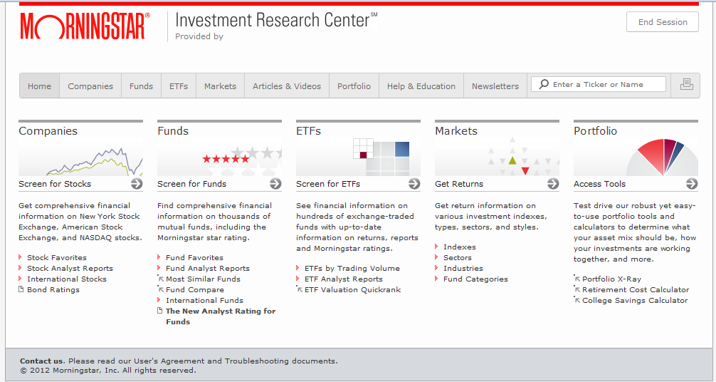

Morningstar is also famous for its box chart of mutual fund information:
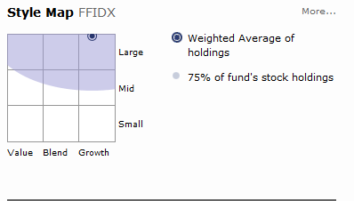
It is considered the industry standard for visualizing mutual fund growth and potential.
EDUCATION RESOURCES
Learning Express Library

Online test prep materials and study guides are available on NC LIVE through the Learning Express Library. A mix of eBooks and interactive online tools can help you prepare for the SAT, ACT, GRE, and other standardized tests.

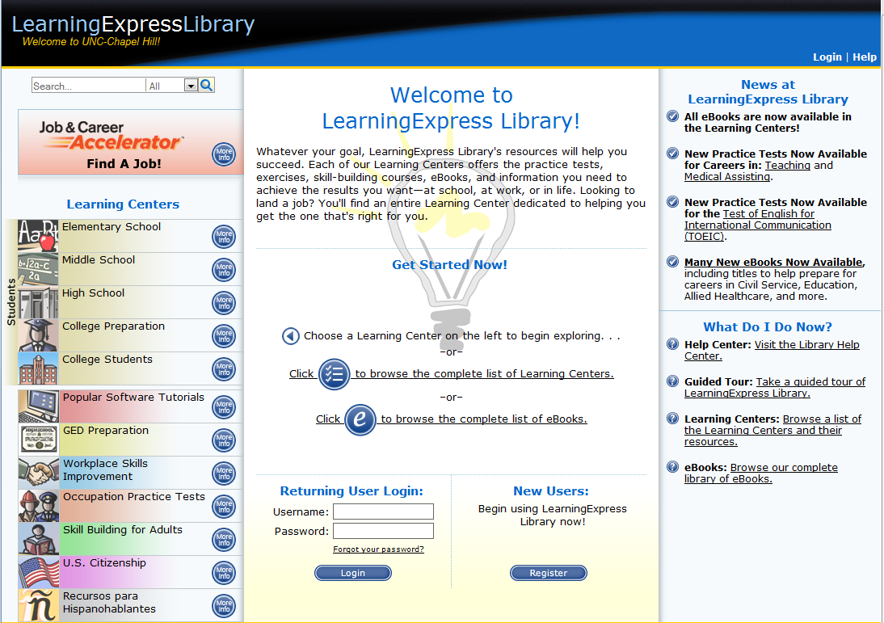

This is a great, free resource for materials that often are quite costly. Though the interface is a little old and clunky, the material contained within the site is current and useful. There are even tutorials for computer programs, ranging from Microsoft Word to Adobe Dreamweaver.

CQ Researcher

CQ Researcher provides reliable and balanced information on current, controversial issues from the Congressional Quarterly researchers.

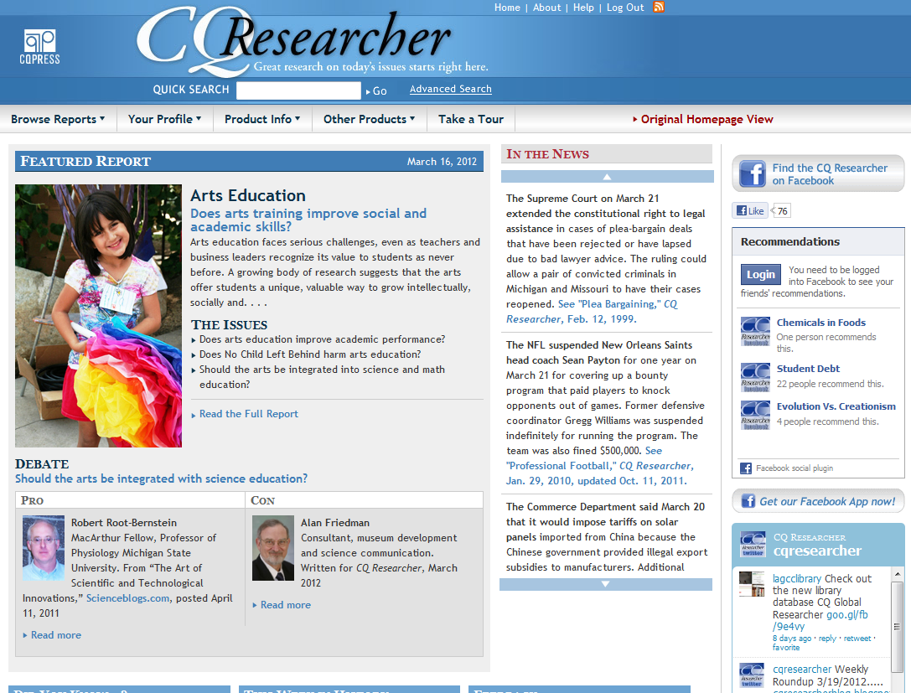

The reports present pros and cons for each issue from experts on the issues. This is some of the same information that our lawmakers in Congress receive when they prepare to vote on controversial bills.
NOTE: Images and screen captures may differ from those seen on another system.

This work is licensed under a Creative Commons Attribution-NonCommercial 4.0 International License2.

