

DOING MORE WITH WORD: MICROSOFT OFFICE 2013

GETTING STARTED PAGE 02
Prerequisites
What You Will Learn

USING MICROSOFT WORD PAGE 03
Viewing Toolbars
Adding and Removing Buttons

MORE TASKS IN MICROSOFT WORD PAGE 05
Modifying Line Spacing
Creating Bulleted and Numbered Lists
Creating Tables
Formatting Columns
Formatting Margins
Adding Headers and Footers
Inserting Text Boxes
Inserting Other Graphics
Changing Views

CLOSING MICROSOFT WORD PAGE 14
Saving Documents
Finding More Help
Closing the Program

View our full schedule, handouts, and additional tutorials on our website:
cws.web.unc.edu
Getting Started

Prerequisites:
It is assumed that user is both familiar and comfortable with the following prior to working with Microsoft Word:
- Using the mouse and the left-click feature
- Basic navigation through Microsoft Windows
- Basic typing and keyboard commands
- Basic components of Microsoft Word
- Basic text formatting in Microsoft Word

Please let the instructor know if you do not meet these prerequisites. To download a sample document to practice these tasks, visit www.lib.unc.edu/cws/handouts and click on Word Practice Document under Doing More With Word. Ask the instructor if you need help downloading the document.

What You Will Learn:

Viewing Toolbars |  | Modifying Line Spacing
Creating Bulleted and Numbered Lists | Creating Tables | Formatting Columns
Formatting Margins | Adding Headers and Footers | Inserting Text Boxes
Inserting Other Graphics | Inserting Symbols | Saving Documents
Changing Orientation of Documents | Finding More Help | Closing the Program

Using Microsoft Word

Viewing Toolbars

We talked about many of the basic features of Word in the Microsoft Word Basics class. There are numerous other things that Word can do, and this handout will cover some of them.

In addition to the components discussed in the Basics handout (including the Title Bar, the Ribbon Menu system, the FILE Menu, and the HOME, INSERT, and PAGE LAYOUT tabs), Word has many other components that you can choose to turn on and off as you wish.

There are many different toolbars available in Word, and most of them are intended to help with editing one specific thing. For example, there are toolbars for drawing shapes, formatting pictures, and working with tables and borders. In previous versions of Word, it was necessary to open or select these menus from the Title Bar. However, in Word 2013, they should all appear within the Ribbon Menu system—you just need to find them!

The trick to finding what you need in Word 2013 is to think in terms of categories. If you want to put a picture, a text box, a chart, page numbers, Clip Art, a symbol, or shapes in your document, these are all things that you insert into your document. They are found in the INSERT tab:

If you want to format the page margins, change indenting or spacing, format columns, or change the page orientation (e.g., from portrait to landscape), these are all things that have to do with the way the text is arranged on the page, so go to the PAGE LAYOUT tab:

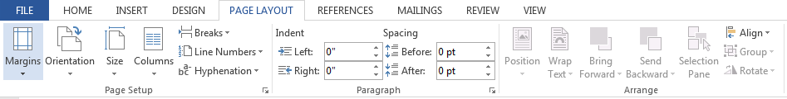

If you want to insert endnotes, footnotes, format or manage citations, or format a table of contents or index, think of these elements as reference materials. To access these tools, click the REFERENCES tab:

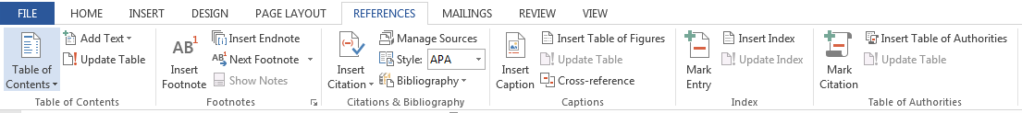

If you like to use comments and track changes (as well as spell-check and the built-in thesaurus), think of these tools as part of the review process—tools used to edit and prepare documents for sharing. To access them, click the REVIEW tab:

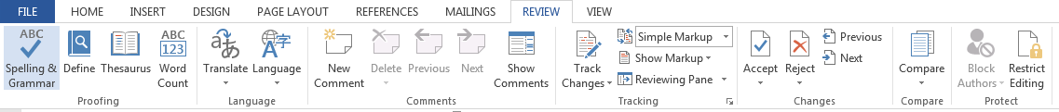

In addition to these tabbed menu toolbars, additional contextual tabs may appear while you’re working. For example, if you insert a shape, the DRAWING TOOLS tab and menu will appear. If you click on text, this tab and menu will disappear, as you can’t format text with drawing tools. To make the context tab reappear, simply click on the shape again. This same principle can be applied to any context tab (e.g., a CHART TOOLS tab will appear if you insert a chart). Some contextual tabs may also have additional tabs (e.g., a DESIGN tab).

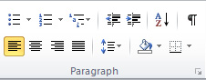If ever you can’t find a menu item or tool you’re used to working with from earlier versions of Word, try clicking on the small, diagonally-pointing arrow in the bottom, right-hand corner of any of the tab boxes. This will open up the larger menu in a separate window, with all available tools.

More Tasks In Microsoft Word

Modifying Line Spacing

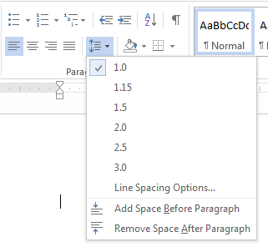Line spacing in Word refers to the amount of space between lines of text. The default in Word 2010 is 1.15 spacing, which leaves a little bit more space than single-spacing, or what you would find in a normal book. Single spacing is generally easy for the eye to read. There may be times, however, when you want to change this spacing. One common option is to double-space text:
This text is double-spaced. Double-spacing is especially useful if someone else is proofreading your document. It allows for more room to write comments on the page.

To change the line spacing:

1. Select text you want to format by highlighting it.
2. On the Home tab, click on the Line Spacing button in the Paragraph group.
3. Choose the spacing you want from the menu that appears.
For more options, select Line Spacing Options. In the dialog box that appears, you can choose other spacing options, including spacing between paragraphs. This can be done by changing the values in the Before and After boxes.

Creating Bulleted and Numbered Lists

Word allows you to create lists within your document that can be organized with bullets or numbers. Lists are useful for presenting text that wouldn’t make the most sense in paragraph form (for example, step-by-step instructions) or for emphasizing key points. Bullets are usually small circles at the beginning of item in a list, and numbers are used for lists that are arranged in sequential order.
Here’s an example of a bulleted list:
- Bananas
- Milk
- Eggs
- Ice Cream

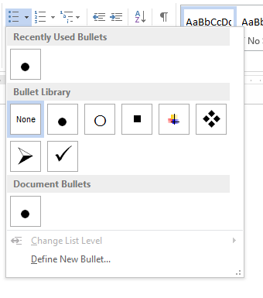To create a list:

- On the HOME tab, select either the Bullets or Numbering buttons from the Paragraph group. If you want to choose a particular style for your bullets or numbers, click on the triangle next to the button and choose a style from the menu that appears.

- You will see the first bullet or number appear on your document. Type your first line of text and then hit Enter.

- Another bullet or number will appear automatically. Type your next line of text and hit Enter.

- When you have finished your list, hit Enter twice to end the bullets or numbering.

To delete a bullet point or number, put your cursor to the right of the bullet and hit the Backspace key.

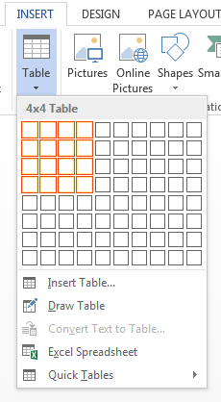
Creating Tables

Tables are a great way to present information in an organized format, whether that information is text or numbers.

Tables are made up of horizontal rows and vertical columns, with lines or borders around each column and row. A cell is a single box where a row and column intersect. Cells are where you put your information (text or numbers).

Here is an example of a table:
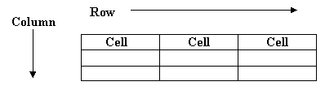

To create a table in Microsoft Word:

- Select the INSERT tab and click on the Table button.
- Move your mouse to highlight the number of boxes to reflect the size you want your table to be (each box represents a cell). Click to create the table.

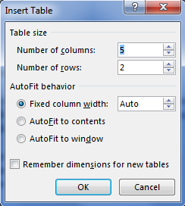
OR

- Select Insert Table from the menu that appears.

- In the dialog box that appears, choose the number of columns and rows you want. Don’t worry if you’re not sure how many you need—you can add or delete columns and rows later.

- You can change the column width under AutoFit behavior. Leaving the settings on Fixed column width and Auto will create a table that is as wide as your page.

- Click OK.

Once you’ve created your table, you are ready to enter text! To enter text into a cell, just click inside a cell and begin typing. You can format text in a table the same way that you would format text in a paragraph (with different fonts, sizes, colors, bold, underlining, italics, alignment, etc.). Use the arrow keys to move from one cell to another.

After you’ve inserted a table, Word will display two new tabs at the top of the screen under the words “Table Tools”: the Design tab and the Layout tab. The buttons on these tabs give you many options for formatting your table. Experiment with these buttons until your table is formatted the way you want. Don’t be afraid to make amistake–remember, you can always use the Undo feature in Word (in the upper left corner of the screen:
Experimenting is the best way to become familiar with this and other features in Word!

Formatting Columns

Depending on the type of document you’re creating, you may want your text to appear in two or more columns on the page. This style is often used in newsletters or magazines.

This is an example of text that is formatted in columns. This is an example of text that is formatted in columns. This is an example of text that is formatted in columns. This is an example of text that is formatted in columns.

This is an example of text that is formatted in columns. This is an example of text that is formatted in columns. This is an example of text that is formatted in columns. This is an example of text that is formatted in columns.

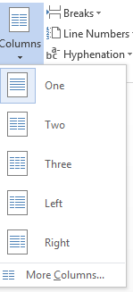Once you’ve got some text entered in your document, follow these steps to put them into two or more columns:

- Select the PAGE LAYOUT tab.
- Click on the Columns button in the Page Setup group.
- Choose the number of columns you want from the menu that appears.

If you want more options than what is on the menu, click on More Columns…
Change the settings in the Columns dialog box to the settings you want and click OK.

From the Columns dialog box, you can also change other aspects of formatting. For example, you can specify the width of the columns and the amount of space between them, you can choose to put a line between columns, and you can select which part of your document you want to apply columns to.

When you create columns this way, the text will fill the first column from the top to the bottom of the page before wrapping to the second column. If you want your text to begin wrapping to the second column in a different place, follow these steps:
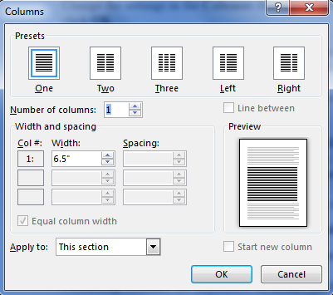
- Put your cursor in the text where you want the first column to end.

- On the PAGE LAYOUT tab, click on the Breaks button in the Page Setup group.

- Choose Column from the menu that appears.

Formatting columns can sometimes be tricky, but don’t be afraid to experiment with it until you get your document to look the way you want. If you make a mistake, you can always start over or use the Undo feature in Word to undo the last command you did.

Formatting Margins

Margins are the space between the edge of the printed page, and the text. On this piece of paper, there are one-inch margins at the top, on the left and the right side, and at the bottom of the page.

Margins can be formatted manually (by dragging the indent markers pictured below), and by entering/selecting a number/value. To adjust margins manually, you must be able to see the page rulers. These should appear at the top (below the menus) and on the left-hand side of the document. If you do not see the rulers, you can make them visible by going to the View tab and checking the box next to Ruler.
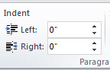
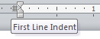To adjust the first line of a paragraph (e.g., to indent all paragraphs by half an inch), highlight the text you would like to change, and then drag the top indent marker to the right or to the left.
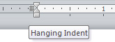
To adjust the indent of lines below the first line in a paragraph (e.g., when formatting reference lists), highlight the text you would like to change, and then drag the bottom indent marker to the right or to the left.

To format margins by entering a number/value, highlight the text you wish to change, and then click the Page Layout tab, and go to the Paragraph group. You can then adjust the values for Indent by entering a number or by clicking the up and down arrow buttons.

Adding Headers and Footers

Headers and footers are sections at the top and bottom of a page, respectively, which contain information like page numbers, dates, or authors. The information in headers and footers is usually the same for all pages of a document (for example, the author’s name might appear in the upper right-hand corner of every page).

To insert a header or footer:
- Select the INSERT tab.
- Click on the Header, Footer, or Page Number button from the Header & Footer group.
- Click on the style you want from the menu that appears.

- The main body of text will be grayed out and there will be boxes with dotted lines around it at the top and bottom of the page. The Header & Footer Tools tab will also appear.
- Type your text into the boxes with the dotted lines.
- Click “Close Header and Footer” on the menu when you are finished.

You can use the Header & Footer Tools tab to help you enter information and format your headers and footers.

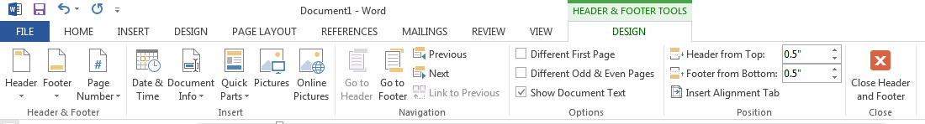

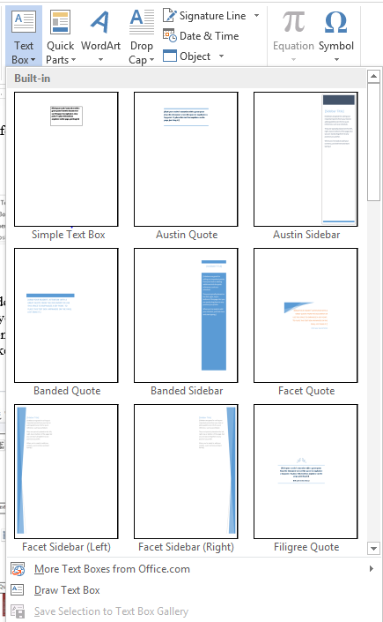
Inserting Text Boxes

If you are creating a newsletter, flyer, announcement, or other similar type of document, you might have some text that you want to make stand out and draw the reader’s eye. One way you can do this is by using a text box. Text boxes give you the flexibility to position text anywhere on the page, similar to a picture. You can also format text boxes with things like colors and borders.

To create a text box:
- On the INSERT tab, select the Text Box button from the Text group.
- Choose the style that you want from the menu that appears. Keep in mind that you can move the box to a different part of the screen or adjust its size after you choose the style.
- The text box will appear in your document with some highlighted text. Begin typing the text you want in the box.

You can format the text inside the text box the same way that you would format other text (with different fonts, sizes, colors, bold, underlining, italics, alignment, etc.).

Similar to pictures or other shapes, you can resize or move your text box around the page. To resize, hover your mouse over one of the blue circles or squares on the border. Your mouse will turn into a two-headed arrow. Left click and drag the mouse (while holding the mouse button down) until the box is the size you want. Dragging the circles in the corners will keep the proportions of the box fixed, while dragging the squares in the middle of each side will only change either the height or width of the box.

To move the box, hover your mouse over the border until it looks like a plus sign (+) with arrows. Left click and drag the mouse (while holding the mouse button down) until the box is placed where you want it.

As mentioned before, you can format the style of your text box by changing the border, color, shading, etc. You can do this by using the TEXT BOX TOOLS tab that appears when you insert a text box. Experiment with the buttons on this tab until your text box looks the way you want.

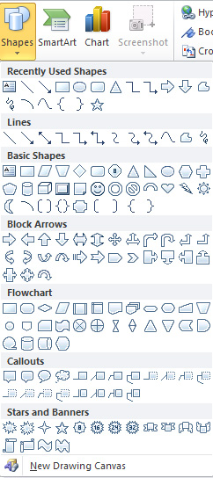Inserting Other Graphics

Word lets you style your documents with much more than just words–there are all kinds of graphics you can use to enhance your work! Many of these can be found on the Insert tab.

Shapes
Some shapes available are lines, arrows, rectangles, and ovals.

- On the INSERT tab, click on the Shapes button from the Illustrations group.

- Your mouse will turn into a crosshair: . Left click and drag (while holding down the mouse button) until the shape is the size you want.

You will also see a Drawing Tools tab at the top of the screen that will give you many options for formatting your shapes. Holding down the Shift key while using the rectangle tool will create a perfect square, and holding it down while using the oval tool will create a perfect circle.

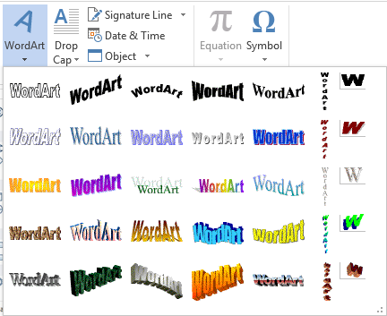WordArt

Another tool to help you style your document is WordArt. Formatting WordArt is similar to formatting a picture or a text box.

1. On the INSERT tab, click on the WordArt button from the Text group.

2. Select a style from the WordArt gallery that appears and click OK.

3. Enter your text into the dialog box that appears and click OK.

You can change the size of the WordArt you’ve created similar to the way you would change the size of an image. Click on the word and a box with squares in the corners will appear around it:


Hover your mouse over one of the squares until it becomes a two-headed arrow. Left click and drag the mouse (while holding the mouse button down) until the text is the size you want.

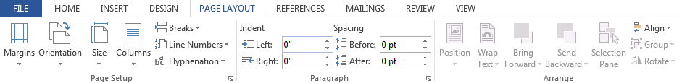Changing Views and Overall Look

There will be times in which you create documents that don't fit on a standard piece of paper in its normal dimensions (8.5" by 11").
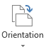Click on the PAGE LAYOUT Tab.
From this menu, you can alter the margins, the width, height, orientation (portrait = 11" long; landscape = 11" wide), as well as choose from a variety of templates different types of paper and document styles that come with the program.
To change the orientation of your page, click on the Orientation button. Click on Landscape from the drop-down box that appears. Your document should now be in a landscape position. If you wish to return to a portrait orientation, go through the same steps, clicking on the Landscape option instead of Portrait.

To change the margins of your page, click on the Margins button. It is typically set on 1” margins all the way around the page, which means that there will be one inch of white space on the top, bottom, left, and right of your page. However, you may need to change it—you can use one of the pre-made options, or you can create custom margins.

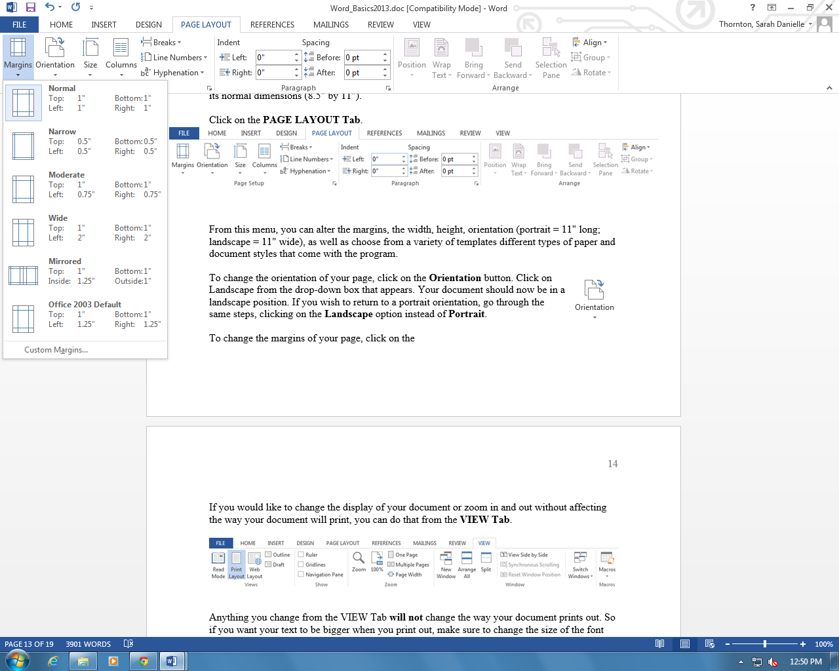

If you would like to change the display of your document or zoom in and out without affecting the way your document will print, you can do that from the VIEW Tab.

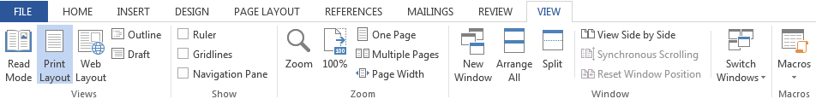

Anything you change from the VIEW Tab will not change the way your document prints out. So if you want your text to be bigger when you print out, make sure to change the size of the font instead of the zoom.

PRACTICE
Change the orientation of your document to Landscape.
Closing Microsoft Word
Saving Documents
When you finish typing and want to leave the computer, it is important to save your work, even if you are printing a hard copy. To save your work in MS Word, it is essential to know WHAT you are trying to save and WHERE you are trying to save it.
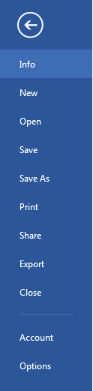 Click on the File Tab, then click Save to get started.
You can change the file name that Word has automatically chosen just by typing a new one in the “File name” box at the bottom of the window that appears.
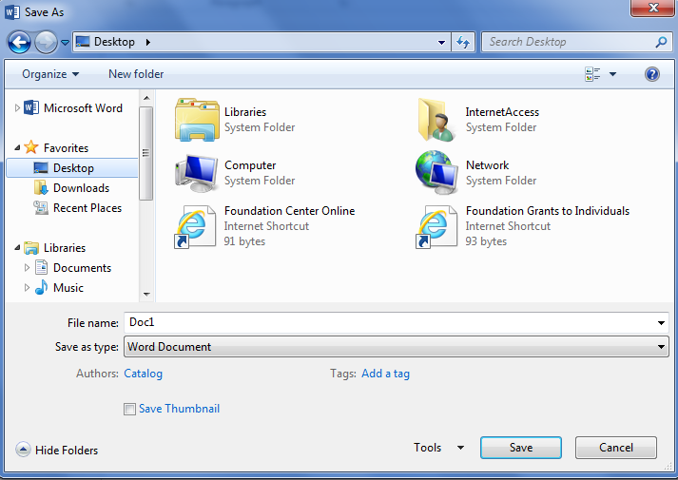

MS Word will automatically save your document with the suffix (“extension”) “.docx”—this simply lets your computer know that the file needs to be opened in Word 2013. You do not have to type this extension name—just highlight the words (the default is “Doc1”) and write a new file name.
As evidenced in the picture above, there are many places where you can save a file, some of which are portable and some of which are immobile.
The My Documents folder on your computer’s hard drive is a good place to store your documents. A blank CD (compact disc) is a great portable storage device and can contain a LOT of data. Another good option is a USB key/thumb drive/flash drive.
Due to differences between older versions of Word and the new 2013 version, older versions of Word cannot open documents saved in Word 2013 with the suffix “.docx”. If you think you might want to share your document with someone who has an older version of Word on their computer, you can save your document in a format that is compatible with older version, like “.doc”.
To do this, click on the File Tab, then click Save As, then choose “Word 97-2003 Document” from the drop-down menu underneath the File Name text box.

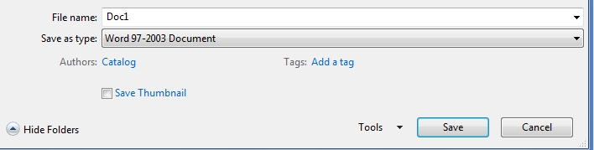

Follow the normal steps above to name your document.
It is important to note that every following command of SAVE will overwrite your original file, creating the most up-to-date version. To save multiple versions of your document, you will need to save copies with slightly different names.
If you want to save the changed document without destroying the original one:
Click on the FILE Tab and then click “Save As,” giving your document a new file name, different from the original. You use the “Browse” folder to view places to save your file on the computer.
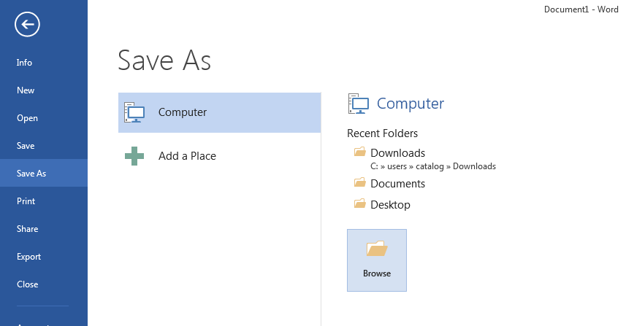

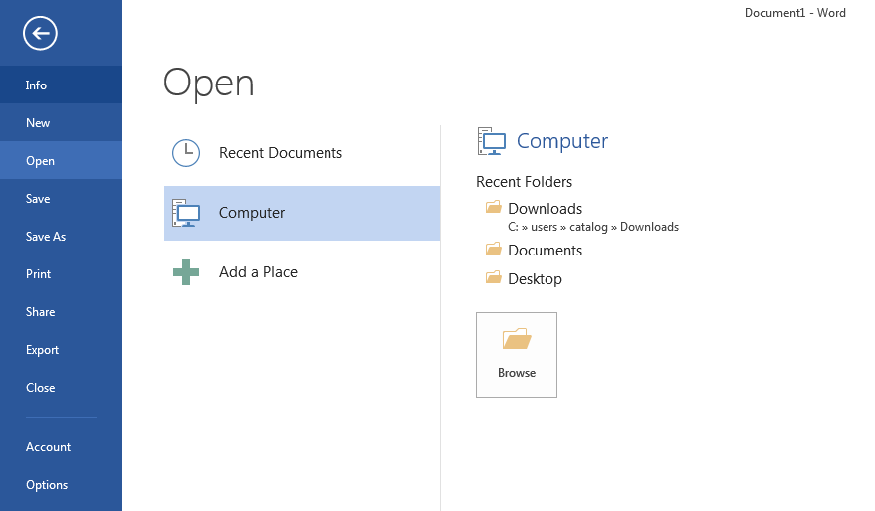If you want to open up a saved document in Word:
Click on the FILE Tab, then click Open.
Microsoft Word 2013 will give you a list of “Recent Documents” that have previously been opened on the computer. To locate the file on your computer, click “Computer”, then “Browse.” Find where the file is located on your computer and double-click on the file name of the document you want to open.

Finding More Help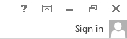
You can get help with MS Word by clicking the Question Mark Button located in the top right corner of the window.
Tutorials are also available on the Internet. Some of them come straight from Microsoft! Of course, you can also always come and ask quick questions at the library.

Closing the Program
Congratulations! You have completed this course in Microsoft Word Basics. As you become more and more comfortable with the program, it is always helpful to continue to experiment with options that you come across–sometimes, you can uncover a tool that would have stayed hidden–and you can improve proficiency by learning the fine details of the program. When you are finished,
Click on the FILE Menu then click Close.
OR
Click on the X in the top right corner of the computer screen.
It’s that easy! If you don’t save before attempting to close the program, Word will prompt you to save the file. Make sure you save if you don’t want to lose any changes!!
NOTE: Images and screen captures may differ from those seen on another system.
This work is licensed under a Creative Commons Attribution-NonCommercial 4.0 International License.

