

WORD BASICS: MICROSOFT OFFICE 2007

GETTING STARTED PAGE 02
Prerequisites
What You Will Learn

USING MICROSOFT WORD PAGE 03
Microsoft Word Components
The Keyboard

SIMPLE TASKS IN MICROSOFT WORD PAGE 08
Typing Text
Deleting Text
Undoing and Redoing
Formatting Text
Spelling and Grammar Check
Copying, Cutting, and Pasting Text
Inserting Images
Changing Views and Overall Look

CLOSING MICROSOFT WORD PAGE 14
Saving Documents
Printing Documents
Finding More Help
Closing the Program

View our full schedule, handouts, and additional tutorials on our website:
cws.web.unc.edu
Getting Started

Prerequisites:

It is assumed that user is both familiar and comfortable with the following prior to working with Microsoft Word:
- Using the mouse and the left-click feature
- Basic navigation through Microsoft Windows
- Basic typing and keyboard commands
Please let the instructor know if you do not meet these prerequisites.

What You Will Learn:

Starting and opening the software application | Microsoft Word components and features | Keyboard functions
Simple tasks in Microsoft Word | Typing text | Formatting text
Undoing and Redoing | Copying, pasting, cutting and deleting text | Inserting clip art
Changing views and setup | Spelling and Grammar check | Microsoft Word Help
Saving documents | Printing documents | Exiting the program

Using Microsoft Word

A word processor is a computer program used to create and print text documents that might otherwise be prepared on a typewriter. The key advantage of a word processor is its ability to make changes easily, such as correcting spelling, adding, deleting, formatting and relocating text. Once created, the document can be printed quickly and accurately saved for later modifications. In fact, the document that you are reading now was created using only a small amount of the many features available in Microsoft Word!

Opening Microsoft Word:

Before you get started with Microsoft Word (commonly referred to as MS Word), you will need to locate and open it on the computer. It may be on your desktop.
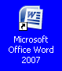
From the computer desktop:

1. Double-click on the MS Word icon →

Go to the Start Menu if the MS Word icon is not on the desktop:

1. Click → Start → Programs → Microsoft Word*

* Occasionally, Microsoft Word will be in a folder called "Microsoft Office" or something similar – this will make one more step between "Programs" and "Microsoft Word" in the diagram above.

MS Word will open a blank page called "Document 1."

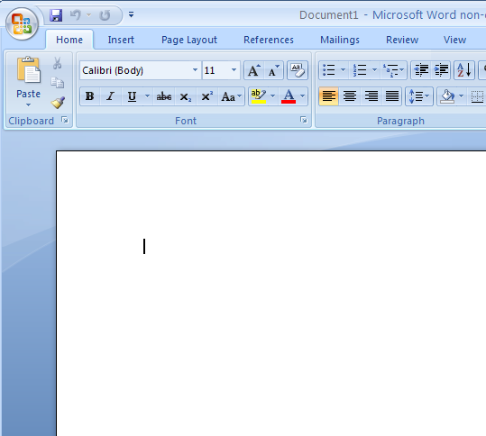
This is an image of the upper-left corner of MS Word.

This box features two important bits of information: which file you are currently working on (in this case, "Document 1" since we have not yet renamed it) and which program you are using (in this case, "Microsoft Word.")

This box shows a blinking cursor, ready for your commands.

The Title Bar

This is a close-up view of the Title Bar, where file information is located. Notice the three buttons on the right side, controlling program features.

The Ribbon Menu System
The tabbed Ribbon menu system is how you navigate through Word and access the various Word commands. If you have used previous versions of Word, the Ribbon system replaces the traditional menus. Above the Ribbon in the upper-left corner is the Microsoft Office Button. From here, you can access important options such as New, Save, Save As, and Print. By default the Quick Access Toolbar is pinned next to the Microsoft Office Button, and includes commands such as Undo and Redo.
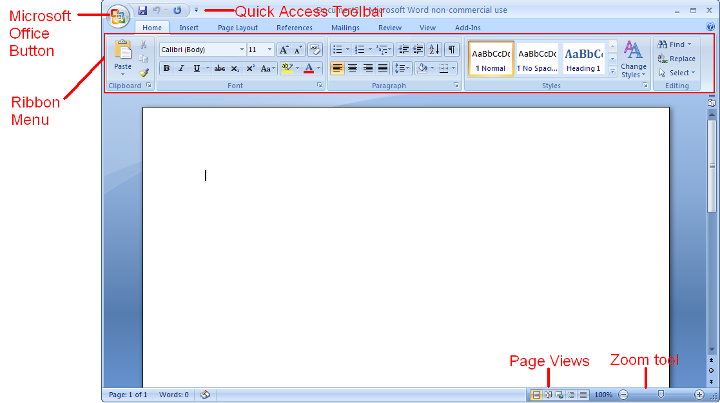

The Microsoft Office Button
The Microsoft Office Button appears at the top of the Word window. When you click the button, a menu appears. From this menu you can create a new document, open existing files, save files in a variety of ways, and print. You can also add security features, send, publish, and close files.

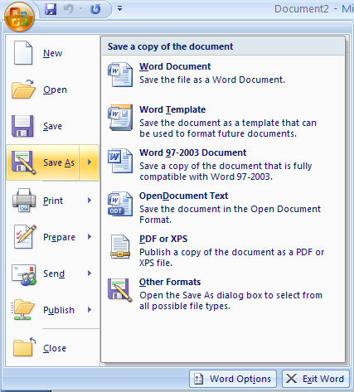

Home Tab Toolbar

Toolbars provide "shortcuts" to commands also found in the Menu Bar. Toolbars are usually located just below the Menu Bar and exist to offer another way to perform the same task.

The most commonly used commands in MS Word are also the most accessible. Some of these commands are:

Paste | Cut | Copy | Font

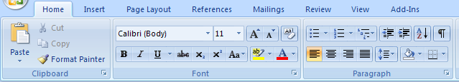

Font Style | Font Size | Font Color | Text Alignment
The Home Tab Toolbar offers options that can change the font, size, color, alignment, organization and style of the text in the document. For example, (starting from the left side of the Toolbar) the "Calibri" indicates the FONT of your text, the "11" indicates the SIZE of your text; and so on.

The Ruler

The ruler is found below the Ribbon. The ruler tells you where you are on the page, along with the dimensions of the overall document. Just like a real-world piece of paper, the default setting is 8.5 x 11 inches, and margins have been incorporated for you. Similar to most options in MS Word, this is entirely customizable and the user can create document of any dimension.
The Keyboard

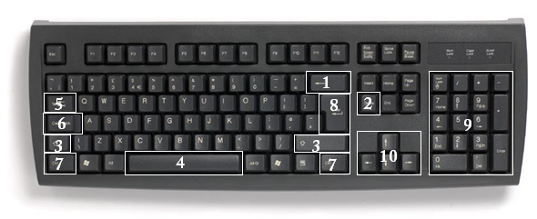
In order to use MS Word effectively, you must input commands using both the mouse and the keyboard. The above image of a keyboard may closely resemble (if it is not identical to) the keyboard in front of you; learning just a few certain keys will help to improve your efficiency in typing as well as present you with more options within the program. The following is a list of commonly used keys that have special functions in MS Word (key functions can change depending on which program you are using):

- Backspace: This key deletes backwards as you type.
- Delete: This key deletes forwards as you type.
- Shift: This key, when pressed WITH another key, will perform a secondary function.
- Spacebar: This key enters a space between words as you type.
- Tab: This key will force the cursor to indent, or jump forward 10 spaces.
- Caps Lock: This key will present the capitalized version of each letter key.
- Control (Ctrl): This key, when pressed WITH another key, performs as shortcut.
- Enter: This key executes a command (pressed in MS Word, it begins a new line).
- Number keypad: This is a redundant keypad existing only for user preference.
- Arrow keys: Like the mouse, these keys are used to navigate through the document.
Simple Tasks in Microsoft Word

Typing Text

To enter text, type just as you would if you were using a typewriter.

To capitalize a letter, hold down the SHIFT key while typing the letter.

Or, press the CAPS LOCK key on the left-hand side of your keyboard. You will have to press the CAPS LOCK key again—once you are done capitalizing—to remove the lock.

You do not need to press ENTER to start a new line—Microsoft Word will automatically wrap your sentence at the end of the line.

To move the cursor from its position at the end of the your sentence to anywhere else on the page, use the mouse or the arrow keys to move the cursor where you want the letters or spaces to be (left-click the mouse to place the cursor) and then type what you want to add—the text will adjust to include it.

Press ENTER to start a new paragraph (this is sometimes called a “carriage return”).

PRACTICE - Type the following text in your document:
Dear Diary,
Today was a good day. I got a promotion at work. My boss says it is because I’m a SUPER salesperson! The whole office went out to lunch to celebrate.

Deleting Text

While typing a document, sometimes you will make a mistake. Unlike a typewriter, MS Word can delete text on the screen and leave no trace—it is as if you never typed on the page in the first place.

There are two different buttons on the keyboard that will allow you to erase text. They are the “Delete” key and the “Backspace” key (#s 1 and 2 on the keyboard map on page 7). The “Backspace” key deletes words to the LEFT of the cursor, and the “Delete” key deletes words to the RIGHT of the cursor.

This is my crea | tive sentence.

BACKSPACE ↔ DELETE

Let’s assume that the vertical line dissecting the word “creative” in the example above is our cursor. Pressing the “Backspace” key will erase “a,” “e,” “r,” “c,” and so on, moving LEFT. The “Delete” key will erase “t,” “i,” “v,” “e,” and so on, moving RIGHT.

To delete a whole chunk of text at once, left-click with your mouse and drag to highlight a section of text. Then simply press “Backspace” or “Delete” and all of the highlighted text will disappear!

PRACTICE
Delete the following sentence from the text you typed earlier: My boss says it’s because I’m a SUPER salesperson!

Undoing and Redoing

The UNDO and REDO features of Microsoft Windows applications are great tools to rely on (especially in MS Word). The program will keep a list of the last 25 commands that you have performed, and it allows for taking "one step" backwards in order to erase what you have just done.
Click on the UNDO button in the Quick Access Toolbar to go back one step (up to 25).
Click on the REDO button in the Quick Access Toolbar to go forward one step (up to 25).

PRACTICE
Undo your previous deletion so that your sentence reappears in the paragraph.

Formatting Text

Changing the look of what you've written is called "formatting." This can include changing the text style, size, color, and more.

This is a sentence that features many different fonts.

This is a sentence that features many different sizes.

From the Home Tab, the "B" will make your text BOLD, the "I" will put it in italics, and the "U" will add an underline to your text. These features do not have to be used independently of each other either—in other words, you can bold, underline, and italicize a single piece of text.

The alignment of the text can be altered using the buttons with the horizontal lines on them. You can align text

To the LEFT,
To the CENTER,
And to the RIGHT.

In order to apply certain stylistic or other changes to text, you must first HIGHLIGHT the text. This is a common procedure in Microsoft Windows applications, and, because it is so useful, it is a skill worth practicing.

You can also change the font color by clicking on the appropriate buttons in the Formatting Toolbar. Experiment and remember—you can always start over with a fresh, new document, so don't worry about making mistakes! If you do, however, there is always the incredible "UNDO" tool.

PRACTICE
Use the alignment button to center the line with ‘Dear Diary,’ on it. Change the font color to your favorite color. Highlight the rest of the sentences to select them. Now change the font to Times New Roman, font size to 14 and italicize it. Your document should now look similar to below:
Dear Diary,
Today was a good day. I got a promotion at work. My boss says it’s because I’m a SUPER salesperson! The whole office went out to lunch to celebrate.

Spelling and Grammar Check:

One benefit of using a computerized word processor is its ability to recognize, change and give advice about your writing. MS Word has utilities that can check your spelling and grammar against a master database, and can offer advice on a variety of different grammatical styles.

MS Word automatically underlines any words that it does not recognize in red, assuming that they are not spelled right, and green if it does not recognize the grammar, assuming that the sentence does not make logical sense. For example:

The quickly brown fox jumps over the laziy dog.

In this case, "quickly brown fox" should read "quick brown fox" and "laziy" should be "lazy." If you right-click on the word, a menu with pop up with options, including "Ignore" if you do not want help on this specific phrase.

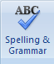
You can also choose to add words to the MS Word database, if you are going to be typing them consistently and do not want to flag each one – this is especially useful for names of people as MS Word will interpret these as misspellings.

The spelling and grammar tools can be found out the Review Tab.

Copying, Cutting, and Pasting Text

In MS Word, you can CUT or COPY text from one area of the document and save that text to be PASTED elsewhere (these commands are found on the Home Tab).

When you CUT text, you actually delete it from where you took it, as opposed to COPYING it, which makes a copy of your selection.

When you CUT or COPY text, it is stored on the CLIPBOARD. The Clipboard is a tool in MS Word that stores cuts and copies of your work, to be pasted in other places in the document. Once your selection is on the CLIPBOARD, you can PASTE it as many times as you want!

CUTTING a selection will also make a copy of it, just in case you want to PASTE it elsewhere.

To CUT a selection, first highlight it. Then, click on the CUT icon from the Home Tab.

The highlighted text will disappear, as you have just cut it out, but a copy is now on your clipboard, and MS Word is waiting for you to paste it somewhere else.

To PASTE this cut selection, place your cursor where you want the selection to go. Click on the PASTE icon from the Home Tab toolbar, and it will pop the text into place, right where you have your cursor.

To COPY, simply follow those same steps, replacing the CUT command with COPY.

The COPY command will not alter your original selection at all, as it simply makes a copy of the selection without changing or deleting it in any way.

PRACTICE
Highlight the first sentence of your paragraph “Today was a good day.” Select COPY. Move the cursor to the end of your paragraph and press enter a couple of times to move the cursor further down the page. Now press PASTE. Your document should now look similar to below:
Dear Diary,
Today was a good day. I got a promotion at work. My boss says it’s because I’m a SUPER salesperson! The whole office went out to lunch to celebrate.

Today was a good day.

Inserting Clip Art Images:

Clip Art is a collection of cartoon and computer-generated images that cover a broad array of commonly needed icons and pictures. These include business, holiday, nature, entertainment, academic and other themes, along with standard bullets and symbols.

To insert a clip art picture into a Microsoft Word document, you will first need to place your cursor (left-click) where you wish to insert you picture in your document.
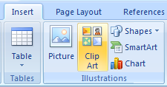
Then, from the Insert tab on the Ribbon, click on “Clip Art.”

An Insert Clip Art Window will appear. You can search for a word related to the type of picture you are looking for.

Navigate the window and make a selection. It will appear in your document where the cursor is. To resize, grab one of the corners of the image by left-clicking and holding – drag it to size and fine tune the placement.

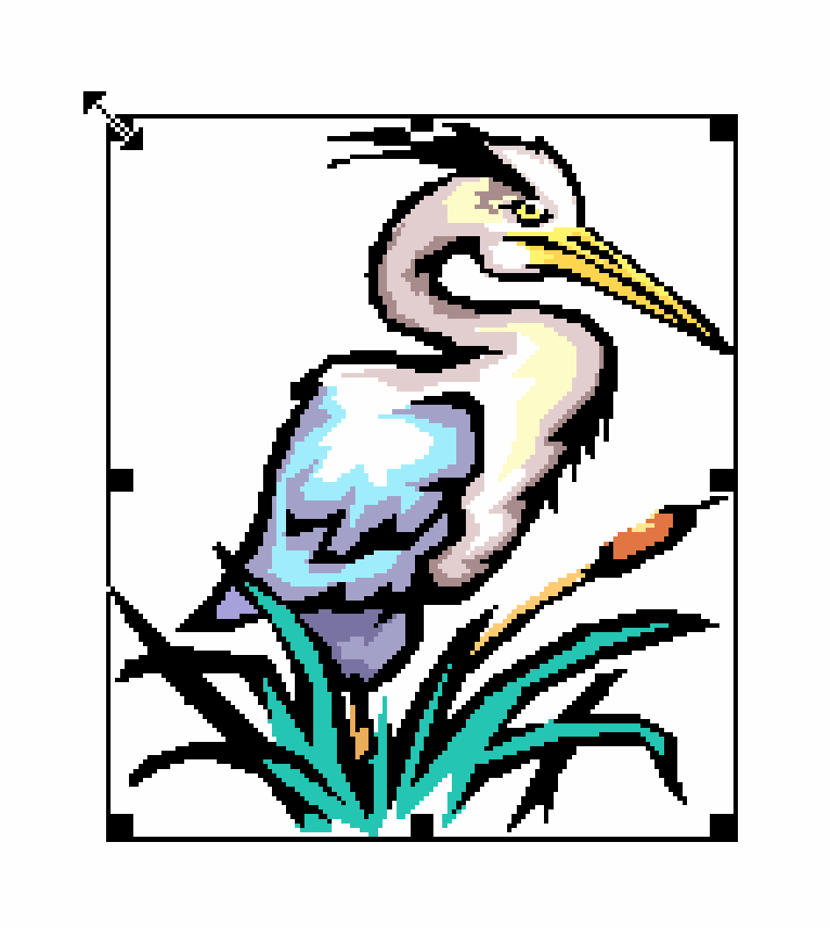
You can move the image to another place in the document by left-clicking and holding on the center of it; drag it to its desired location. More options, such as aligning the image with text (or special effects like wrapping text around or through an image) can be found by right-clicking the center, and choosing the Format Picture option from the menu.

Occasionally, images are not as they seem. In other words, it may look one way in the preview, but come out far different in the document.

To resize your image, grab one of the corners of the image by left-clicking and holding—drag it to your desired size and fine-tune the placement.

The cursor will change from a typing icon to a double-arrow when it can be used to resize the image. Drag the corner toward the upper-left corner of the screen, and the image will grow. Drag toward the bottom-right, and it will shrink.

You can move the image to another place in the document by left-clicking and holding on the center of it; drag it to its desired location. More options, such as aligning the image with text (or special effects like, wrapping text around or through an image) can be found by clicking on the picture, and then choosing the Picture Tools tab.

You can also insert a photograph or other multimedia from your files using this same process. On the Insert Tab, click on Picture and locate the files that you want to include.

PRACTICE
Place your cursor under the sentence “Today was a good day” and navigate to the Insert Clip Art window. Search for ‘computer’. Pick an image you like and click it to insert it into your document. Take a minute or two to resize the image to a size you like

Changing Views and Overall Look:

There will be times in which you create documents that don't fit on a standard piece of paper in its normal dimensions (8.5" by 11").

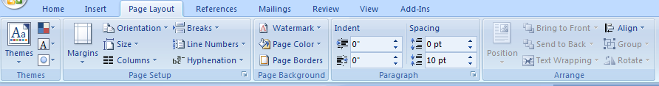
Click on the Page Layout Tab.

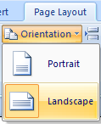
From this menu, you can alter the margins, the width, height, orientation (portrait = 11" long; landscape = 11" wide), as well as choose from a variety of templates different types of paper and document styles that come with the program.

To change the orientation of your page, click on the Orientation button. Click on Landscape from the drop-down box that appears. Your document should now be in a landscape position. If you wish to return to a portrait orientation, go through the same steps, clicking on the Landscape option instead of Portrait.

Your document should now be in a landscape position. If you wish to place it back in a portrait position, go through the same steps but instead of clicking on the Landscape option, click on the Portrait option.

Anything you change from the View Tab will not change the way your document prints out. So if you want your text to be bigger when you print out, make sure to change the size of the font instead of the zoom.

PRACTICE
Change the orientation of your document to Landscape.

Closing Microsoft Word

Saving Documents:

When you finish typing and want to leave the computer, it is important to save your work, even if you are printing a hard copy. To save your work in MS Word, it is essential to know WHAT you are trying to save and WHERE you are trying to save it.

Click on the Microsoft Office Button → then click Save to get started.

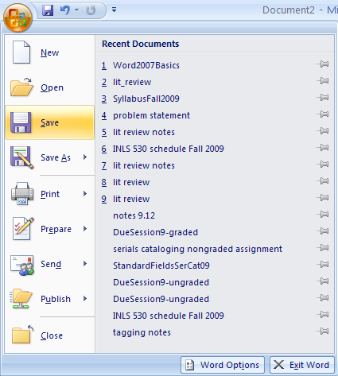

You can change the file name that Word has automatically chosen just by typing a new one in the “File name” box at the bottom of the window that appears.

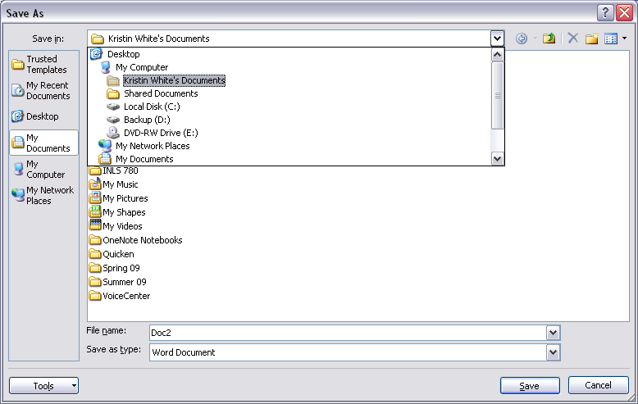

MS Word will automatically save your document with the suffix (“extension”) “.docx”—this simply lets your computer know that the file needs to be opened in Word 2007. You do not have to type this extension name—just highlight the words (the default is “Document1”) and write a new file name.

As evidenced in the picture above, there are many places where you can save a file, some of which are portable and some of which are immobile.

The My Documents folder on your computer’s hard drive is a good place to store your documents. A blank CD (compact disc) is a great portable storage device and can contain a LOT of data. Another good option is a USB key/thumb drive/flash drive.

Due to differences between older versions of Word and the new 2010 version, older versions of Word cannot open documents saved in Word 2010 with the suffix “.docx”. If you think you might want to share your document with someone who has an older version of Word on their computer, you can save your document in a format that is compatible with older version, like “.doc”.

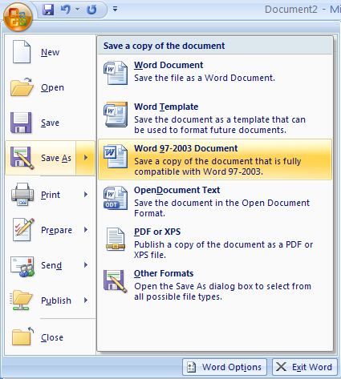
To do this, click on the Microsoft Office button, click Save As, then choose Word 97-2003 Document.

Follow the normal steps above to name your document.

It is important to note that every following command of SAVE will overwrite your original file, creating the most up-to-date version. To save multiple versions of your document, you will need to save copies with slightly different names.

If you want to save the changed document without destroying the original one:

If you want to save the changed document without destroying the original one:

Click on the Microsoft Office Button and then click “Save As,” giving your document a new file name, different from the original.

If you want to open up a saved document in Word:

Click on the Microsoft Office Button, then click Open.

Locate where the file is located on your computer and double-click on the file name of the document you want to open.
Printing Documents:

To print your MS Word document:

Click on the Microsoft Office Button, then click Print; a print preview and print options will appear.

Click OK for your document to start printing.

As with all commands in MS Word, you can make changes along the way. From the Print menu, you can alter how many copies will be made, in what order the pages will be printed, etc.

As with all commands in MS Word, you can make changes along the way. From the Print menu, you can alter how many copies will be made, in what order the pages will be and much more.

Finding More Help:
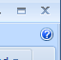
You can get help with MS Word by clicking the Question Mark Button located in the top right corner of the window.
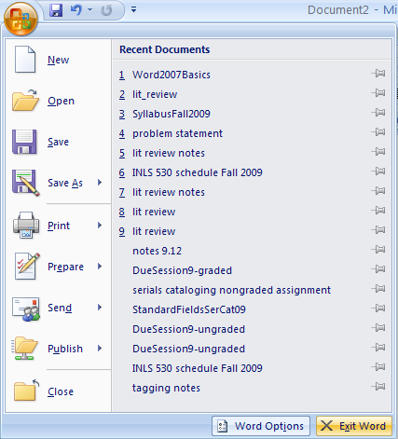
Tutorials are also available on the Internet. Some of them come straight from Microsoft! Of course, you can also always come and ask quick questions at the library.

Closing the Program:

Congratulations! You have completed this course in Microsoft Word Basics. As you become more and more comfortable with the program, it is always helpful to continue to experiment with options that you come across–sometimes, you can uncover a tool that would have stayed hidden–and you can improve proficiency by learning the fine details of the program. When you are finished,

Click on the Microsoft Office button → then click Exit Word.
OR
Click on the X in the top right corner of the computer screen.

It’s that easy! If you don’t save before attempting to close the program, Word will prompt you to save the file. Make sure you save if you don’t want to lose any changes!!
NOTE: Images and screen captures may differ from those seen on another system.

This work is licensed under a Creative Commons Attribution-NonCommercial 4.0 International License.

