

DOING MORE WITH POWERPOINT: MICROSOFT OFFICE 2007

GETTING STARTED PAGE 02
Prerequisites
What You Will Learn

USING MICROSOFT POWERPOINT PAGE 03
Slide Views

MORE TASKS IN MICROSOFT POWERPOINT PAGE 05
Formatting Bulleted and Numbered Lists
Inserting Notes
Inserting AutoShapes
Inserting WordArt
Inserting Hyperlinks
More Chart Options
Printing

CLOSING MICROSOFT POWERPOINT PAGE 13
Saving Slide Shows
Finding More Help
Closing the Program

View our full schedule, handouts, and additional tutorials on our website:
cws.web.unc.edu
Getting Started

Prerequisites:

It is assumed that the user is both familiar and comfortable with the following prior to working with Microsoft PowerPoint:

- Using the mouse and the left-click feature
- Basic navigation through Microsoft Windows
- Basic typing and keyboard commands
- Familiarity with Microsoft Word
- Basic familiarity with Microsoft PowerPoint

Please let the instructor know if you do not meet these prerequisites. To download a sample presentation to practice these tasks, visit www.lib.unc.edu/cws/handouts and click on PowerPoint Practice Document under Doing More With PowerPoint. Ask the instructor if you need help downloading the document.

What You Will Learn:

Slide Views | Formatting Bulleted and Numbered Lists | Inserting Notes
Inserting AutoShapes | Inserting WordArt | Inserting Hyperlinks
Saving Slide Shows | More Chart Options | Printing
Finding More Help | Closing the Program

Using Microsoft PowerPoint 2007

Slide Views

When you are creating a PowerPoint presentation, you may need to rearrange the order of your slides. PowerPoint gives you several different ways to view your slides to make this easier.

Normal View – the default view when you open PowerPoint. It displays small slides on the left, the main pane with the slide you’re working on in the middle, and the task pane on the right. Below the slide on the main page is a section where you can enter notes for your presentation that will not appear on the slides.
To move slides in Normal View:
- Click on a slide on the left-hand side of the screen.
- Hold down the mouse button and drag the slide to where you want it. You will see a horizontal line between slides that shows where the slide will be placed when you let go of the mouse button.
Normal view:
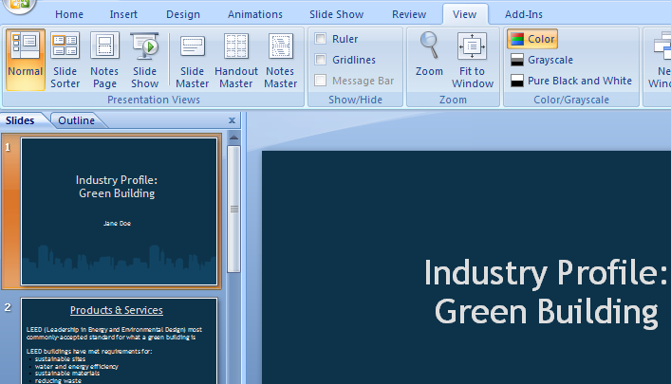

Slide Sorter – displays your slides in a grid layout. From the View tab, in the Presentation Views box, click on the Slide Sorter button to see this view.
To move slides in Slide Sorter view:
- Click on the slide you want to move.
- Hold down the mouse button and drag the slide to where you want it. You will see a vertical line between slides that shows where the slide will be placed when you let go of the mouse button.
Slide sorter view:
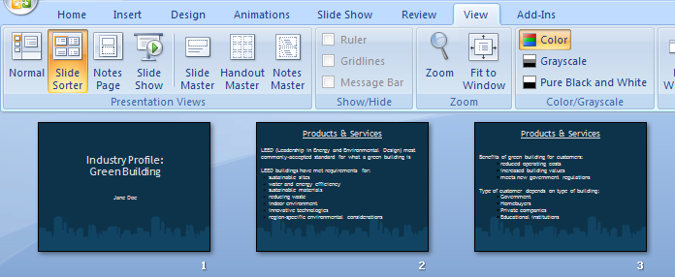

Outline View – similar to normal view, but instead of small slides on the left, it displays the text of all your slides. From the View tab, in the Presentation Views box, click on the Normal button to see this view. Select the Outline tab at the top of the left-hand column. This view is best used for editing the text of your slides.

Outline view:
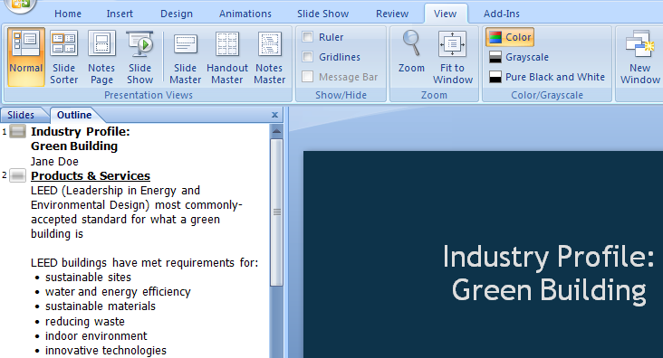
More Tasks in Microsoft PowerPoint 2007

Formatting Bulleted and Numbered Lists

Several of the slide layouts in PowerPoint use bulleted lists to help you format the text on that slide. You can choose one of these slides with pre-set formatting for your list, or you can choose to create a bulleted list slide of your own. You can also format the look of your list.

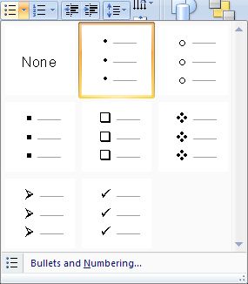To format a bulleted list:

- On the Home tab, in the Paragraph group, click on the downward-pointing arrow next to the Bullets button.

- On menu that appears, click on the style of bullets you want.

- If you want to adjust the size or color of the bullets, click on Bullets and Numbering at the bottom of the menu for more options.

If you don't like the bullet options available to you in this menu, you can customize your own.

- On the Home tab, in the Paragraph group, click on the downward-pointing arrow next to the Bullets button.
- At the bottom of the menu that appears, click on Bullets and Numbering.
- On the Bulleted tab, click on either Picture or Customize
- Choose a symbol or picture from the dialog box that appears and click OK.

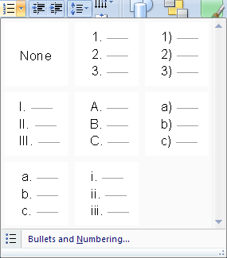The Picture option will give you a choice of colorful pictures to choose from to use as bullet points. You can even use your own picture by clicking on the Import button. The Customize option gives you a choice of many different symbols to use as bullets.

To format a numbered list:

- On the Home tab, in the Paragraph group, click on the downward-pointing arrow next to the Numbering button.

- On menu that appears, click on the style of numbering you want.
- If you want to adjust the size, color, or starting number, click on Bullets and Numbering at the bottom of the menu for more options.

To delete a bullet point or number, put your cursor to the right of the bullet and hit the Backspace key. When you delete an item from a numbered list, the other numbers will automatically adjust so that the numbers are in order.

Inserting Notes

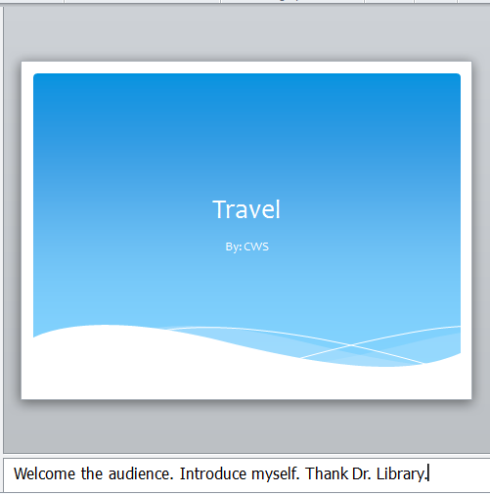You may want to make notes when creating a presentation. In the Normal view, at the bottom of the slide you are viewing, is a section that says “Click to add notes”. Click in that space and start typing your note. You have the option to print out the notes in the event you want to use them as cue cards when presenting your slides. We will cover that option in the Printing section.
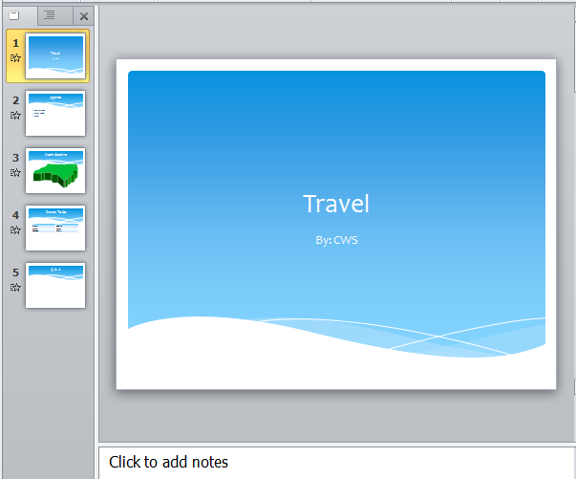

Inserting AutoShapes

PowerPoint gives you many ways to enhance your presentation with graphics like arrows, stars, banners, and many other shapes. These are called AutoShapes, and they are available on the Insert tab in the Illustrations group. Click on the Shapes button.

Click on the shape you want to insert. Your mouse will turn into a crosshair: . Left click and drag (while holding down the mouse button) until the shape is the size you want.

You can resize any shape using the circles and squares around the border of the shape (if your shape doesn’t have these circles, simply click on it once). Hover your mouse over one of the circles until it becomes a two-headed arrow. Left click and drag the mouse (while holding the mouse button down) until the shape is the size you want. Dragging the circles in the corners will keep the proportions of the shape fixed, while dragging the squares on the sides will only change either the height or width of the shape. Clicking on the green circle and dragging the mouse will rotate the shape.
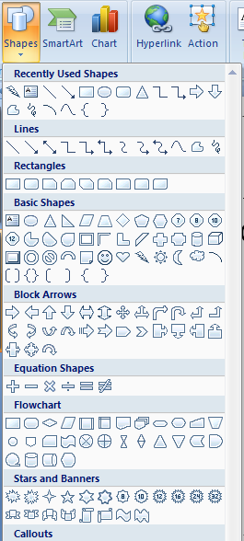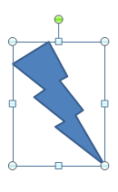
Once you’ve inserted a shape, you will see a new Format tab on the ribbon menu. This gives you many other options for formatting your shapes. Don’t be afraid to experiment with them – you can always use the Undo feature if you make a mistake!

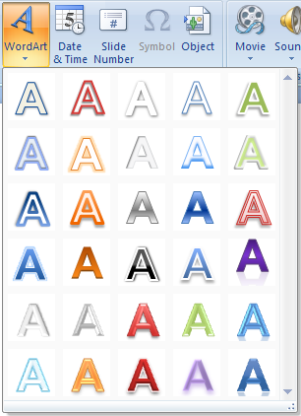

Inserting WordArt

Another tool to help you add style to your document is WordArt. The WordArt tool is also available on the Insert tab. Formatting WordArt is similar to formatting a shape.

1. On the Insert tab, in the Text group, click on the WordArt button.

2. Click on a lettering style from the WordArt gallery that appears.

3. A text box with the words “Your Text Here” will appear in the lettering style you chose. Simply begin typing your own text.


You can change the size of the WordArt you’ve created similar to the way you would change the size of a shape. Click on the word and you will see circles and squares appear around the border of the word:


Hover your mouse over one of the circles or squares until it becomes a two-headed arrow. Left click and drag the mouse (while holding the mouse button down) until the text is the size you want.

As with inserting shapes, once you insert WordArt you will see a new Format tab on the ribbon menu bar. This gives you many more options for formatting your WordArt. Don’t be afraid to experiment with them – you can always use the Undo feature if you make a mistake!

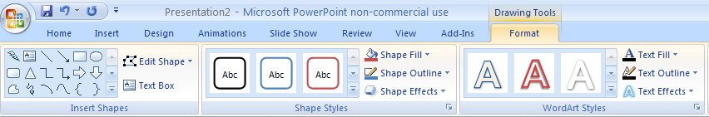

Inserting Hyperlinks

You may decide that you want to add a link on one of your slides to a website, or a hyperlink, that provides more information related to your presentation. Adding a hyperlink will allow you to click on that link during your presentation to visit that website. It’s a great way to make your presentation more interactive.

To insert a hyperlink:

- Highlight the text in your slide that you want to make a hyperlink. Your link can be one or a few words, or it can be an address for a website (for example: CNN or www.cnn.com).
- On the Insert tab, in the Links group, click on the Hyperlink button.

- In the dialog box that appears, make sure that Existing File or Web Page is selected on the left.
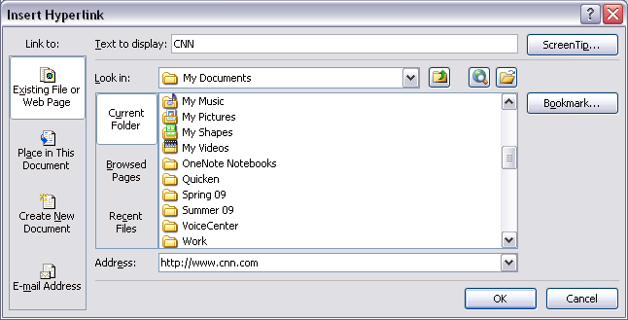
- The text that you highlighted should appear next to Text to display.
- Enter the address for the website you want to link to next to Address.
- Click OK.

Check to make sure that the link works by clicking on it. It may not work while you are in Normal View (while you are editing your slides), but it should work when you switch to viewing the slide show.

More Chart Options

In the Introduction to PowerPoint class, we looked at how to add a bar graph to your slides. PowerPoint gives you many other options of different kinds of charts or graphs, so you’re not stuck with using a bar graph if that doesn’t fit your needs.

To view and choose another type of chart:
- 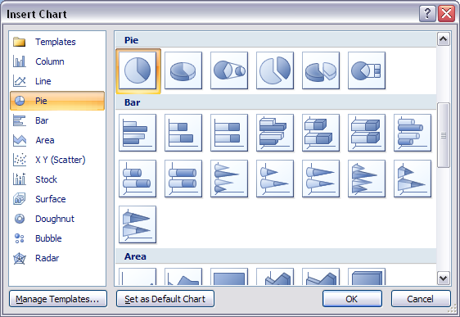On the Insert tab, in the Illustrations group, click on the Chart button.
- A dialog box will appear. Click on the different chart types in the list on the left to see what they would look like. Once you find one that you like, click on it and then click OK.
- A new window will open next to the window with your PowerPoint slides. The new window displays an Excel spreadsheet. Here you will need to enter your own data that you want the chart to represent.

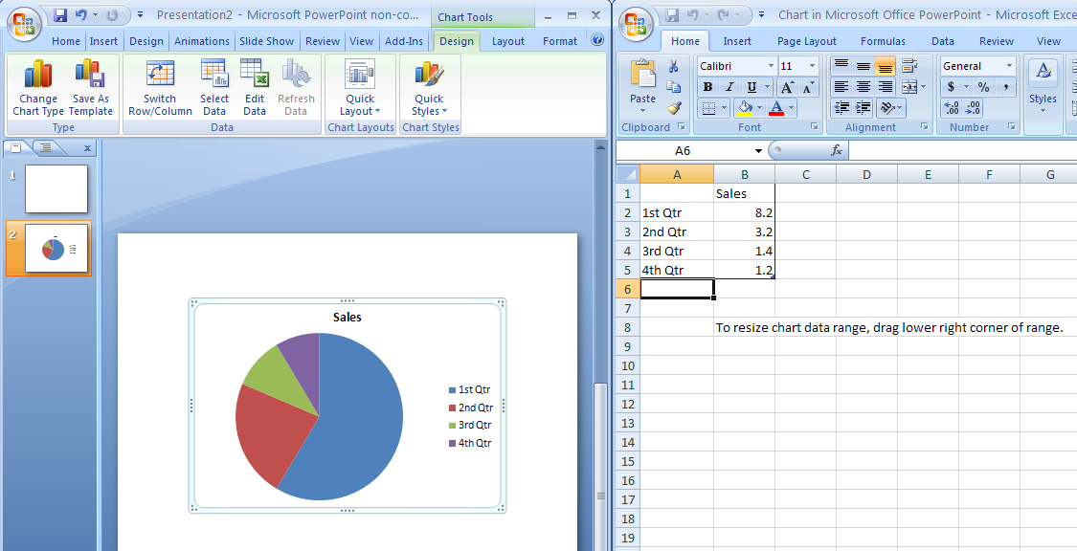

After you have inserted your chart, you will see three new tabs on the ribbon menu under the heading Chart Tools: Design, Layout, and Format. These give you many more options for modifying your chart. One way to modify it is by adding things like labels or values. To do this, on the Layout tab, in the Labels group, click on the Data Labels button. The options here will let you display the numerical values, percentages, or both for each category right on the chart. In the Labels group on the Layout tab, you can also change the title of the chart or modify the chart’s legend.

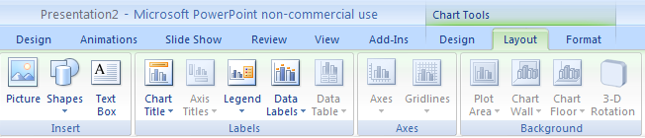

Printing

Once you've finished creating your presentation, it's time to print. PowerPoint allows you to print your slides in several formats, depending on what you need for your presentation. You can print them as slides, handouts, notes pages, and outlines.

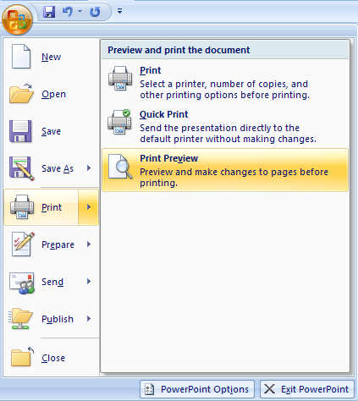Before you start printing, it's a good idea to preview your print job so that you know what it will look like on paper. To do this:
- Click on the Microsoft Office button in the upper left corner of the screen. Hover your mouse over Print, and click on Print Preview from the menu that appears to the right.
- Click on the downward-pointing arrow below the Print What box at the top of the screen

- Choose the layout you want for printing your presentation.
- Click on Close to close the preview when you are finished or click Print to print the selected layout (both are buttons in the ribbon menu at the top of the screen).

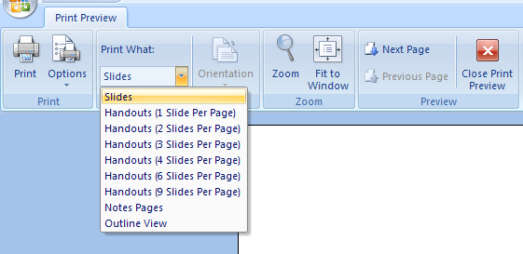z
You have several layout options to choose from:

Slides – Prints each slide on a separate page, just as it appears on the screen.

Handouts – Prints multiple slides on a single page (up to 9). Each slide will appear with a border around it so it is easy to distinguish one slide from another. This is a good option if you want to give members of your audience a paper copy of your slides.

Notes page – Prints one slide per page along with any notes you entered in the Notes section when you created your slides. This is helpful when you are presenting your slides so you can have a copy of your notes during the presentation.

Outline – Prints your slides as they appear in the Outline View of PowerPoint.
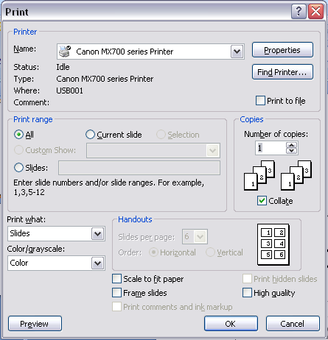
When you are ready to print your slides, the procedure for printing is similar to the one for printing in Microsoft Word.
- Click on the Office button ► Print.
- In the box below Print What, click on the downward arrow and select the layout you want (slides, handouts, notes pages, or outline view).
- If you chose Handouts, select the number of slides per page.
- Click OK.
Closing Microsoft PowerPoint

Saving Slide Shows:

When you come to a stopping point and want to leave the computer, it is important to save your work (even if you are printing a hard copy — saving should be a reflex). To save your work in MS PowerPoint, it is essential to know WHAT you are trying to save as well as WHERE you are trying to save it.

Click ►Office button ►Save in the upper left corner of the screen to get started.

You can change the filename that PowerPoint has chosen just by typing a new one in the File name box at the bottom of the window that appears.

MS PowerPoint will automatically save your document with the suffix “.pptx” – this is simply a tag that lets PowerPoint know that your work is specific to this program. You do not have to type it – just highlight what is there (default is “Presentation1”) and write a new file name.

The My Documents folder on your computer’s hard drive is a good place to store your documents. A blank CD (compact disc) or a USB Jump Drive are great portable storage devices and can contain a LOT of data.

It is important to note that every consequent command of SAVE will overwrite your original file, creating the most up-to-date version.

If you want to save any changes to your PowerPoint slides without destroying the original one:

Click ►Office button ►Save As and give your document a new filename (unique from the original).

To bring a saved document back up on the screen from MS PowerPoint:

Click ►Office button ►Open.

Locate where the file is saved (which folder, that is) and click on the filename of the document you want.

Click ►Open.

Finding More Help:

You can get help with MS PowerPoint by clicking on the Help button in the upper right corner of the screen: . You can type your question directly into the search box that appears.

Tutorials are also available on the Internet. Your instructor can help you with locating some of these resources.

Closing the Program:

Congratulations! You have completed this course in Doing More with PowerPoint 2007. As you become more and more comfortable with the program, it is always helpful to continue to experiment with options that you come across – sometimes, you can uncover a tool that would have stayed hidden – and you can improve proficiency by learning the fine details of the program. When you are finished,

Click ►Office button ►Exit PowerPoint

OR

Click on the X in the top right corner of the computer screen.

NOTE: Images and screen captures may differ from those seen on another system.

This work is licensed under a Creative Commons Attribution-NonCommercial 4.0 International License2.

