

EXCEL BASICS: MICROSOFT OFFICE 2010

GETTING STARTED PAGE 02
Prerequisites
What You Will Learn

Using Microsoft Excel PAGE 03
Opening Microsoft Excel
Microsoft Excel Features
Keyboard Review
Pointer Shapes

Microsoft Excel Basics PAGE 09
Typing in Cells
Formatting Cells
Inserting Rows and Columns
Sorting Data
Basic Formulas
Cell Reference
AutoSum and Excel Equations

CLOSING MICROSOFT EXCEL PAGE 17
Saving Spreadsheets
Printing Spreadsheets
Finding More Help
Closing the Program

To complete feedback forms, and to view our full schedule, handouts, and additional tutorials, visit our website:
cws.web.unc.edu

GETTING STARTED

Prerequisites:

This is a class for beginning computer users. You are only expected to know how to use the mouse and keyboard, open a program, and turn the computer on and off. You should also be familiar with the Microsoft Windows operating system.

Today, we will be going over the basics of using Microsoft Excel. We will be using PC desktop computers running the Windows operating system. Microsoft Excel is part of the suite of programs called “Microsoft Office,” which also includes Word, PowerPoint, and more.

Please let the instructor know if you have questions or concerns before the class, or as we go along.

You Will Learn How To:

Find and open Microsoft Excel in Windows | Use Microsoft Excel’s menu and toolbar | Review the keyboard functions
Understand the different pointer shapes | Type in cells | Format cells
Insert rows and columns | Sort your data | Basic formulas
Cell references | Use Autosum | Save worksheets
Print worksheets | Exit the program

USING MICROSOFT EXCEL

Microsoft Excel is an example of a program called a “spreadsheet.” Spreadsheets are used to organize real world data, such as a check register or a rolodex. Data can be numerical or alphanumeric (involving letters or numbers). The key benefit to using a spreadsheet program is that you can make changes easily, including correcting spelling or values, adding, deleting, formatting, and relocating data. You can also program the spreadsheet to perform certain functions automatically (such as addition and subtraction), and a spreadsheet can hold almost limitless amounts of data—a whole filing cabinet’s worth of information can be included in a single spreadsheet. Once you create a spreadsheet, you can effortlessly print it (as many copies as you want!), save it for later modifications, or send it to a colleague via e-mail. Microsoft Excel is a very powerful calculator—This handout covers just a small number of its features!

Microsoft Excel is available on both PCs and Macs, so what you learn in class today should be applicable to any computer you use. The program may look slightly different depending on the version and computer that you’re using, but Microsoft Excel will function in the same basic ways. There are other spreadsheet programs out there, including Google Spreadsheets (part of Google Docs), OpenOffice Calc, Apple iWorks Numbers, Lotus 1-2-3, and WordPerfect Quattro. They have many features in common with Microsoft Excel, and you should feel free to choose any program you prefer.

Opening Microsoft Excel:
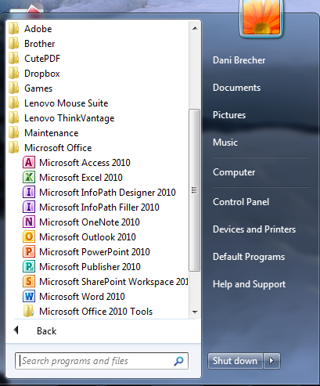
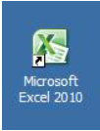To get started with Microsoft Excel (often called “Excel”), you will need to locate and open the program on your computer. To open the program, point to Excel’s icon on the desktop with your mouse and double-click on it with the left mouse button.

If you don’t see the Excel icon on your desktop, you’ll have to access the program from the Start Menu. Click on the button in the bottom left corner to pull up the Start Menu. You may see the Excel icon here, so click on it once with your left button. If you still don’t see it, click on “All Programs” and scroll through the list of programs until you find it. It may also be located in a folder called “Microsoft Office” or something similar—it will depend on your specific machine. Click once with your left button to open the program.

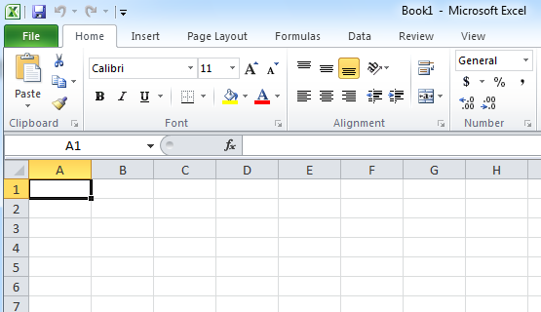Excel will then open a blank page called “Book1.”

This is an image of the upper-left corner of Excel.

This box features two important pieces of information: the name of the file that you are currently working on (in this case, “Book1” since we have not yet renamed it) and which program you are using (“Microsoft Excel”).

You will see a dark box around one of the lighter color boxes on the spreadsheet. This means that a cell is selected and you will be able to enter information in that space.

Microsoft Excel Features:

The Title Bar
This is a close-up view of the Title Bar, where file information is located. It shows the name of the file (here, “Book1,” the default title) and the name of the program (“Microsoft Excel”). You will be able to name your file something new the first time that you save it. Notice the three buttons on the right side of the Title Bar, controlling the size and closing of the program.

The Ribbon Menu System

The tabbed Ribbon menu system is how you navigate through Excel and access various Excel commands. If you have used previous versions of Excel, the Ribbon system replaces the traditional menus.

At the bottom, left area of the spreadsheet, you will find worksheet tabs. By default, three worksheet tabs appear each time you create a new workbook. On the bottom, right area of the spreadsheet you will find page view commands, the zoom tool, and the horizontal scrolling bar.
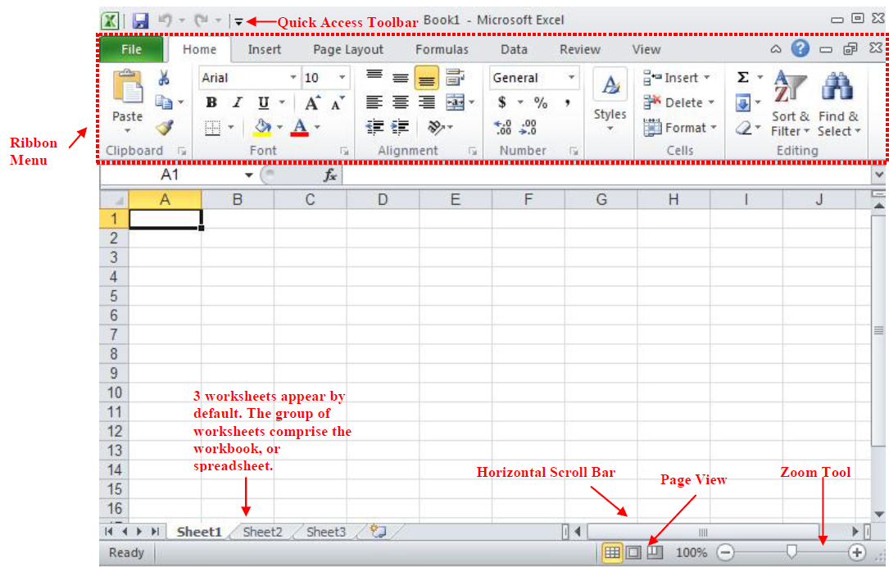
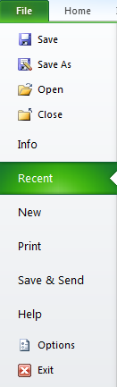

The File Menu

In Microsoft Office 2007, there was something called the Microsoft Office Button () in the top left-hand corner. In Microsoft Office 2010, this has been replaced with a tab in the Ribbon called “File.” When you left-click on this tab, a drop-down menu appears. From this menu, you can perform the same functions as were found under the Microsoft Office Button menu, such as: Create a new worksheet, open existing files, save files in a variety of ways, and print.

Quick Access Toolbar

On the top left-hand side of the Title Bar, you will see several little icons above the File menu. These let you perform common tasks, such as saving and undoing, without having to find them in a menu. We’ll go over the meanings of the icons a little later.

The Home Tab

The most commonly used commands in Excel are also the most accessible. Some of these commands available in the Home Tab are:

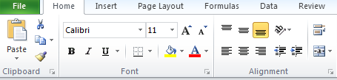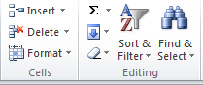
Font Style
Font Name
Font Size
Font Color
Alignment
AutoSum
Sort
The Home Tab Toolbar offers options that can change the font, size, color, alignment, organization and style of the text in the spreadsheet and individual cells. For example, the “Calibri” indicates the FONT of your text, the “11” indicates the SIZE of your text; etc. We will go over how to use all of these options to format your text in a little while.

Each of these options expands into a menu if you left-click on the tiny down-arrow in the bottom right corner of the window.

This tab works the exact same way as the MS Word Formatting Toolbar. The main difference is that the format changes will only affect the selected cell or cells, all unselected cells remain in the default setting (“Calibri” font, size “11”).

Formula Bar

The Formula Bar is generally found below the ribbon menu. The left side denotes which cell is selected (“C5”) and the right side allows you to input equations or text into the selected cell.
There are two ways to input information into a cell. You may either select an individual cell and type the equation or text into the Formula Bar or type the equation or text directly into the selected cell.

Equations (for example, =SUM(D5+E5)) will automatically be hidden inside the cell and can only be viewed using the formula bar; the result of the equation will display in the cell.

If any written text is longer than the cell width, then the spreadsheet will cover up any portion longer than the cell width. The information will still be in the cell, you just won’t be able to see it at all times.

Keyboard Review:


In order to use Excel effectively, you must input commands using both the mouse and the keyboard. The above image of a keyboard should look similar to the keyboard in front of you; learning just a few certain keys will help to improve your efficiency in typing as well as present you with more options within the program. The following is a list of commonly used keys that you may already be familiar with:

- Backspace: This key deletes letters backwards.
- Delete: This key deletes letters forward.
- Shift: This key, when pressed WITH another key, will perform a secondary function.
- Spacebar: This key enters a space between words or letters.
- Tab: This key will indent what you type, or move the text to the right. The default indent distance is usually ½ inch.
- Caps Lock: Pressing this key will make every letter you type capitalized.
- Control (Ctrl): This key, when pressed WITH another key, performs a shortcut.
- Enter: This key either gives you a new line, or executes a command.
- Number Keypad: These are exactly the same as the numbers at the top of the keyboard; some people just find them easier to use in this position.
- Arrow Keys: Like the mouse, these keys are used to navigate through a document or page.

Pointer Shapes:

As with other Microsoft programs, the pointer often changes its shape as you work in Excel. Each pointer shape indicates a different mode of operation. This table shows the various pointer shapes you may see while working in Excel.

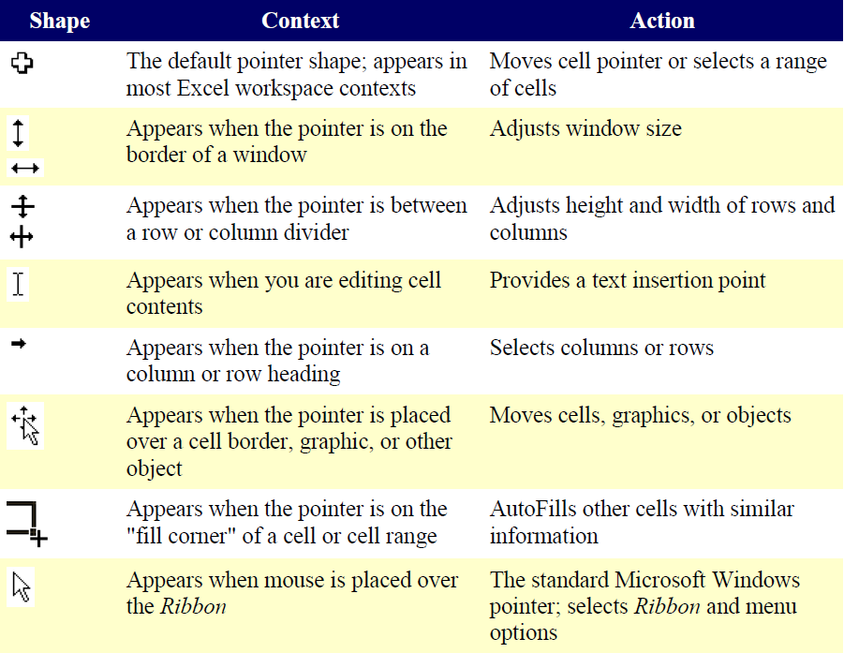
MICROSOFT EXCEL BASICS

Typing in Cells:

Cells are the small rectangular boxes that make up the spreadsheet. The boxes are the intersection of columns (A, B, C, etc.) and rows (1, 2, 3, etc.). To reference a cell, use the column and the row name. For example, the cell in the first column and first row is called “A1”. All the information entered into an Excel spreadsheet is entered into cells.

Click on a cell to begin typing in it. It is that easy! When you are finished typing in the cell, press the Enter key and you will be taken to the next cell down. You can then begin typing in that cell. You can easily navigate around the cells using your arrow keys.

Keep in mind that the Formatting toolbar in Microsoft Excel 2010 is exactly the same as the one used for Microsoft Word 2010. The biggest difference between the two programs is that, in Excel, the format is set for each individual cell. So if you change the font and applied the bold option in cell C5, then this format will only be applied to cell C5. All remaining cells will remain in default mode until they have been changed.

Sometimes you may only wish to adjust the format of one particular cell. In this case, simply select the cell by clicking the mouse on it and make any necessary adjustments to the font, size, style, and alignment. Those changes will not carry over when you begin typing in a new cell.

Other times, you may wish to adjust the text format of a group of cells, entire rows, or entire columns.

In Excel, you can choose groups of cells in rectangular units—all the cells you select must form a rectangle of some kind. To select a group of cells, begin by clicking on the cell that would be in the upper-left hand corner of your rectangle. Hold down the Shift key on your keyboard and use the arrows (←, →, ↑, ↓) on the keyboard to expand the selection of cells, or click and drag your mouse.

Once the group of cells has been selected, you can make adjustments to the font, size, style, and alignment and they will be applied to all selected cells.
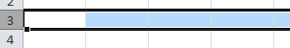
To select an entire row, click on the Row Number with your mouse—note how the entire row becomes highlighted. All formatting changes will now be applied to the whole row.
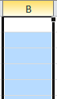
To select an entire column, click on the Column Number with your mouse—again, the entire column will become highlighted. All formatting changes will be applied to the whole column.

PRACTICE:
Select cell A1. Type 123 in that cell and press Enter on the keyboard. Select cell C6. Type abc in that cell and press Tab on the keyboard. Pressing Enter, Tab or left-clicking another cell will indicate to Excel that you are done typing in that cell.

Left-click in the Formula Bar. You should now see a blinking cursor in the bar. Type hello in the bar and press Enter. As you’re typing in the formula bar, the data appears in the highlighted cell. 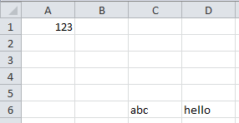Now use the Undo button in the quick access toolbar to remove “hello”. Select cell C6. Press the delete button on your keyboard to delete “abc” from that cell.

Formatting Cells:

The cell width and height will usually need to be adjusted to view all the information entered into a cell.

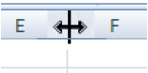To adjust the cell width, move the mouse pointer in between two cell columns in the column header. Hold down the left mouse button and drag the mouse left to shorten the width or right to expand the width. Notice that all cells within the column are automatically adjusted.
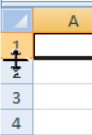
Adjust the cell height using the same method. Move the mouse cursor between two rows, hold down the left mouse button and move the mouse up to decrease the height and down to increase the height.

Before you begin entering data into a spreadsheet, you may already know the width and height you want your cells to have. In this case, you can adjust all the widths and heights by doing the following:
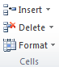
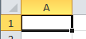Select the “square” between Column A and Row 1. This will select ALL the cells in the spreadsheet. From the “Home” tab of the Ribbon Menu, within the “Cells” box, click on “Format,” and select Row Height. You will now be asked to enter a numerical value for height. The default value is 15, but you can enter your own height value (10, 20, 25, etc.).
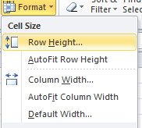
Repeat the same steps for Column width. From the “Home” tab of the Ribbon Menu, within the “Cells” box, click on “Format,” and select Column Width. Note that the default value for the width is 8.43. Enter your own width value (5, 10, 15, 20, etc.).

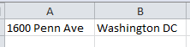PRACTICE:
In cell A1, type “1600 Penn Ave”. In cell B1, type “Washington DC”. You will notice that the street address is cut off and the city blends into cell C1. If you highlight cell A1, you will see the entire address is still there and shows up in the formula bar. Adjust the cell width for columns A and B so you can see all the data in both cells.

Set the row height for the entire worksheet to 20. Set the column width for the entire worksheet to 15. With the entire spreadsheet still selected, Hit the Delete key on the keyboard to remove all data from the cells.

For any given cell or selected cells, you can also format the way your data is represented within the cell(s). Select a single cell or multiple cells. Again, from the “Home” tab of the Ribbon Menu, within the “Cells” box, click on “Format.” Select “Format Cells.” The format window will now appear, giving you a wide variety of options on how to format your cell.

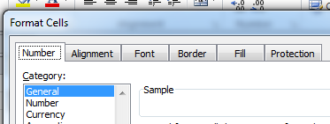

Number – This allows you to choose how to represent the numbers that are entered into a cell (number, currency, time, etc.).

Alignment – This determines how the data will be aligned within the cell (left-side, centered, or right-side).

Font – Select the type of font to be used within the cells.

Border – This option lets you choose what type of border, if any, you would like around the cells or some of the cells.

Fill – This allows you to change the background color of the cell.

Protection – This option allows you to “lock” cell information so that other users cannot make changes.

Inserting Rows and Columns:
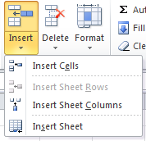
When you are working on a spreadsheet, you may realize that you left out a row or column of data and need to add it in.

To insert a row, click on the row below where you want your new row to be (remember to click on the row number to highlight the entire row). From the “Home” tab, within the “Cells” box, click “Insert.” Select “Insert Sheet Rows.” A new row will automatically be inserted and the row numbers automatically adjusted.

To insert a column, click on the column to the right of where you want your new column to be (remember to click on the column letter to highlight the entire column). From the “Home” tab, within the “Cells” box, click “Insert.” Select “Insert Sheet Columns.” A new column will automatically be inserted and the column letters automatically adjusted.

PRACTICE:
Enter the data as shown in the screenshot below.
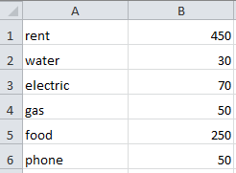

Now let’s insert a heading. Insert a row abouve row 1. In cells A1 and B1 enter Bill and January.

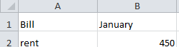

Sorting Data:

Once you have created your spreadsheet and entered in some data, you may want to organize the data in a certain way. This could be alphabetically, numerically, or another way.

First, select all the cells that represent the data to be sorted, including the header descriptions. Then, select the first cell in Row 1. Click and drag to select all the cells that you want to sort.

Using the mouse, select Sort & Filter from the Editing panel. Select Custom Sort…
The following window should appear: Ensure that the “My data has headers” box is checked.

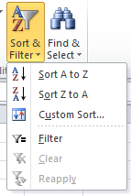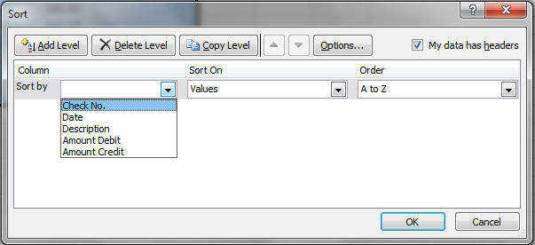

Select the column you wish to sort by. Do you want to sort by alphabetical order, reverse alphabetical order, date, or amount? When you press “OK,” your spreadsheet will be sorted in the order that you specified.

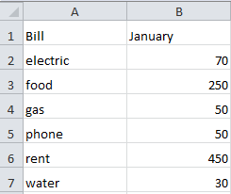PRACTICE:
Select all the data on your worksheet (cells A1 through B7) and go to the Custom Sort menu. Ensure that “My data has headers” is checked. Choose to sort by Bill and click OK. Your list should now be sorted alphabetically.

Basic Formulas

Excel can calculate basic equations like addition, subtraction, multiplication, and division. Let’s say you just want to add two numbers, with the answer appearing in a particular cell. (As you may remember, all formulas begin with an = sign. This lets Excel know that you are entering a formula.)

To write a formula that adds two numbers together (for example, 181 + 376):

- Click on the cell where you want the answer to the equation to appear.
- Begin by typing the = sign.
- 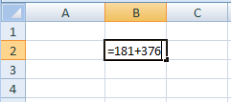Type the numbers you want to add separated by the + sign (without spaces): 181+376.
- Your entire equation should look like this: =181+376
- Press the Enter key.
- You will now see the sum appear in the cell – in this case, 557.

You can repeat these steps for subtraction, multiplication, or division too. Instead of the plus sign (+), use - for subtraction, * for multiplication, and / for division.

Cell references

What if you want to be able to add numbers in two different cells, but those numbers might change and you don’t want to have to retype your equation every time they do? In situations like this, you can use cell references within your equation. This tells Excel to use whatever value is in a specific cell to calculate the equation. That way, if the number in one of the cells does change, your equation will automatically recalculate the answer.
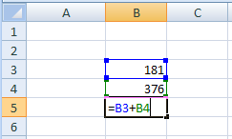
In the example to the right, we want to add the contents of cells B3 and B4 (181 + 376). We could write our formula the way we did above, but then if we changed the value in cell B3 to 200, our equation wouldn’t reflect the sum of these two cells anymore. We would have to update the equation manually.

Instead, we can write our equation using the names of the cells rather than the numbers in them. The name of a cell is its column letter and its row number (A2, C3, etc.).

To write a formula using cell references:
- Type the numbers you want to add in two different cells.
- Click on the cell where you want the answer to the equation to appear.
- Begin the equation by typing the = sign.
- Either click on or type in the name of the cell with the first number to be added (in this example, B3).
- Type the + sign.
- Either click on or type in the name of the cell with the second number to be added (in this example, B4). Your equation should look like this: =B3+B4
- Press the Enter key.
- You will now see the answer appear in the cell – in this example, 557.

Now, if you changed the value of cell B3 to 200, the answer that appears in the cell where you typed your equation will be 576 (200+376). It automatically recalculates when one of the numbers in a referenced cell changes.

Once you have entered your equation, when you click on the cell with that equation it will highlight the cells it is referencing by drawing colored borders around them (see the example above). This helps you see if it is using the cells you want it to use or if you have made a mistake in typing the formula.

AutoSum and Excel Equations:

One of the most powerful features of Excel is its ability to perform basic math functions on data. Excel can add, subtract, multiply, divide, find the average, and perform general counting functions on the numerical data that you enter. To enable this feature, highlight all of the cells in a column, plus one additional empty cell in which to display the result.
Select the AutoSum icon from the ribbon menu:
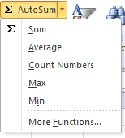
If you click directly on the ∑, Excel will automatically add up the numbers you have selected. If you click on the little dropdown arrow next to it (▼), you will get the full choice of mathematical functions.

If you double-click on the cell in which the answer appears, you will see an equation that looks something like this (you will also see this equation in the Formula Bar):

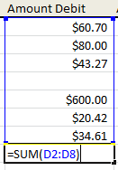
Let’s break down what exactly the equation means:

= indicates that you are starting an equation in this cell.
SUM tells the function to be performed. In this case, all the cells will be added together.
( ) The parentheses contain the cells that the function will be performed on.
D2 This is the first cell to be included in the addition formula.
D8 This is the last cell to be included in the addition formula.
: indicates that all cells between the first and the last should be included in the formula.

The spreadsheet will often “select” the cells that it thinks you wish to include. But you can manually change the cell range by typing into the Formula Bar.

When you are ready to execute the formula, just press the “Enter” key.

Other mathematical functions you can perform from the AutoSum button include:

Average – This function will calculate the average of the selected cells.
Count Numbers – This function simply counts the number of cells selected.
Max – This function will return the highest value of the selected cells.
Min – This function will return the lowest value of the selected cells.

*Remember* Excel equations are similar to programming languages, so have some patience and if at first you don’t succeed, try again. Even Excel professionals create incorrect formulas on their first try.

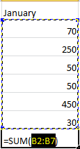Once you get an equation to work, you will technically be a computer programmer!

PRACTICE:
Select cell B8. Click the AutoSum button. Excel will highlight the amounts in cells B2:B7. Click Enter to accept this. The total amount now appears in cell B8. Now change the amount of electric to 90. Note that the total price changes automatically.

CLOSING MICROSOFT EXCEL

Saving Spreadsheets:
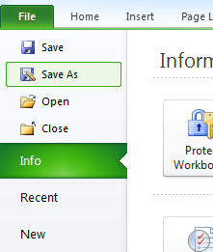
When you finish your spreadsheet and want to leave the computer, it is important to save your work, even if you are printing a hard copy. To save your work in Excel, it is essential to know WHAT you are trying to save and WHERE you are trying to save it.

Click on the File Tab, then click “Save As” to get started.

You can change the filename that Excel has chosen just by typing a new one in the “File name” box at the bottom of the window that appears.

The My Documents folder on your computer’s hard drive is a good place to store your documents. A blank CD or a USB jump drive are great portable storage options and can contain a LOT of data.
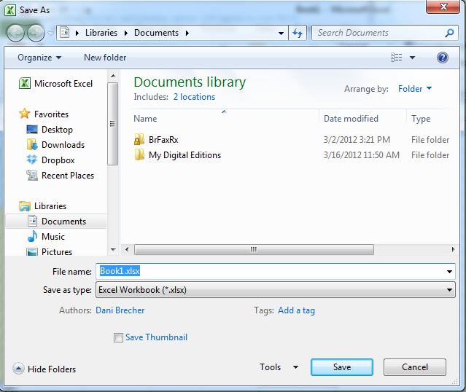
Excel will automatically save your document with the suffix “.xlsx”–this is simply a tag that lets Excel know that your work is specific to this program and what version it is in. You do not have to type it–just highlight what is there (default is “Book1”) and write a new file name. You may also chose to save it in an older format so that it can be opened with older versions of Excel.

After the first save, you can just click “Save” to preserve your work. However, it is important to note that every following command of SAVE will overwrite your original file, creating the most up-to-date version.

If you would like to keep saving different versions of your worksheet, be sure to use the “Save As” function each time you save, using a slightly different name for each version.
Finding More Help:

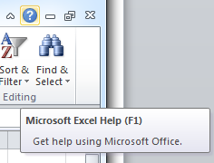You can get help with Excel by clicking on the Question Mark symbol in the upper-right hand corner of the main menu bar or by pressing the “F1” button. This will take you to help from Office.com, Microsoft’s help website.

There are also many other resources and tutorials available online. You might try a Google search with the words “Excel 2010” and the function you are trying to perform. Ask your instructor for help finding these resources if you have any trouble.

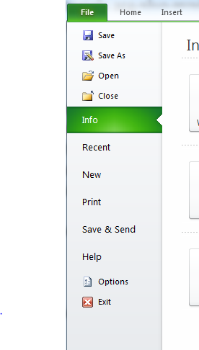Closing the Program:

Click on the File Tab, then click “Exit.”

OR

Click on the X in the top right corner of the Excel screen.

It’s that easy! If you don’t save before attempting to close the program, Excel will prompt you to save the file. Make sure you save if you don’t want to lose any changes!!

NOTE: Images and screen captures may differ from those seen on another system.

This work is licensed under a Creative Commons Attribution-NonCommercial 4.0 International License.

