INTERNET BASICS

GETTING STARTED PAGE 02
Prerequisites
What You Will Learn

BASIC WEB SKILLS/USING A WEB BROWSER PAGE 03
Locate and Open a Web Browser
Using a Browser’s Menu Options
Using the Browser’s Navigation Bar
Using Tabs
Using the Browser’s Help Feature
Changing Text Size

WEBSITE ADDRESSES/URLS PAGE 09
Go to a Specific Web Address
Following Links on a Web Page

USING SEARCH ENGINES PAGE 11
Finding Information with a Search Engine
Refining Your Search
Understanding Error Messages

NAVIGATING THE WEB PAGE 13
Identifying Advertisements
Viruses and Personal Safety

GLOSSARY PAGE 14
Getting Started

Prerequisites

It is assumed that the user is familiar and/or comfortable with computer hardware, software and the operating system Microsoft Windows.

- This workshop is intended for new Internet users.
- We will be using PC desktop computers running the Microsoft Windows Operating System.
- This handout covers mostly Google Chrome or Mozilla Firefox. You may use another browser if you wish, but some things may look different than pictured.
- It is important to note that the “Internet,” the “Net,” and the “Web” are all, for our purposes, the exact same thing. These terms are used interchangeably in popular culture.

Please let the instructor know if you have questions or concerns prior to starting class.

What You Will Learn

Locate and open a  web browser | Use the browser’s menu  and toolbar | Use the browser’s  help feature
Recognize and navigate to a web address (URL) | Identify and follow links on a web page | Change the size of text on a web page
Use a search engine and refine your search | Understand error messages | Understand virus safety and protect personal info
Navigate a variety of  web pages | Preview and print a  web page | Manipulate and alter multiple windows and tabs
Identify advertisements on a web page

BASIC WEB SKILLS/USING A WEB BROWSER

The Web, also known as the World Wide Web (WWW), is essentially a collection of an uncountable number of pages of information displayed on the Internet. It is an information-sharing tool that is growing at an unbelievable rate. According to a Google study, there are over a trillion unique web pages and over 4.5 million new websites are registered each month! You can view this information with the help of a “web browser”—a window that allows you to view online content (e.g., Internet Explorer, Mozilla Firefox, Safari, and Google Chrome). Because there is so much information on the Internet, and so many individual sites and pages, it would be nearly impossible to find what you were looking for by just “browsing” or flipping through sites, not only because of the sheer size of the collection, but also because you wouldn’t know what address to go to! To deal with this, we use a web browser to access a search engine which allows us to search for a particular topic, word, or phrase.

The Internet is a communications network that connects computers from all around the world. To reach different websites, we use search engines like Google or Bing to search for websites about a particular topic, word, or phrase. Just like you might use the library catalog to find a book or the phone book to find a business, search engines organize information and make it accessible for Internet users. If you can think of a topic, there is probably a website about it!

Locate and Open a Web Browser

A web browser is a program that lets you see information and images on web sites. A browser reads the information on a web page and displays it on your computer screen. The three most popular web browsers are called “Microsoft Internet Explorer”, “Mozilla Firefox”, and “Google Chrome”. You should be able to use at least one of these browsers at your local public library.

To open one of these browsers

Point to the browser’s icon on the desktop (see images below) with your mouse and double-click on it with the left mouse button (alternatively, left-click once, and then press the “Enter” key). A window like the one pictured below should come up on the screen.
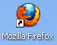
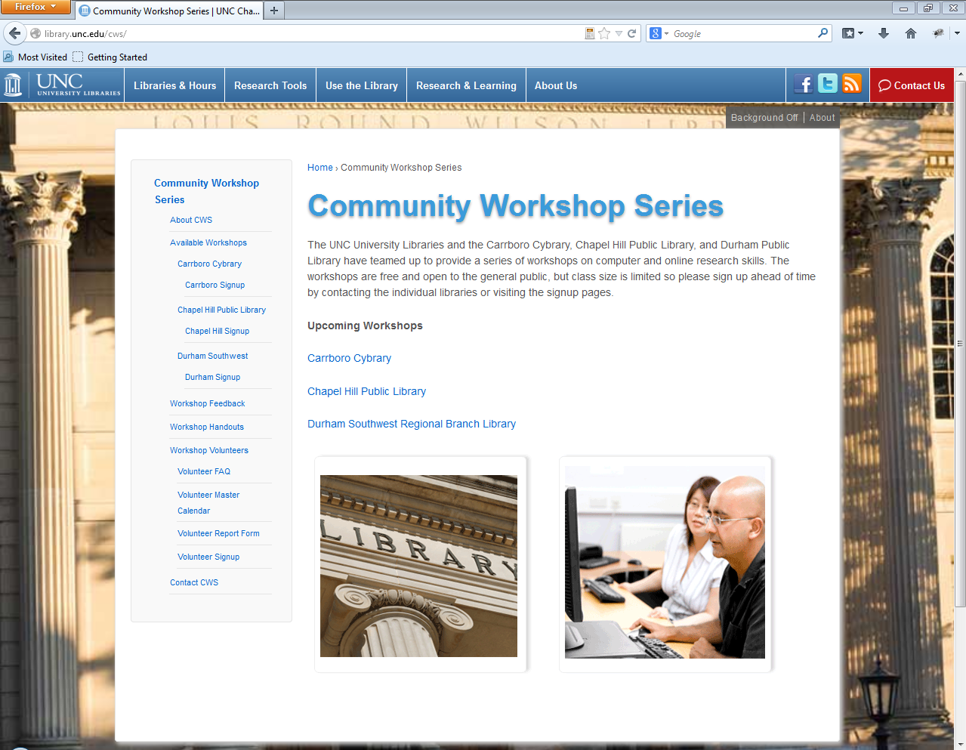
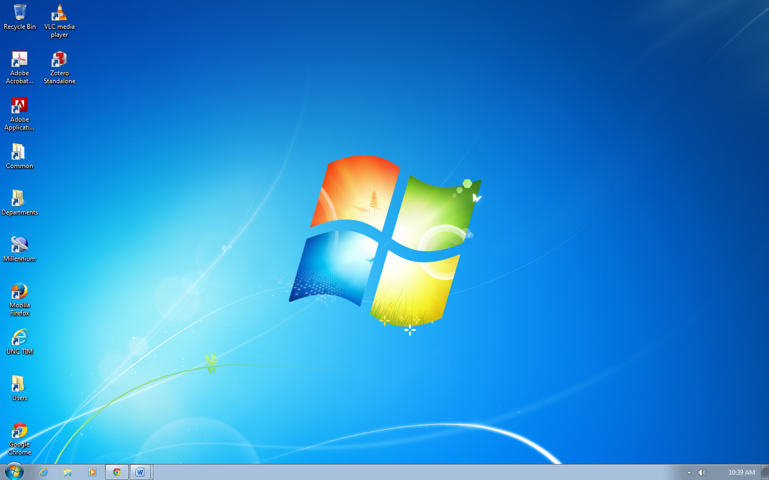

Using the Browser’s Menu Options

Typical Menu Bars are not usually included in updated browsers. They now have menu options that can be accessed via icons on the right side of your screen, just below the X.

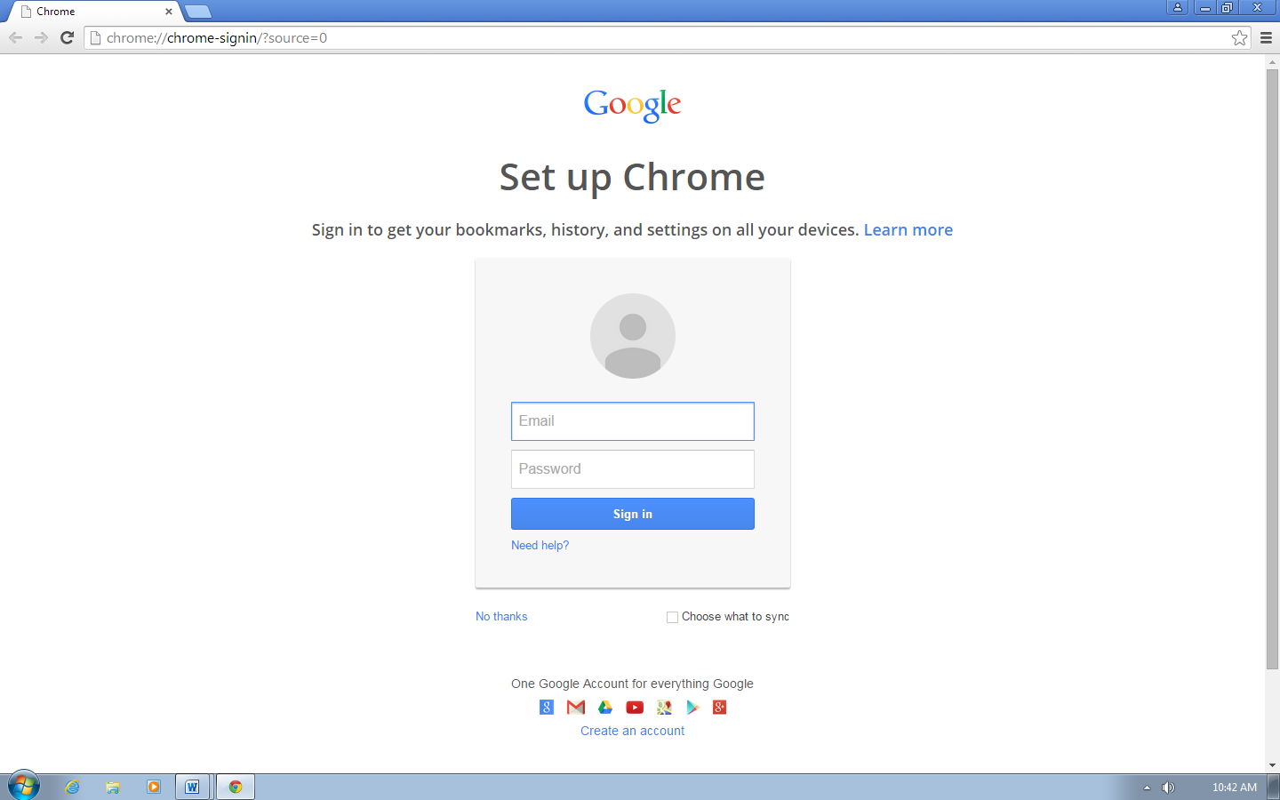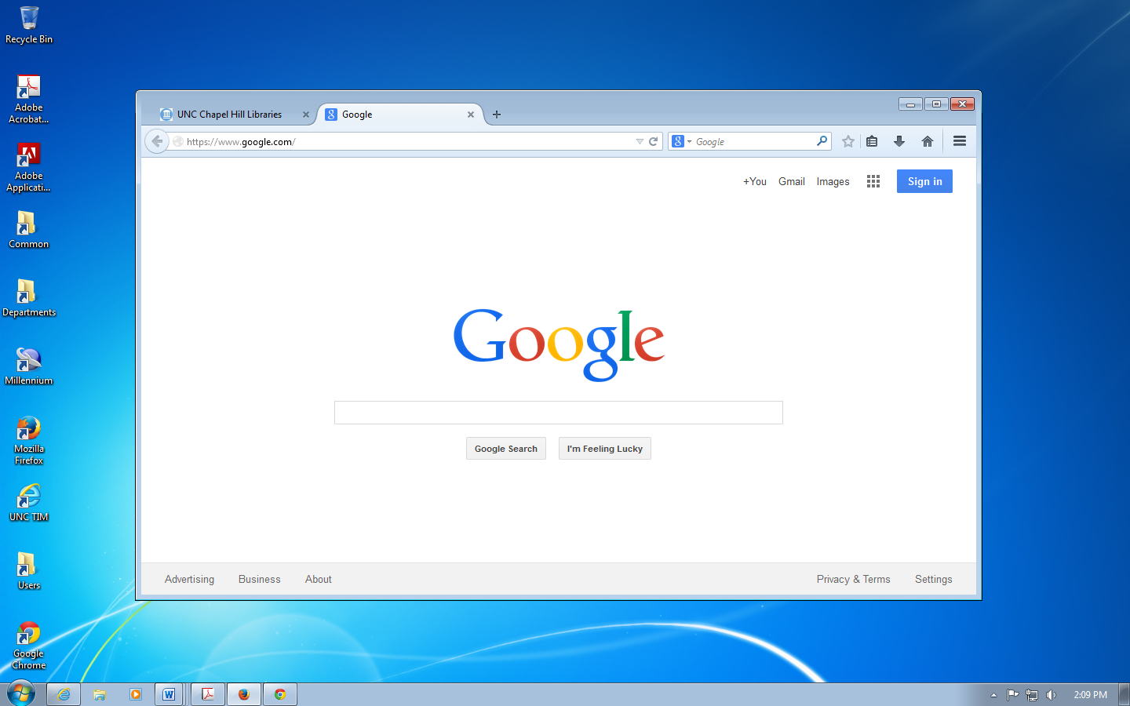

The picture on the left is of the Google Chrome menu icons. To access menu options, click on the icon with three horizontal lines. The picture on the right is of the Firefox menu icons. To access its menu options, click on the three horizontal lines icon, i.e., “Open Menu.” To select one, point with your mouse and left-click once.

Each menu item contains many options. Here’s a brief overview of the things you can do with each menu item:
Print: Use this option to print your current web page.
File: Here you can change your browser to and from Full Screen, Save, Find a word or phrase in a web page, and view suggested sites.
Zoom: Zoom in or out to more easily view pages in your web browser.
View: You can change the display of your browser here, including text size.
Safety: Here you can manage your browsing history and activate filters for browsing.
Favorites or Bookmarks: This is a place to store and access your favorite and most used websites. Access these options by clicking on the star icon.
Options: These are more advanced settings for your web browser; most likely you will never need to use these options.
Help (or ? icon): If you need more help with the browser, try this menu item.

Using the Brower’s Navigation Bar

The Navigation Bar is located directly above or below the Menu Bar and contains buttons that provide shortcuts to frequently used navigation and menu options, such as forward, back, stop, refresh, and home.

The following is a description of the most frequently used Navigation bar buttons:
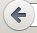

The Back button takes you back to the previous web page that you viewed.


The Forward button takes you forward to the web page that you viewed before you clicked “Back.”

The Refresh button will reload the web page that you are currently viewing. Web pages (especially news sites) will change throughout the day, so it is important to refresh them periodically to see the most recent changes.


The Stop button will stop a web page from loading. If a page is taking a particularly long time to load, you can try clicking Stop, then Refresh. Sometimes the Stop button will only show up if a page is loading and will replace the Refresh button in the navigation bar.

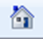
The Home button will take you to the webpage that opened when you first opened your browser window. If you are at a library, this is most likely the library’s home page. It is possible to change your web browser’s settings to open a different Home site. In Google Chrome, you will need to sign into your Google account (you have one if you have a Gmail address) in order to view your bookmarks and Home page. (See image below). You can do this on any computer, just make sure you sign out of your Google account before you leave!
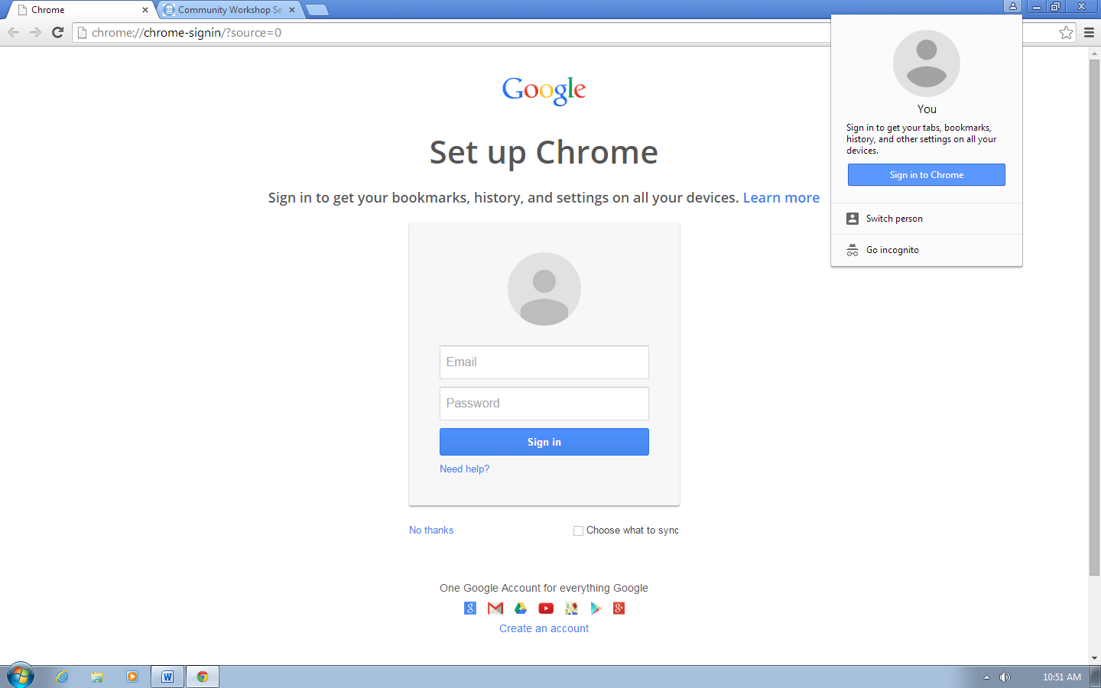

The address bar is a long, white box where you will type the address of the site you wish to go to. We will learn more about web addresses and the address bar in a little bit.

Using Tabs

Tabs work just like tabbed dividers in a filing cabinet or a binder—they allow you to organize different pages while keeping them all accessible. You can open a new tab by going to File→New Tab, OR by clicking the small button with the plus sign (+) to the right of the last tab, OR by holding down the control (CTRL) key and typing the letter ‘T.’

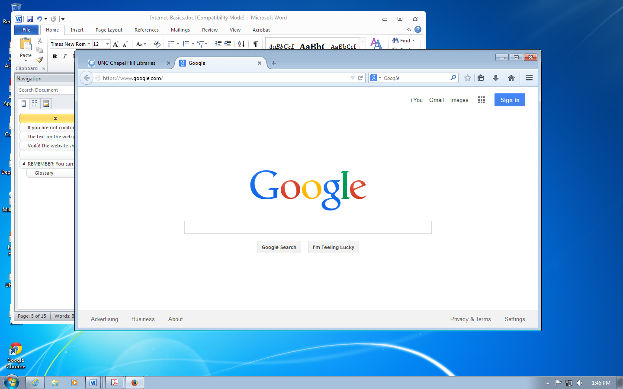

Tab 1 Tab 2 (active) New Tab

The benefit of using tabs, instead of new windows, is that you can view multiple tabs within one window, and can switch between tabs very quickly by simply clicking on the tabs. In the example above, if I wanted to view the Google page, I would simply click the tab that says “Google.” To switch back to the UNC page, I would click the tab that says “UNC.” It is possible to have multiple windows open, and for each window to have more than one tab open.

Using the Browser’s Help Feature

As with many other programs, web browsers have Help features that you can use if you ever need a hand. The help feature can be found in the browser’s menu options. To easily access Help options in Google Chrome, click the F1 key on your keyboard, or select the Help option in the horizontal lines menu.
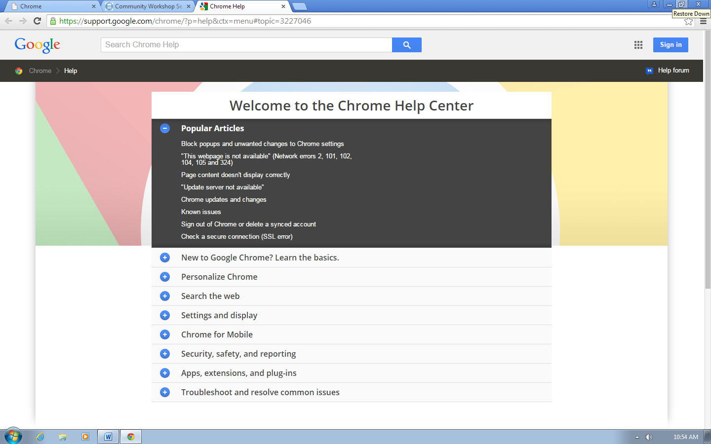

In Firefox, you can access Help options by following these steps:

1. Left Click once on the icon that is three horizontal lines at the top right of your screen.

2. Slide the mouse down to the Question Mark (?) icon at the bottom of those menu options.

4. The icon will turn blue (meaning it is highlighted and ready to be selected).

5. Click once with the left mouse button to open specific help options.

*It is important to note that all web browsers are not the same. Like different televisions that all display the same channels, all web browsers take you to the same Internet, but can be designed differently. The “Help” feature on many web browsers may not be found the way it is shown here, but there is very often a “Help” menu option, or a “Help” button at the top of the browser window.

Feel free to explore the help features. You can even search for a particular item if it does not appear to be in the index. In fact, you can also search the Internet for help on a variety of topics using a search engine—your instructor can tell you how to do this!

Changing Text Size

If you are not comfortable with the text size on a web page, you can zoom in or out according to your preferences. (Most browsers are defaulted to a 100% zoom – zooming in (+) makes things larger, and zooming out (-) makes them smaller).

In Google Chrome:
- Left-Click once on the horizontal lines icon to open the menu options.
- Move your mouse down to the “Zoom” option.
- You can click on the + or – icons that surround the number in order to zoom in or out.

In Firefox:
- Left-Click once on the three horizontal lines icon to open the menu options.
- You will see at the top of the options that there is a 100% surrounded by a minus icon on the left and a plus icon on the right.

- Left-click once on either the minus or the plus to zoom out or in – you can click more than once on either icon to continue to zoom out or in.

The appearance on the web page that you are currently looking at should change according to what you have chosen. This tool can be very useful, considering that web pages come in all shapes and sizes—it essentially magnifies or “zooms in” on the text so that it becomes easier to read!

Website Addresses/URLs

Go to a Specific Web Address

Going to a Specific Web Address

Every day, you are probably bombarded with web addresses. Web addresses are also called URLs, which stands for Universal Resource Locator. On the radio, on television commercials, in the newspaper and magazines: “Visit us online at www.businessname.com!” Almost every business and organization has a website now. You can recognize websites because they will almost all start with “www” or “http” and end with “.com” “.org” “.edu” or “.gov” (these endings are called “extensions”). Recently, new specialized extensions were made available such as “.bike” and “.technology” and “.photography”.

Here is an example of a typical web address: www.google.com

You would type this into your address bar to access Google’s website.

Let’s take a look at the anatomy of a web address:

http://www.nytimes.com/world

Now that you know what a web site address looks like, you can go to a specific site by typing it in the browser's address bar, which is located just below the toolbar. Other popular websites include www.amazon.com, www.wikipedia.org, and www.youtube.com.

Here’s another look at the address bar:

To go to a specific website, you’ll need to:

- Left-click once inside the white part of the address bar. This will highlight the address already in the bar. You can also click and drag your mouse from left to right to highlight the text.
- Press Delete or Backspace to empty the address bar.
- Type the new address into the address bar (e.g. www.wikipedia.org).
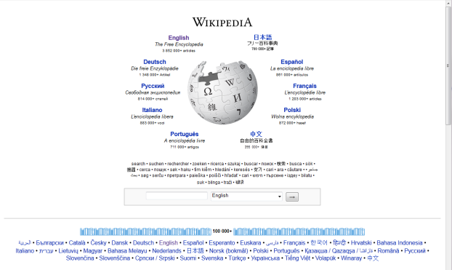
- Press Enter on the keyboard.

Voilà! The website should then appear on your screen:

Following Links on a Web Page

A link (also called a hyperlink) is an underlined word or phrase or an image on a web page that links to either another place on the same page, or to an entirely different web page.

You can tell that you are on a link when you slide the mouse over text or an image and your mouse pointer becomes a hand with a pointing finger.

Go ahead and type a topic into the search box on the Wikipedia site (for example, search for “North Carolina”), and then press Enter on your keyboard.

Run your mouse over the Wikipedia page that comes up. You'll notice that as you hover your mouse over any of the blue words, the words become underlined, your mouse arrow changes to a pointing hand, and (if you allow it to hover for a few seconds) a small description will appear below the link. This should also happen if you hover over any of the images on the page.

Let's follow a link! Try clicking one of the blue words that appears on the Wikipedia page that you are looking at—your instructor can assist you if you need help.

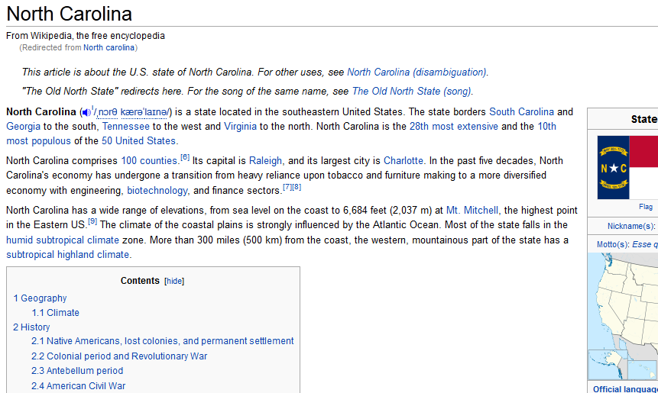

Here is how to do it:

1. Slide the mouse down to a word that is blue, or an image that causes your mouse pointer to turn into a hand.

2. When the pointer turns into a hand, click once with the left mouse button.

You should now see a new page with text and other links. You can go back to the previous page by clicking on the “Back” button on the browser’s toolbar.

Practice going to different links! Remember that you can use the “Back” button to go back to the previous page or use the “Forward” button to return to the page you were looking at before you clicked “Back.”
Using Search Engines

Finding Information with a Search Engine

To find information on the web, you will need to use a search engine. A search engine goes out and finds information for you on the World Wide Web. There are many search engines out available to use.

Google is currently the most popular search engine, but there are many others, such as
Yahoo.com, Bing.com, and Ask.com. Today, we’ll practice using Google.

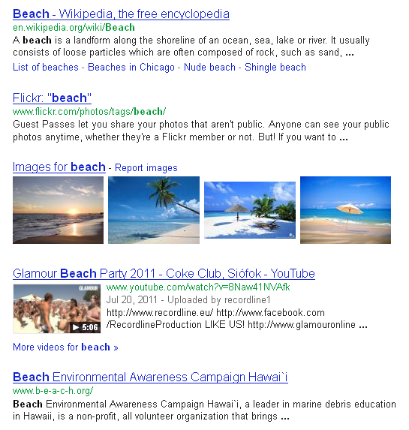
Type the web address www.google.com into the address bar at the top of your screen. Then hit Enter on your keyboard.
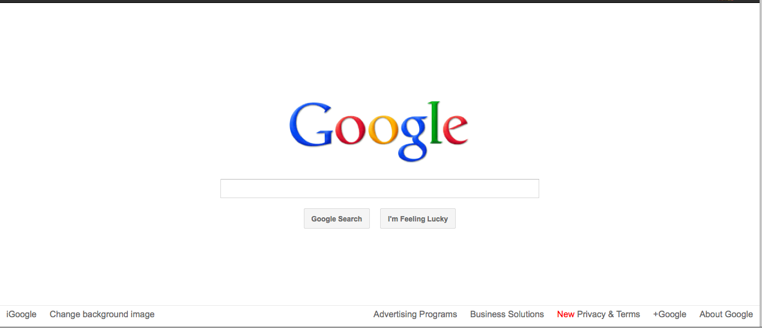
This should bring up the Google homepage on your screen. A blinking cursor will appear in the text box to let you know you can start typing something.

Type a word or a phrase that describes the information that you are looking for (the fewer words, the better—no need to use complete sentences!).

For example, type the word “beach” into your search box to see what Google finds.

Refining Your Search

Try the following steps to narrow down your search:

- If you get too many "hits" (listed websites), try adding extra words that describe what you want—if that gives more instead of fewer results, put “and” between each word. For example, “beach and vacation” will find only pages where both of those words are included.
- Put phrases in quotation marks, e.g. “North Carolina governors,” “Al Pacino,” or “Orange County Main Library.” This will find only those pages that contain these exact phrases.
Understanding Error Messages

Sometimes you will type a website address but an error page comes up instead of the website. This happens from time to time. The most common cause for this is that you have typed the web address incorrectly. You can also sometimes get an error message when you click on a link on a web page. This often means that either the link is “broken,” or the page no longer exists. An error page can mean a variety of things, including any of the following:

- The website is temporarily down
- The website does not exist anymore
- The link you clicked is broken (it was created incorrectly)
- Your browser can’t open the site because of some restrictions
- Too many people are trying to access the site at once

There may be nothing you can do to rectify the situation. In this case, you might just have to move on and go to another website or choose another link. In this day and age, major websites usually never stay down for a long period of time. It is the equivalent of a major television network going down—many, many people are working very hard to bring it back up as soon as possible!
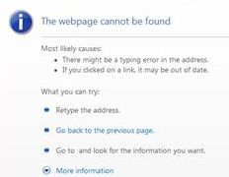

Navigating the Web

Identifying Advertisements

It is common to find advertisements on websites. Many of these advertisements are just trying to sell you things, but some of them are traps. They get you to enter your personal information and tell you that this is for a chance to win money or prizes, but most of the time it’s just to get your email address so they can send you junk mail. In extreme cases, malicious websites may try to steal personal information such as your social security number or your credit card number to steal money from you or even your identity.

Some other advertisements will pop up and tell you that you need to “Click Here” because you have a virus and you need to clean up your computer or something similar. Again, these are just ways that a company tries to access your personal information or sell you something.

REMEMBER: You can always ignore advertisements, just like you can change the television channel at home. You are not forced to do anything on the Internet!

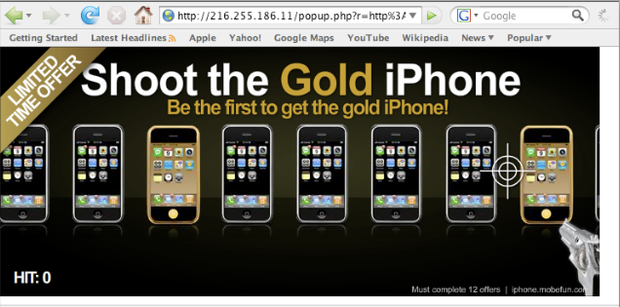

Viruses and Personal Safety

For your own safety, NEVER give out your personal information over the web to unsolicited advertisements or unknown websites. These are most likely not secure. If you are applying for or buying something from a legitimate organization or company, it will be done on a secure site.

A secure site will display a little padlock somewhere in the browser:

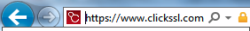

In addition, the web address should begin with https://. The extra ‘s’ in the web address means that the site is secure. It is a good idea only to make purchases from well-known, well-regarded sites, like www.amazon.com or www.target.com. You should also try to read companies’ privacy policies before making a purchase.

Viruses are malicious programs that are loaded onto your computer without your knowledge. They can destroy or delete everything on your hard drive, such as your files and folders, or extract personal information. Your computer can become infected when you download pictures and files from the web or email messages, so avoid downloading files from the Internet unless you are sure it is safe. If you receive an e-mail from a friend with an attachment, especially if it seems strange, verify that they intended to send you the attachment before you open it.

Your home computer should be protected against viruses. You can equip it with virus protection software that stops viruses from attacking the computer’s hard drive and your files. When you try to download something from the web, the virus protection software will scan the downloaded file or image to make sure that it does not contain any viruses.

If you have any additional questions about navigating the web, using a web browser, or using a search engine, please feel free to ask your instructor!

GLOSSARY

Internet vocabulary to know:

- Internet
- URL/Web Address
- Browser
- Menu Bar
- Navigation Bar
- Tabs
- Address Bar
- Search Engine
- Error Message
- Viruses

NOTE: Images and screen captures may differ from those seen on another system.

This work is licensed under a Creative Commons Attribution-NonCommercial 4.0 International License.

