

GOOGLE APPS

GETTING STARTED Page 02
Prerequisites
What You Will Learn

INTRODUCTION Page 03
What is Google?

SETTING UP AN ACCOUNT Page 03
Gmail

DRIVE Page 07
Uploading Files to Google Drive
Sharing/Unsharing Files with Google Drive
Creating Google Drive Files

CONTACTS Page 12

CALENDAR Page 13
Creating Events
Inviting Friends to Events

YOUTUBE Page 16

LOGGING OUT OF YOUR ACCOUNT Page 18

To view our full schedule, handouts, and additional tutorials, visit our website:
cws.web.unc.edu

Last updated January 2016

WHAT YOU WILL LEARN

Prerequisites:

It is assumed for this class that the user is comfortable with basic computer operations. In addition, very basic Internet experience and very basic Gmail experience is recommended.

- This workshop is intended for new Google Apps users. We will not be discussing Gmail in depth – to learn more about Gmail (email), please take the workshop on that topic or visit http://library.unc.edu/wp-content/uploads/2015/12/Email_Basics_Gmail.pdf
- We will be using PC desktop computers running Microsoft Windows Operating System in addition to Google services.
- Please let the instructor know if you have any questions or concerns prior to starting class.
- If you have a Gmail account, you will use the same account to access Google Apps. In fact, Gmail is a Google App!
- For verification purposes, you may need access to a cell phone that accepts text messages or an alternate email address before your account is activated. Please let the instructor know if you do not have this.

What You Will Learn

Understand the pros and cons of e-mail use | Create and access a Google account | Create events and reminders in Google Calendar
Search for videos in Youtube | Subscribe to channels in Youtube | Upload and create documents in Google Drive
 | Organize your documents using Google Drive

INTRODUCTION

What is Google?
According to Wikipedia, Google is “an American multinational technology company specializing in Internet-related services and products. These include online advertising technologies, search, cloud computing, and software.” Google was founded in 1998 in California and has grown into one of the world’s largest technology companies.

When most people think of Google, they think of a search engine – a website where you can type in a topic like “dogs” and get all sorts of information about that topic. And in a way, that’s correct. Google became famous because of their powerful search engine feature.

But Google does much more than that today. As we’ll learn, Google has “apps,” or “applications,” that go along with it. These are free services for those who create Google accounts. There are many of these apps, but we’ll be learning about the following:
- Gmail
- Google Calendar
- Google Drive
- Google Maps
- YouTube

SETTING UP AN ACCOUNT

You don’t need an account to use Google’s search engine, google.com. You also do not need an account to view videos on YouTube (youtube.com) or to get directions using Google Maps (maps.google.com). But if you want to access some of Google’s other popular features, including Drive, Calendar, and Gmail, you do need an account. There’s great news – once you have an account, it’s what you’ll use for all of your Google-related needs! You will only need one username and one password to access the whole world of Google!

Gmail
Many people set up Google accounts because they want to use Gmail, Google’s email service. Even if you don’t want to use Gmail, using this process to set up your account is a good way to start using other Google services! Think of Gmail as an optional bonus. It’s completely free to set up your account, and you can use it or not as you see fit!
Please note that this process requires access to a cell phone! If you do not have a cell phone with you, the instructor will give you an account to practice with.


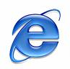
1. Connect to the Internet by double-clicking the Internet Explorer or Firefox desktop icon.

2. Go to the Gmail site by typing gmail.com into the address bar at the top of the screen, and press the Enter key on your keyboard.

3. Depending on what browser you are using and whether or not it has been updated recently, you should see a screen that looks something like this:

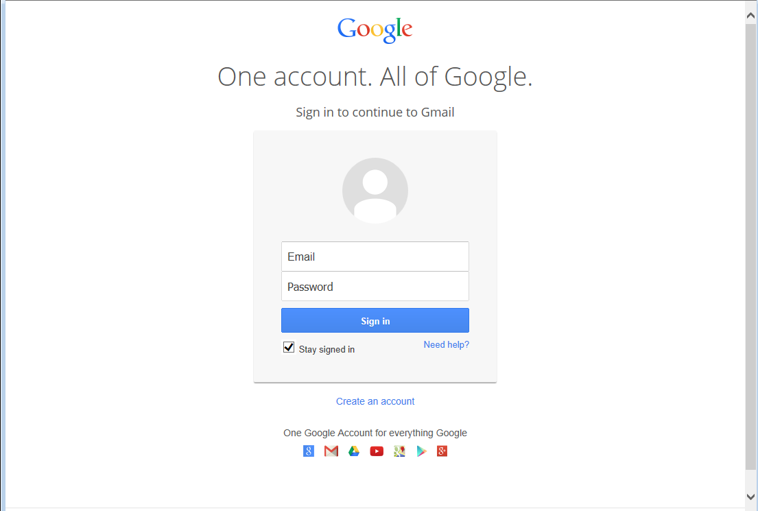

Click on the Create an Account link. Make sure “Stay Signed in” is UNchecked whenever you log in if you are using a public or shared computer!

4. Complete all required information in the form.

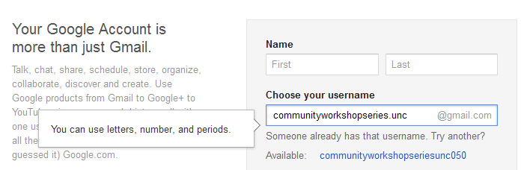

Desired Username: Keep in mind that your Gmail Username will become your e-mail address so choose carefully! Because there are so many people who use Gmail, sometimes you might have to try a few before finding one that is available. When you type in your selection, if this username is already in use it will suggest some alternative usernames that are available which will be displayed below the username box. Common e-mail addresses are: firstname.lastname OR firstinitial.lastname. People often choose to use their name if they will be using this e-mail address for professional purposes.

Tip: Your Username/e-mail address doesn't have to be your given name. With e-mail, you can, for example, choose something that is related to your occupation or interests. For example, you might want to be bluebird@gmail.com. If you find that name is already taken, you could always add some numbers after it to make it more unique. If you were born in 1960, you could be bluebird1960@gmail.com. Don’t use the same words/numbers you plan to use in your password though!

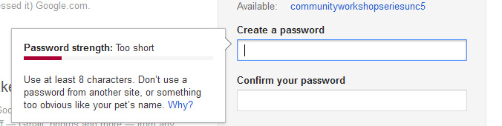

Password: You will also need to select your password. Make sure your password is something that you can remember, but no one else can easily figure out! Don’t ever share your password with anyone else. Follow the guidelines provided for the required number of characters. To protect your password, it's a good idea to change it periodically.

Here are tips from Google regarding passwords (https://www.google.com/accounts/PasswordHelp):
Tips for creating a secure password:
- Include punctuation marks and/or numbers.
- Mix capital and lowercase letters.
- Include similar looking substitutions, such as the number zero for the letter 'O' or '$' for the letter 'S'.
- Create a unique acronym.
- Include phonetic replacements, such as 'Luv2Laf' for 'Love to Laugh'.

Things to avoid:
- Don't use a password that is listed as an example of how to pick a good password.
- Don't use a password that contains personal information (name, birth date, etc.)
- Don't use words or acronyms that can be found in a dictionary.
- Don't use keyboard patterns (asdf) or sequential numbers (1234).
- Don't make your password all numbers, uppercase letters or lowercase letters.
- Don't use repeating characters (aa11).
Tips for keeping your password secure:
- Never tell your password to anyone (this includes significant others, roommates, parrots).
- Avoid writing your password down (unless you have problems remembering, then keep it in a safe place!).
- Never send your password by e-mail.
- Periodically change your password (e.g., every six months).
- Do not save your password in your internet browser (your browser will likely ask if you wish to save the password) – other people who use your computer will be able to log in as you!
For now, write down your Google Username and password. This is crucial because you will NOT be able to access your e-mail without them, but keep this piece of paper in a safe place!

Google Username: ______________________________

Password: ______________________________

Verification
5. After you’ve entered your Birthday and Gender it will ask for a Mobile Phone Number and Your Current E-mail Address. If you do not have a Mobile Phone Number with you that can accept either a text message or voicemail, ask the instructor for an e-mail address to use. This number or e-mail address will ONLY be used to verify that you are not a spammer.

6. Now type the code into the box as you see it on your screen. These codes can be hard to read, if you are having trouble with some of the characters you can choose to listen to them read aloud.

7. Finally, you have to agree to the Terms of Service. Read through the text, and then click "I Agree."

If you do not wish to use Google+ uncheck the second box (let the instructor know if you have questions about this).

Congratulations – You now have an e-mail account! Remember that your e-mail address is your Google Username directly followed by "@gmail.com."

Before you are directed to your e-mail inbox, Google will ask you if you would like to set up a Profile picture, this is an optional step and you may choose to skip it and continue to Gmail.

GOOGLE DRIVE

Google Drive allows users to store a variety of files. It gives users the opportunity to share files with certain email addresses, publicly, or anyone that has the link to the file (for example, if you email a link to your friends). It provides 15 gigabytes of storage for free and if you have a Gmail address, you already have access to Google Drive. Google Drive also allows users to collaborate and make changes to files at the same time. This can be helpful for teams and groups.

Open an internet browser and navigate to drive.google.com

If you do not have a Google account or Gmail address, you can click ‘create an account’ to get a Google account. If you already have a Google account, enter your email address and password.

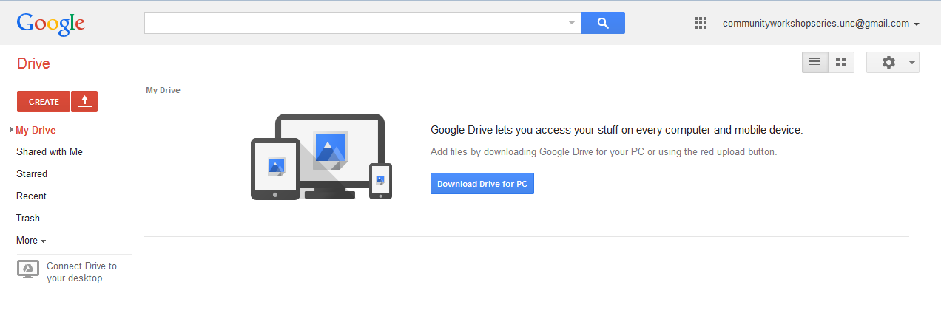
After logging in, you will see the Google Drive introductory screen. If you click ‘Download Drive for PC’, it will create a Google Drive folder on your computer that will sync to your online Google Drive account. Do not do this now if you are on a library computer!

Uploading Files to Google Drive
To upload files to Google Drive, click the red up arrow. 

When you select a file to upload, an upload window will appear at the bottom right of the screen to show the progress of the upload. Once the file is completely uploaded, it will appear on your list of files.

The amount of space you have left on Google Drive appears in the bottom left-hand corner of the screen.

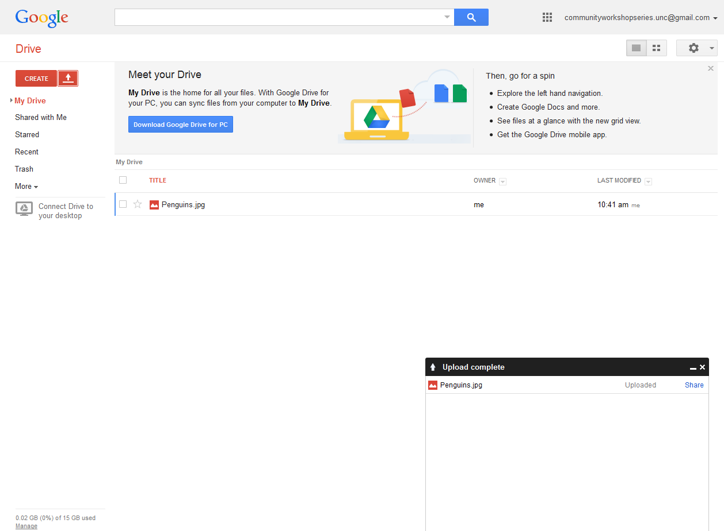

Sharing/Unsharing Files with Google Drive
To start sharing a file, select it by clicking the check box to the left of the filename. When you select a file, options appear at the top of the screen. These options allow you to share files, move files to different folers, delete files, or preview files. To work with multiple files at once, you can click on multiple boxes next to the file names.

Click on the icon that looks like a person with a plus sign next to it to share. That will open a Sharing settings window.

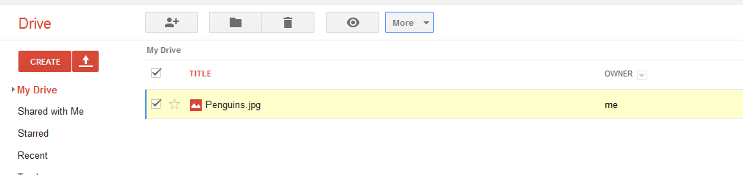

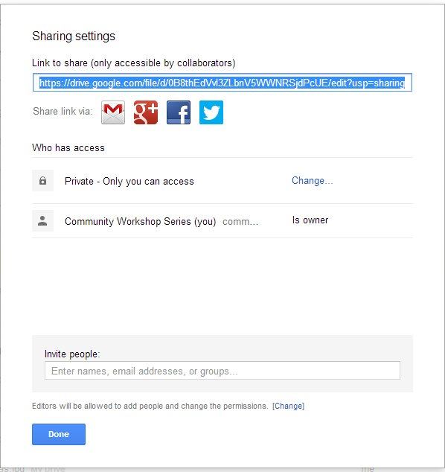
Sharing with other Google users
In the “Invite people” box, you can add multiple email addresses separated by commas. If you want to add people or groups that are in your Gmail contacts, you can simply type their name or group name. As you type, the possible names, groups, and email addresses that are in your Gmail contacts will appear and you can select them.

Once you have entered an email address, a “Send” button will appear and you can click it to send an email to people letting them know you shared a file with them. The specific people you have named will need to login using a Google account before they can view or edit the file.

Sharing with non-Google users
If you do not want people to have to sign into a Google account to view or edit the file, click the “Change” link under “Who has access.” You will get another window with some some different sharing options.
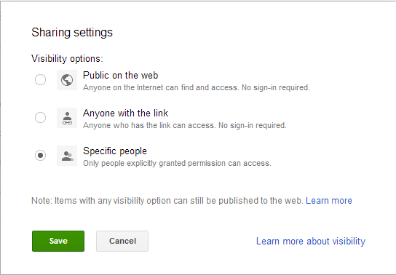

Public on the web – Only use this option if you do not mind anyone on the internet being able to access your file. The default option will be that anyone will be able to view the file, but only you will be able to edit it.

Anyone with the link – with this option, you can send the file link to certain people you want to give access to. They will not have to sign-in with a Google account to view it. However, if they send the link to other people, the other people will also be able to view the file. Think carefully before using this option!

Unsharing Files
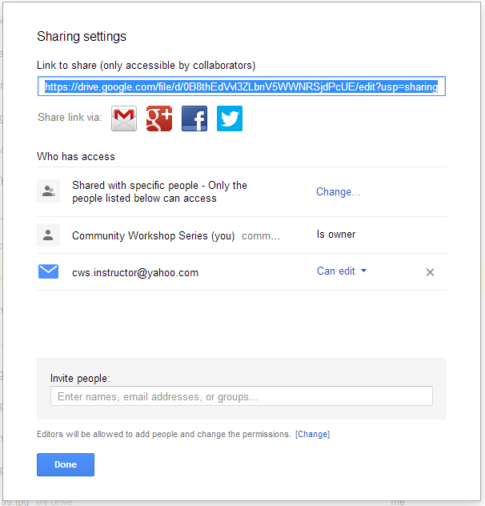
To unshare a file, go back to your list of files and select it by clicking the check box to the left of the filename. Click on the icon that looks like a person with a plus sign next to it to share. That will open a Sharing settings window.

If you have shared with specific users, the users that currently have access to the file will be listed. You will have to click the “x” next to each person’s name to unshare the file and prevent them from accessing it any further. Click the “Save Changes” button to confirm the changes in access.

If you have shared with the public or anyone with the link, you can click the “Change” link and simply select “Specific people” and save it. This will cut off the public and link access.
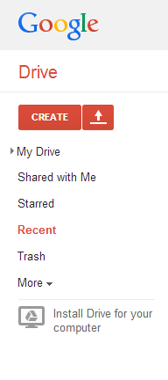
If other users have shared files with you, you can see these files by clicking Shared with Me in the left navigation pane.

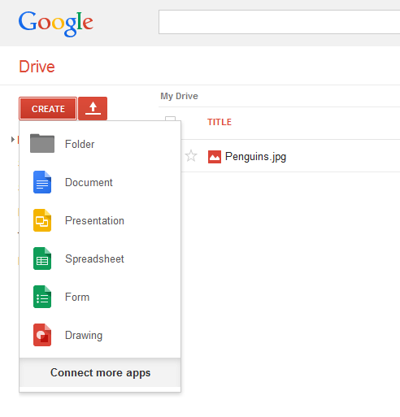

Creating Google Drive Files
One feature in Google Drive that separates it from other cloud storage services is that you can actually create files directly in Google Drive. You can create documents, presentations, spreadsheets, forms, and drawings. These files use a format that can only be read by Google Drive. This means that you can only access them when you are connected to the internet. However, once you have created these files in Google Drive, you can download the files in different formats that other programs can open.
Here is an example of how to create a Google Document and then export it to Microsoft Word.

Go to CREATE > Document. Once a document page appears, type in “This is the new document I created in Google Drive.”

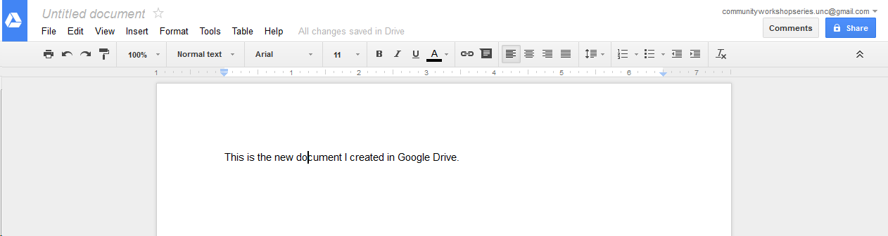

Navigate to File > Download as > Microsoft Word (.docx). This will give you the opportunity to put the file on your local machine. Once it is on your local machine, you can open it in Microsoft Word and edit it as you would edit any other Microsoft Word document.
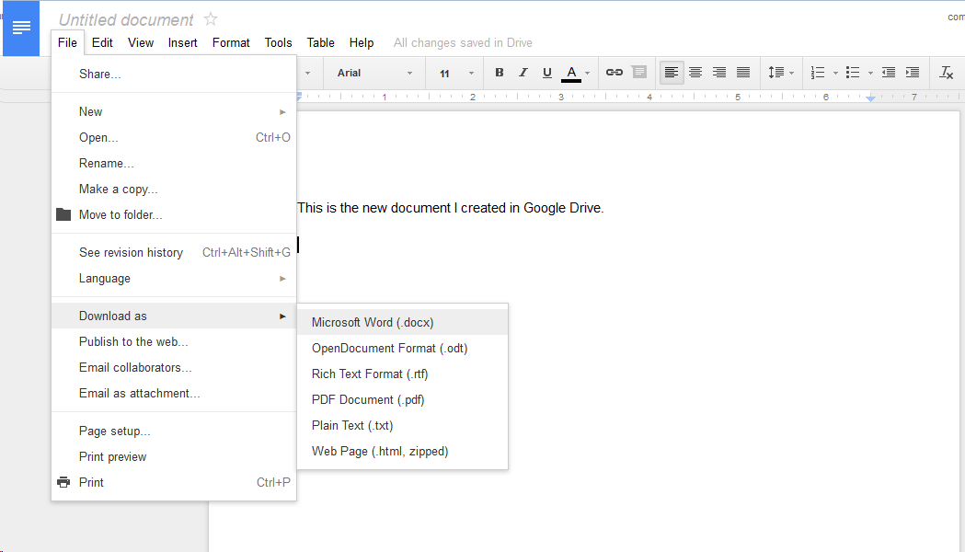
One word of caution, if you want to access files from the internet that are not in Google’s format, you will not be able to. For example, you will be able to view a Word Document online but not edit it directly. If you want to edit something like a Word Document and you are on your home computer, you can open it from the Google Drive folder on your machine and edit it from there. If you are not on your home machine, you will have to download the file, edit it offline, and then upload the new version back to your Google Drive.

Also note that you can have files with the same name in Google Drive. For example, you can have multiple documents titled “Sales” in your Google Drive. Be sure to provide descriptive file names so you can tell them apart without having to open each one!

Getting More Help
For additional help for Google Drive, click the gear icon near the top right-hand corner of your screen. Choose Help from the menu.

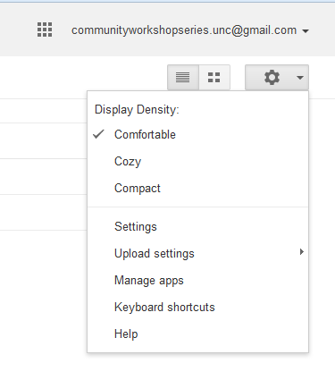

CONTACTS
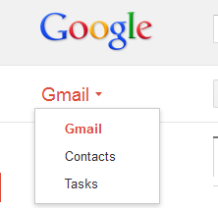
Contacts
The Contacts feature allows you to keep track of e-mail addresses, which can sometimes be hard to remember. To access your address book, click on the dropdown list under Mail, and select the Contacts link.

Adding addresses: To add an address, click on the New Contact button.
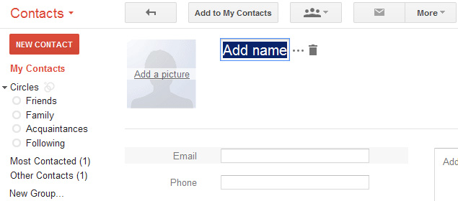
You can add as little or as much additional information about each e-mail address as you prefer. Keep in mind, however, that if you add the name of the person associated with the e-mail address, it will be easier to look up later since e-mail addresses don’t always contain the person’s name. E-mail addresses are automatically added to your Contacts list whenever you reply to an e-mail, so there’s no need to add a contact manually if you correspond with that person frequently.

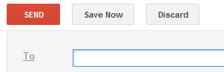
Looking up addresses: Once an e-mail address is saved in your address book, you can look it up when sending an e-mail. If you can't remember the e-mail address off hand, just click on the To link. A pop-up box with a list of all your saved contacts will appear, click on the contacts you wish to send the e-mail to (a check will appear next to the selected contacts) and click on done when all have been selected. Otherwise, just start typing the first letter or two of the person’s e-mail address or name, and Google will suggest e-mail addresses for you.

CALENDAR

Gmail also has a calendar that you can use to keep track of your schedule. To access it from Gmail, click on the grid icon at the top of the screen, and then click on Calendar. This menu can also get you to Drive, Youtube, Maps, and More.

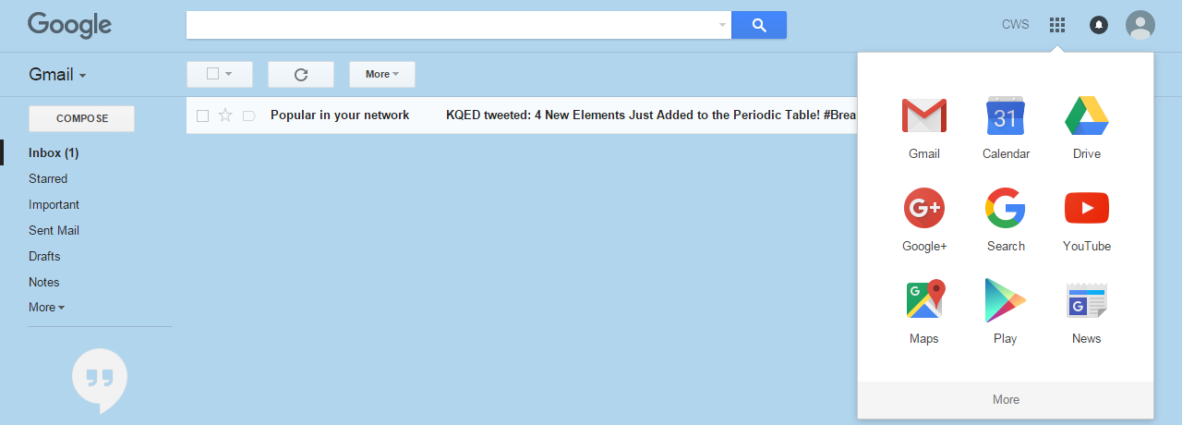

You can create multiple calendars, and can even color code them.

Creating Events
Once you’re on the calendar page, you’ll see a view of the current week. If you’ve never used the calendar before, it will look like something like this:
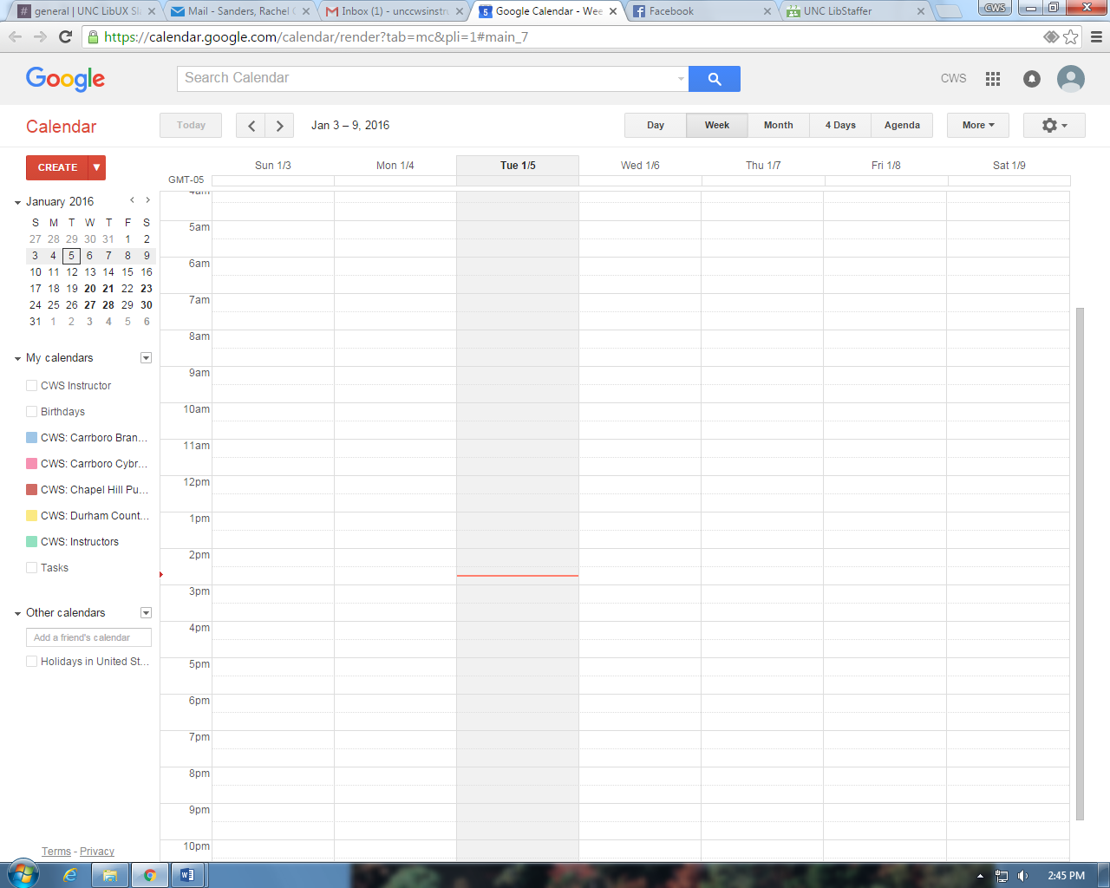

To create an event, click on “Create” on the upper left side of the page. This is what you’ll see:
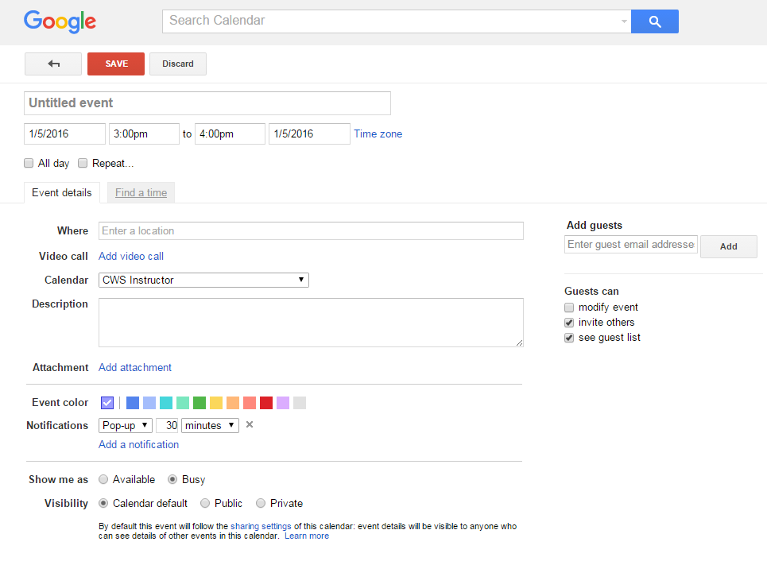
From here, you can add an event title, event location, event time, color code the event on your calendar, and add invite people via email to the event.

Inviting Friends to Events
To invite friends to events, just click on “Add” under “Add guests.” If they’re already in your contacts list/address book, just start typing their name or email address and click on it when it shows up. To add someone who you haven’t emailed before, you’ll need to type their full email address and click “Add.”

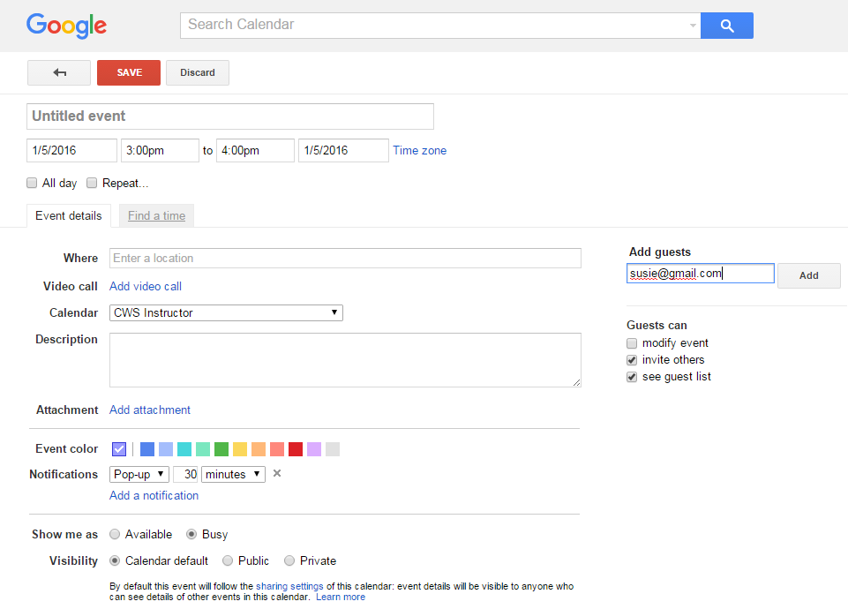

This will create a list under “Add guests” where you can see who you’ve already invited. You can also see if the person has RSVP’d yet.

YOUTUBE

YouTube is a website where you can view and upload videos. Anyone with a Google account can upload a video, and if you have a Google account, you can “like” videos and “subscribe” to users whose videos you want to see on a regular basis. To access it, just go to youtube.com. From the main page, you can enter the name of a video that you’d like to see.

If you have a Google account, your Google/Gmail/Drive/Calendar username and password are the same as your Youtube username and password since Google operates Youtube. You do not have to use your Youtube account, and you do not have to upload videos, like videos, or subscribe to channels. If you are logged in to your Google account when you go to youtube.com, Google will track what you are watching and make suggestions. To avoid this, just log out of your account.

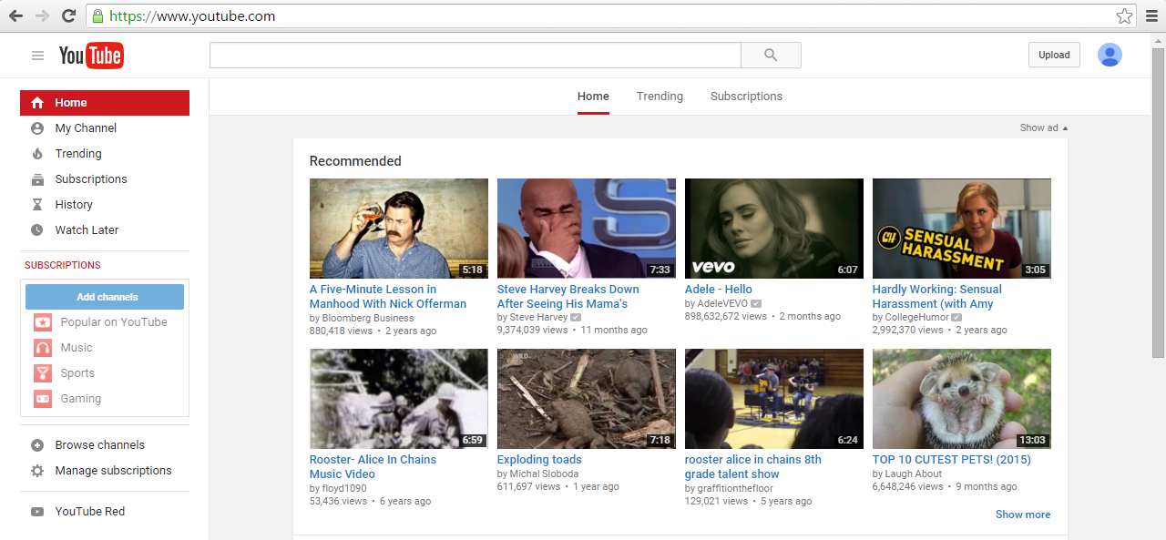

Once you’ve searched for a video, you’ll get a page of results.
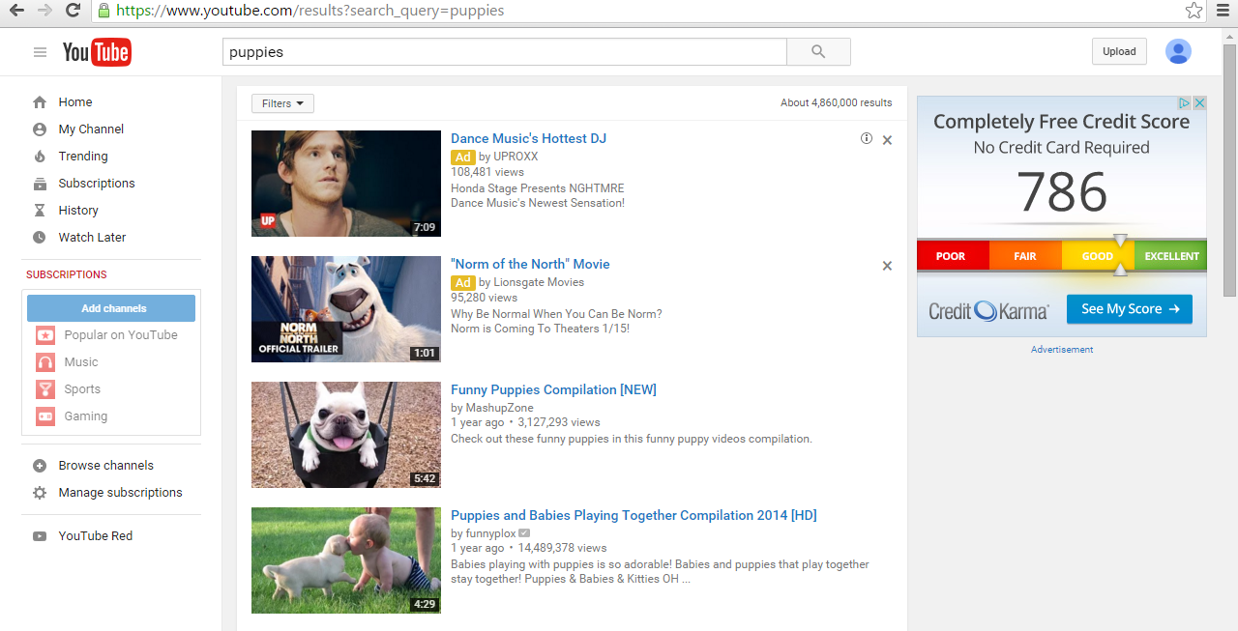

As you can see, there are lots of results available. Click on a video to start watching. You’ll notice that there is an ad on the right – avoid clicking on these, as they will take you to websites other than Youtube, and may not be secure.

When you click on a video, it will begin to play. You may see a quick ad before your video starts; just wait a few seconds and it should go away.
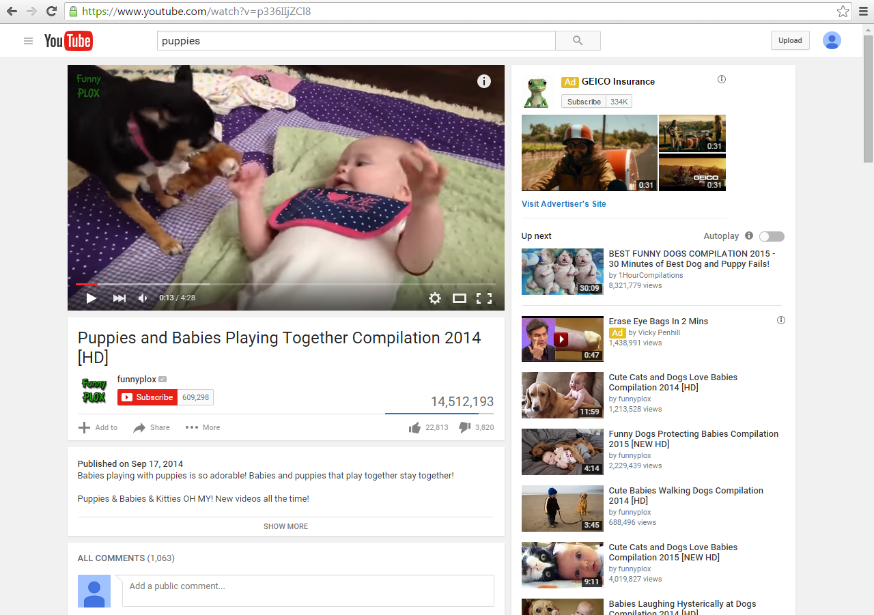
LOGGING OUT OF YOUR ACCOUNT

Since all of the services we’ve covered are controlled by Google, when you log out of one you are logging out of all of them.

To log out, click on the head icon in the upper right corner of the page, then click “Sign Out.”

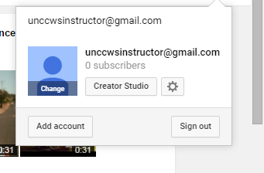

You might see a page that looks like this. You’re logged out!
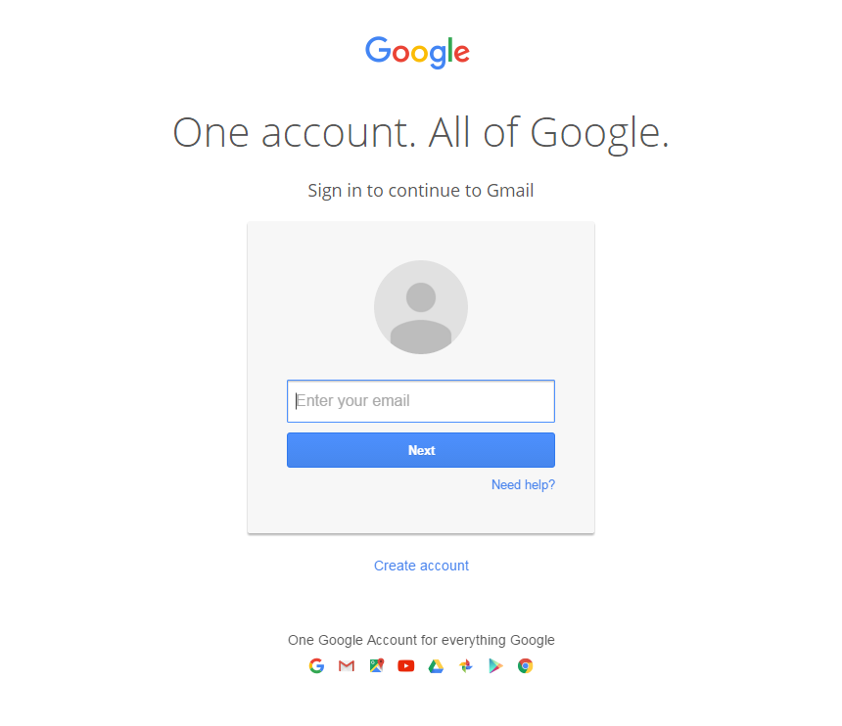
Remember to log out whenever you are using a public or shared computer to protect your privacy.
NOTE: Images and screen captures may differ from those seen on another system.

This work is licensed under a Creative Commons Attribution-NonCommercial 4.0 International License.

