FILE ORGANIZATION

GETTING STARTED PAGE 02
Prerequisites
What You Will Learn

PRINCIPLES OF FILE ORGANIZATION PAGE 03
Organization Trees
Creating Categories

FILES AND FOLDERS PAGE 05
Creating Folders
Saving Files in Folders
Moving vs. Copying
Deleting Files and Folders

DIFFERENT VIEWS PAGE 10

CREATING SHORTCUTS PAGE 10

KEEPING THINGS ORGANIZED PAGE 11

To view our full schedule, handouts, and additional tutorials, visit our website:
cws.web.unc.edu
Getting Started

Prerequisites:

It is assumed that the user is somewhat familiar and/or comfortable with the operating system Microsoft Windows, and with using the mouse and keyboard.

- This workshop is intended for new computer users.
- We will be using PC desktop computers running the Microsoft Windows XP, Vista or 7 Operating System.
- It is possible that you will not be able to complete all of these tasks on public library computers due to security restrictions. However, we will do our best to facilitate your learning with the access we do have, and will help you to develop the skills necessary to organize your files at home.

Please let the instructor know if you have questions or concerns prior to starting class.

What You Will Learn:

Principles of file organization | Drawing an  organization tree | Creating categories
Creating folders | Saving files in folders | Moving vs. copying
Deleting files and folders | Creating shortcuts | Keeping things organized

Principles of File Organization

Keeping the files on your computer organized can make working on your computer more enjoyable and finding things much easier. Just like throwing all of your personal papers into a pile in a corner of a room could make working with or even finding a particular document rather difficult, storing all of your computer’s documents on the desktop or in any one folder can make quite a mess. In this tutorial, we will be learning how to keep documents and files on your computer organized (if only it were this simple in the rest of the world!).

Organization Trees
One way to think about organization on your computer is through the use of organization trees. An organization tree is simply a way of thinking about organization in a hierarchical sense (with different levels and categories), kind of like a family tree. In this case, each of the boxes below represents a folder on your computer (we’ll discuss what this means in a moment).

Your turn! Using the blank organization tree below, brainstorm what sort of categories you might create for the files you have on your computer. Feel free to add boxes or leave boxes blank. Think about:

- What kind of files do you have (e.g., music, Word documents, photos)?
- Who will be using the computer? Would it be useful for each person to have their own folder for documents? For pictures? For music?
- For documents (text files), where/ for what purpose are they used? Home? Work? School?
- Is time involved (e.g., would it be useful to sort by year or by month)?
- What sorts of files do you use most often? It might be useful to keep these toward the top of your organization tree, since they will be easiest to access.

If you find this exercise difficult, think about how you organize your physical papers at home or at work – would the same organization style work on your computer?

Once you have your folder organization figured out, it’s time to start putting it to use! Don’t worry if you’ve forgotten some category or type of file—you can always add or remove folders later.
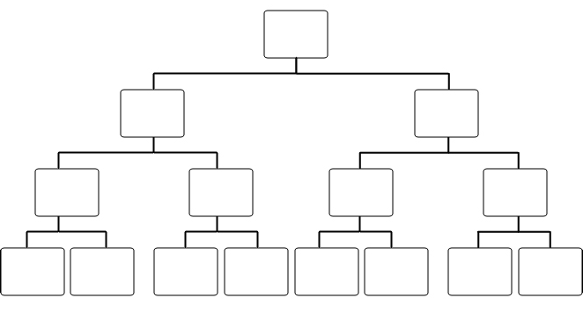
Files and Folders

Folders on a computer work just like manila folders do in real life. They’re used to organize and store individual files. Files, on the other hand, are individual Word documents, individual songs/audio files, or individual photos. File names will often end with an extension, which tells you what type of file you’re working with. For example, a Word document file name will most likely end with the extension “.doc” or “.docx,” while a photo file will most likely end with the extension “.jpg” or “.gif” to distinguish it from other types of files. Folders do not have extensions after their names.

Folder File

Extension

Folder name



My Documents

Your computer will often have folders created for you automatically. As you can see in the image at the right, this computer already has a folder for music, pictures, and videos. Your computer may have folders similar to this.

However, usually these folders are very general (high up in the organization tree), like Pictures, Music, and Videos, and you will need to create new folders if you don’t want things to get too messy.
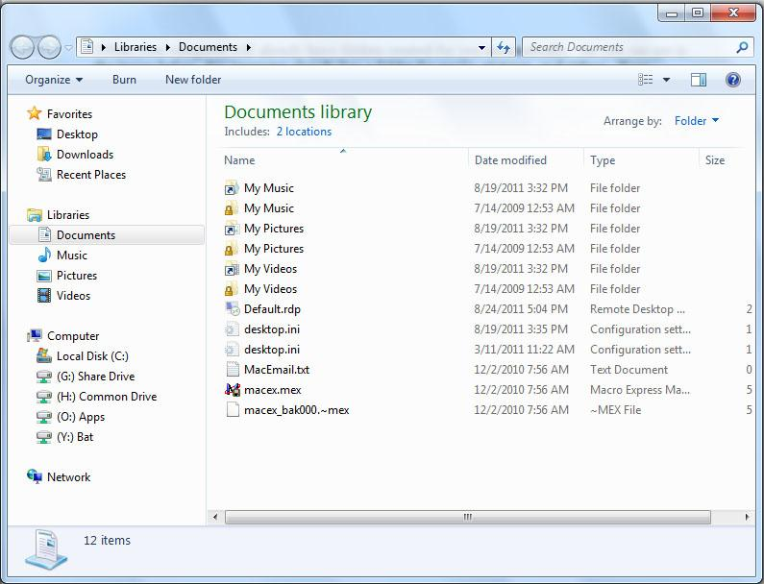
Creating Folders

To create a new folder, you will first need to open a Windows Explorer window. Click the Start button then move your mouse over to Libraries and click once with the left mouse button. This will bring up a window like the image you saw above on page 5.

Before we start creating new folders, we want to make sure we’re in the right spot! Remember the organization tree you drew? This is where it will come in handy. The top box in the organization tree was called Libraries, just like the folder we’re currently in.

One level below Libraries, you will probably see folders like those in the image on page 5, such as Documents, Music, Pictures, and Videos. Click on the Documents folder. Let’s add a folder called “Text Documents” where we can store files such as Microsoft Word documents (e.g., letters to friends, recipes, etc.).
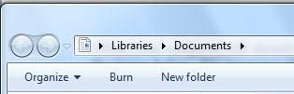
In the Documents window, left-click once on the New folder button at the top (see image to right). This will create a new folder inside the folder you’re currently viewing (so, a new folder inside Documents). To see what folder you’re currently inside, simply read the file location in the Address bar (see image below). Sometimes this will appear as one simple name (such as “Documents” in the image below), and sometimes it will appear as a path. For example, the location of the folder we just created might look like this:

Current Location

C:\ ►Libraries ► Documents ►Text_Documents

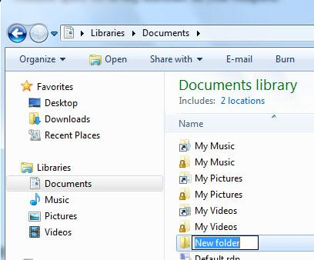
Each arrow in the path indicates a different level. You can read this just like you read the organization tree: The left side of the path is the highest point on the organization tree, while the right side is the lowest. Starting from the right side, we can see which folder we’re currently inside (in this case, “Documents”). Text Documents is inside the folder Documents. The folder Documents is inside the folder Libraries. And finally Libraries is inside the C Drive (which is represented here by a paper icon and is often written as C:\). The C Drive is the most common space for saving materials on your computer.

Once you have created the new folder, it’s important to name it. The title should automatically appear highlighted inside a text box when you first create it, and you should be able to change it by just typing. If the name of the folder is not highlighted, click once on the name, then wait a second, and click once more on the name to edit it. Refer back to your organization tree to see what folders you wanted to create below the “Documents” folder, and choose one of those folder names. For our example, we’ll name this folder “Text Documents.” To go inside the folder and see the path like we described above, simply double-click with your left mouse button. If “Text Documents” is the last word you see on the right-hand side of the path, then you are currently inside the folder “Text Documents.”

You will be able to repeat this process of creating folders inside of folders as many times as you like. However, don’t get too carried away. If you create folders inside of folders inside of folders… (you get the picture), it could become more confusing than having no folders at all. Rather, think carefully about the organization structure that works best for you, and stick to that.

Saving Files in Folders

Microsoft Office 2007
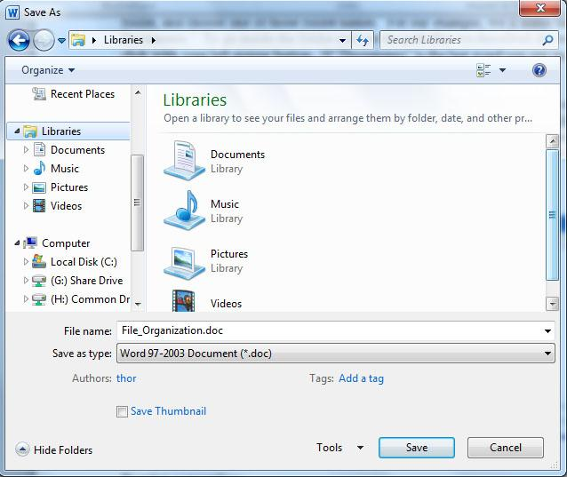
To save a file within a particular folder, go to the MS Office Button, and then click Save As. This will allow you to save the file within any folder you choose.

Within the window that appears (see image at right), you can select the Desktop, Documents or My Computer from the buttons on in the left panel to save your work in folders in any of these spaces. To save our work in the new folder we created, we would click on Documents, and then choose the folder Text Documents.

Microsoft Office 2010
To save a file, click on the File Tab and click Save As. The window to choose the folder looks the same as in Microsoft Office 2007.

Microsoft Office 2013
To save a file, click on the File Tab and click Save As. The window to choose the folder looks the same as in Microsoft Office 2007.

Naming conventions

Almost as important as where you save something, is how you save something. Saving a Word document with the name “Word Document” might work the first time, but what about when you create a second Word Document? You could save it as “Word Document 2,” but pretty soon you won’t be able to tell any documents apart. It’s important to assign names to files that are meaningful (for example, “Resume” or “ChickenPotPieRecipe”). Also, if you create many Word documents, including the date is helpful. For example, if you write many letters to your friend, Claire, you might name the files something like: LetterToClaire9_23_2012.doc so that you will be able to tell them apart. Some programs don’t recognize spaces, so saving your files without spaces or with underscores instead of spaces is a good habit to get into.

Finally, once you have your location specified and an appropriate name typed in, click Save in the bottom, right-hand corner of the Save As window.

Moving vs. Copying

To move a file from one folder to another, you can simply drag and drop the file from one window to another (or from the Desktop to the Explorer window). Your instructor can show you how this is done.

Files and folders can be moved from place to place. You can also make copies of files or folders and place the copy somewhere else. This is an important distinction to make, because if you make a copy of a folder when you intended to move it, you now have two separate, identical folders, and when you make changes to one, those changes will not be made to the other. Conversely, if you want to have a copy of a folder (for example, you want to copy a folder onto a removable flash drive or CD), if you move it by mistake, the folder will no longer exist in the original space. There is an easy way to make sure you are truly moving a file or folder instead of copying (or vice versa). Simply drag the file or folder using the right mouse button (right-click and hold down the mouse button). Release the mouse button when you have moved the file or folder to the desired location. When you release the mouse button, a small box will open with the options “Move Here” or “Copy Here.” Simply select the appropriate option.

Deleting Files and Folders

To delete a folder (or file), simply select it by clicking once with the left mouse button. Then, click the Organize button at the top of the windows explorer window and select Delete from this menu. A window will appear asking if you are sure you want to send the folder and all of its contents to the Recycle Bin. If you are sure you want to delete it, click “Yes.”

NOTE: Always check to make sure a folder is empty before deleting it. You can check to see what a folder contains by simply double-clicking the folder icon with your left mouse button.

If you have accidentally placed something in the Recycle Bin and you would like to get it back out, you can either drag it back into the correct folder or right-click on the file and choose “Restore” from the menu—that will put the file back in the exact same place you deleted it from.
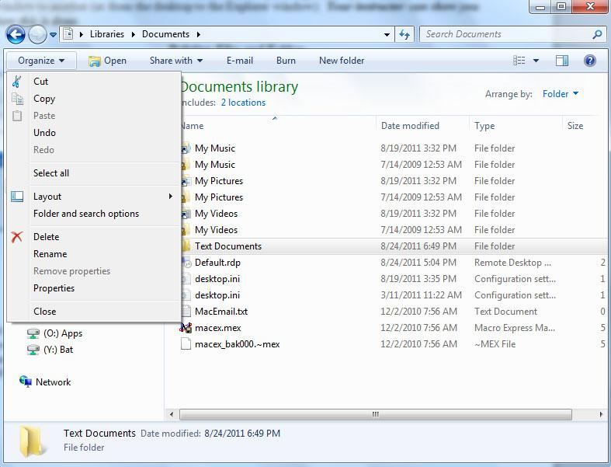
Different Views

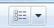
It is possible to view your folders and files in several different ways. Each person has his or her own personal preference (e.g., viewing lists vs. viewing icons), and this may change depending on the circumstance. To change the way that your files and folders are displayed, within the Windows Explorer window, click the icon that you see in the image to the right in the file menu, you will then be able to select from the following options:
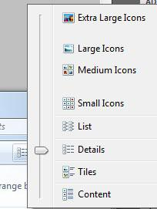

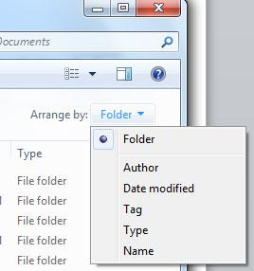

Whatever view is currently selected will have a small dot next to it. Go ahead and select all of the different options. This can be changed at any time, so don’t be afraid to play around with it and decide what works best for you. You can also change the way that your files and folders are arranged (e.g., by alphabetical order, by type of file) by clicking on the arrow next to Arrange by, and then selecting one of the available options.

Creating Shortcuts

Shortcuts on a computer (just like in real life) can make getting somewhere much quicker. In the case of your computer, creating a shortcut to a particular folder that you use often can eliminate the need to navigate through several layers of folders. To create a shortcut to a folder:

- Right-click an open area on your desktop, point to New, and then click Shortcut.
- Click the Browse button.
- Navigate to the folder to which you want to create a shortcut, click the name of the folder, click the Open button, and then click the Next button.
- Type a name for the shortcut. If a Finish button appears at the bottom of the dialog box, click it. If a Next button appears at the bottom of the dialog box, click it, click the icon you want to use for the shortcut, and then click Finish.
[Steps adapted from the Microsoft Support Web site.]

Keeping Things Organized

Now that your computer is so wonderfully organized, let’s keep it that way! Just as papers and clutter pile up around the house, files may accumulate on your desktop or in “catch-all” folders. To keep your computer organized, periodically review what’s on your desktop, move files into appropriate folders, and add and remove (especially empty) folders as necessary.

If you have any questions about creating, naming, moving, copying, organizing or deleting files or folders, please just ask your instructor—we’re happy to help!

NOTE: Images and screen captures may differ from those seen on another system.

This work is licensed under a Creative Commons Attribution-NonCommercial 4.0 International License.

