

FACEBOOK

GETTING STARTED PAGE 02
Class Overview
What You Will Learn

FACEBOOK PAGE 03
What Is Facebook? (page 3)
Creating a Profile (page 3)
Privacy (page 5)
Editing your Profile (page 9)
Finding Friends (page 10)
Updating Your Status (page 12)
Uploading and Sharing Photos (page 13)
Sharing Links (page 15)
Navigating a Timeline (page 16)
Send Messages (page 17)
Chat (page 18)
Events (page 19)
Join and Create Groups (page 21)
Organize Your News Feed (page 22)
Find Pages (page 23)

To complete feedback forms, and to view our full schedule, handouts, and additional tutorials, visit our website:
cws.web.unc.edu

Last Updated December 2015

GETTING STARTED

Class Overview

This is a class for beginning computer users. You should be familiar with the Microsoft Windows operating system and using a browser to surf the Internet.

We will be going over how to use Facebook to connect with friends and family, share your photos, and keep up with your interests. You will learn how to create a Facebook profile, add and remove friends, upload photos, share posts, follow pages, and more.

Please let the instructor know if you have questions or concerns before the class, or as we go along.

You Will Learn How To

Create and Edit a Facebook profile | Add and Remove Friends | Decode Facebook’s privacy policies
Update status and share links | Upload/share photos | Navigate a Timeline
Organize your News Feed | Join and Create Groups | Send Messages and Chat
Create Events | Follow Pages | Install Apps


FACEBOOK

What Is Facebook?

Facebook is a social networking site that allows you to create a personal profile page that can contain information about you (name, birthday, family relationships, political and religious affiliations, hobbies/interests, favorite quotes, education and work information), photos, groups you are a member of on Facebook, and spaces to post thoughts and opinions. It is a way to communicate and connect with friends and acquaintances. As of December 2015, there were more than 1 billion active users on Facebook all around the world, and it continues to grow.

Creating a Profile

In order to use Facebook, you must set up a “profile,” or an account with certain personal information. When you first visit Facebook, you will see a page like the one below. To create a profile, at the minimum, you must give your first and last name, e-mail address, gender, and birthdate. You will also need to create a password for your account.

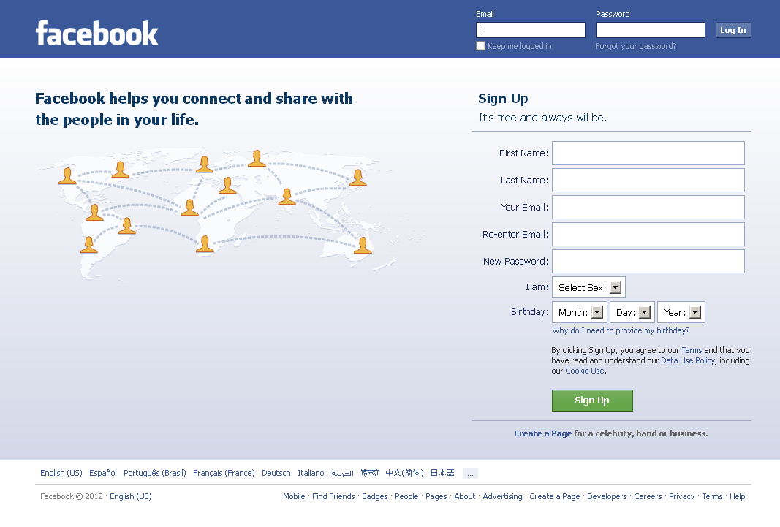

To get started on Facebook, this is all the information you need to provide. Other people will be able to see your name, but you can choose to hide the rest of your information (more on this later). Conversely, you can add as much information to your profile as you like—if you would like to share your interests in recreational goat herding, you can certainly do that.

Once you click the green “Sign Up” button, a confirmation notice will be sent to your e-mail. You will need to visit your e-mail in order to complete the sign-up process.

When you return to Facebook, you will be guided through a three-step process to build your profile. First, Facebook will ask you if you want to find your friends who are already on Facebook—it will do this by accessing your e-mail address book. We do not recommend that you do this. Providing your e-mail address and password to a third-party is a serious security and privacy breach. You do not need to feel like you need to provide this information. It is a convenient way to find your friends, but there are other ways to find friends too, which we will talk about shortly.

When you skip the step, Facebook will try one more time to get you to use this service. Again, feel free to press “Skip.”

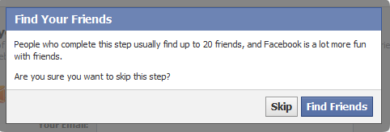

The second step asks you to fill in additional profile information—your education and employer. You can choose to add this information, or you can opt to skip it. The benefit of adding this information is that it will make it easier for old classmates and co-workers to find you.

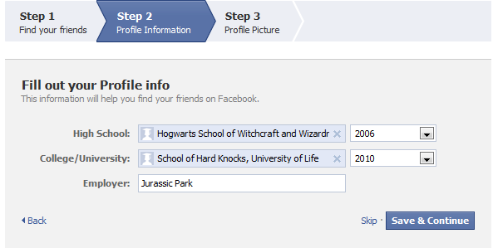

Finally, Facebook will ask you to upload a profile picture. This will make it easier for your friends to recognize that your profile belongs to the real you, especially if you have a common name. You can either upload a photo that you already have saved on your computer, or take a new photo if your computer has a webcam built in. We will talk more later about editing your profile picture and uploading photos. You can change your photo at any time, so if you get a new haircut or are simply tired of your profile picture, you can change that any time.
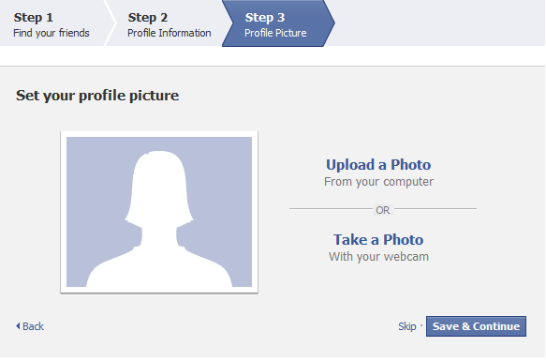

At this point, your basic profile will be set up. It will include your name, birthday, photo, and work and education information. You can add more (or take away more) later. Here’s an example of what it might look like:

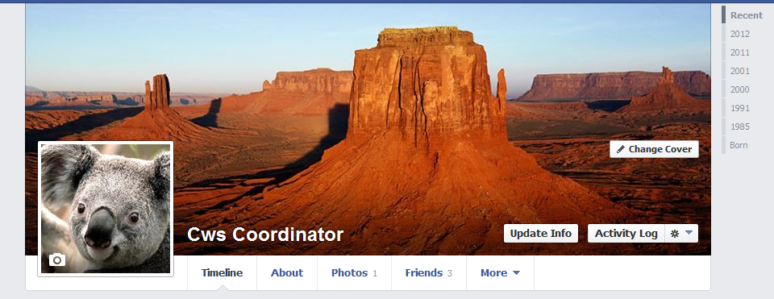

Privacy on Facebook

You can decide to share certain information (such as your photos and work history) with everyone and other more sensitive information (such as your birth date, e-mail address and phone number) with just your friends. You can adjust privacy settings for most of your information, as well as for the content you later post to Facebook. Certain basic information (your Name, Profile Picture, Current City, Gender, Networks, Friend List and Pages) is always available to everyone. In order to change your privacy settings, find the menu in the top right corner of your screen:

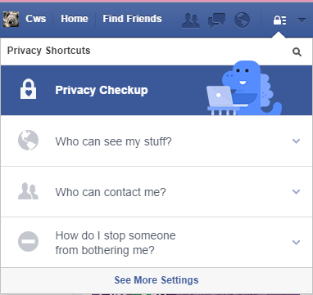
This little blue dinosaur is a new feature of Facebook. He is supposed to make the whole privacy setup process easier for you. So, you have the option of clicking on each component of the privacy settings, but if you like, you can go through the “Privacy Checkup” by clicking on that option.

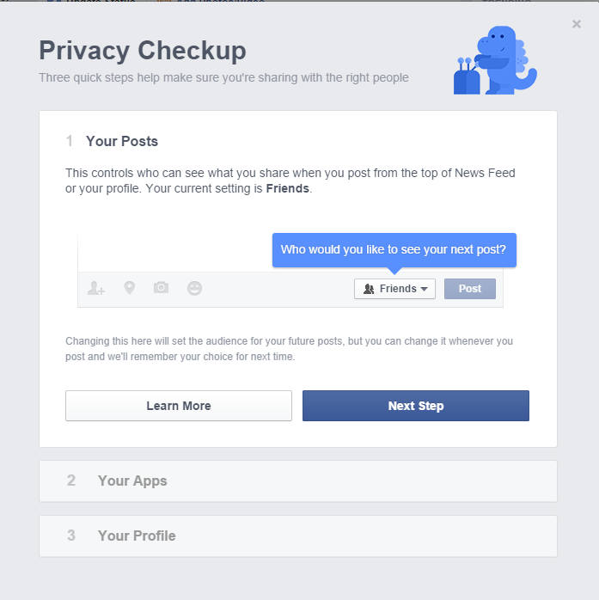

1.

The first step in your Privacy Checkup is to decide who you would like to see your posts. Your default will probably be set to “Friends,” but you can change it to different options:
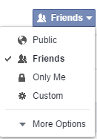

2. Once you have decided who you want to be able to see your posts, you can move on to the next step of the privacy checkup: Apps. You will be able to change who sees your posts for each App that you have installed on your Facebook account.
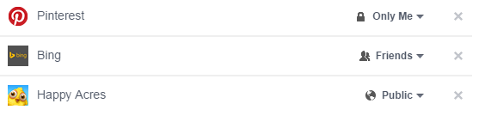
At each step of the Privacy Checkup, you can click the option to “Learn More” if you want more information about the step.

3. The last step in the Privacy Checkup involves different parts of your profile.
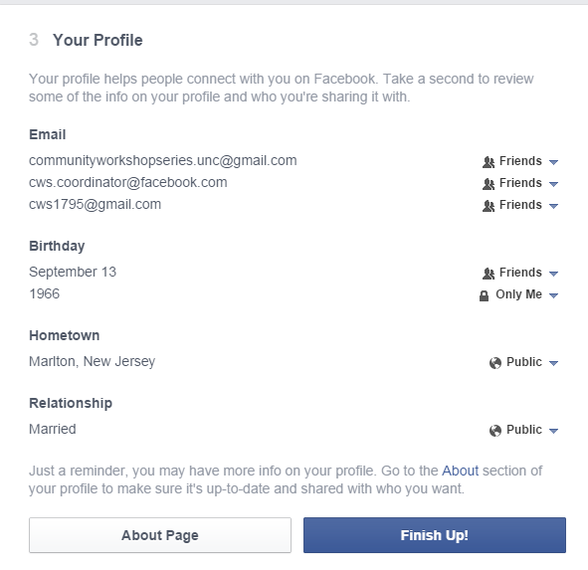

You can choose different privacy settings for each component of your profile. However, you may have more on your profile than shows up in the Privacy Checker. You should go to the “About” section of your profile to check the other components.

Facebook privacy policies change often, so one website has started a guide that is always up to date:
http://lifehacker.com/5813990/the-always-up-to-date-guide-to-managing-your-facebook-privacy

The privacy options available for sharing information are: public (everyone), friends, and only me. There is also an option to choose custom privacy settings. You can choose to let only specific people see certain things, or certain groups of people. You can organize your friends into groups (such as co-workers, classmates, family, etc.), and limit what groups you share certain things with. You can access the options in the screenshot below by clicking the “See more settings” option on the Privacy Shortcuts menu (see the first screenshot on page 6).

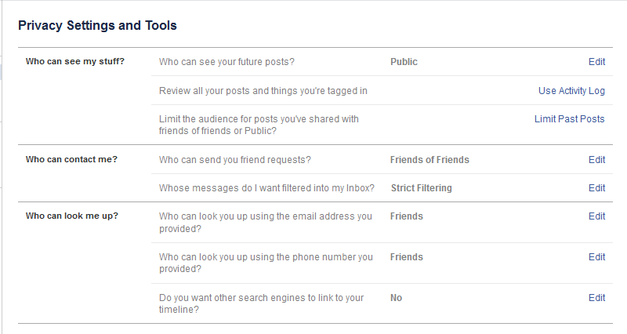

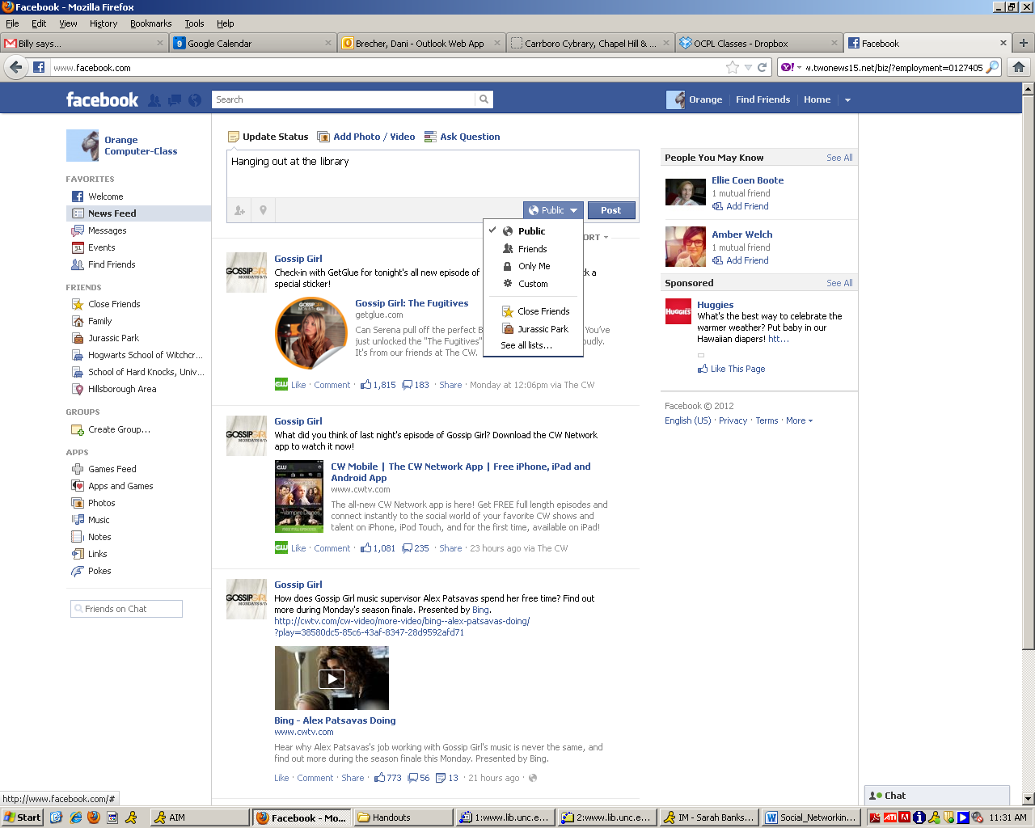
While you create these general rules for your privacy settings (ex. share photos with friends), you can also choose who you share individual items with if it differs from your general settings. For example, if you want to share a picture of a surprise present, but keep it hidden from the birthday boy or girl, you can change the setting of individual post.

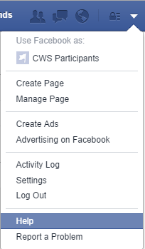
If you find that you need more help in setting up your Privacy Settings, you can go to the Privacy page in the Facebook Help Center. To get to that page, click on the down arrow that is next to the Privacy lock icon on your home page, and click “Help”.
Next, choose the “Privacy” option that comes up in the new menu. If you don’t see your issue in the box that pops up, click on the “See more help about privacy” option. This will take you to a page that has more options:

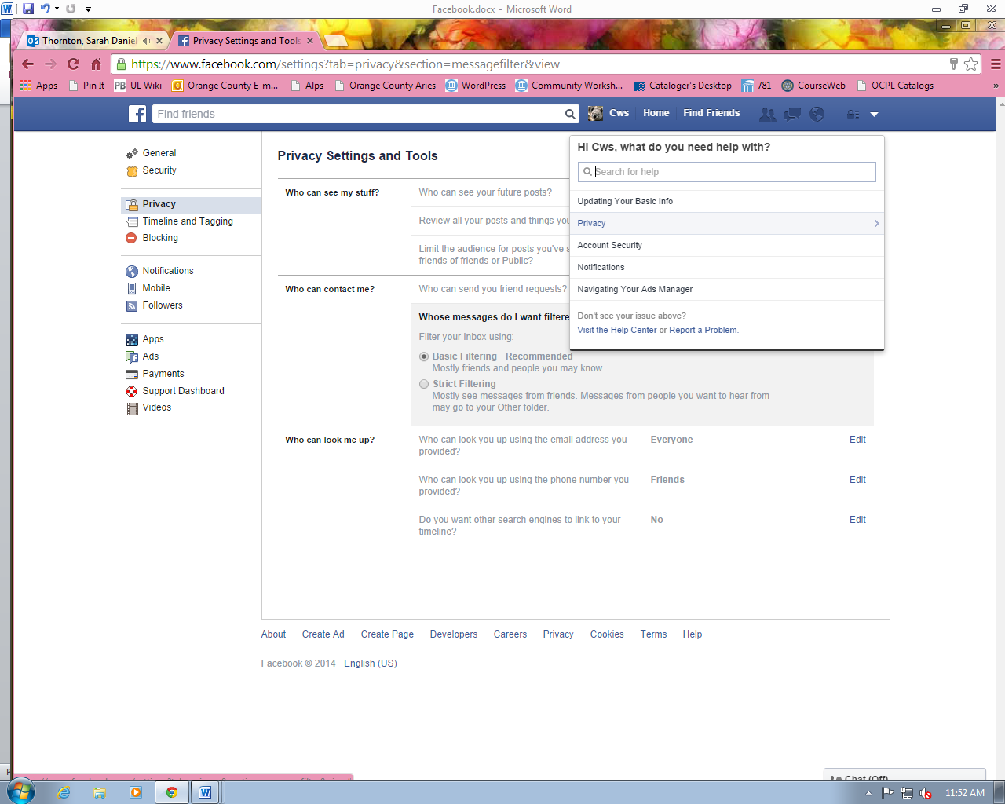

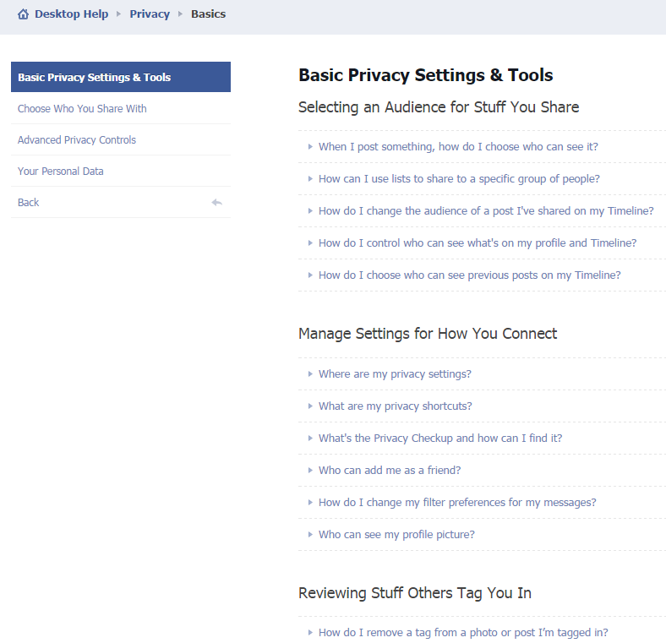

Editing Your Profile

Now that you have your basic profile set up, and you understand how the privacy settings work, you may want to go back and edit your profile. To do this, go to your Timeline by clicking on your name at the top of your screen. Next, click on the “About” tab. You will then be taken to the page that has all of your personal information. It will look like this:
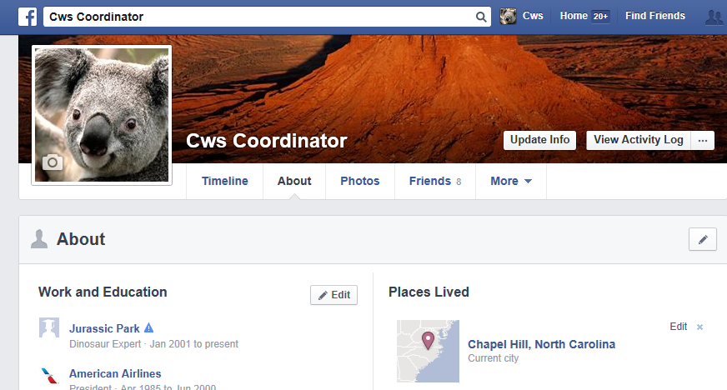

Notice the Edit buttons next to the different sections of your information – this means that when you click on those buttons, you will be able to make changes.

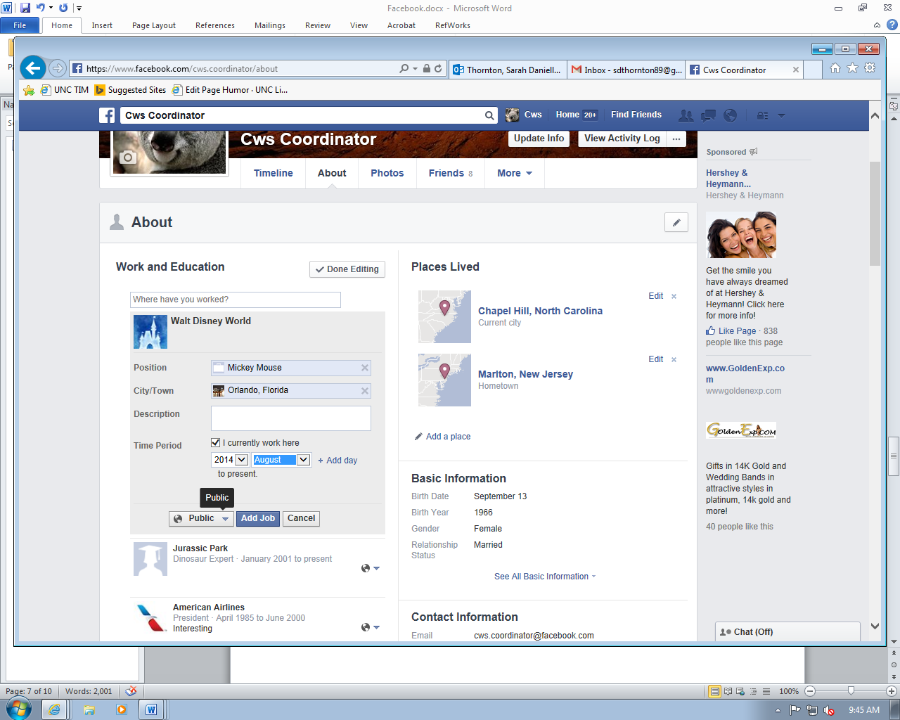
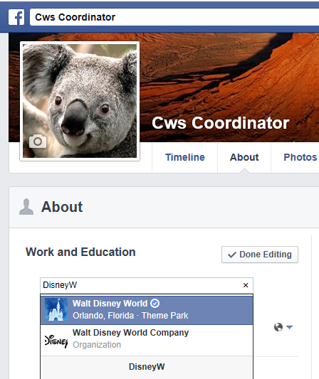
When you begin to type in a new field, whether it is work and education, places lived, etc., Facebook will start to give you suggestions of places that already exist. If you work at a small business that has few employees, you may not be able to find your workplace. However, you do have the option to enter in something that doesn’t exist. The benefit of having somewhere that Facebook knows on your profile (e.g., Disney World) is that you can easily find/be found by co-workers.

Once you have finished adding a new job, you can then choose who will be able to see that edit. Once you’ve made that decision, click on “Add Job” to save your edit.

If you change your mind about who you want to be able to see certain aspects of your information, you can always go back and click on the globe icon to change that setting.

Finding Friends

Facebook is most useful when you use it to keep in touch and connect with people in your life, whether through sharing messages, photos, or favorite news stories. When you connect with someone on Facebook, this process is called “friending” and the person you are connected to is called your “Facebook Friend.”

The best way to find people you know in Facebook is to search for them by name. Enter a person’s name in the search box at the top of the page, then press enter.



The results will then show you a list of names with their profile picture and a little bit of information about them. This will hopefully give you enough information to decide if this is the friend you were looking for or not. *Be aware that some people may have their settings so that they cannot be found by name searching, so they may have to add you first.

If you decide that you want to friend someone, click on the “Add Friend” button on the right side of the page. The other person will then have to confirm you as a friend before you can see the rest of their profile.

The confirmation process ensures that people you don’t want looking at your information can’t get access to it. While you’re waiting for your friend to confirm you, you will see a “Friend Request Sent” box instead of the “Add Friend” box next to their name.

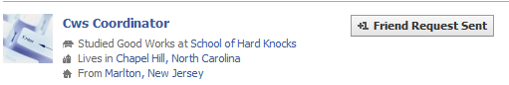

When a friend accepts your Facebook request, you will receive an e-mail letting you know that you are now connected. The next time you log into Facebook, you will also see a notification, letting you know that you have a new Facebook Friend.

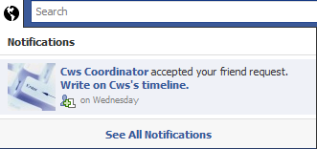

Once you have friends on Facebook, you can check out their profiles, write notes on their timelines or send them messages.

To Remove a friend, go to the Friends tab on your timeline, and click on the “Friends” icon next to the friend you want to remove.
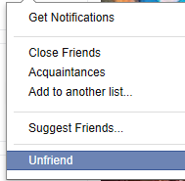
This box will pop up, and you can then click on “Unfriend.” Be careful – you will not be asked if you’re sure you want to unfriend them – it will happen immediately!

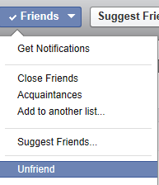
You can also visit the Timeline of the friend that you want to remove and click on the “Friends” box at the top of their Timeline – you will then find the Unfriend option again.

Updating Your Status

One of the most popular features of Facebook is updating your status. When Facebook first started, the Status feature only allowed you to select an option from a pre-made list. For example, you could select that you were “at work,” “at home,” “at school,” etc. Now, the possibilities of the status are nearly endless. Some people use this feature to give basic info. like the first statuses were, but most people go beyond that. Facebook asks you in your status box, “What’s On Your Mind?” You can take this literally and type out your every thought, you can tell a funny story about your day, you can talk about a delicious meal you recently had, or you can type out the lyrics to a song that is stuck in your head – the choice is yours.
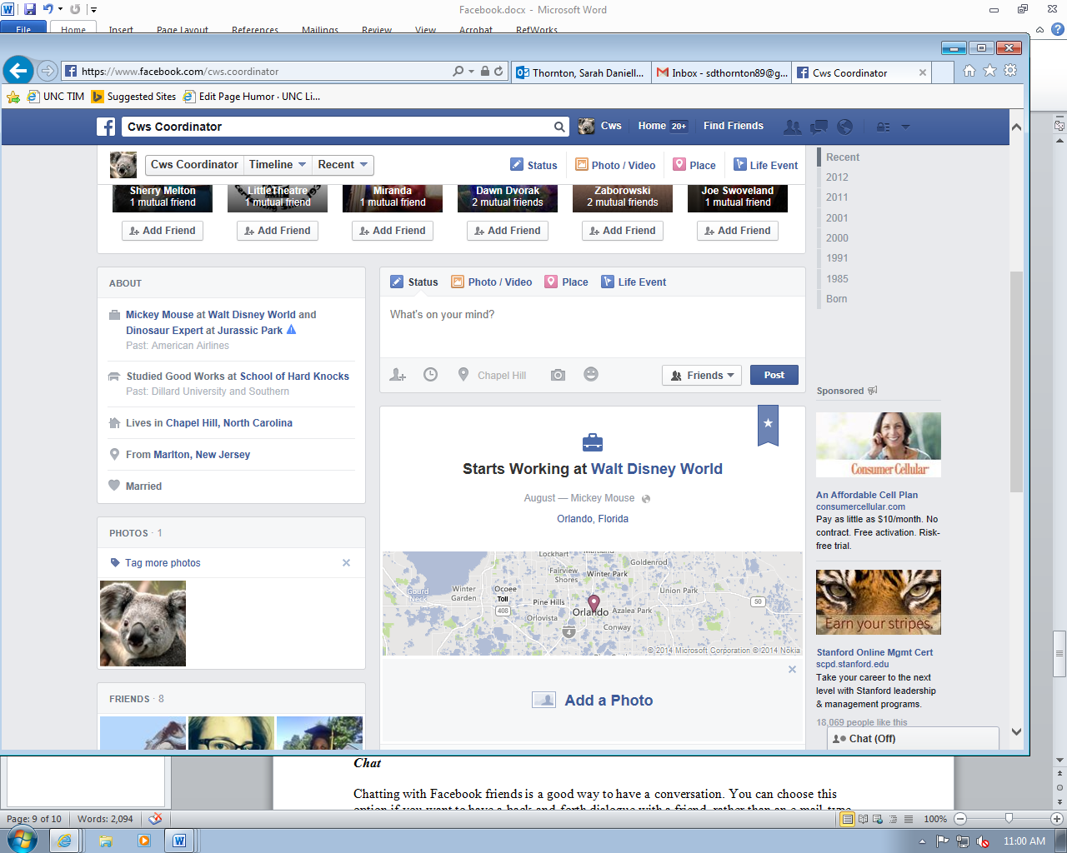

The first step in updating your status is to find the status box on your Timeline or on your Home page. Then, start typing! The options above the text box allow you to specify what sort of post you are sharing: Status, Photo/Video (we’ll go over these later), Place, and Life Event.

You can also see that there are other options under the text box. Let’s go over what each one does:

This icon allows you to “tag” a friend in your status update. If you click on this icon, you can start typing your friend’s name until Facebook finds them – in order to tag them, you must be friends with them on Facebook! Tagging a friend associates them with your post. They will receive a notification that you have tagged them, and if they have their privacy settings set a certain way, they may have to approve the tag before it is final. However, once the tag is set, your friends and their friends will be able to see the post.

*This option is only available when you are on your Timeline. It allows you to select a year that your status took place. For example, if you wanted to post something that happened in 2005, you could use this option to specify that.

This option allows you to say where you are for this status update. Sometimes it will automatically update to your current location – this depends on how your privacy settings are set up.

This option allows you to upload a photo. We will go over photo uploading in the next section.

This option allows you to add feelings and activities to your status.
You can say what you’re watching, reading, listening to… Pretty much anything!

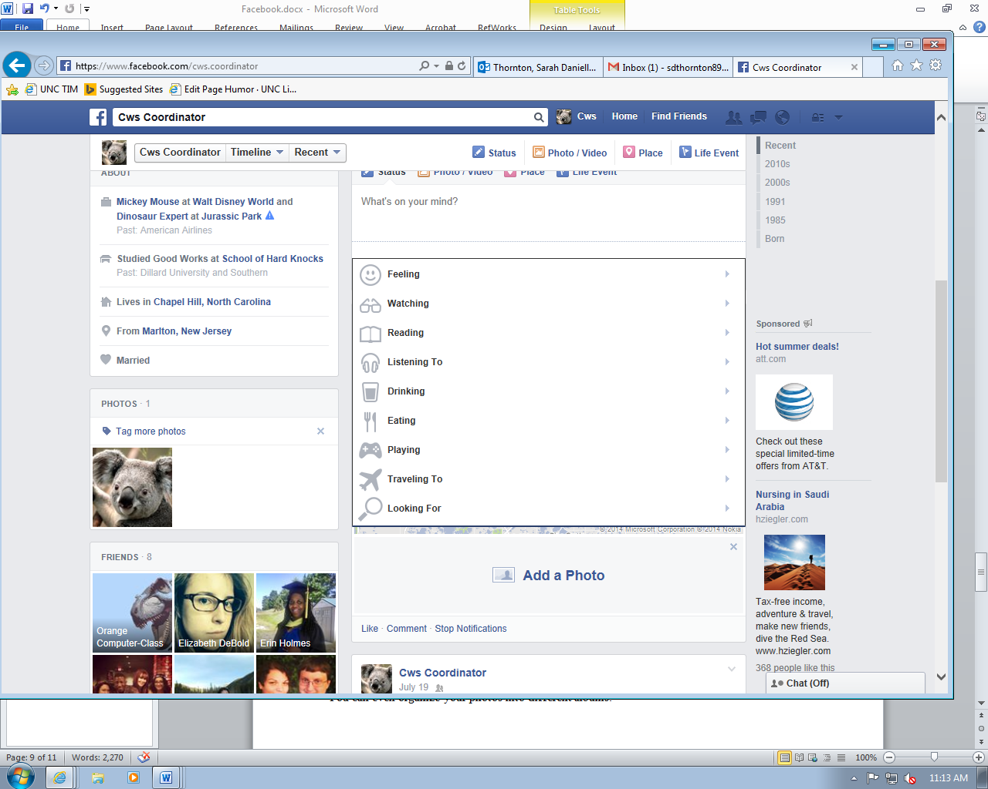

Uploading and Sharing Photos

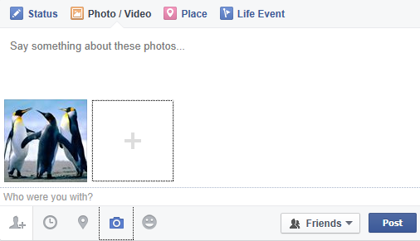
One great thing about Facebook is that you can upload your pictures to share with your friends. You can even organize your photos into different albums. The easiest way to upload a photo is to use the Photo option that we talked about in the Status box. This is best for when you only have one or two pictures that you want to post quickly and aren’t worried about them having their own album. To post a photo this way, click on the camera icon to select a file from your computer. Once you’ve found the picture that you want to post, the picture will show up in a preview in your status box. You can then post it as is, or you can say something about the picture and can tag your friends.
If you want to upload an entire photo album, you can do this a couple of different ways.

- Choose the Photo/Video option in the status box. This will give you the option to create a new album.
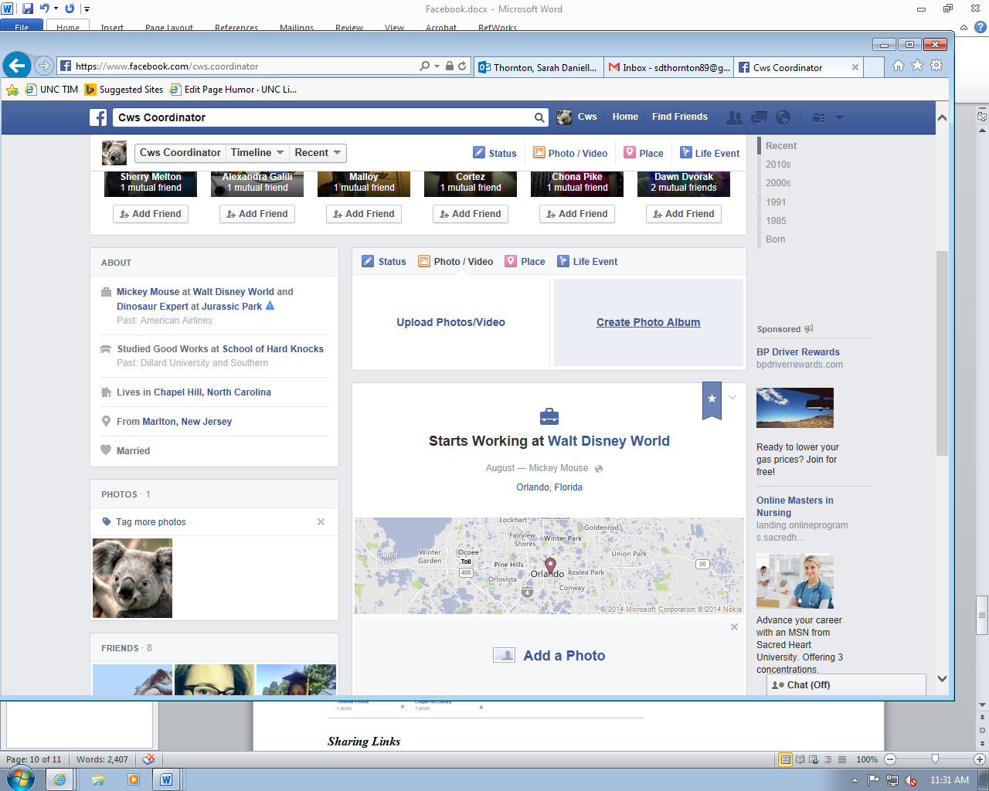
When you choose this option, a box will open that allows you to select photos from your computer. When you select the first picture to upload, the album page will open.

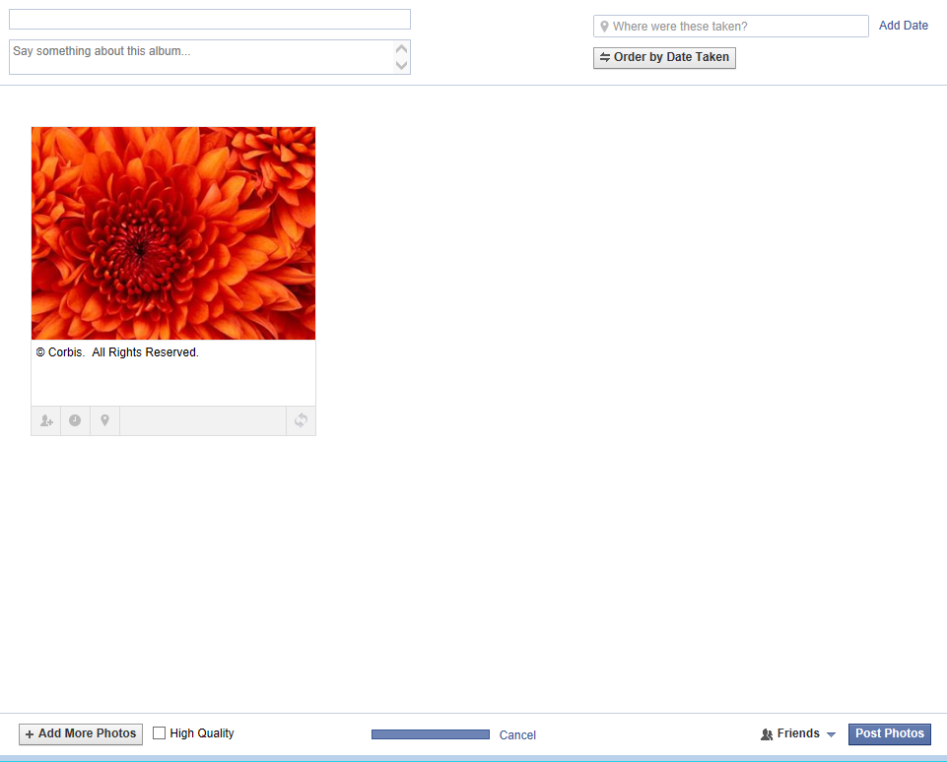
You will then be able to name your album, say something about it, change the album location, tag friends in your pictures, and add more pictures.

If you don’t give your album a name, Facebook will default it to “Untitled Album.” You can always change it later if you’re in a hurry. Once you get all of your pictures in the album and you’ve edited to your liking, you can post the photos. Then you have your album!

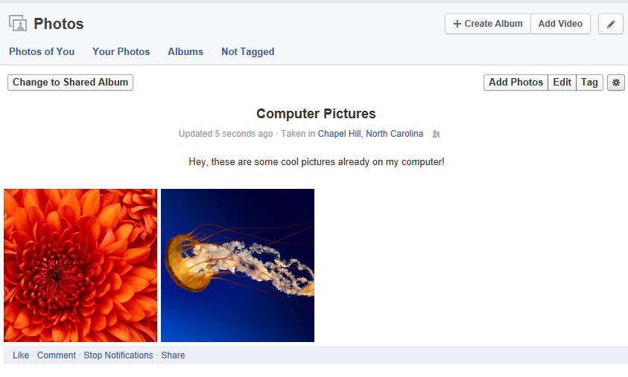

- The second way to create an album is to go to the Photos tab on your timeline. If you click on the “Create Album” button, you’ll be taken through the same steps as if you do it through your status box.
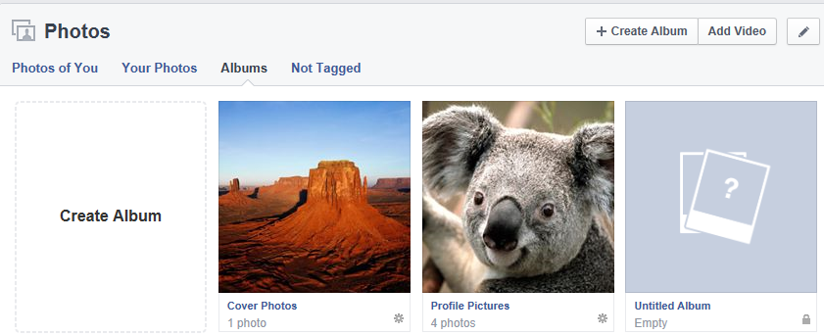

Sharing Links

Sharing links through Facebook is a good way to recommend websites, articles, and videos to your friends – it’s also really simple! A lot of websites will have a button that allows you to share the page with your friends – it will be in different places depending on what site you’re on, but it will probably be identified by the Facebook icon. (You also may have to click on a “Share” button to bring up the share options). Here’s what it looks like on YouTube:
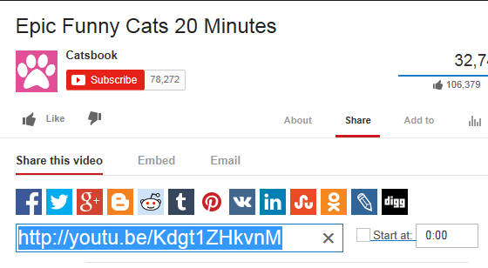

Another way to share links on Facebook is by copying the URL from the address bar in your Internet browser, and then pasting it into your status box. Here are the steps to do that:

- Highlight the entire URL in your address box of the page that you want to share.
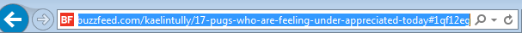
- Right-click once in the highlighted portion, then select “Copy” OR use the keyboard shortcut: Ctrl+C (to do this, hold down the Ctrl button and then hit C – then the text is copied).
- Go back to your Facebook and find the status box. Right-click once in the box, then select “Paste” OR use the keyboard shortcut: Ctrl+V (to do this, hold down the Ctrl button and then hit V – then the text is pasted).
- Once you’ve pasted the link, you’ll notice that Facebook will bring up a preview of the page you’re sharing.
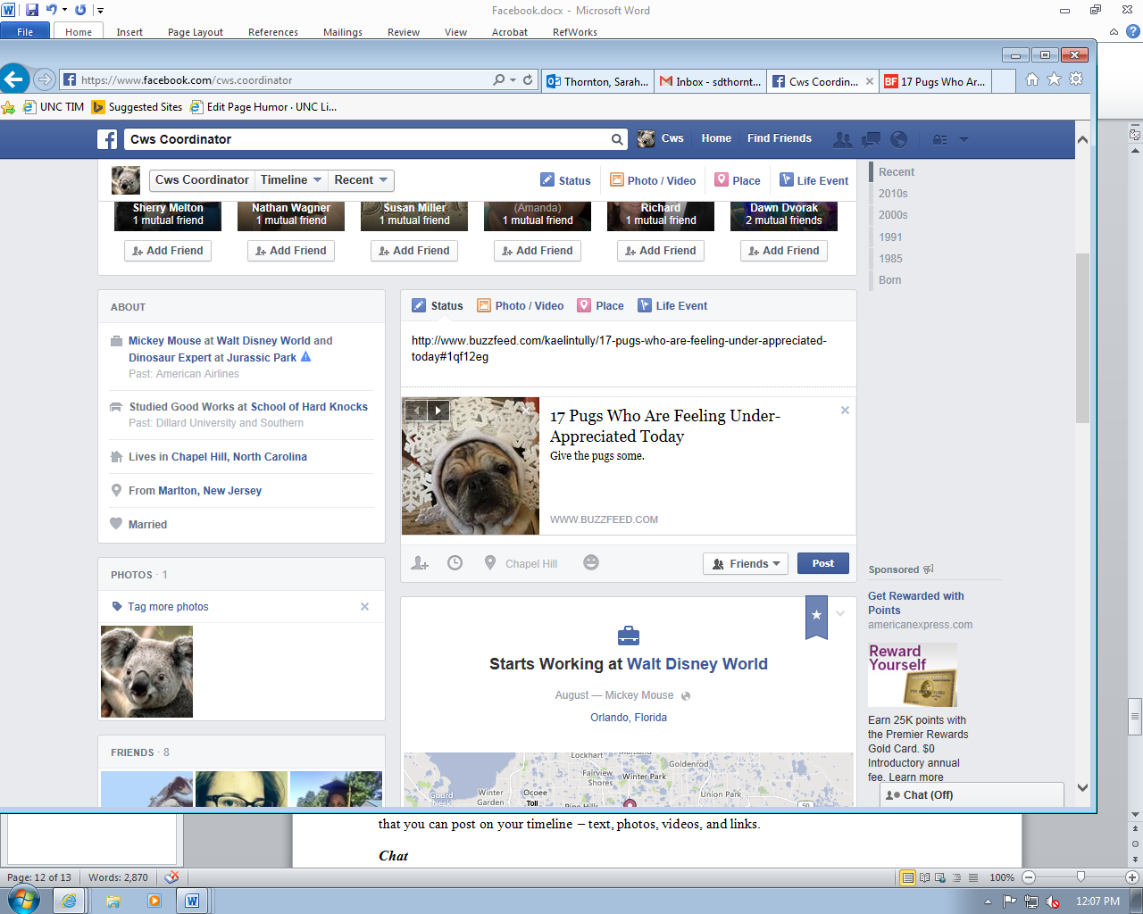
- If you want your post to show up without the entire URL link, you can now backspace the whole link, and if you want, you can say something about the link you’re posting. Additionally, you can tag friends in the post, just like you can in a status update. Now you’re ready to post!
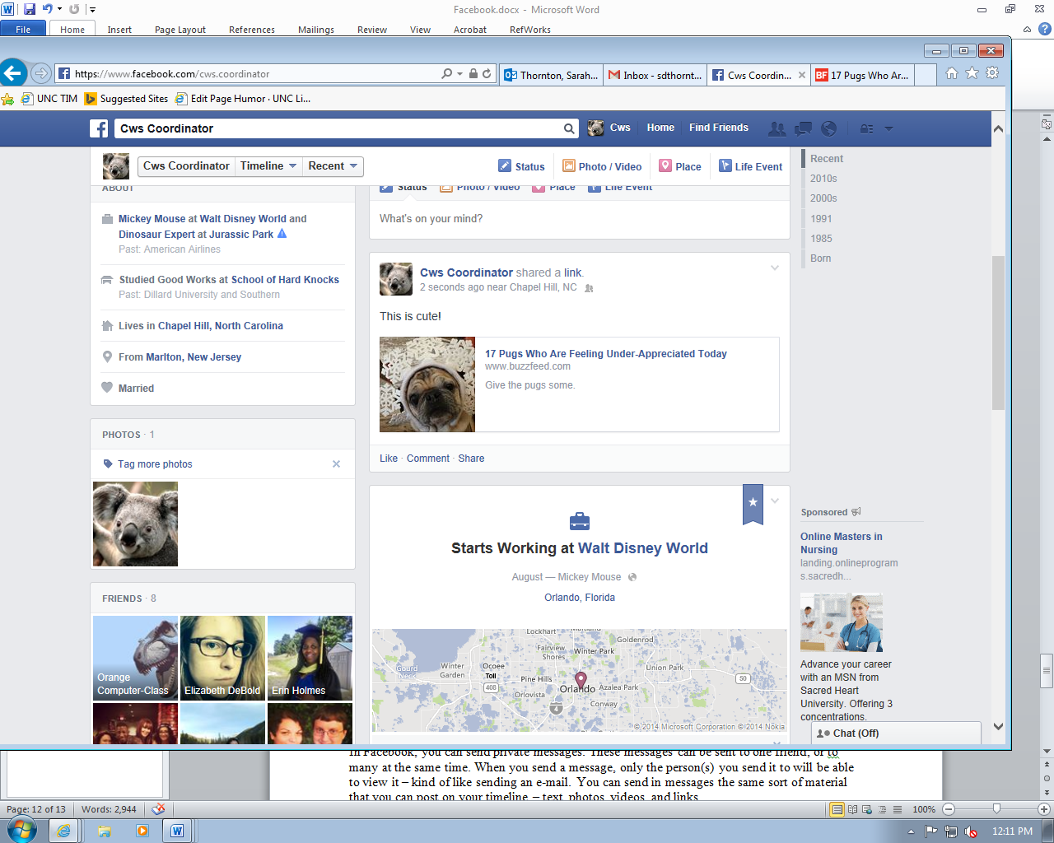

Navigating a Timeline

The Timeline is how Facebook organizes your posts. It’s done by year, hence the name Timeline. This feature allows you to access posts from years ago much more easily than just scrolling for hours at a time (what you used to have to do!). On the right side of your timeline, you will see a list of years:

These years indicate several things: the years that you’ve had Facebook, years that you’ve posted Life Events to, and your birthdate. To look at the posts for a particular year, just click on the year!

Other things that may show up on the left side of your Timeline are: About You information, Friends, Pages you’ve “Liked” (we’ll go over this later), and your Recent Activity on Facebook. If you don’t want a section to show up on your Timeline, you can hide it – just click on the Pen icon to edit and select “Hide Section.”

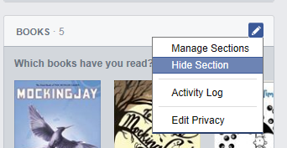

You can also “Manage” your sections - just select the Manage Sections option that is right above Hide Section, and this screen will appear:

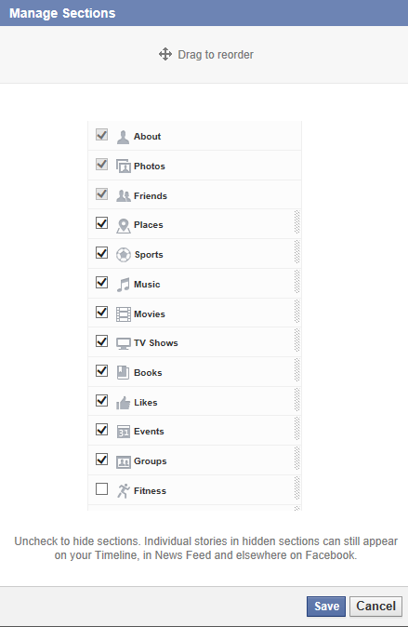
This gives you another way to hide sections, and you can also reorder them to change which order they appear on your timeline.

Send Messages

In Facebook, you can send private messages. These messages can be sent to one friend, or to many at the same time. When you send a message, only the person(s) you send it to will be able to view it – kind of like sending an e-mail. You can send in messages the same sort of material that you can post on your timeline – text, photos, videos, and links.

To send a message, click on the Message bubble icon at the top of your screen. 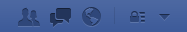

Select “Send a New Message.” When you do this, the message box will pop up at the bottom of your screen.
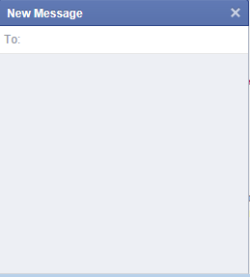
Now, in the To: box, start typing the name of the friend you’d like to message. Facebook will recognize their name (just like in tagging) and you will be able to select the name. After you’ve selected the first name, you can continue to add as many names as you’d like – just remember that everyone you send the message to will see who all you included in the recipients, and when they reply, everyone in the message will get that reply.

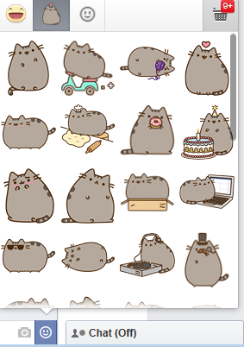
When you click in the box to start typing the message, you will then be able to add a photo or emoticon/sticker to the message. Some sticker sets are free (like Pusheen!) But you may have to purchase others – we don’t really recommend this, but you certainly have the option!

Once you have your message ready, you can either hit Enter on the keyboard or click Send to send your message! If you get a reply to your message, you will get a red number bubble that will show up on your message icon at the top of your screen. The number indicates how many unread messages you have. Keep in mind that you may have multiple conversations going when you see that number (It doesn’t mean that the last person you messaged sent you multiple messages).

Chat

Chatting with Facebook friends is a good way to have a conversation. You can choose this option if you want to have a back-and-forth dialogue with a friend, rather than an e-mail style message. To chat with a friend, scroll to the bottom of your Facebook page to find the Chat box. It will probably be off if you have never used it before.
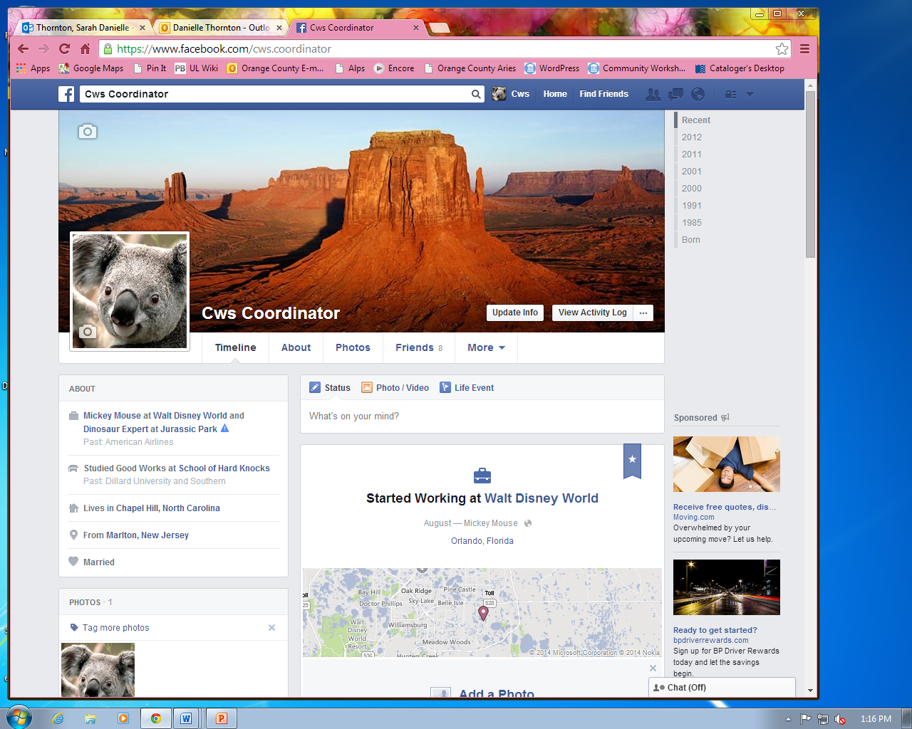
When you click on the box, you will turn your chat on. To turn it back off, click on the gear icon and choose the turn off chat option.
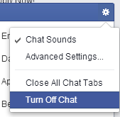

The main purpose of the Chat function is so that you can talk to friends who you know are online and available for chatting.

*Note: There is a very small difference between Facebook messages and chat. Sending messages can be like a chat conversation if the recipient is also online – it will then look just like a chat conversation.

Events

Events on Facebook are a cheaper (and more environmentally friendly!) way to send out invitations and get RSVPs for a get-together. To access your events, go to your Facebook home page. There you will see Events listed on the left-hand menu.
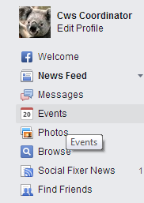

When you click on the Events button, you will be taken to a sort of “home” for events you have been invited to and/or created. If you are currently not associated with any events, your screen will look like this:
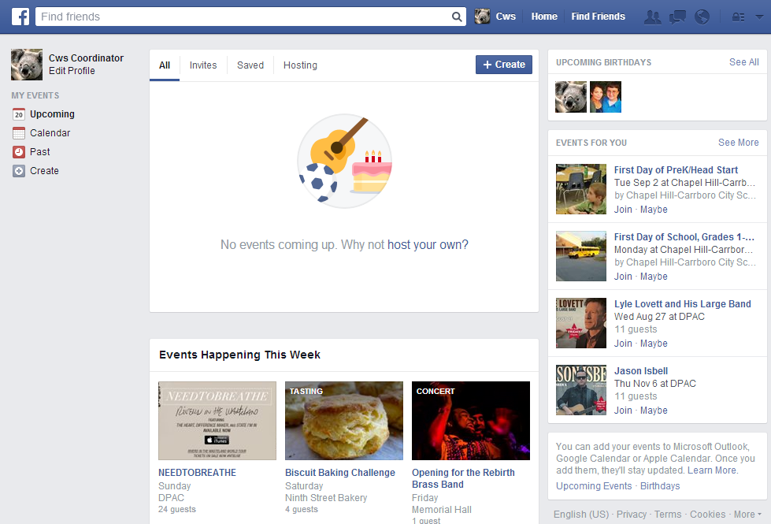

There is a tab for all of your events, ones you are invited to, saved events, and events you are hosting. Additionally, you can view past events, a calendar, upcoming birthdays of your Facebook friends, and events happening this week in your area.

When you are invited to an event, it will show up as a notification. When you click on the notification, you will be taken to the event page on which you can either respond Accept, Decline, or Maybe. As event members post on the page, you will receive updates. You can also post on the event page.

To create an event, click on the Create button on your events home page. A box will pop up that allows you to name your event, give details (maybe explain the directions or special features of the events), add an address, date, and time.
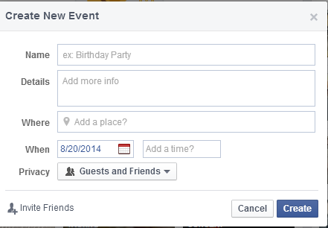

The privacy option allows you to select who can see the event. The default option is set to “Guests and Friends,” which means that your guests can invite people to the event, but you can change it to make it more open or less open as you prefer.
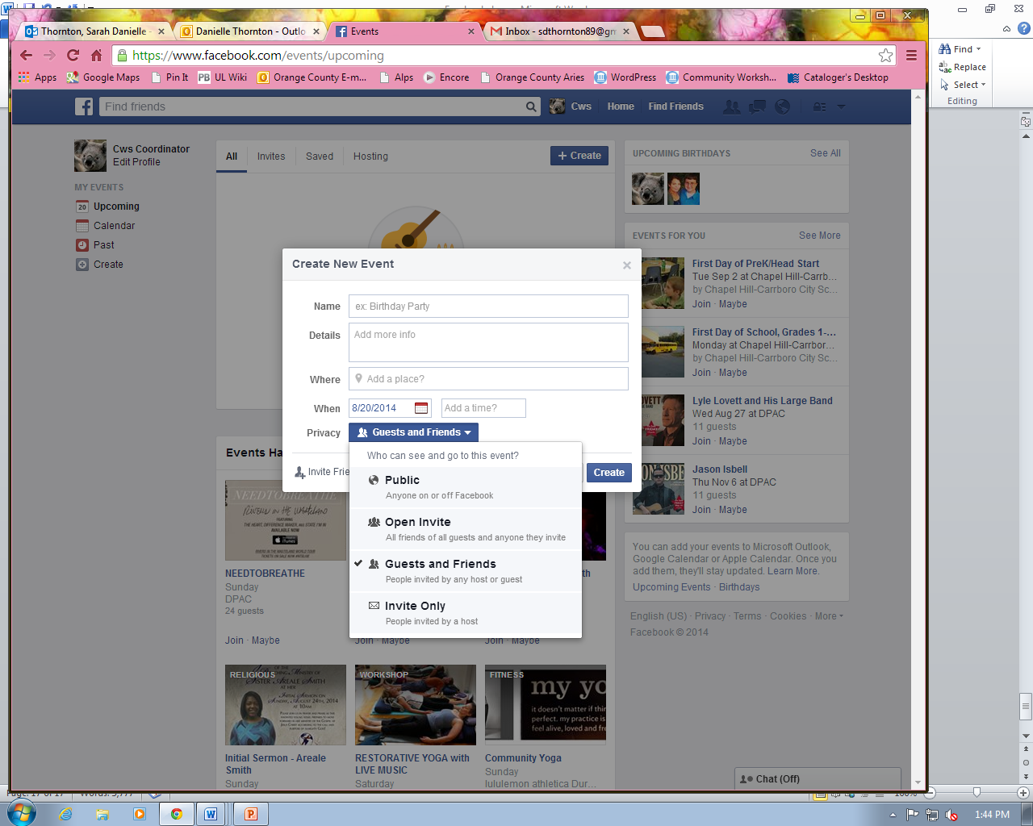

Once you have the privacy and details set the way you want them, you can start to invite your friends. When you click on “Invite Friends,” an additional box will appear that will allow you to select which friends you want to invite to your event. Hint: You can always go back later and invite other friends who you may have forgotten in the first round. Also, you can change your event details as needed. Once you’ve created your event, it will look something like this: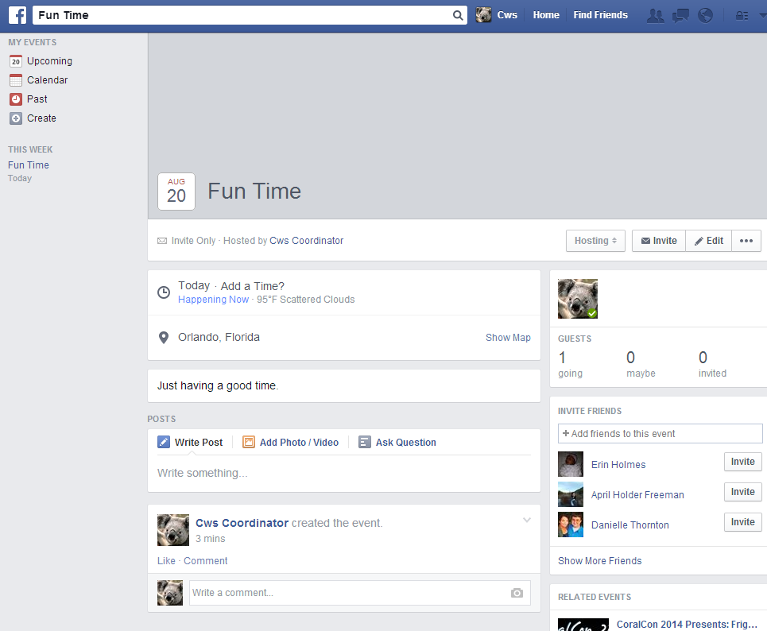

*Names of actual people have been blacked out – you would normally see your friends’ names next to the “Invite” buttons on the right of the event page.

Join and Create Groups

Just as you can join clubs and organizations in real life, you can join (and create) groups on Facebook. To access your groups, look on the left side of your home page. You can click on the gray “Groups” option to get started.
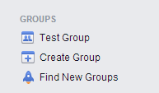
You will then be taken to your groups page. At the top, you’ll be able to navigate to different group options. Suggested groups will be groups that align with interests similar to your own. Friends’ groups will be groups that your friends are a part of, local groups will be groups in your area, invites are groups you have been invited to join, and Your Groups are groups that you are either a part of or created. If you find a group you would like to be a part of, you can click on “join group.” Depending on how their privacy options are set, your membership may have to be approved by the group creator. Also, you can create a group by choosing the Create Group option.
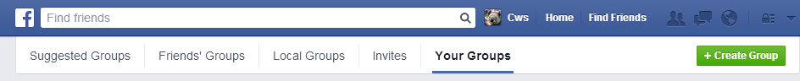

If you choose to create a group, a box will pop up for you to provide more information, kind of like you did in events.
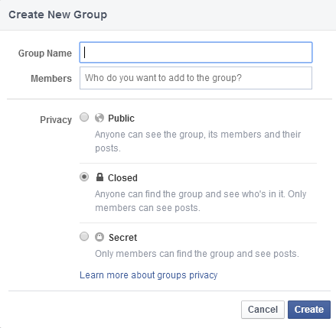

Organize Your News Feed

Your News Feed is where your friends’ posts will show up. You have the option to organize it however you like! The most general option you have is to sort your feed either by “Top Stories” or “Most Recent.” Top Stories means either important events, or photos/statuses/videos that have gotten a lot of likes/comments from other people. When you choose to view by Most Recent, you will see posts from your friends in order, starting with the most recent and ending with the least recent. To choose either of these, click on the “News Feed” option on the left of your home page.
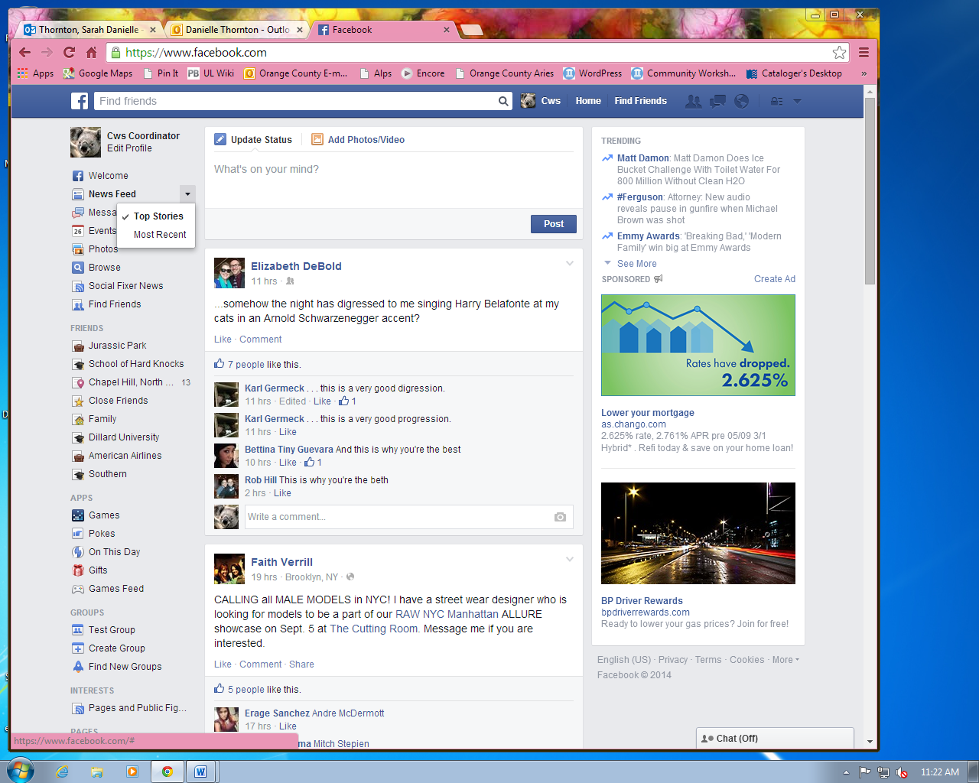Now you can click on whichever one you prefer.

There are other options when it comes to your News Feed organization as well. If you have added things like work information or educational institutions to your profile, you will see that they show up under “Friends” on the left side of your home page.
If you would like to only see posts from your co-workers at Jurassic Park, you can click on Jurassic Park to display those posts on your News Feed.

This can be useful if you are trying to find posts related to a certain person or group of people.

Find Pages

Pages can be many things. Musicians, sports teams, celebrities, books, and TV shows often have their own Facebook Page that users can “like” or become fans of. Additionally, local organizations and businesses can also have pages to promote their mission or product. When you “like” a page, you will start to see posts from that page on your News Feed – just as you see your friends’ posts. You can also create your own page if you’re interested, but that goes a bit beyond the scope of this class. However, the setup for a page you create is similar to the setup you go through in creating your Facebook profile.

To find a page, search for the person/thing that you want to start following. Do this by searching in the same box that you used to find your friends. When you start typing, Facebook will start to auto-fill suggestions. Some people/things may have more than one page – for that, you will have to use your judgment on which one you’d rather “like.” Here’s what comes up when you type “brad pitt” into the search box:

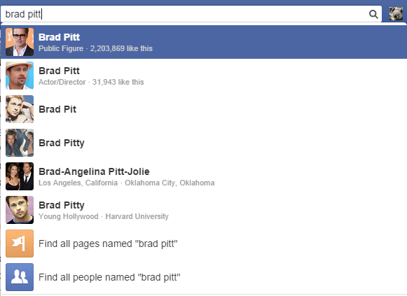
In this case, you’d probably want to look at the Public Figure option, but there are others available.

Another way to do this is found on your home page. Look on the left side under “Pages.”

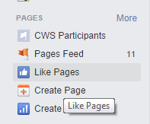

Click on the “Like Pages” option. This will take you to a page that gives you suggestions for pages to like based on popular pages and what your friends like. Should you wish to like a page, click on the Thumbs Up Like button for the page.
NOTE: Images and screen captures may differ from those seen on another system.

This work is licensed under a Creative Commons Attribution-NonCommercial 4.0 International License2.

