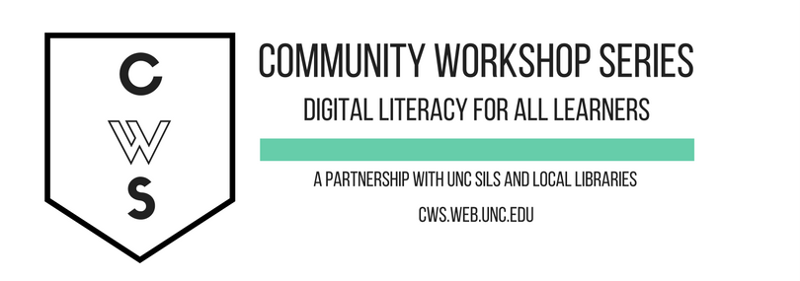

E-MAIL Basics

GETTING STARTED PAGE 2
Prerequisites
You Will Be Able To…

INTRODUCTION PAGE 3
What is E-mail?
Pros, Cons and Tips
Text Speak Dictionary

SETTING UP AN ACCOUNT PAGE 5
Setting up your E-mail Account

MANAGING YOUR E-MAIL PAGE 9
Checking your E-mail
Composing and Sending Messages
Receiving and Reading Messages

ADDITIONAL FEATURES PAGE 15
Address Book
Calendar
Notepad
Messenger
Themes

GETTING HELP PAGE 18
At the Library
What If I Forget my Password?
Yahoo! Mail Help

WHAT YOU WILL LEARN

Prerequisites:

It is assumed for this class that the user is comfortable with basic computer operations. In addition, very basic Internet experience is recommended.

- This workshop is intended for new e-mail users.

- We will be using PC desktop computers running Microsoft Windows Operating System in addition to the Yahoo! Mail client.

- Please let the instructor know if you questions or concerns prior to starting class.

- For verification purposes, you may need access to a cell phone that accepts text messages or an alternate email address before your account is activated. Please let the instructor know if you do not have this.

After this class you will be able to:

Understand the pros and cons of e-mail use | Create and access an e-mail account | Open and read received e-mail
Compose and send e-mail | Attach a document or picture to an e-mail | Open an attachment
Organize your e-mails | Retrieve a document or picture from a received e-mail | Utilize the Address Book feature

INTRODUCTION

What is E-mail?
E-mail, short for Electronic Mail, consists of messages which are sent and received using the Internet. While there are many different e-mail services available that allow you to create an e-mail account and send and receive e-mail and attachments, we have chosen to focus this class on the services available through Gmail and Yahoo! Mail because they are free and are two of the more popular e-mail services available.

The Pros
- It's fast. Most messages are delivered within minutes – sometimes seconds – around the world without the inconvenience and cost of using postal service. In fact, postal service is often referred to as "snail mail" by e-mail users.

- It's personal. While the nature of e-mail is informal, its efficiency is an excellent substitute for telephone conversations.

- You can think through your response. Like a letter, you can type your reply and make changes before sending.

- The sender and the receiver don't have to be working at the same time. E-mail avoids problems such as telephone tag or trying to contact someone in a different time zone.

- E-mail makes it easy to keep a record of your communication. You can save and refer to later copies of the e-mails you send as well as those you receive.

- You can reach a lot of people at once. It is possible to send one message to hundreds of recipients at once, or you can send a private message to one individual.

The Cons
- Junk Mail (also referred to as spam). This is as annoying in e-mail as it is with traditional mail. Most e-mail services now filter incoming mail and sort e-mail messages that are most likely advertisements or scams into a folder called “spam.”

- Friendly spam. Try not to forward unnecessary messages to friends who may not appreciate hearing the latest list of “Top Ten Things…”

- Ads. The reason you can get free e-mail services like Yahoo! is because of advertisements. You pay the price of having to click around them to read your mail.

- Misinterpretation. E-mail arrives without tone or hand gestures which can lead to misunderstandings.

- E-mail messages can be passed on to others. You should always count on the possibility of your message ending up in the inbox of someone it wasn't intended for.

- You can hide behind e-mail. It's tempting to use e-mail instead of facing a person when you have to deal with an unpleasant situation. It's best to talk to a person face-to-face under these circumstances.

Don't use e-mail for:
- Long or complicated messages
  - Sometimes it’s more effective to speak to someone in person or on the phone. It can be difficult to effectively write down a complicated message in e-mail format.
- Questions that require a lot of clarification
  - If a message is going to require several exchanges back and forth to make sure it is understood, more direct communication is best.
- Delivering indiscreet, sensitive, or private information
  - While your E-mail account is personal, keep in mind that, while rare, passwords have been stolen and there are ways for interested parties to intercept information. Do not send your social security number, credit card number, or bank account information in an e-mail if it can be avoided.
- Angry exchanges
- Things you should say in person

Text Speak Dictionary

Many users of e-mail use an abbreviated form of English that began with text messages. These abbreviations can sometimes be confusing, so here is a brief list of the most commonly used “text speak” words.

?: What?
<3: Heart
<3333: Bigger heart (more 3s increase the size of the heart)
2day: Today
4u: For you
b/c: Because
b4: Before
BRB: Be right back
BTW: By the way
C U: See you
EZ: Easy
FB: Facebook
FTW: For the win
GR8: Great
H8: Hate
IMHO: In my humble opinion
JK: Just kidding
L8R: Later
LOL: Laughing out loud
Meh: Indicates a shrug
NP: No problem
OMG: Oh my God
PLZ: Please
RLY?: Really?
SRSLY: Seriously
Sum1: Someone
THNX: Thank you
TTYL: Talk to you later
U: You
XOXO: Hugs and kisses
Y?: Why?

For an extensive list of possible texting and chat abbreviations, check out: http://www.webopedia.com/quick_ref/textmessageabbreviations.asp

GETTING STARTED



Instructions for Yahoo! Mail:

1. Connect to the Internet by double-clicking the Internet Explorer or Firefox desktop icon.

2. Go to the Yahoo! Mail site by typing mail.yahoo.com into the address bar at the top of the screen.

3. Depending on your browser and whether or not it has been recently updated, you should see a box that looks something like this:

Make sure “Keep me signed in” is UNchecked whenever you sign in.

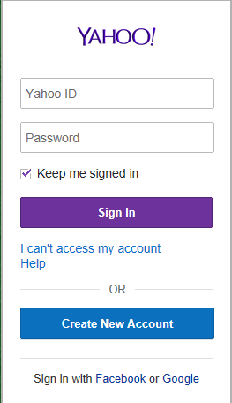

Click on the Create New Account link at the bottom of the box.

4. Complete the form with the requested information.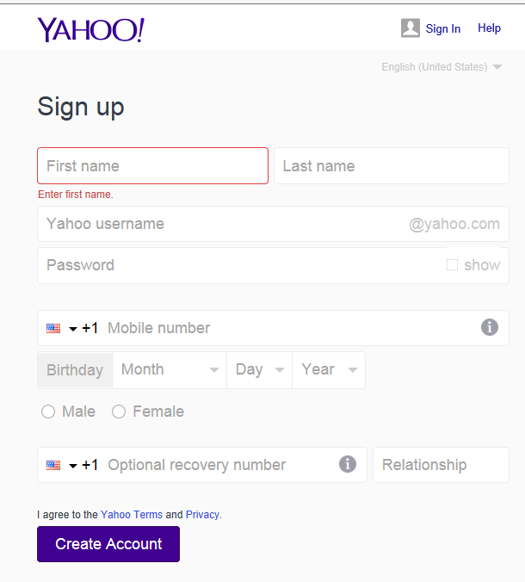
Yahoo! ID: Keep in mind that your Yahoo! ID will become your e-mail address, so choose carefully! When you have typed in your selection, Yahoo! will notify you if your selected username is already taken. Because there are so many people who use Yahoo! Mail, sometimes you might have to try a few before finding one that is available. If the ID is not available you will see the below message. For suggestions for available IDs, click in the username box. Common e-mail addresses are: firstname.lastname OR firstinitial.lastname.
People often choose to use their name if they will be using this e-mail address for professional purposes.
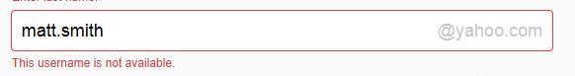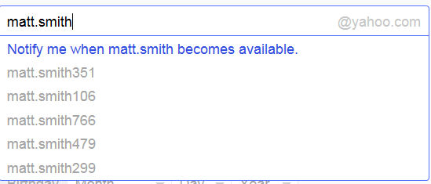

Tip: Your ID/e-mail address doesn’t have to be your given name. With e-mail, you can choose something that is related to your occupation or interests. For example, you might want to be bluebird@yahoo.com. If you find that that is already taken, you could always add some numbers after it to make it more unique. If you were born in 1960, you could be bluebird1960@yahoo.com. Don’t use the same words/numbers you plan to use in your password though!

Password: You will also need to select your password. Make sure your password is something that you can remember, but no one else can easily figure out! Don’t ever share your password with anyone else. Follow the guidelines provided for the required number of characters. To protect your password, it's a good idea to change it periodically.
Tips for creating a secure password:
- Include punctuation marks and/or numbers.
- Mix capital and lowercase letters.
- Include similar looking substitutions, such as the number zero for the letter 'O' or '$' for the letter 'S'.
- Create a unique acronym.
- Include phonetic replacements, such as 'Luv2Laf' for 'Love to Laugh'.
Things to avoid:
- Don't use a password that is listed as an example of how to pick a good password.
- Don't use a password that contains personal information (name, birth date, etc.)
- Don't use words or acronyms that can be found in a dictionary.
- Don't use keyboard patterns (asdf) or sequential numbers (1234).
- Don't make your password all numbers, uppercase letters or lowercase letters.
- Don't use repeating characters (aa11).
Tips for keeping your password secure:
- Never tell your password to anyone (this includes significant others, roommates, parrots).
- Avoid writing your password down (unless you have problems remembering, then keep it in a safe place!).
- Never send your password by e-mail.
- Periodically change your password (e.g., every six months).
- Do not save your password in your internet browser (your browser will likely ask if you wish to save the password)- other people using that computer will be able to login!

For now, write down your Yahoo! ID and Password. This is crucial because you will NOT be able to access your e-mail without them, but keep this piece of paper in a safe place!

Yahoo! ID: ______________________________

Password: _______________________________

5. If you forget your password, the next section of the form makes it possible for you to retrieve it. Here you can select a question that Yahoo! can ask you to make sure you are really who you say you are. That way, your password won’t be given out to someone trying to break into your account.
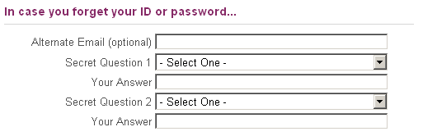

6. The next portion of the form is simply another security measure. Type the code into the box as you see it on your screen.
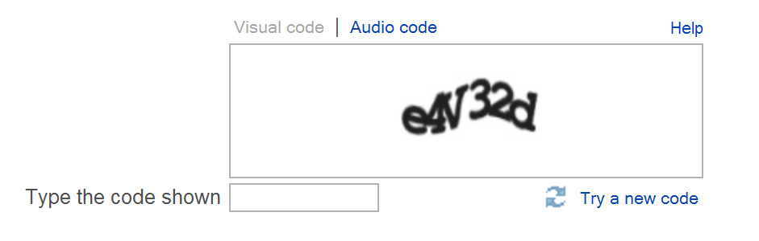
7. Finally, you have to agree to the Terms of Service. You may read through the text by clicking the “Yahoo! Terms of Service,” “Yahoo! Privacy Policy” and “Mail Terms of Service” links, and then click “Create My Account.”
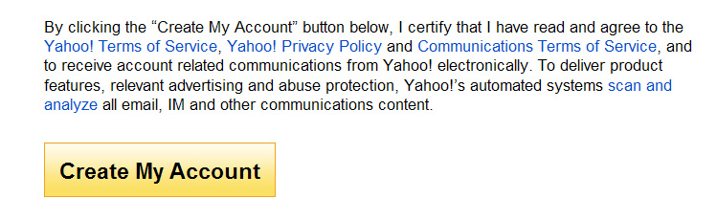
Congratulations - You now have an e-mail account! Remember that your e-mail address is your Yahoo! ID directly followed by “@yahoo.com”.

MANAGING YOUR E-MAIL

Checking Your E-mail
Once your have set up your e-mail account, you can check your mail anywhere that you can access the Internet. This is how it is done:

- Connect to the Internet by double-clicking the Internet Explorer or Firefox desktop icon.

- Go to the Yahoo! Mail site by typing mail.yahoo.com into the address bar at the top of the screen.

- Type your Yahoo! ID and Password into the box on the right.

- Yahoo! will automatically open to your inbox, which may contain both read and unread e-mails. The Inbox is where all of your incoming messages are stored.
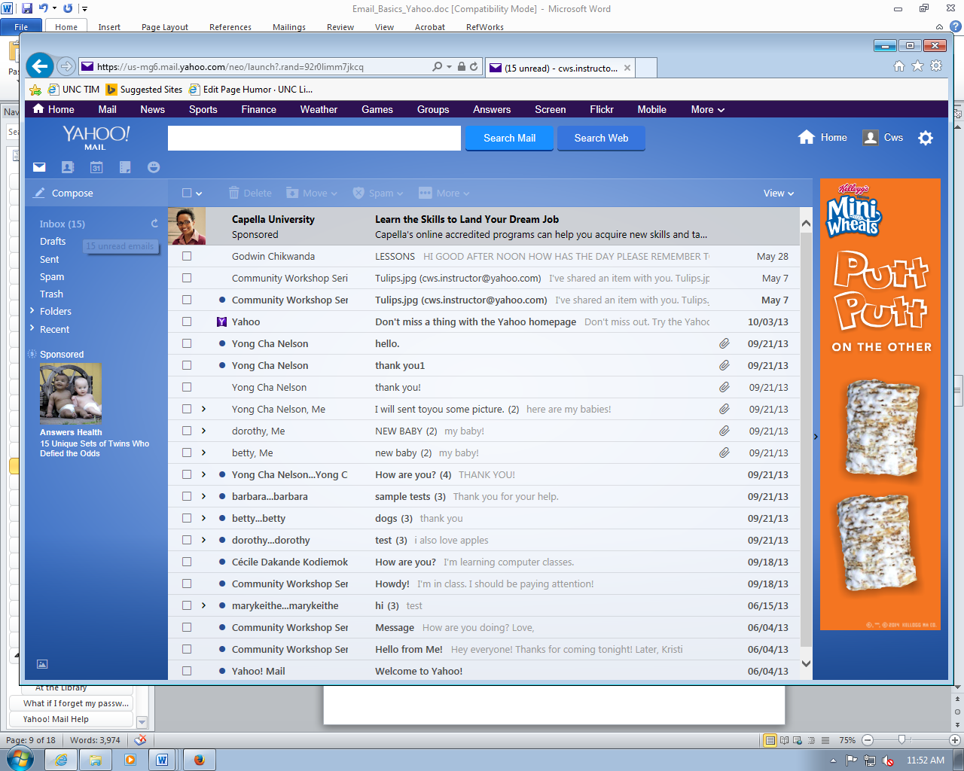

Click on the Subject of the message to open and read it. We will go into more detail regarding Receiving and Reading messages in a later section.

Composing and Sending Messages

To compose a message, click the Compose button at the top left of any screen.

The compose screen is a blank message form which looks something like this:

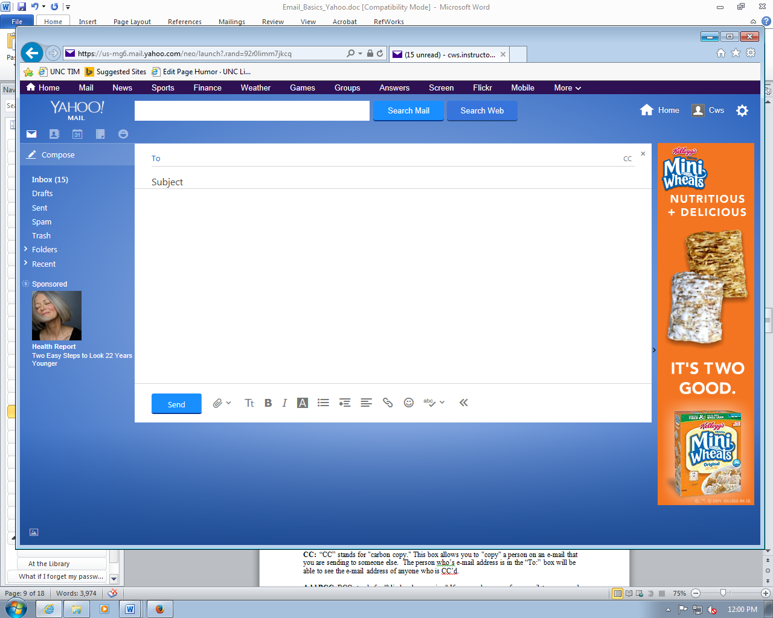

To: is where you type the e-mail address of the person(s) to whom you wish to send the e-mail.

CC: Click on the “CC” to "carbon copy" a recipient your message. This allows you to "copy" a person on an e-mail that you are sending to someone else. The person whose e-mail address is in the “To:” box will be able to see the e-mail address of anyone who is CC’d.

Add BCC: If you click on CC, you’ll see that the BCC option becomes available. This stands for "blind carbon copies." If you send a copy of an e-mail to someone by putting their address here, the recipients in the To: and CC: boxes will not be able to see that person's address. To enter e-mail addresses as a BCC, click on Add BCC and a new BCC box will appear below CC.

You can enter multiple recipients in all three address boxes. Separate the addresses with a comma and a space. Example: bluecat461@yahoo.com, ggsmith18@yahoo.com

Subject: is a brief summary of the subject of your message. It is important to include a subject line because it will benefit the recipient by allowing them to see what your e-mail is about before they open it. It is especially helpful if you are sending e-mail to someone who might not recognize your e-mail address. This will help indicate to them that the e-mail is not spam or junk e-mail.

The box where you actually type your message is easy to spot because it's the largest one in the window. Click inside to start typing. If you want to change the appearance of your text, you can use the formatting toolbar at the bottom of the box. The formatting options are similar to those used in Microsoft Word.

Once you have completed your message, send it by clicking on the blue Send button at the bottom of the window.

IMPORTANT: You cannot cancel a message once you have sent it, so make sure you want to send the message before you click Send. Be sure to check your spelling by clicking on the Check Spelling icon (a check mark with ABC next to it) on the formatting bar.

By default, Yahoo! Mail saves the messages you send in your Sent messages folder so you have a record of what you sent and when. You can find your Sent message folder from the main Mail tab in the Menu bar on the left.

Attaching a file to your message
You can attach files to your e-mail messages. This feature allows you to send pictures, documents, and even audio files.

To attach a file, first you need to do the same things you do to compose a message.

- Click on Compose

- Type the address

- Type the subject

- Type the message

- When you finish typing your message, click on the Paperclip icon that is right next to the send button. This will bring up a window for you to find and select the document you wish to attach from your computers files.

- Click on the file you wish to attach and click Open. If you have more files to attach, repeat these steps before moving on. This may take a little time, depending on the size of your file. Once the file is attached, you'll see the name listed at the bottom of your message box.
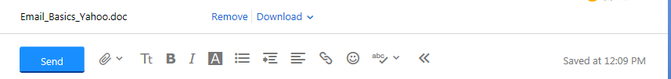

- Click Send to send the message.

Receiving and Reading Messages
As we went over earlier, when you log into Yahoo! Mail, the number of new or unread messages is indicated in parentheses next to the word “Inbox.” Click on the Inbox link to check your mail.

By default, e-mail messages are viewed in the Inbox. New messages are in bold font. To view your message, click on the subject to open it.

Once you have read your message, you have several options:

Deleting a Message: When you click on this option, the message you are viewing is moved to the Trash folder. Periodically, Yahoo! will delete the messages in the trash folder.

Replying to the message: Or, Reply to sender. This option is indicated by the single backwards arrow in the row of options above your open e-mail. Selecting this option will include the original message at the bottom of the e-mail and automatically address the message to the person who sent it to you. You can then add text to the existing message and delete portions of the original text if you wish before sending your reply to the original sender (kind of like replying to a letter and including the original letter in your new envelope).
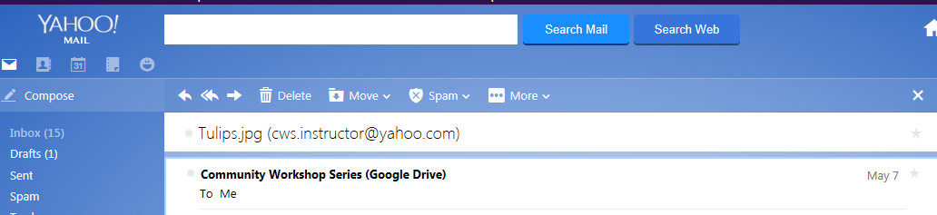

Reply to All: If you prefer, you can choose this option – indicated by the double backwards arrows – to send the message to all recipients of the original message.

Forwarding the Message: This option is indicated by the straight forward pointing arrow to the left of the trash can icon. This feature copies the message you are viewing for delivery to another e-mail address. You can add text at the beginning of the message before sending it.

Spam: Clicking Spam will move your e-mail to the Spam folder.

Moving a Message to a Folder: You have the ability to organize your e-mail into folders. You can do this by selecting the “Move” option while an e-mail is open. Several of these folders have already been created for you. All accounts will have Inbox, Draft, Sent, Spam, and Trash folders. You can find these folders on the main Mail tab on the left hand menu bar.

- You can create individual folders of your own by clicking the arrow next to the folder icon with the word Move – this will give you the option to move the e-mail to an already existing folder, or to create a new folder to move it to.
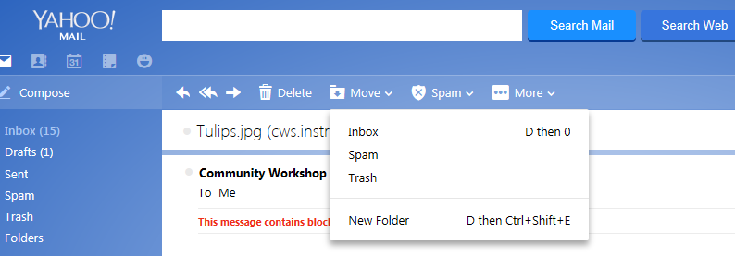

- A pop-up box will appear. To create a folder, simply type the name you want and click OK.

- Messages can be moved to folders by selecting them in the Inbox, checking the boxes next to each message you would like to move, then clicking on the Move menu button, and selecting the desired folder. Or, if you would like to move a message you’ve opened, simply click Move from the message screen.

Receiving an attachment: When you receive a message with an attachment, a paper clip appears next to the subject of the message in your inbox window.

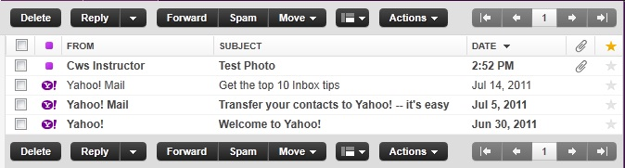

Click on the subject of the message to open it. At the bottom of the message you will see the attachment(s) listed:
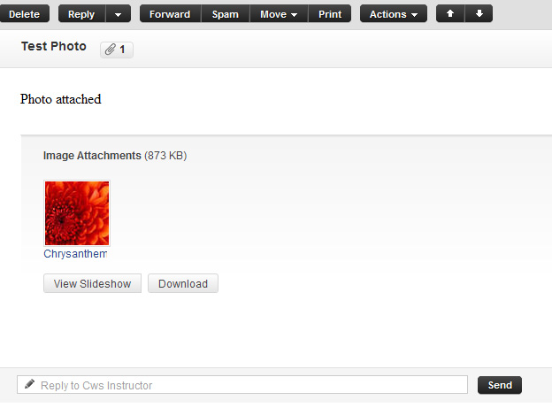

To open the attachment, click the Download button. Yahoo! will scan the attachment for possible viruses and give you a report.
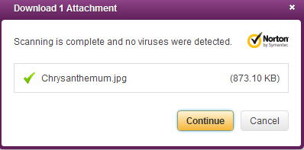

Once it has been scanned and you know it does not contain viruses, click on Continue. A box will pop up and ask you if you would like to open the file, or if you would like to save it to a disk:
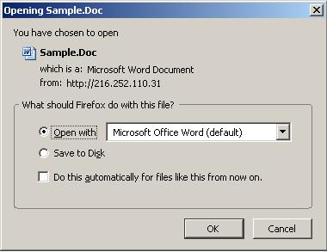
To open the file, select Open With, and then click the OK button, and the program that runs this type of file (such as Word) will open the attached file.

To save the file to your computer, select Save File. If you choose this option, you won't get to see the contents of the file first.

IMPORTANT: Never open an attachment if you don’t know the person who sent it. This is the most common way computer viruses are sent. Do not open a file that ends in .exe unless you already know what it is and why you’re receiving it. If you think any attachment – even from someone you do know – looks suspicious, do not open it. Yahoo! has some virus protections built in, but it won’t catch everything. If you would like to learn more about computer viruses, how they are transmitted, and what damage they can do to your computer, go to this web address: http://computer.howstuffworks.com/virus.htm

ADDITIONAL FEATURES

Yahoo! Mail has several additional features that you can make use of if you like. These features are not required for basic e-mail operation, but you might find them helpful.

Notice the icon links at the top of your screen:

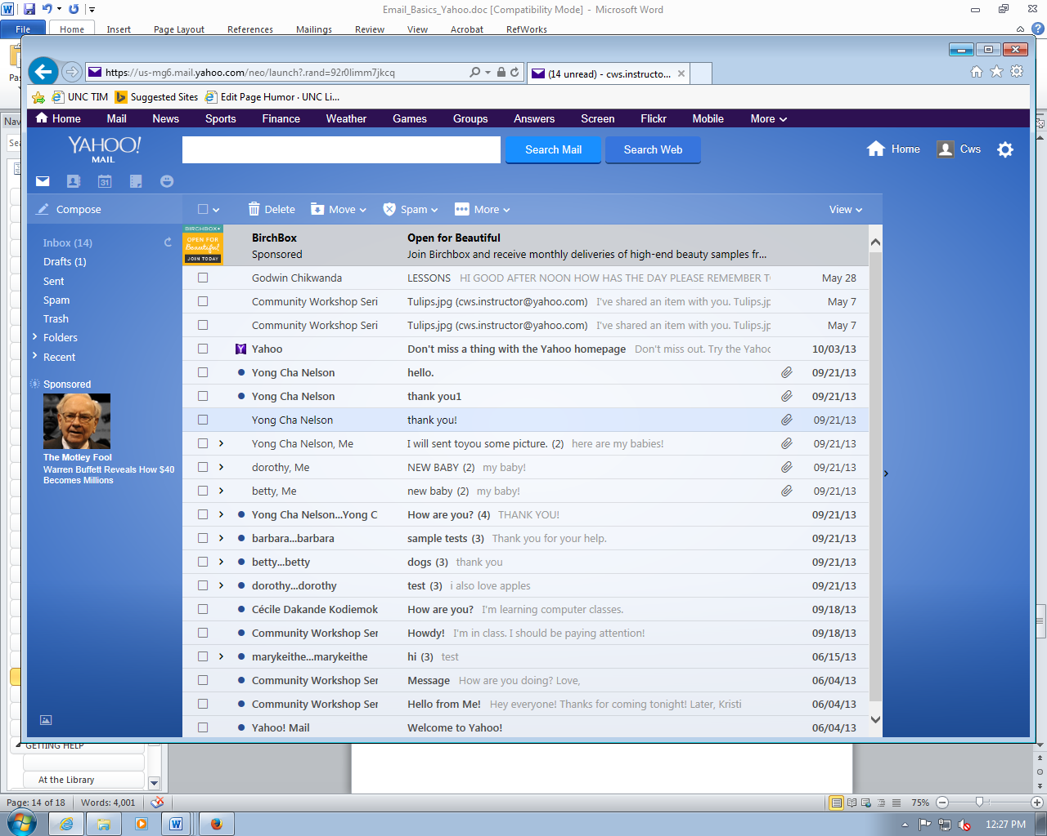

Contacts
The Contacts feature allows you to keep track of e-mail addresses, which can sometimes be hard to remember. To access your Address Book, click on the Address Book icon.

Adding addresses: To add an address, click the New Contact button. You can add as little or as much additional information about each e-mail address as you like. Keep in mind, however, that if you add the name of the person associated with the e-mail address, it will be easier to look up later since e-mail addresses don’t always contain the person’s name.
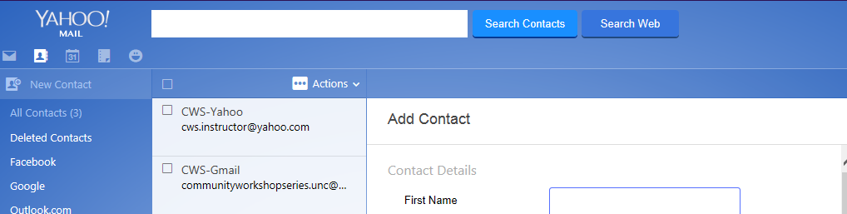

Calendar
There is a link on the top icons menu for the Calendar. (It is a picture of a calendar with the number 31). This is a neat tool that gives you an online personal calendar that you can access anywhere you have Internet access. To add something to your calendar, just click the Add Event button. This will bring up a form that you can fill out with as much or little information about the event as you wish. You can also keep track of tasks you need to complete using the To Do feature. Click on the Plus button next to one of the To Do options on the right-hand side of the screen. As you complete tasks, you will be able to mark them as done. The different options (day, week, month, year) at the top of the calendar allows you to choose how you view the calendar- one day at time up to a year at a time.
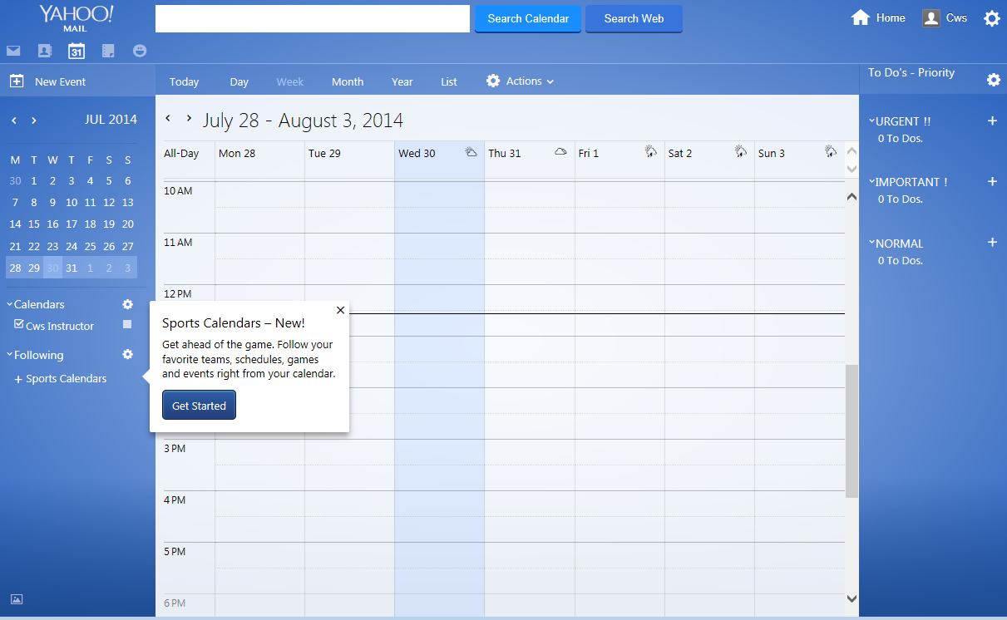

Notepad
Notepad is a very straightforward feature that allows you to keep simple text documents. The link for this can also be found at the top menu as the icon that looks like a notepad. You can create folders to organize them, and you can keep track of what date they were written.

Messenger
The Messenger feature can be accessed by clicking on the smiley face icon at the top menu. This allows you to chat with your Yahoo! contacts.

Themes
The Themes feature can be found by clicking on the Gear icon on the right side of your screen:
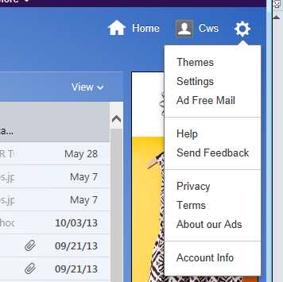
This option allows you to select a theme to apply to your Yahoo! mail. When you click on themes, you will have some options to choose from:

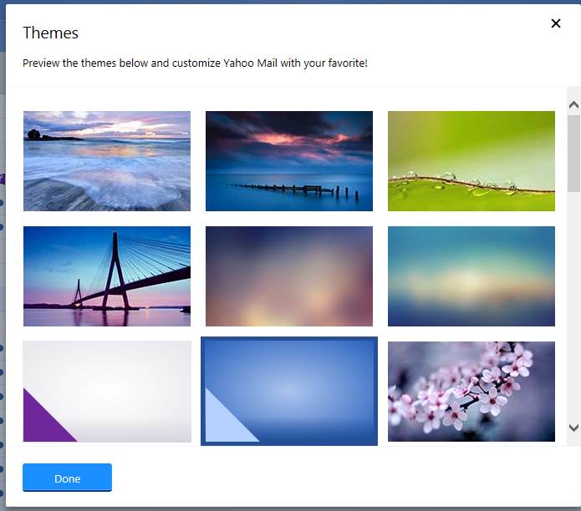
GETTING HELP

At the Library
You can access your Yahoo! account from anywhere there is Internet, including your public library. However, the library has no control over your free e-mail account. When the Internet is busiest, your account is likely to be slow. At times, you may not be able to access it at all. While library staff might be able to help you with the features of your account, remember that they cannot look up your username and password for you.

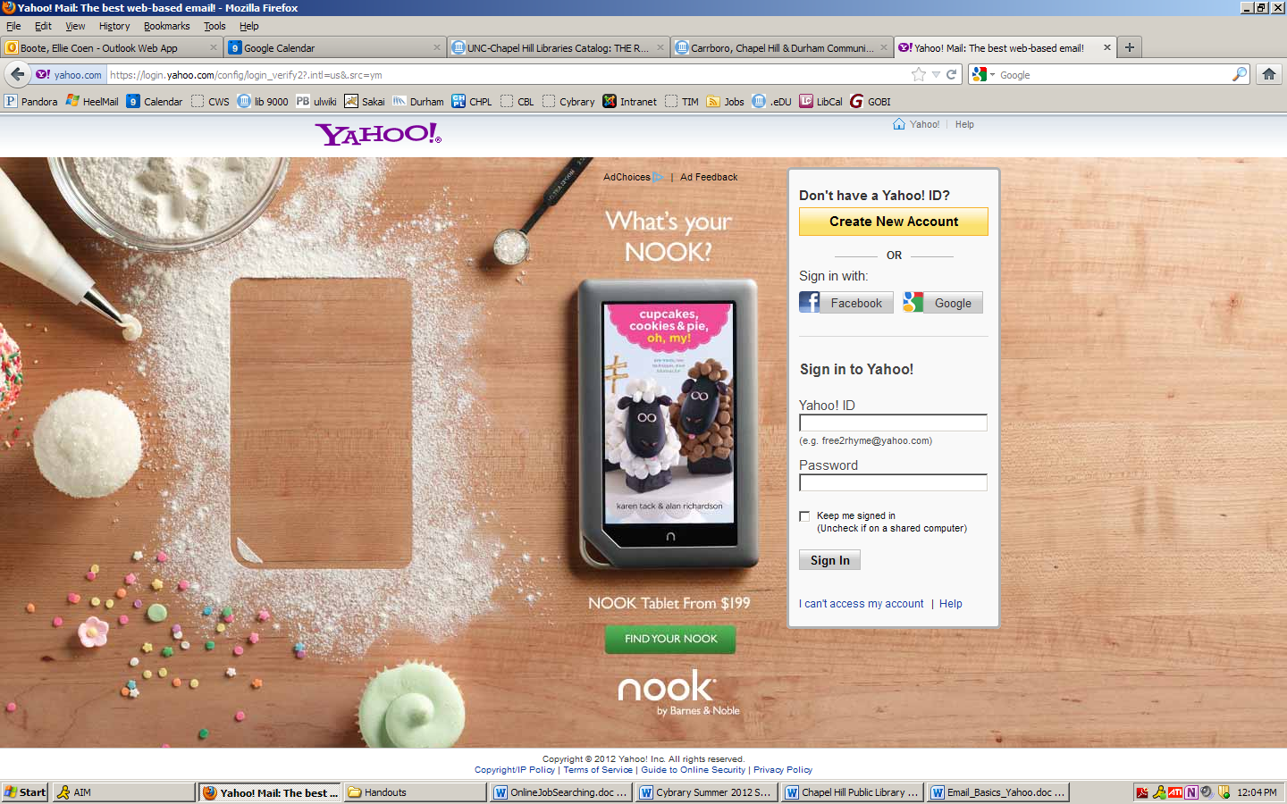
What if I forget my password?
If you remember can’t remember both your ID and Password, Yahoo! can help you remember it. Remember those personal questions you answered when you were signing up? Click on the link for I can’t access my account below the Sign In button, and Yahoo! will prompt you to answer these questions or provide other identifying information. If your answer matches the one you provided when you signed-up, or if you can provide enough personal information, you should be able to retrieve your forgotten information.

Note: This feature only works if you can remember either your ID or Password. If you have forgotten both, you may need to create a new account.

Yahoo! Mail Help
If you have a specific question click on the Help option found in the Menu that comes up when you click on the Gear icon.

On the Help page, you can type your question or problem into the search box, or you can browse through the categories and find one that best meets your needs.

NOTE: Images and screen captures may differ from those seen on another system.

This work is licensed under a Creative Commons Attribution-NonCommercial 4.0 International License.

