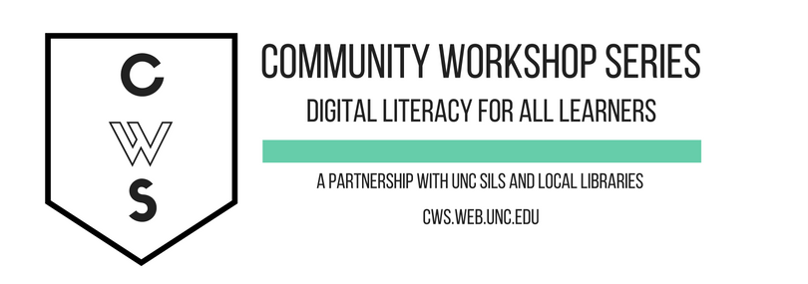

E-MAIL BASICS:

GETTING STARTED PAGE 02
Prerequisites
What You Will Learn

INTRODUCTION PAGE 03
What is E-mail?
Pros, Cons, and Tips
Text Speak Dictionary

SETTING UP AN ACCOUNT PAGE 05
Setting Up Your E-mail Account

MANAGING YOUR E-MAIL: GMAIL PAGE 09
Checking Your E-mail
Composing and Sending Messages
Receiving and Reading Messages

GETTING HELP PAGE 17
At the Library
Gmail Help
What If I Forget My Password?

To complete feedback forms, and to view our full schedule, handouts, and additional tutorials, visit our website:
cws.web.unc.edu

WHAT YOU WILL LEARN

Prerequisites

It is assumed for this class that the user is comfortable with basic computer operations. In addition, very basic Internet experience is recommended.

- This workshop is intended for new e-mail users.

- We will be using PC desktop computers running Microsoft Windows Operating System in addition to Gmail e-mail services.

- Please let the instructor know if you have any questions or concerns prior to starting class.

- For verification purposes, you may need access to a cell phone that accepts text messages or an alternate email address before your account is activated. Please let the instructor know if you do not have this.

You don’t have to create an email account tonight if you’re not ready to! The instructor has information for our CWS practice account that you can use.

What You Will Learn

Understand the pros and cons of e-mail use | Create and access an e-mail account | Open and read received e-mail
Compose and send e-mail | Attach a document or picture to an e-mail | Open an attachment
Organize your e-mails | Retrieve a document or picture from a received e-mail | Find help

INTRODUCTION

What is E-mail?
E-mail, short for Electronic Mail, consists of messages which are sent and received using the Internet. While there are many different e-mail services available that allow you to create an e-mail account and send and receive e-mail and attachments, we have chosen to focus this class on the services available through Gmail because it is free and one of the more popular e-mail services available.

The Pros
- It's fast. Most messages are delivered within minutes – sometimes seconds – around the world without the inconvenience and cost of using a postal service. In fact, postal service is often referred to as "snail mail" by e-mail users.
- It's personal. While the nature of e-mail is informal, its efficiency is an excellent substitute for telephone conversations.
- You can think through your response. Like a letter, you can type your reply and make changes before sending.
- The sender and the receiver don't have to be working at the same time. E-mail avoids problems such as telephone tag or tying to contact someone in a different time zone.
- E-mail makes it easy to keep a record of your communication. You can save and refer to later copies of the e-mails you send as well as those you receive.
- You can reach a lot of people at once. It is possible to send one message to hundreds of recipients at once, or you can send a private message to one individual.

The Cons
- Junk Mail (also referred to as spam). This is as annoying in e-mail as it is with traditional mail. Most e-mail services now filter incoming mail and sort e-mail messages that are most likely advertisements or scams into a folder called “spam.”
- Friendly spam. Try not to forward unnecessary messages to friends who may not appreciate hearing the latest list of “Top Ten Things…”
- Ads. The reason you can get free e-mail services like Gmail is because of advertisements. You pay the price of having to click around them to read your mail.
- Misinterpretation. E-mail arrives without tone or facial expressions, which can lead to misunderstanding.
- E-mail messages can be passed on to others. You should always count on the possibility of your message ending up in the inbox of someone it wasn't intended for.
- You can hide behind e-mail. It's tempting to use e-mail instead of facing a person when you have to deal with an unpleasant situation. It's best to talk to a person face-to-face under these circumstances.

Don’t use e-mail for:
- Long or complicated messages
  - Sometimes it's more effective to speak to someone in person or on the phone. It can be difficult to effectively write down a complicated message in e-mail format.
- Questions that require a lot of clarification
  - If a message is going to require several exchanges back and forth to make sure it is understood, more direct communication is best.
- Delivering indiscreet, sensitive, or private information.
  - While your e-mail account is personal, keep in mind that, while rare, passwords have been stolen and there are ways for interested parties to intercept information. Do not send your social security number, credit card number, or bank account information in an e-mail if it can be avoided.
- Angry exchanges
- Things you should say in person

Text Speak Dictionary
Many users of e-mail use an abbreviated form of English that began with text messages. These abbreviations can sometimes be confusing, so here is a brief list of the most commonly used “text speak” words.

?: What?
<3: Heart
<3333: Bigger heart (more 3s increase the size of the heart)
2day: Today
4u: For you
b/c: Because
b4: Before
BRB: Be right back
BTW: By the way
C U: See you
EZ: Easy
FB: Facebook
FTW: For the win
GR8: Great
H8: Hate
IMHO: In my humble opinion
JK: Just kidding
L8R: Later
LOL: Laughing out loud
Meh: Indicates a shrug
NP: No problem
OMG: Oh my gosh
PLZ: Please
RLY?: Really?
SRSLY: Seriously
Sum1: Someone
THNX: Thank you
TTYL: Talk to you later
U: You
XOXO: Hugs and kisses
Y?: Why?
YOLO – You only live once

For an extensive list of possible texting and chat abbreviations, check out: http://www.webopedia.com/quick_ref/textmessageabbreviations.

GETTING STARTED

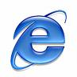

Setting Up An E-mail Account
1. Connect to the Internet by double-clicking the Internet Explorer or Firefox desktop icon.

2. Go to the Gmail site by typing gmail.com into the address bar at the top of the screen, and press the Enter key on your keyboard.

3. Depending on what browser you are using and whether or not it has been updated recently, you should see a screen that looks something like this:

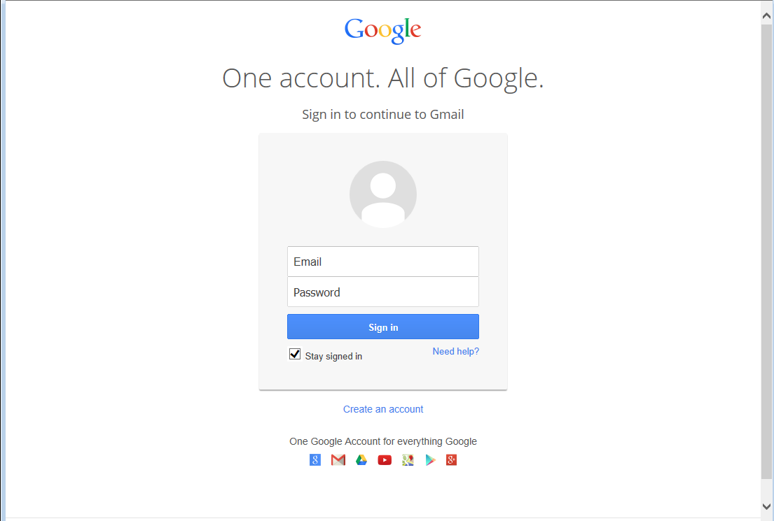

Click on the Create an Account link

Make sure “Stay Signed in” is UNchecked whenever you log in

4. Complete all required information in the form.
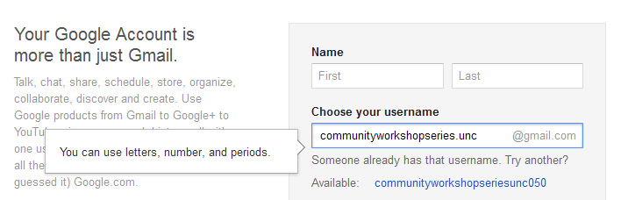

Desired Username: Keep in mind that your Gmail Username will become your e-mail address so choose carefully! Because there are so many people who use Gmail, sometimes you might have to try a few before finding one that is available. When you type in your selection, if this username is already in use it will suggest some alternative usernames that are available which will be displayed below the username box. Common e-mail addresses are: firstname.lastname OR firstinitial.lastname. People often choose to use their name if they will be using this e-mail address for professional purposes.

Tip: Your Username/e-mail address doesn't have to be your given name. With e-mail, you can, for example, choose something that is related to your occupation or interests. For example, you might want to be bluebird@gmail.com. If you find that name is already taken, you could always add some numbers after it to make it more unique. If you were born in 1960, you could be bluebird1960@gmail.com. Don’t use the same words/numbers you plan to use in your password though!

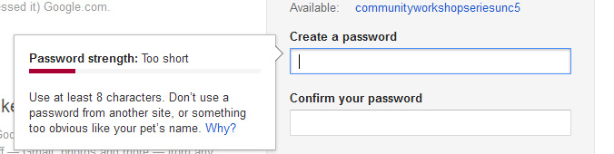

Password: You will also need to select your password. Make sure your password is something that you can remember, but no one else can easily figure out! Don’t ever share your password with anyone else. Follow the guidelines provided for the required number of characters. To protect your password, it's a good idea to change it periodically.

Here are tips from Google regarding passwords (https://www.google.com/accounts/PasswordHelp):
Tips for creating a secure password:
- Include punctuation marks and/or numbers.
- Mix capital and lowercase letters.
- Include similar looking substitutions, such as the number zero for the letter 'O' or '$' for the letter 'S'.
- Create a unique acronym.
- Include phonetic replacements, such as 'Luv2Laf' for 'Love to Laugh'.
Things to avoid:
- Don't use a password that is listed as an example of how to pick a good password.
- Don't use a password that contains personal information (name, birth date, etc.)
- Don't use words or acronyms that can be found in a dictionary.
- Don't use keyboard patterns (asdf) or sequential numbers (1234).
- Don't make your password all numbers, uppercase letters or lowercase letters.
- Don't use repeating characters (aa11).
Tips for keeping your password secure:
- Never tell your password to anyone (this includes significant others, roommates, parrots).
- Avoid writing your password down (unless you have problems remembering, then keep it in a safe place!).
- Never send your password by e-mail.
- Periodically change your password (e.g., every six months).
- Do not save your password in your internet browser (your browser will likely ask if you wish to save the password) – other people who use your computer will be able to log in as you!
For now, write down your Google Username and password. This is crucial because you will NOT be able to access your e-mail without them, but keep this piece of paper in a safe place!

Google Username: ______________________________

Password: ______________________________

VERIFICATION
5. After you’ve entered your Birthday and Gender it will ask for a Mobile Phone Number and Your Current E-mail Address. If you do not have a Mobile Phone Number with you that can accept either a text message or voicemail, ask the instructor for an e-mail address to use. This number or e-mail address will ONLY be used to verify that you are not a spammer.

6. Now type the code into the box as you see it on your screen. These codes can be hard to read, if you are having trouble with some of the characters you can choose to listen to them read aloud.

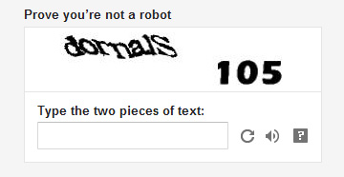

7. Finally, you have to agree to the Terms of Service. Read through the text, and then click "I Agree."
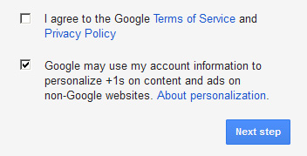
If you do not wish to use Google+ uncheck the second box (let the instructor know if you have questions about this).

Congratulations – You now have an e-mail account! Remember that your e-mail address is your Google Username directly followed by "@gmail.com."

Before you are directed to your e-mail inbox, Google will ask you if you would like to set up a Profile picture, this is an optional step and you may choose to skip it and Continue to Gmail.

MANAGING YOUR E-MAIL

Once you have set up your e-mail account, you can check your mail anywhere that you can access the Internet. This is how it is done:

1. Connect to the Internet by double-clicking the Internet Explorer or Firefox desktop icon.

2. Go to the Gmail site by typing gmail.com into the address bar at the top of the screen.

3. Type your Google Username and Password into the box.

4. You will be directed to your inbox when you logon. The number of new or unread message in your inbox is displayed next to Inbox on the left-hand navigation column. Any messages you have not read will also appear in bold type. Gmail separates your email using tabs. So e-mails like newsletters from a retail store will appear in the Promotions tab to help keep your Primary inbox clear. If you have a new message in any of those tabs, you will have an icon next to the tab name.

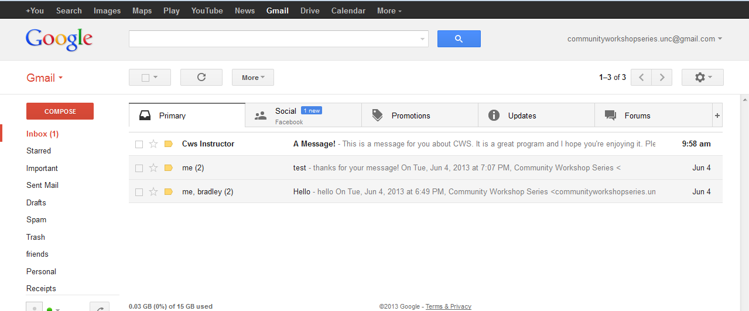

If you prefer to have all of your messages on one tab, you can click on the Settings icon , go to Configure inbox and unchecking the tabs you do not wish to see. Deselecting all the categories will show you one inbox with no tabs.

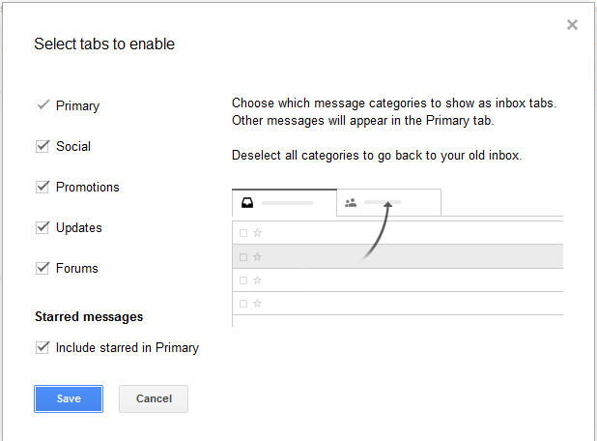
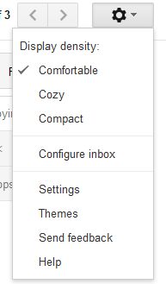

5. The inbox is where all of your incoming messages are stored. Click on the subject of the message to open and read it. We will go into more detail regarding Receiving and Reading messages in a later section.

Composing and Sending Messages
To create a new message, click the red Compose button on the top left side of the screen.

The compose screen is a blank message that shows up in the lower right hand corner of the screen:

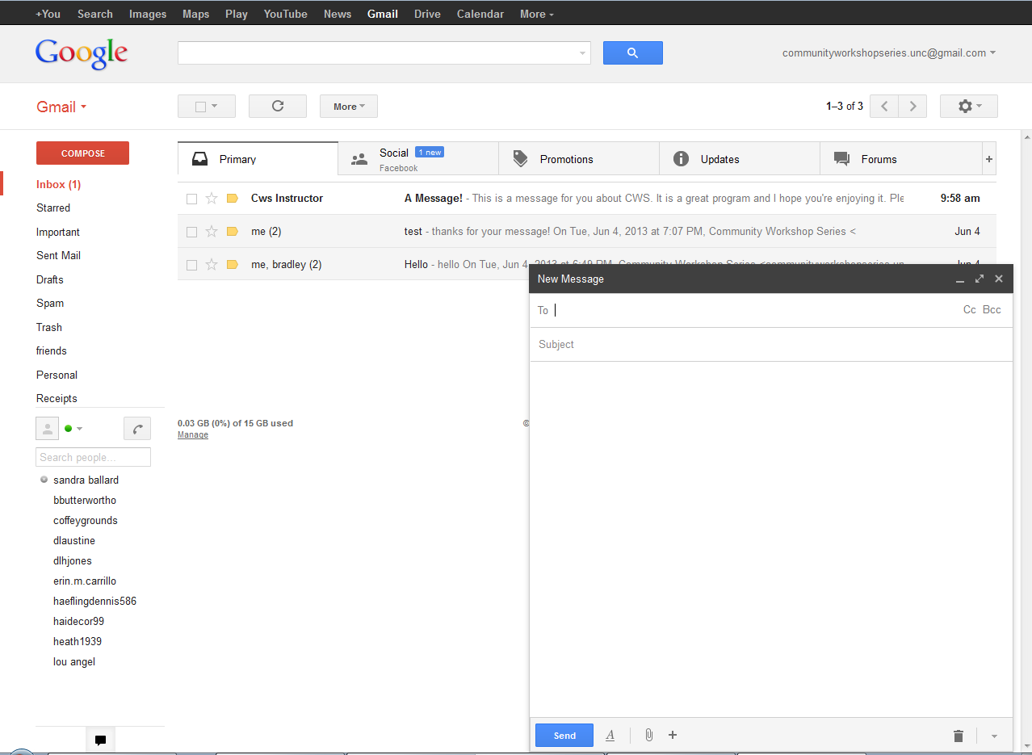

To (Recipients): is where you type the e-mail address of the person(s) to whom you wish to send the e-mail.

Subject: is a brief summary of the subject of your message. It is important to include a subject line because it will allow the recipient to see what your e-mail is about before they open it. It is especially helpful if you are sending e-mail to someone who might not recognize your e-mail address. This will help indicate to them that the e-mail is not spam or junk e-mail.

Add CC / Add BCC: To add secondary addresses to your e-mail, click on these links on the right side of the To field and additional boxes will appear.

- Add CC: “CC” stands for "carbon copy." This box allows you to "copy" a person on an e-mail that you are sending to someone else. The person whose e-mail address is in the “To:” box will be able to see the e-mail address of anyone who is CC’d.

- Add BCC: This is for "blind carbon copies." If you send a copy of an e-mail to someone by putting their address here, the recipients in the To: and CC: boxes will not be able to see that person's address.

You can enter multiple recipients in all three address boxes. Separate the addresses with a comma and a space. Gmail will put a gray box around valid email addresses when you separate them with a comma. Example: bluecat461@gmail.com, ggsmith18@gmail.com

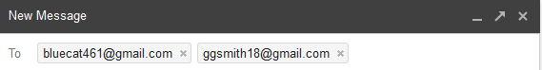

The box where you actually type your message is easy to spot because it's the largest one in the window. Click inside to start typing. If you want to change the appearance of your text, you can click the A icon next to the send button for formatting options. The formatting options are similar to those used in Microsoft Word.

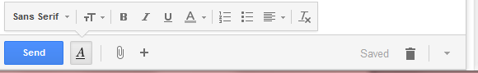

Once you have completed your message, send it by clicking on the Send button at the bottom of the window.

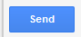

IMPORTANT: You cannot cancel a message once you have sent it, so make sure you want to send the message before you click Send. Be sure to check your spelling using the Check Spelling link on the formatting toolbar.

By default, Gmail saves the messages you send in your Sent Mail folder so you have a record of what you sent and when. You can find your Sent Mail folder in the sidebar on the left side of the page.

Attaching a file to your message
You can attach files to your e-mail messages. This feature allows you to send pictures, documents and even sounds.

To attach a file, first you need to do the same things you do to compose a message.

1. Click on Compose Mail.

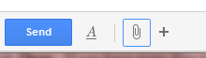
2. Type the address

3. Type the subject

4. Type the message

When you finish typing your message, click on the paperclip icon next to the A at the bottom of the compose window.

This opens the Attachment window:
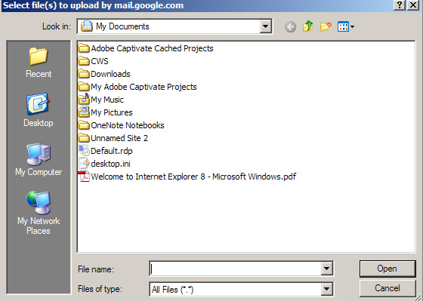

1. Click on the down arrow of the "Look in:" drop-down menu to find the file on your computer. Click on the file you wish to attach and click Open. If you have more files to attach, repeat these steps before moving on to step #2.

2. Gmail will automatically attach the files to your message. This may take a little time, depending on the size of your file. Once the file is attached, you'll see the name and size displayed underneath the Subject box.

Click Send to send the message.

Receiving and Reading Messages
As we went over earlier, when you log into Gmail, the number of new or unread messages is indicated in parentheses next to the word “Inbox” in the left-hand navigation column.

By default, e-mail messages are viewed in the Inbox. New messages are in bold font. To view your message, click on the subject to open it.
Once you have read your message, you have several options.
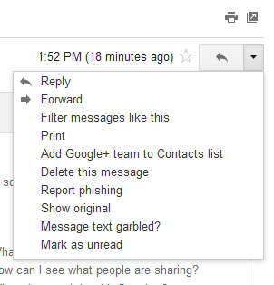
Replying to the message: Selecting this option will include the original message at the bottom of the e-mail and automatically address the message to the person who sent it to you. You can then add text to the existing message and delete portions of the original text if you wish before sending your reply to the original sender (kind of like replying to a letter and including the original letter in your new envelope).

Click on the Reply button to reply only to the sender. Or click on the arrow on the Reply button and select Reply to all if you prefer to send the message to all recipients of the original message.

Forwarding the Message: This feature copies the message you are viewing for delivery to another e-mail address. You can't see the original message but you can add text at the beginning of the message before sending it.

Deleting a Message: When you click on this option, the message you are viewing is moved to the Trash folder. Gmail does not automatically delete messages in the Trash folder right away, so you must enter the trash folder by clicking on it in the left navigation bar, select messages you wish to delete, and then click the Delete Forever button in order to delete messages permanently.

Assigning Labels: You have the ability to organize your e-mail with labels. When you assign a label to an e-mail, it can then be found in the corresponding folder. For instance, if you receive an e-mail related to work, and assign it the Work label, it can then be found in the Work folder (listed on the left-hand navigation column).

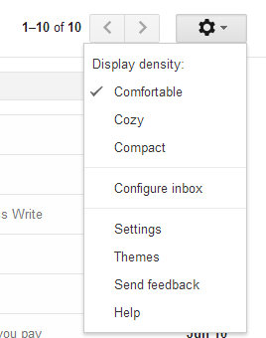
Several labels have already been created for you (Personal, Receipts, Travel, Work). To create labels of your own or edit existing labels, click on the gear icon at the top right of the screen and select Settings.

Click the Labels tab and you will see a list of all the labels you currently have. You can create as many labels as you want and choose which ones to show in the left hand navigation menu and assign colors to each individual label. Show if unread means that the label will only appear in the navigation pane if there are any unread messages with that label.

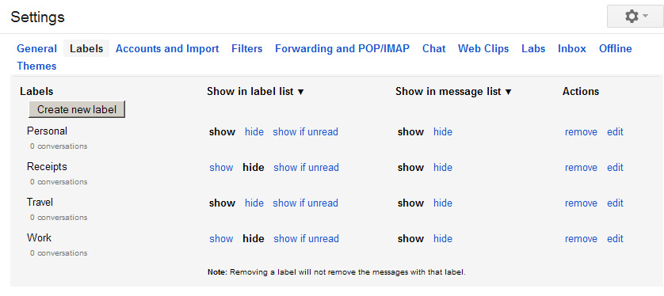

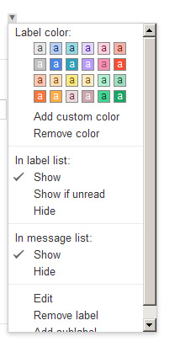

Change colors by selecting the small square to the left of the label in the Inbox view. This allows you to color code your messages and view them by each label category. Labeling an e-mail does not automatically move it out of the inbox, see below on moving messages.

Moving Messages: Messages can be moved to folders by selecting them in the Inbox, and selecting a location using the Move To menu.

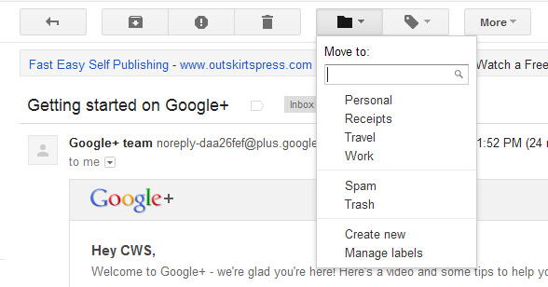

Receiving an attachment: When you receive a message with an attachment, a paper clip appears next to the subject of the message in your inbox.

Click on the subject of the message to open the e-mail. At the bottom of the message, you will see a preview of the attached file and its name.
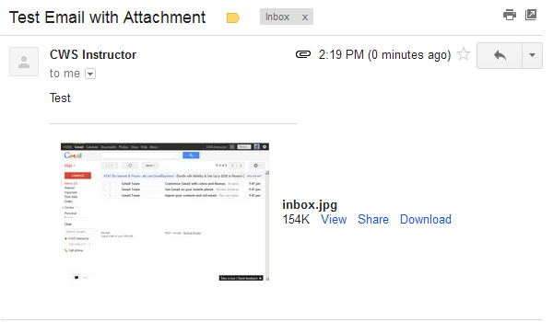
This e-mail has an image file attached to it called inbox.jpg.

If you click on the Download link, Gmail will download the attachment to your computer.
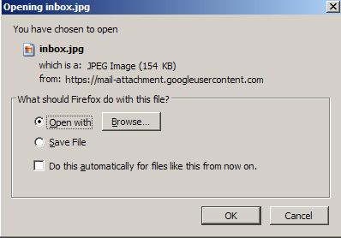
A box will pop up and ask you if you would like to open the file, or if you would like to save it to a disk:

To open the file, select Open With, and then click the OK button, and the program that runs this type of file (such as Word) will open the attached file.

To save the file to your computer, select Save File. If you choose this option, you won't get to see the contents of the file first.

IMPORTANT: Never open an attachment if you don't know the person who sent it. This is the most common way computer viruses are sent. Do not open a file that ends in .exe unless you already know what it is and why you're receiving it. If you think any attachment – even from someone you know – looks suspicious, do not open it. If you would like to learn more about computer viruses, how they are transmitted, and what damage they can do to your computer, go to this web address:

http://computer.howstuffworks.com/virus.htm

GETTING HELP

At the Library
You can access your Gmail account from anywhere there is an internet connection or wireless internet, including your public library. However, the library has no control over your free e-mail account. While library staff might be able to help you with the features of your account, remember that they cannot look up your username and password for you.

Gmail Help
If you have a specific question, at the top right corner of your Gmail page you will find the Gear icon. Click on the Gear icon, and then click on the Help link. It will open a window with a search box and you can type your question or problem into the search box. To learn more about Gmail in general, you can click Help Center to open a page where you can choose a category to read about. This page includes a ton of great information, including tutorials on how to handle spam and how to set up filters. There is more to learn about e-mail than we can cover in a class, so make use of this resource.

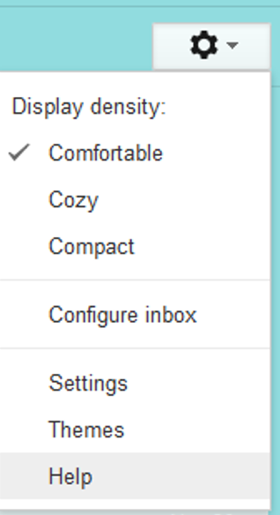

Forgotten Email Address/Username
This process requires access to a cell phone or an alternate email address.
- Go to Gmail.com and click on “Need Help?” under the sign in area.
- Choose “I don’t know my username” and click “Continue.”
- You can choose “Enter your recovery email address” if you have a backup email account registered with Gmail. If you do not have a backup account registered with Gmail, click “Enter your recovery phone number.”
- Gmail will ask you to verify your cell phone number. They will then send you a text message with steps to recover your password. You will also be required to enter the name associated with the account.

Forgotten Password
This process requires access to a cell phone.
- Go to Gmail.com and click on “Need Help?” under the sign in area.
- Choose “I don’t know my password.” When you click on this, a box will appear asking you to put in your email address. Put in your email address and click “Continue.”
- A box will appear asking you to enter the last password that you remember. Enter a password if you can remember one; otherwise click “I don’t know.”
- If you remembered a password, Gmail will ask you to verify your cell phone number. They will then send you a text message with steps to recover your password.
  - If you do not have cell phone access, there are other recovery options. Click “I can’t access my phone” and follow the instructions.

NOTE: Images and screen captures may differ from those seen on another system.

This work is licensed under a Creative Commons Attribution-NonCommercial 4.0 International License.

