

INTRODUCTION TO CLOUD STORAGE

GETTING STARTED PAGE 02
Class Overview
What You Will Learn

What is the Cloud? PAGE 03
Basic Vocabulary
Advantages of the Cloud
Disadvantages of the Cloud

Cloud Storage Services PAGE 04
Dropbox.com
Google Drive
Apple iCloud
OneDrive
Amzaon Cloud Drive
SugarSync
Bitcasa Infinite Drive

Getting Setup with Dropbox PAGE 06
Dropbox.com Home Screen
Uploading a File to Dropbox.com
Sharing/Unsharing Files with Dropbox

Getting Setup with Google Drive PAGE 15
Uploading a File to Google Drive
Sharing/Unsharing Files with Google Drive
Creating Google Drive Files

View our full schedule, handouts, and additional tutorials on our website:
cws.web.unc.edu
GETTING STARTED

Class Overview

This is a class for beginning computer users. You should be familiar with the Microsoft Windows operating system and using a browser to surf the Internet.

We will be going over the basics of cloud storage. We’ll learn what cloud storage is and some cloud storage services currently available. We will discuss the pros and cons of using cloud storage and create a cloud storage account using Dropbox.com or Google Drive. If you do not feel comfortable with any of the activities, it is completely fine not to participate.

Please let the instructor know if you have any questions or concerns before the class, or as we go along.

You Will Learn:

Vocabulary words | What is the cloud | Advantages of the cloud
Disadvantages of the cloud | Cloud storage services | Getting started with Dropbox
Getting started with Google Drive

WHAT IS THE CLOUD?

Vocabulary Words to Know
Upload – Take a file from a local machine and send it “up” to cloud storage
Download – Take a file from cloud storage and bring it “down” to your local machine
Server - A computer that responds to requests over a computer network

The cloud is simply a network of computers. It refers to a network of computers owned by one person or company, where other people or companies can store their data. On your personal machine, everything is stored on one physical storage device – your hard drive. Cloud storage refers to a virtual storage area that can span across many different physical storage devices. When you use cloud storage, some of your files may be on a physical server in New York while other files are on a physical server in California. Since most users do not know where their physical files are, using cloud storage can be thought of as a vague, untouchable thing – much like a cloud itself!

Most data you access via the internet that is not stored on your personal computer is part of the cloud. For example, if you use an internet-based email service like Gmail, Yahoo, or Live, you can access your email anywhere you have an internet connection. This is because the data is stored on servers owned by the respective e-mail providers, not your local machine. Your email is in the cloud.

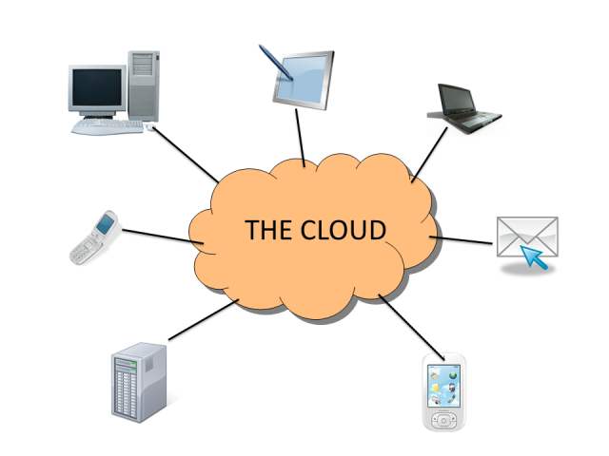
Although the cloud is more like an idea than something you can physically touch, the computers that make up the “cloud” require physical space. The facilities that store the physical equipment used by the cloud are called data centers. Sometimes you may also hear the term server farm. Data centers can be anywhere in the world. They are generally in warehouses that have complex cooling systems to keep the computers from overheating.

Advantages of the Cloud

Syncing
Many cloud storage services offer syncing services. When you set up the software on your local machine, it will create a special folder on your computer and any changes made to the files in that folder will be automatically synced to your cloud storage as long as your computer is connected to the internet. When you access your cloud storage from a different computer, you will see the same files that are in that folder on your personal computer. Also, any files you upload to your cloud storage from a different computer will be synced to that same cloud storage folder.

Convenience
One of the biggest benefits of using the cloud is that your data can be accessed from multiple devices. Cloud storage services can usually be accessed from any device with an internet connection. You can check your email, read your documents, view your online photos, or listen to your online music from any computer, tablet, or internet-enabled cell phone.

Online Backups
One advantage to using a cloud service is that it can serve as an online backup for important files in case your computer stops working. If your computer crashes or you accidentally delete pictures from your hard drive, you can simply login to the cloud service and download your files again. Some cloud storage services may prompt you to automatically add files to the synced folder as soon as you add them to your computer to serve as a backup.

Disadvantages of the Cloud

Internet Connection Required
Since data stored on the cloud is on a third party’s computer, you will need an internet connection to access it. If you do not have access to the internet, you will not be able access the network of computers that store your data.

Bandwidth Costs
Bandwidth refers to the amount of data that can be carried over the internet from one point to another. Some internet service providers give users a monthly bandwidth allocation. By transferring data to and from the cloud, you will be using part of the allocation and may have to pay overage charges if you go over that allocation.

Privacy
One downside of the cloud is potential privacy issues. Make sure you read the terms of service and privacy policy of any cloud storage service closely. You want to make sure that you are not agreeing to anything that you are uncomfortable with. For example, any cloud storage company in the U.S. can be required to give the government access to your files with a subpoena.

A website called Terms of Service – Didn’t Read, www.tosdr.org, attempts to break down terms of service into easy to understand language. You can reference that site if you want to fully understand what you are agreeing to.

CLOUD STORAGE SERVICES

There are many cloud storage services available and many offer a free plan for a limited amount of space. Depending on your needs, a free plan might be plenty for you. This is a list of just a few available cloud storage services.

Dropbox.com
Dropbox.com is one of the most popular cloud storage services available. It was started in 2007 by a man that kept forgetting to carry his flash drive around. Dropbox uses encryption to help keep your data secure and everything you upload is automatically private. Dropbox offers different plans for individuals and businesses but it starts off giving each individual 2 gigabytes of free storage.

Google Drive
Google Drive allows users to store a variety of files. It gives users the opportunity to share files with certain email addresses, publicly, or anyone that has the link to the file (for example, if you email a link to your friends). It provides 15 gigabytes of storage for free and if you have a Gmail address, you already have access to Google Drive. Google Drive also allows users to collaborate and make changes to files at the same time. This can be helpful for teams and groups.

Apple iCloud
iCloud was launched by Apple in 2011. It allows users to always have access to the latest information from their Apple devices (iPhone, iPad, Mac, etc.). iCloud is particularly useful for sharing photos, calendars, etc. with other users. You do not have to have an Apple device to have an iCloud account, but you can only access your information when using an Apple device or a PC to which you’ve downloaded the iCloud software. However, you can get web-only access to your account that allows you to create new documents—use ‘Pages’ to create letters, flyers, and more; use ‘Numbers’ to create spreadsheets; and use ‘Keynote’ to create presentations. You have 1 gigabyte of free storage for any documents you create in iCloud.
OneDrive
OneDrive is Microsoft’s cloud storage service. It offers 7 gigabytes of free storage for new users and users can purchase additional storage space. It has Office Web Apps support, which means that users can create, edit and share Microsoft Office documents directly within a web browser.

Amazon Cloud Drive
Amazon.com offers a cloud storage service that gives users 5 gigabytes of free storage. If you have an Amazon.com account, you can log into the cloud storage service using your existing username and password.

GETTING SETUP WITH DROPBOX
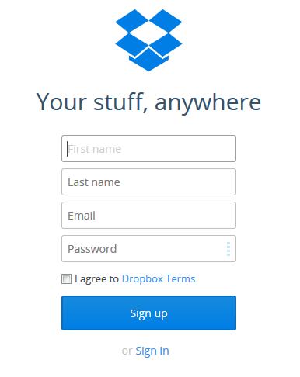
Please note that though these instructions are for a Windows computer, it should work much the same way on a Mac computer. When you first go to dropbox.com, you will see a button labeled “Sign up” in the middle of the screen. When you click the sign up button, you will need to provide your first name, last name, email address and a password. Make sure to keep note of the email address and password you use. Note: Dropbox.com will send you an email and you will have to confirm your account.

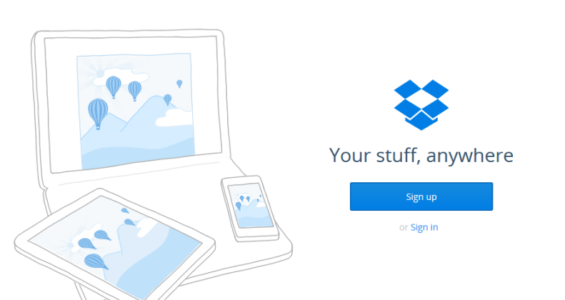

My Dropbox.com email address: _______________
My Dropbox.com password: ___________________

Once you are logged in for the first time, a download window may automatically popup. Cancel this for now if you are on the library’s computer! You will be able to install it later on your personal computer.

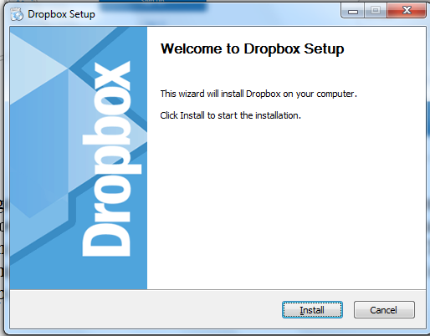
If you are using your own computer, you can save this file and install Dropbox on your computer. This will create a folder on your computer that will be used to sync with Dropbox’s cloud storage. Save the file to the Desktop and double-click so you can install it.

Once you click on Install, the program will install and prompt you to either sign up for a Dropbox.com account or enter your credentials. Select “I already have a Dropbox account” and click next. Enter your email address and password that you used when you signed up and you can name the computer. This is so you can keep track of the different installations of Dropbox that you may have across multiple machines.
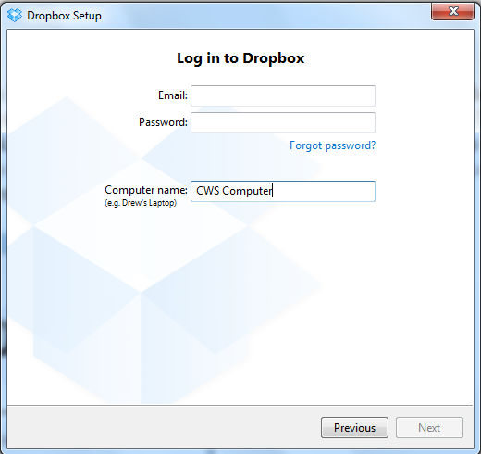
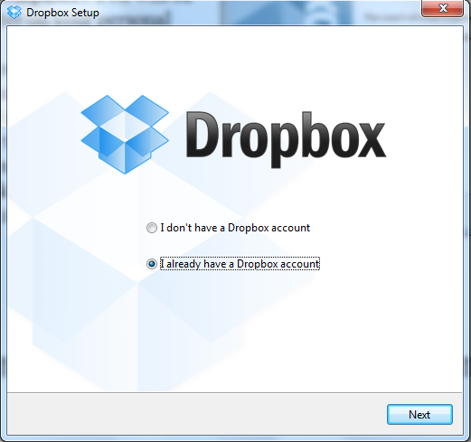

Dropbox will then provide you with a few screens with different options, such as an option to upgrade to a paid plan for more storage and enter your mobile phone number to connect Dropbox.com to your phone. You can skip these options for now. Don’t worry – you can set them up later if you choose. When asked to choose the setup type, use Typical. This will create the Dropbox folder on your desktop.
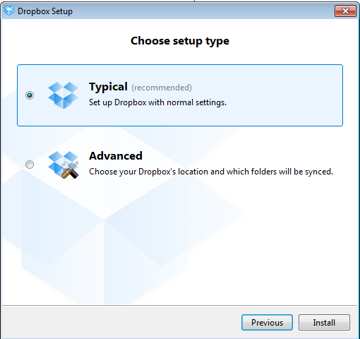
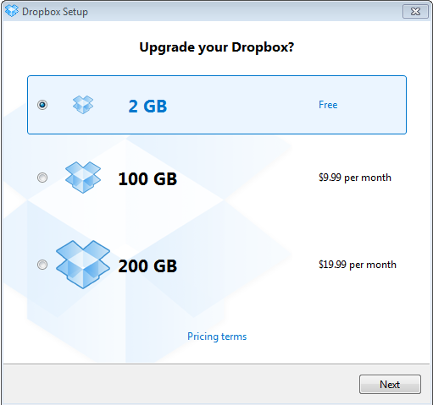
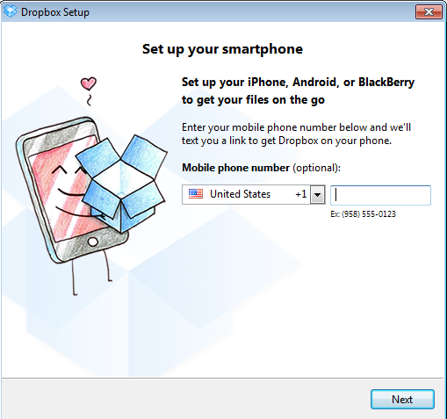
Once you have completed the setup, you will have an icon on your Desktop. If you double-click the icon, it opens a Windows Explorer window with a Getting Started.pdf guide included. This is Dropbox.com’s starter user manual that is given to all users. You will see it has a small green checkmark on the icon. This means that the file has been successfully synced to Dropbox.com and you will be able to access this file each time you log into the account.
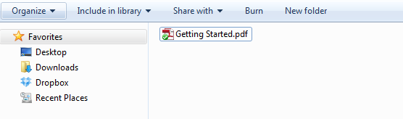

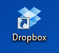

You can now treat this Dropbox folder like any other folder on your computer. You can save files directly to this folder. You can add, remove or edit any files. You can also create additional folders within this folder. When you add or edit files in this folder, it will sync to Dropbox.com. When a file is syncing, the icon includes a small blue circle. Any files that are done syncing will have the green checkmark.

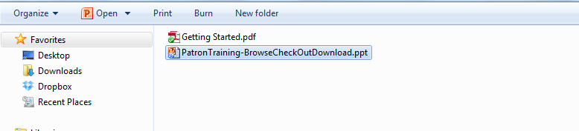

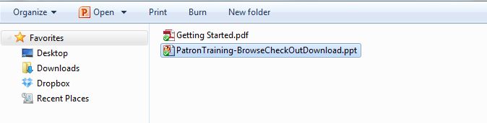

Dropbox also puts an icon in your task bar. Clicking on this icon will take you to your folder.

Dropbox.com Home Screen
When you are logged into Dropbox.com, your home screen shows you a list of all the files, what kind of file it is, and when the file was last modified.

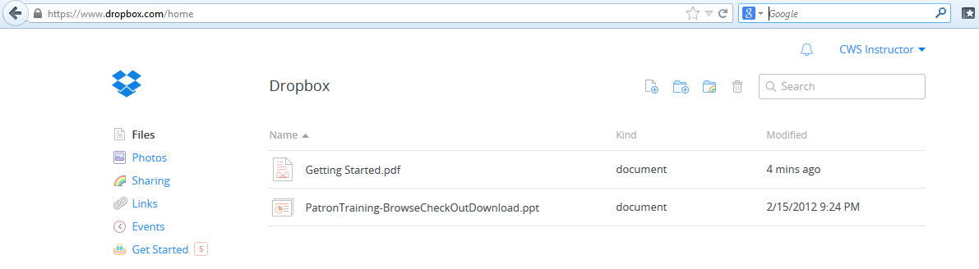

On the left side of the screen, you will see a navigation menu with the following options:

Files – navigates to the home menu where you can see all of your files
Photos – lists only the photos and videos you have in your account
Sharing – lists the folders you have chosen to share with others
Links – lists the links you have chosen to share with others. When you provide someone a link to a file, they can open it even if they do not have a Dropbox account
Events – shows a 6-month timeline of the files that have been changed in your account
Get Started – provides a list of steps you can complete to get a free additional 250 megabytes of space.

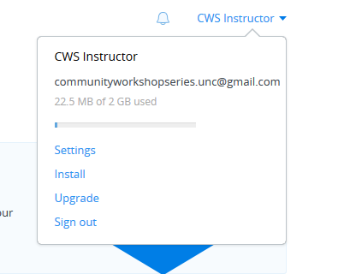
Clicking on your name in the top right-hand corner will bring up a list of options. This is where you can check on the amount of space you have left to use. This is also where you can install a Dropbox folder on another computer or upgrade your account for additional storage. You also sign out of your account from this menu.

A few icons at the top of the screen allow users to perform basic tasks and search within Dropbox.


Show deleted files
Create a folder
Search for a file
Share a folder
Upload a file

Uploading a File to Dropbox
Try uploading a file now. Click on the Upload a file icon. Click on Choose Files and navigate to Pictures > Sample Pictures and choose a file. Note that the file appears in your Dropbox.com folder.

If you have installed Dropbox on your computer, the icon in the taskbar will also provide a notification showing that the file is also in the Dropbox folder on your computer.

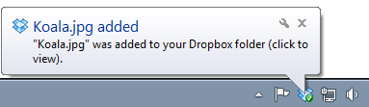

Sharing/Unsharing Files with Dropbox
Note: You will not be able to share files unless you have confirmed your email address.

Dropbox.com allows users to share folders with other users of Dropbox. You can create a folder and add individual files to that folder. You will then share everything in that folder with the users you have listed. Users will have to login using their Dropbox.com accounts to view the folders.
If you want to share individual files with people that do not currently have a Dropbox account, you will need to share a link.

Sharing Folders
Click on Sharing on in the navigation bar on the left side of the screen then click the New shared folder button.

Next, click on “I’d like to create and share a new folder” and then type in a new folder name. For example, you can call it “Family Shared” so you will know that the folder is shared with your family.

Next, you will have to add the email addresses for the people you want to share the folder with. This step will allow you to import contacts from a Gmail, Yahoo, or Facebook account. We recommend NOT doing this. To share with more than one person, enter the first email address and type a space. Then enter the next email address. You do not have to use commas or semicolons to separate the email addresses – a space will separate them. Optionally, you may add a message to the group.

If you leave “Allow members to invite others” checked, the Dropbox users that you share the folder with will be able to share the files with other Dropbox users of their choice. Think carefully before deciding to leave this box checked!

Clicking “Share folder” will send the users an email prompting them to log into their Dropbox.com accounts and view the folder.

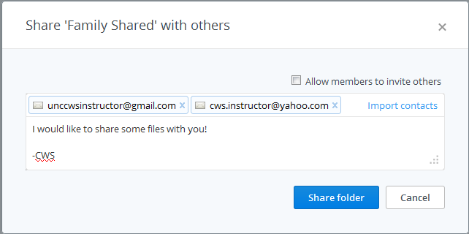

Once you have shared the folder, navigate back to your home screen. You will then see the shared folder available.
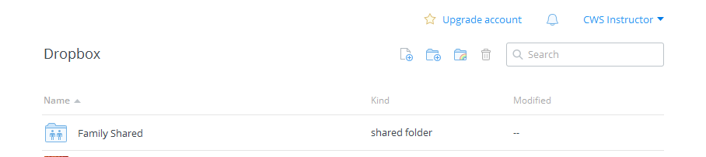

You can then drag and drop individual files into that folder. Clicking on the folder name will show you all the files that the other users have access to as shown in the example below.

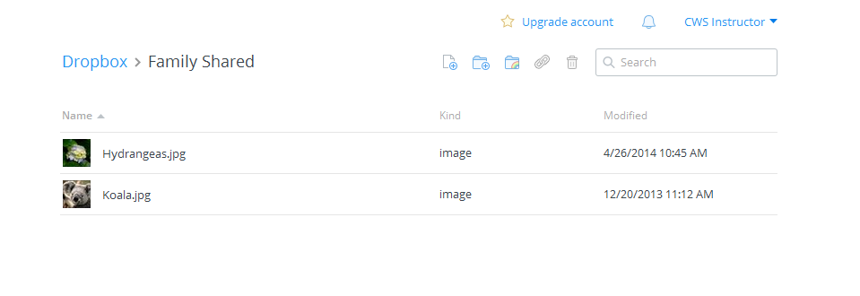
Sharing Links

To share files with people that are not currently users of Dropbox, navigate to your home screen. Use your mouse to hover over the name of the file you would like to share. A link icon will appear to the right of the modifed date.
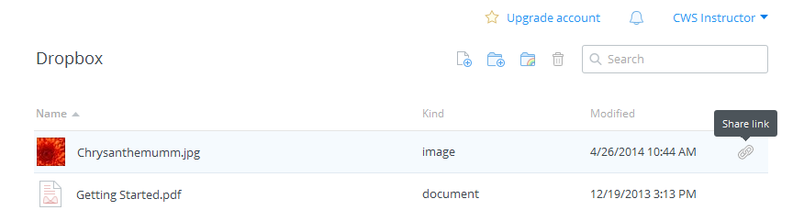

Clicking on the link will open a new tab or window with a “Share this image” popup window. You will have to add the email addresses for the people you want to share the folder with. This step will allow you to import contacts from a Gmail, Yahoo, or Facebook account. We recommend NOT doing this.

To share with more than one person, enter the first email address and type a space. Then enter the next email address. You do not have to use commas or semicolons to separate the email addresses – a space will separate them. Optionally, you may add a message.

Clicking “Send” will send an email address from Dropbox.com letting the users know that you want to share a file with them. Clicking “Get link” will copy a link to your clipboard that you can then paste (using ctrl+V on a PC) into an email, web address bar, or another program like Microsoft Word.

Anyone that has the link will be able to see a file that you choose to share this way. For example, your friend could forward the email with the link to all of his friends and they would also have access to the file. Think carefully before sharing files this way!

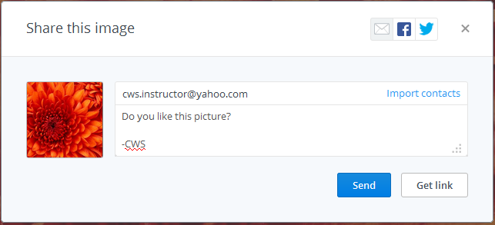
Unsharing Folders or Links

To unshare a folder, navigate to the Sharing page. All your shared folders will be listed with an “Options” link. Clicking on “Options” will bring up a window similar to the one below that shows a list of members that have accessed the folder. To revoke access for everyone, simply click the “Unshare folder” icon. To revoke access for a particular person, click the gear icon that appears next to their name. If you have invited them to view the folder, but they have not yet accepted, you will have the option to “uninvite” them. If they have already logged in and accepted your invitation, you will have the option to “kick out”.
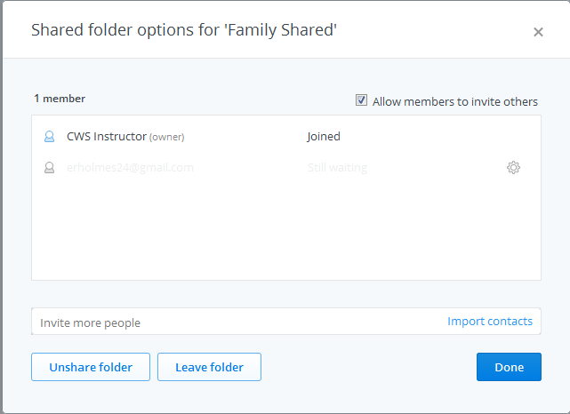

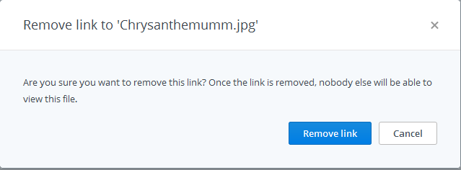
To unshare a link, navigate to the Links page. Each link that you have shared will be listed and there will be an “x” on the right side. Clicking that x will bring up a box asking you to confirm removing the link.

Getting More Help

For further assistance with Dropbox.com, view the Getting Started.pdf document or visit www.dropbox.com/help

GETTING SETUP WITH GOOGLE DRIVE
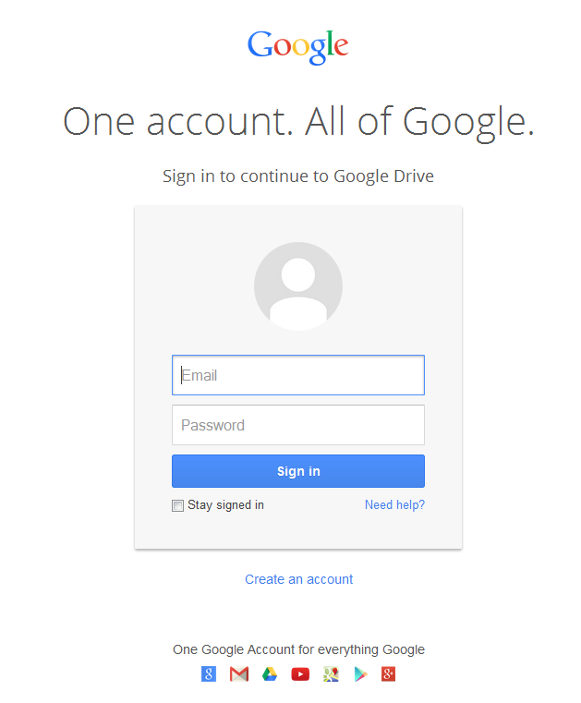
Open an internet browser and navigate to drive.google.com

If you do not have a Google account or Gmail address, you can click ‘create an account’ to get a Google account. If you already have a Google account, enter your email address and password.

After logging in, you will see the Google Drive introductory screen. If you click ‘Download Drive for PC’, it will create a Google Drive folder on your computer that will sync to your online Google Drive account. Do not do this now if you are on a library computer!

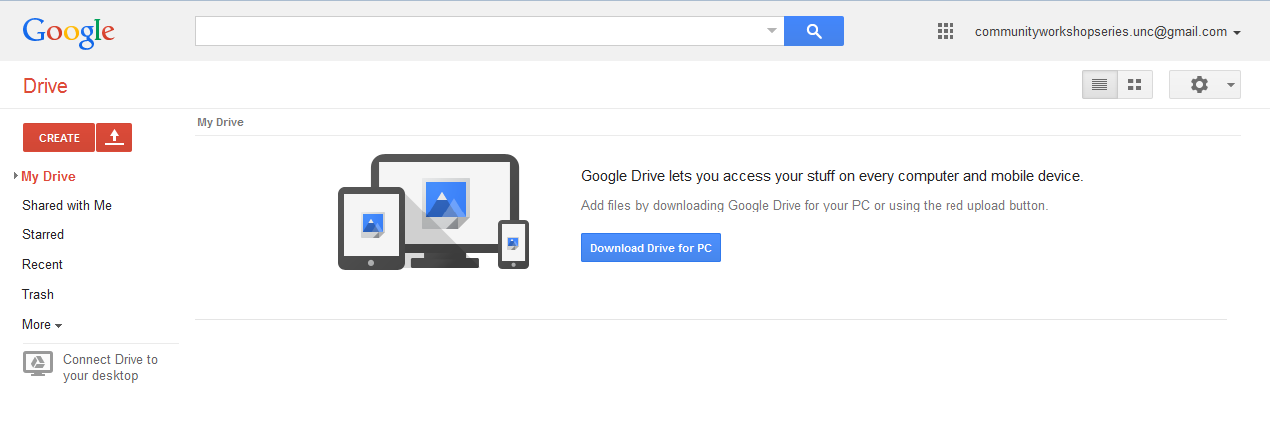

Uploading Files to Google Drive
To upload files to Google Drive, click the red up arrow. 

When you select a file to upload, an upload window will appear at the bottom right of the screen to show the progress of the upload. Once the file is completely uploaded, it will appear on your list of files.

The amount of space you have left on Google Drive appears in the bottom left-hand corner of the screen.

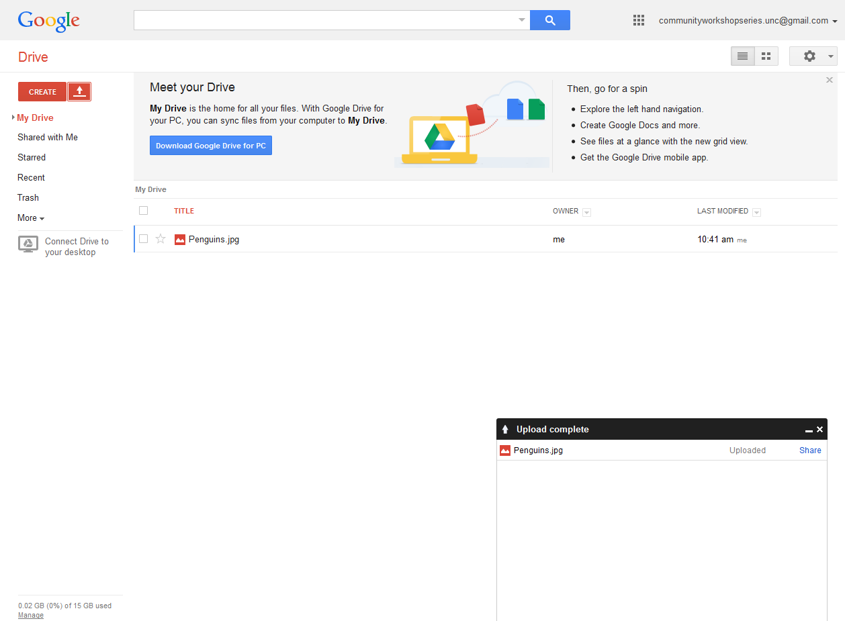

Sharing/Unsharing Files with Google Drive

To start sharing a file, select it by clicking the check box to the left of the filename. When you select a file, options appear at the top of the screen. These options allow you to share files, move files to different folers, delete files, or preview files. To work with multiple files at once, you can click on multiple boxes next to the file names.

Click on the icon that looks like a person with a plus sign next to it to share. That will open a Sharing settings window.

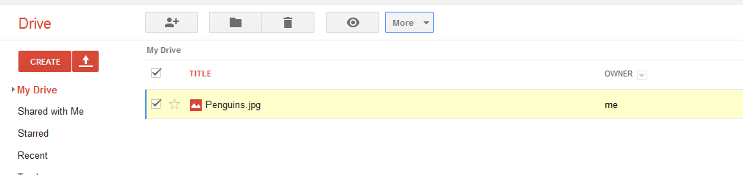

Sharing with other Google users
In the “Invite people” box, you can add multiple email addresses separated by commas. If you want to add people or groups that are in your Gmail contacts, you can simply type their name or group name. As you type, the possible names, groups, and email addresses that are in your Gmail contacts will appear and you can select them.
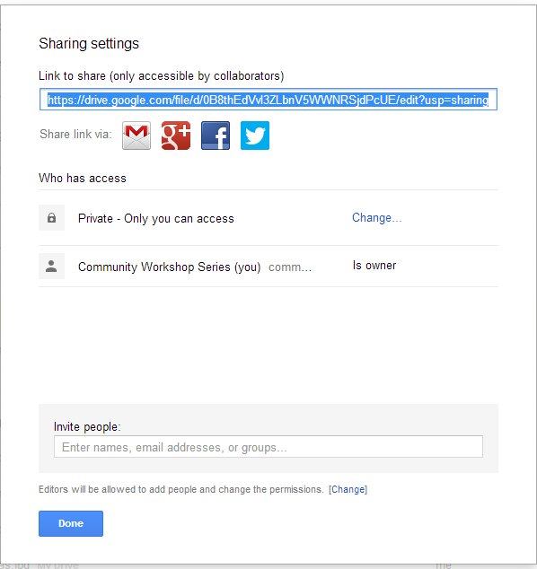
Once you have entered an email address, a “Send” button will appear and you can click it to send an email to people letting them know you shared a file with them. The specific people you have named will need to login using a Google account before they can view or edit the file.

Sharing with non-Google users
If you do not want people to have to sign into a Google account to view or edit the file, click the “Change” link under “Who has access.” You will get another window with some some different sharing options.
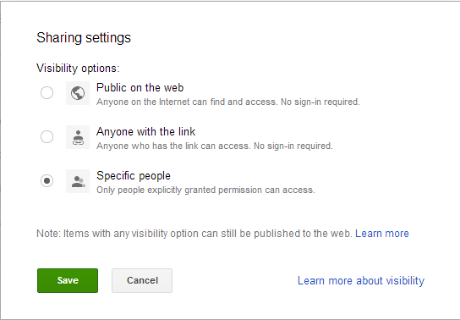

Public on the web – Only use this option if you do not mind anyone on the internet being able to access your file. The default option will be that anyone will be able to view the file, but only you will be able to edit it.

Anyone with the link – with this option, you can send the file link to certain people you want to give access to. They will not have to sign-in with a Google account to view it. However, if they send the link to other people, the other people will also be able to view the file. Think carefully before using this option!

Unsharing Files
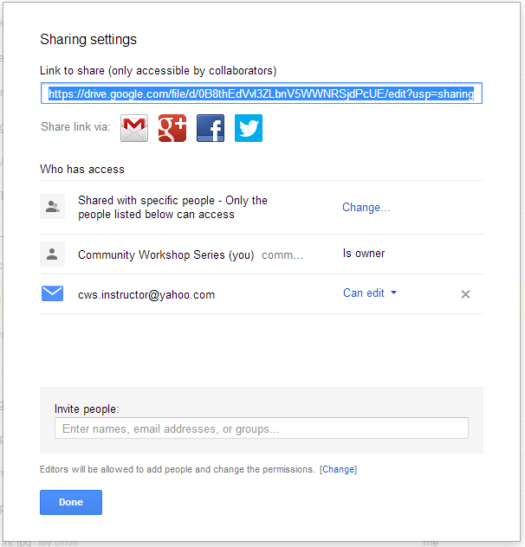
To unshare a file, go back to your list of files and select it by clicking the check box to the left of the filename. Click on the icon that looks like a person with a plus sign next to it to share. That will open a Sharing settings window.

If you have shared with specific users, the users that currently have access to the file will be listed. You will have to click the “x” next to each person’s name to unshare the file and prevent them from accessing it any further. Click the “Save Changes” button to confirm the changes in access.

If you have shared with the public or anyone with the link, you can click the “Change” link and simply select “Specific people” and save it. This will cut off the public and link access.

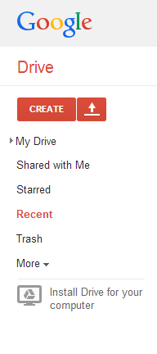

If other users have shared files with you, you can see these files by clicking Shared with Me in the left navigation pane.

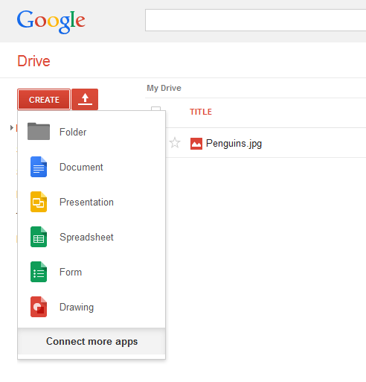

Creating Google Drive Files
One feature in Google Drive that separates it from other cloud storage services is that you can actually create files directly in Google Drive. You can create documents, presentations, spreadsheets, forms, and drawings. These files use a format that can only be read by Google Drive. This means that you can only access them when you are connected to the internet. However, once you have created these files in Google Drive, you can download the files in different formats that other programs can open.

Here is an example of how to create a Google Document and then export it to Microsoft Word.

Go to CREATE > Document. Once a document page appears, type in “This is the new document I created in Google Drive.”

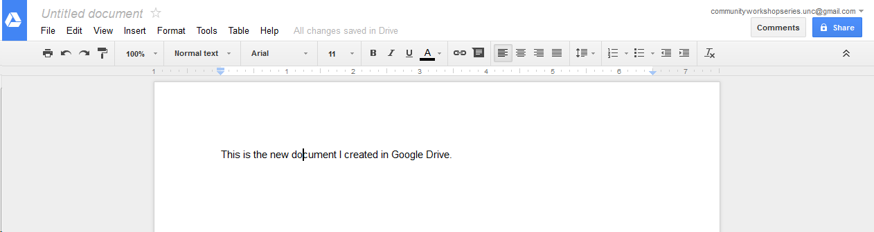

Navigate to File > Download as > Microsoft Word (.docx). This will give you the opportunity to put the file on your local machine. Once it is on your local machine, you can open it in Microsoft Word and edit it as you would edit any other Microsoft Word document.
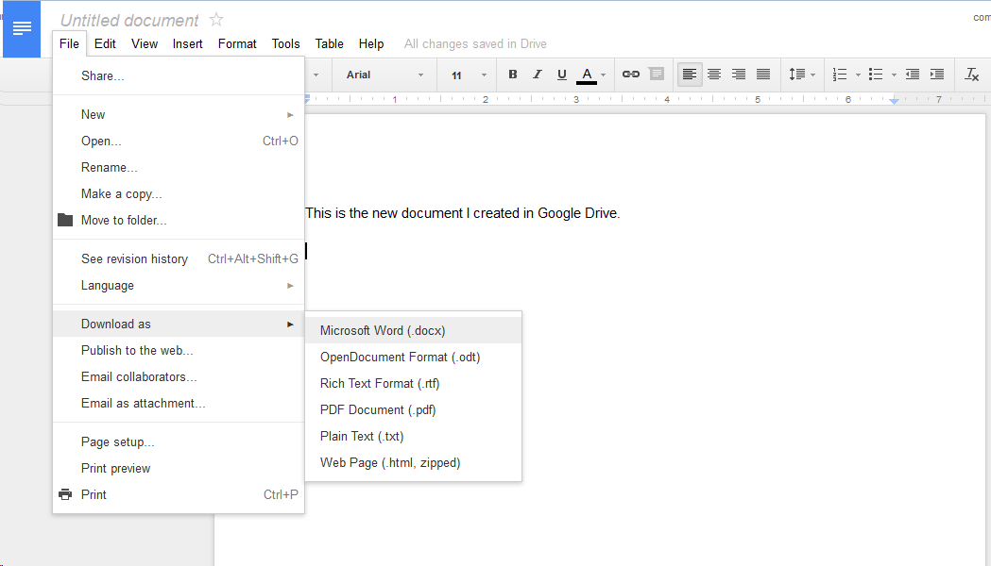

One word of caution, if you want to access files from the internet that are not in Google’s format, you will not be able to. For example, you will be able to view a Word Document online but not edit it directly. If you want to edit something like a Word Document and you are on your home computer, you can open it from the Google Drive folder on your machine and edit it from there. If you are not on your home machine, you will have to download the file, edit it offline, and then upload the new version back to your Google Drive.

Also note that you can have files with the same name in Google Drive. For example, you can have multiple documents titled “Sales” in your Google Drive. Be sure to provide descriptive file names so you can tell them apart without having to open each one!

Getting More Help

For additional help for Google Drive, click the gear icon near the top right-hand corner of your screen. Choose Help from the menu.

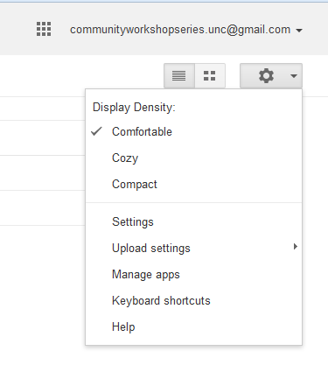
NOTE: Images and screen captures may differ from those seen on another system.

This work is licensed under a Creative Commons Attribution-NonCommercial 4.0 International License2.

