INSL 500-002 Human Information Interactions
This course surveys human information interactions through a broad examination of information science over time and social domains. Students examine cognitive, affective, social, and organizational/institutional approaches to understanding interactions between people and information. During the class, we will place special emphasis on groups, organizations and real-world examples.

Course Objectives
Students successfully completing this course will:
• become familiar with empirical and theoretical literature related to information seeking, including the recognition of information needs, actions taken to resolve those needs, the roles of intermediaries (both human and machine), and the retrieval and use of information;
• understand key concepts related to the effects, influences, and impacts of information on people (individually and in groups);
• develop skills in reading, writing, and discussing information science concepts, models, frameworks, and theories; • critically apply theories and empirical findings to the definition and solution of problems related to human information interactions.

Teaching Philosophy
This is a survey course for both you and me! We will engage with core concepts and real-world examples of groups, people, and information-seeking together. We will spend a significant amount of time thinking through the context of theories and concepts. As such, I am also keenly aware of the context of this course: a pandemic, a shifting learning environment, politics, economics, and cumulative stress. We will be kind to each other and with ourselves this semester. That means being prepared for class and speaking up when you need more time or resources to become prepared. In exchange, I will be transparent and humane about making our course work for us, to the best of our collective abilities.
“One part of referential thinking [a component of critical thinking] consists of conceptualizing, a process of critical thinking that involves identifying multiple examples, analyzing examples for commonalities, distinguishing examples from non-examples and determining the underlying conceptual structure.”

Affiliations and Role
Tressie McMillan Cottom, Ph.D.
Associate Professor, Senior Research Faculty, MacArthur Fellow (2020-2025)
School of Information and Library Science
Center for Information, Technology and Public Life
Department of Sociology (By Courtesy)

Contact Information
Email: tressiemc@unc.edu
Personal Websites: www.tressiemc.com
Center for Information, Technology, & Public Life: https://citap.unc.edu/

Office Hours
Tuesdays, 2-3:30, in-person (if masked) or by phone or Zoom (in order of preference).
First come, first serve by scheduling yourself using calendly: https://calendly.com/tressiemcphd
Meeting Etiquette:
- Tell me what the meeting is about in the text box (if using Calendly) or in the Calendar invite
- If you want feedback on a paper, please send the paper before we meet.
- If you are asking for a letter of recommendation, please have the details for how and when I submit it prepared in some written form
- Consider if your question would also benefit others in class

Course Texts
No textbook is required.
However, there are THREE key texts for the course:
1. "The Promise of Access: Technology, Inequality, and the Political Economy of Hope" by Daniel Greene (MIT Press, 2021)
2. "The Teaching Machines: The History of Personalized Learning" by Audrey Watters (MIT Press, 2021)
3. "Algorithms of Oppression" by Safiya Noble (NYU Press, 2018)

Expectations
Students will be expected to complete readings in preparation for each class meeting. The assigned readings are listed on the course schedule and will be made available electronically, through the UNC libraries, e-reserves, or the Sakai site for the course.

Assignments
Please see the Assignments tab for a schedule of the semester deadlines. In brief:
Guided Questions – Due Sept. 1
Teaching Machines, Response Essay – Due Sept. 24
Anatomy of a Search Strategy Homework – Due Sept. 29
Reflection essay, Update “Question Behind a Question” Handout – Due Oct 22
Comparing Databases, Dissecting Your Search Results – Due Nov 3
Final Discussion Guide – Due Dec. 10

Guidance
Reaction or Response Papers
From Hunter College's Peer Writing Center, the following guidelines for a reaction paper are good ones for this course:
PART 1: A SUMMARY OF THE WORK To develop the first part of a report, do the following: Identify the author and title of the work and include in parentheses the publisher and publication date. For magazines, give the date of publication. Write an informative summary of the material. Condense the content of the work by highlighting its main points and key supporting points. Use direct quotations from the work to illustrate important ideas. Summarize the material so that the reader gets a general sense of all key aspects of the original work. Do not discuss in great detail any single aspect of the work, and do not neglect to mention other equally important points. Also, keep the summary objective and factual. Do not include in the first part of the paper your personal reaction to the work; your subjective impression will form the basis of the second part of your paper.
PART 2: YOUR REACTION TO THE WORK To develop the second part of a report, do the following: Focus on any or all of the following questions. Check with your instructor to see if s/he wants you to emphasize specific points. How is the assigned work related to ideas and concerns discussed in the course for which you are preparing the paper? For example, what points made in the course textbook, class discussions, or lectures are treated more fully in the work? How is the work related to problems in our present-day world? How is the material related to your life, experiences, feelings and ideas? For instance, what emotions did the work arouse in you? Did the work increase your understanding of a particular issue? Did it change your perspective in any way? Evaluate the merit of the work: the importance of its points, its accuracy, completeness, organization, and so on. You should also indicate here whether or not you would recommend the work to others, and why.

Discussion Guides
Your discussion guides will begin with an extended abstract of the reading. You should describe the text using key terms and theories learned in the course, e.g. "social cognition theory", "information-seeking", "information retrieval". Think of this as translating the book into the LIS and iSchool specific language for LIS and iSchool audiences. After the abstract, you will write 7-10 discussion questions for the book. The discussion questions will assume an information-seeker (or audience) and consider the context of the discussion. At the end of the discussion guide, briefly discuss what assumptions you made about how information-seekers that use your guide will seek, sort, evaluate the text. These are due on December 10, 2021.

Weekly Schedule
Week 1 – Syllabus Review – Date _____________

This class session we will take a tour around the people and ideas that will shape the course. + What we do at SILS +What we do at CITAP +What brought you here +How do you read? +How do you take notes?

Week 2 – Critical Thinking, Against Vocational Awe – Date ___________
This week we will lay a foundation for thinking critically about information and especially about the eco-system of information. That means thinking critically about libraries. Critical thinking =/= being critical of something for the sake of being critical. Critical thinking is a set of instrumental skills, such as asking questions and checking for knowledge biases. Critical thinking is also an orientation towards the world in which a person or a community evaluates the function of an idea, data point, concept, institution or belief.
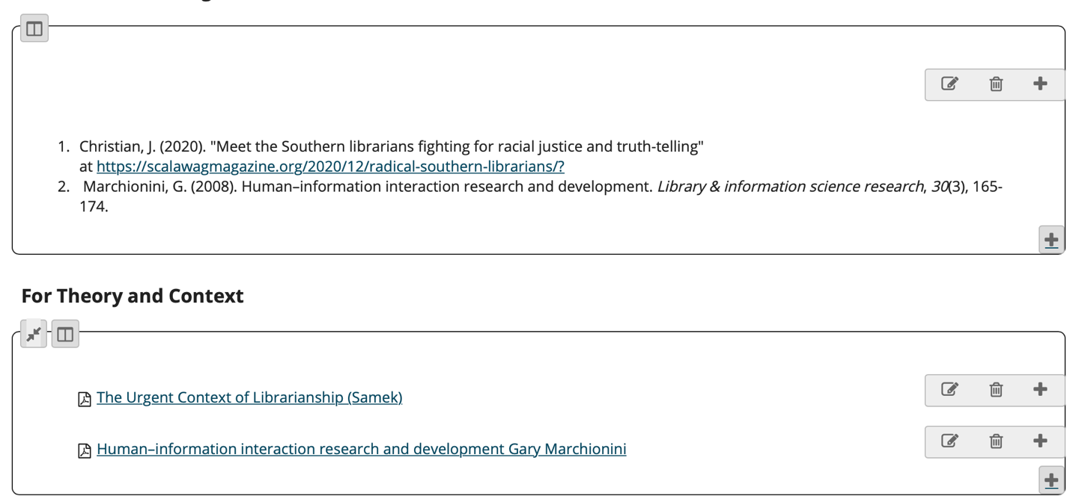

Week 3 – What is a Theory? – Date ________

We will discuss what a theory is and what theory is intended to do this week. Then, you will read a survey of the most used theories about human information interactions. You will notice that the terms shift A LOT. Let's think about how the multi-disciplinary nature of studying humans and information shapes the kinds of theories we use.

Reading
Assignment:
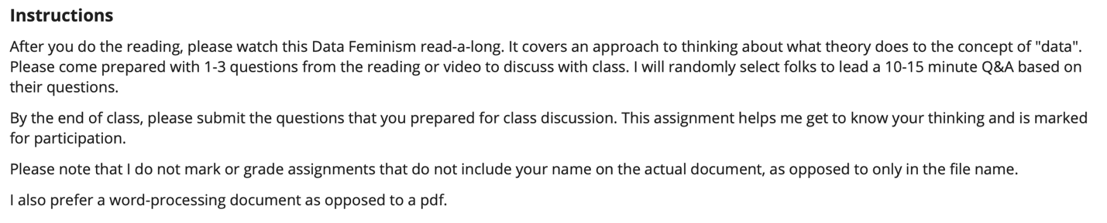

Week 4 – Emotions, Affect, & Information-Seeking – Date _________

People are not computers. Our emotions -- that we have them, can have them at seemingly limitless capacity, and that we can reflect on them -- shapes how we interact with information. This week we will talk about affect, sentiment and popular frameworks for understanding the interplay between emotions and information.

This paragraph from the Lopatovska and Arapakis reading for this week is a good guide for discussion this week and next week:

We examined the two major categories of classical emotion theories: (i) cognitive, which stresses the importance of cognitive evaluation (appraisal) in establishing the meaning of stimuli and ways of copying with it, and (ii) somatic, which emphasizes somatic factors and describe expressions and perceptions of emotional experiences in terms of bodily responses. We, furthermore, discussed the two dominant views on emotion structure, namely: the discrete and dimensional. The former supports the existence of six or more basic emotion categories, which are universally displayed and recognised, while the latter suggests the representation of emotions in terms of a multi-dimensional space of arousal, valence and other.

This week's discussion and reading sets the stage for reading our first book, "Teaching Machines". Our goal is to generate a set of discussion questions, or a reading guide, for the text to be used by other LIS students. That means thinking about the role of theory in the text, what we learn or do not learn about information seeking behaviors, and about affective relationships to information.

Student Research Example: http://unrh.org/sentiment-analysis-online-bookclub/

Readings
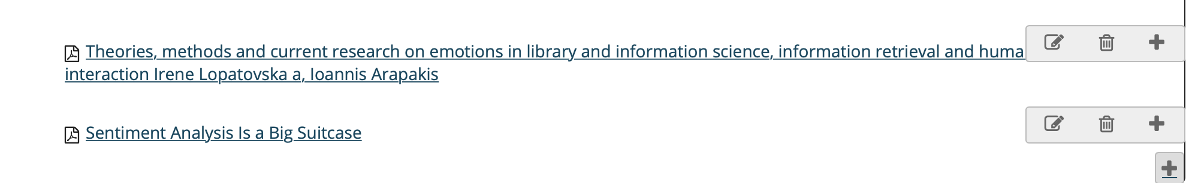

Week 5 – Social Cognition and Teaching Machines – Date _______

People do not seek information or make sense of information in a vacuum. We are social beings. Information, meaning and what we often call "learning" happens in and through social contexts. Social cognition theory is one of the most popular theories for modeling and understanding the relationship between humans' sociality and how we learn.

This week we start reading "Teaching Machines: The History of Personalized Learning" by Audrey Watters (MIT Press 2021).

It is always a good idea to read a book review in tandem with a new-to-you scholarly book. I have included a link to a review on EdSurge. It includes a brief overview of the book and a podcast with Watters. From EdSurge:

[Watters] argues that it’s important for today’s educators and policy leaders to know this history to understand the types of people and institutions who have pushed to bring automation to education. Since the beginning, she adds, there has been a contradiction between the promise of making learning more personalized and the reality that teaching machines often required a higher level of standardization.

As we read "Teaching Machines" this week and next, we will focus on the "contradiction" between personalized learning, standardization, and education.

Your first written assignment is also due next week.

Readings

"The Teaching Machines" by Audrey Watters. You can read the entire text this week, but we will spend a good two weeks on the text, doing both broad reading and then deep reading of sections. If your process prefers to break down the text as you go, this week you should focus on the first three chapters.

Ed Surge, Read and Listen to Podcast: https://www.edsurge.com/news/2021-06-15-new-book-explores-the-long-and-surprising-history-of-teaching-machines

Week 6 – More Social Cognition Theory – Date ________

We are still reading "Teaching Machines". We will finish that book this week and add some additional scholarship on social cognition theory (SCT). Arguably, "self-efficacy" is the most important concept from SCT. We will spend some time this week discussing efficacy -- what is it, how we operationalize it, and examples of it from the reading and our own experiences.

It is also time for your first reflection paper assignment. Consider the social cognitive theory embedded in Skinner's teaching machines. You may want to reflect on how social cognition frameworks influence your research interests or your previous educational experiences. What kinds of "teaching machines" have you engaged with over your academic career?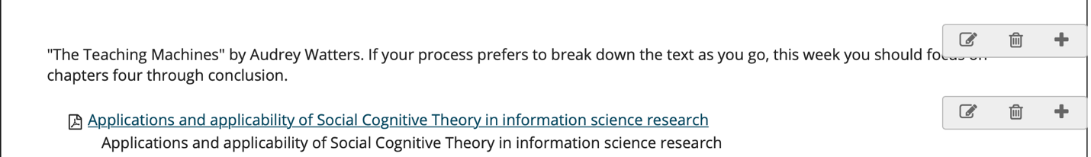

Assignment:

Response essay, approximately 1000 words. Submitted via email to me by the end of the week, possibly shared with class in the future. Consider the social cognitive theory embedded in Skinner's teaching machines. You may want to reflect on how social cognition frameworks influence your research interests or your previous educational experiences. What kinds of "teaching machines" have you engaged with over your academic career?

I cannot grade or mark the work if your name is not listed on the document itself, in text, on the front page.

I grade for completeness, clarity of thought/writing, and engagement with the text.

I do not provide comments (but do provide a grade) if you submit a pdf. If you want comments, please submit an editable document that allows track changes. I will not follow up with you for permission to view your document on Google or a similar platform. Please check these details before you submit.

Week 7 – Information-Seeking – Date________

The saying goes that everybody wants to rule the world. Most of us start our grand ambitions with a question. Information-seeking is the fundamental unit of theory and analysis in information science. It is also what probably unites all of us who think about information across our disciplinary and professional domains. We all have some fascination with how information is produced, shared, and taken up.

We will talk about major theories of information-seeking. And we will unpack the layers of meaning beneath a question.

You have a participation assignment this week.

Readings:
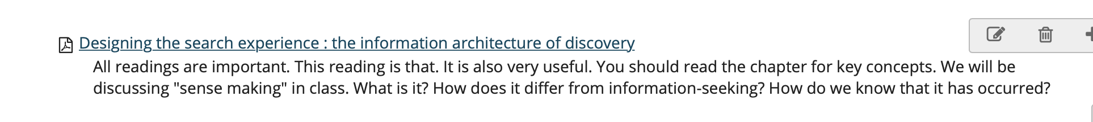
Assignment:
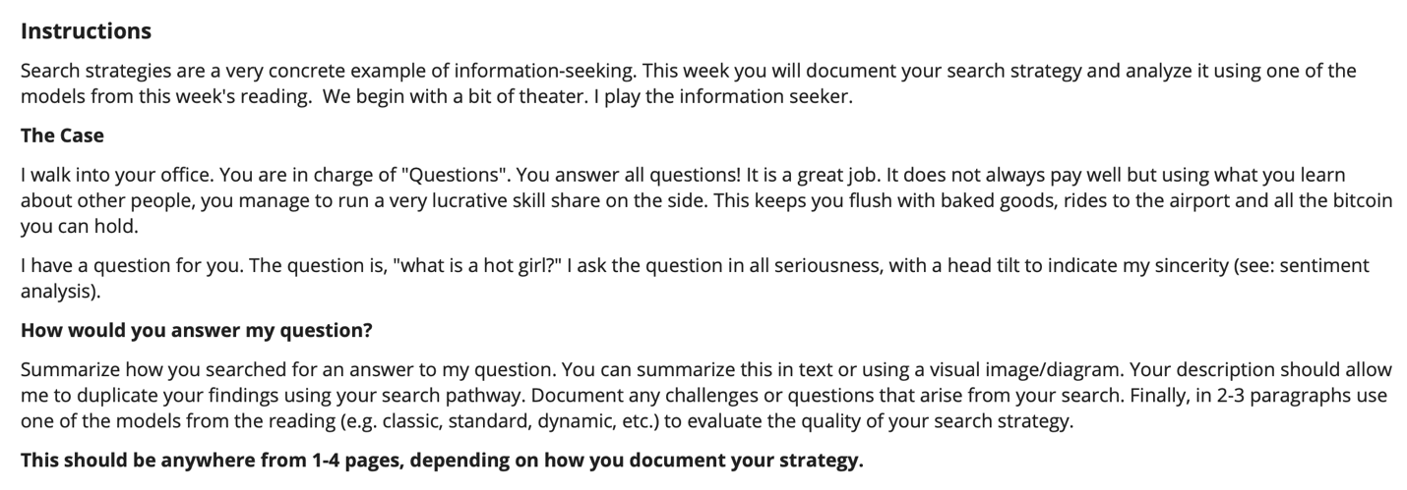

Week 8 – Question Negotiation – Date _______

We all think that we know how to ask a question. What's to it, anyway? You have a need. You state it as a question. You get an answer. Of course, we have also all experienced a question that generates a response we did not expect and a need that we could not quite structure as a question. How we ask questions and interpret them is fundamental to the process of information-seeking. From one of our readings this week: 1. What categories of information does a librarian attempt to obtain from an inquirer? 2. What is the role of system file organization in the negotiation process? 3. What kinds of answers will inquirers accept and what influence might this have on the negotiation process?

This are the guiding questions for the reading this week. I would also add one more: 4) How does the built and social environment shape the questions asked and the answers offered in a library setting? That question is foreshadowing reading we will do in a couple of weeks when we read Greene's book. In addition to the readings, to prepare for class discussion this week you should also scroll through the two information-seeking examples listed under readings (r/whatisthisthing and “Help a Bitch Out” on SmartBitchesTrashyBooks.com.)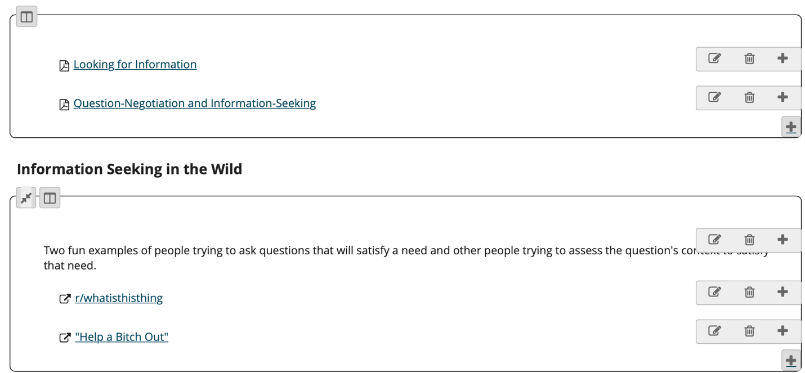
Week 9 – Expressing Information Needs – Date______

The "Four Sons" reference this week is thanks to one of your advanced colleagues, Mariah. If you see them around the Department, let them know I am still using this great allegory to discuss information needs. We will discuss three things:

1. How Info Scholars think about researching information needs (Or, how people ask questions and with what outcomes). That is the methods paper (Nuckles and Ertelt).

2. Some professional strategies for sussing out an information need.

3. Handling ambiguity.

Because we did not meet last week, you should also have time to watch a video about the power of identifying a need that people did not know they had (Gladwell on spaghetti sauce and choice). This speaks to something we know sociologically: people cannot always accurately identify or express the information they need or want. Solving that ambiguity paradox is a significant part of what makes internet search engines so powerful.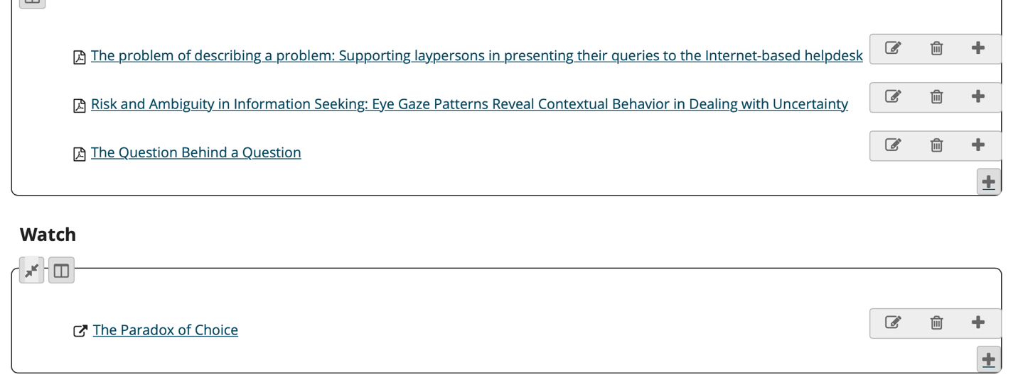

Assignment:

You may have noticed that the Bates primer on how to get to the question behind a question was written in the 1990s. A lot has changed since then. And a lot remains the same. In this week's reflection, consider what you might update, add, or keep in your own version of Bates article. You will write 1-2 paragraphs on how you approached evaluating Bates' recommendations. Next you will spend 1-3 pages outlining your own Best Practices for a modern information or library worker who interfaces with information-seekers.

Week 10 – Choosing Information Sources – Date ______

Well, this is a big one this week. How do we choose which information sources we will seek out and trust? What is the role of the information professional in mediating information sources? How about a layperson on a networked information website like Wikipedia? How does the social or ecological context shape the information we choose to trust? Those are the guiding questions for the week! Come prepared with examples of information sources in your everyday life. What is the last source you sought out? That you evaluated for trustworthiness? How did that go?

Readings:
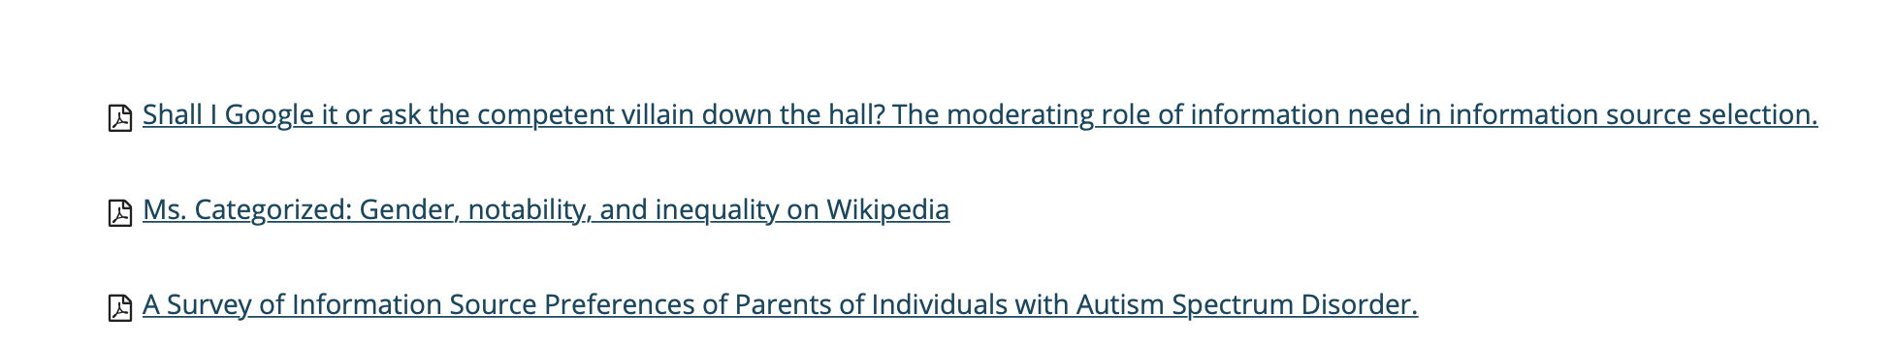

Week 11 – Browsing and Serendipity – Date _____

Have you ever thought about how the word "browser" stems from the word "browsing'? The entire architecture of the internet was predicated on leveraging the human desire for novelty and serendipity in their information-seeking. Of course, browsers are now anything but serendipitous. But that is the spirit of this week's discussion. What role does browsing play in how we seek, sort and value information? How do platforms mediate unstructured information-seeking? How do some libraries think about browsing, online and offline?

Readings

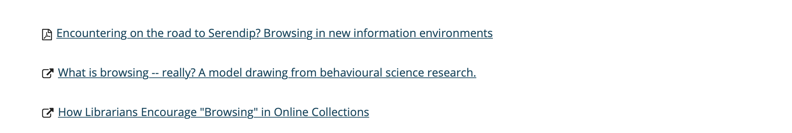

Assignment

This is a response paper week. You should pick and define a set of search terms relevant to your research interests. You can express it as a Boolean search term or a query/text question. As long as you share it with me and decide what it is, I do not have a preference. Next, using the same search term/question, you should record the top three search results in THREE DIFFERENT DATABASES. One of those databases should be Google Scholar. Describe, compare and contrast the type, number, quality of the search results you receive from the three different databases.
Discuss why the searches may be similar or different.

Week 12 – Assessing Information Quality – Date _______

If we could just get everyone to read the RIGHT things, we could get rid of all the wrong things. Isn't that what many of us secretly believe? Or, is that just me??? Regardless, information pros think about information quality in vary precise, if varied, ways. We will discuss how people conceive of "quality". What signifiers do users rely on to judge high quality information? And, how are those signifiers vulnerable to "source hacking" (e.g. deliberate manipulation of source signifiers), plain ol' source neglect (e.g. dead links), and social trust?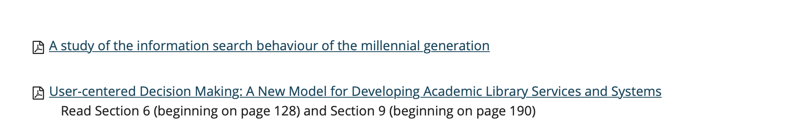Watch:

https://www.youtube.com/watch?v=1OqFY_2JE1c

Week 13 – Info Use Environments Or, Organizational Contexts of Info – Date ______

As one of our readings pointed out (Halverson 2002), the field of info science has primarily thought of information in terms of tasks, items, and individuals. More recently, scholars have started thinking about the context within which information-seeking occurs. This week and next week we are going to read an ethnography in which one of the field sites is an urban library. The other field site is a school. The author, Dan Greene, explores the social and political context that shapes the library as an organization. You will come to class this week and next week with one discussion question for your colleagues. I'll choose at random.

Week 14 – Access Doctrine – Date ________

We are finishing of Greene's book. He spends a lot of time building a theory of "the access doctrine". This week, we will look around our own organizational contexts for examples of the access doctrine. Have your example from work, home, school, church, volunteer organization ready to inform class discussion. More than just describing the example, think about the politics, economics, and culture that shaped the access doctrine example. Is it a rule about who can use what? Where did the rule come from? What was the intent? How does the rule operate in real life? Is your example based on how a job role functions? Describe the job role and explain the contradictions of access embedded in the job. These are just some models. Your example may differ.

Listen: Greene’s podcast interview at CITAP should be in by this week. Link forthcoming.

Week 15 – Oh, The Algorithms – Date _________

And that is a wrap! We have explored what information means, what gives it meaning, the paradoxes of information-seeking, and examples of major concepts in our own lives. We end the course with Noble's book, "Algorithms of Oppression". I save this book for last because it is a great summation of what we have covered AND a good example of critically thinking about information science. For this session, be prepared to at least discuss Noble's first chapter.
We will also discuss your final assignment, a discussion guide on one of the three books we read this semester.

Final Assignment – Due _______

You will write a discussion guide for two of the three assigned books from this semester. Your discussion guides will begin with a 750-1000 word extended abstract of the reading.

You should describe the text using key terms and theories learned in the course, e.g. "social cognition theory", "information-seeking", "information retrieval". Think of this as translating the book into the LIS and iSchool specific language for LIS and iSchool audiences.

After the abstract, you will write 7-10 discussion questions for the book.

The discussion questions will assume an information-seeker (or audience) and consider the context of the discussion.

At the end of the discussion guide, briefly discuss what assumptions you made about how information-seekers that use your guide will seek, sort, evaluate the text. Choose different audiences for each guide. Examples include: high school students in an advanced English course; undergraduate students in a university common reads program; a community-wide book club in a small, rural town; an academic association book forum.

I grade these for completeness, professionalism, and accuracy.

1. Do you use appropriate disciplinary concepts/language?

2. Do you engage with the text?

3. Do you accurately describe the text's main ideas?

4. Do you MODEL how to create an information artifact for an information-seeker?

