One Page Quick Start

If you want to download a not-so-pretty green quick-start one-page theme the link is in this folder: https://ils.unc.edu/courses/2019_spring/inls161_001/02-files/

Open the folder and click the link. after it downloads, if you are using a mac, double click to open it, if you are using a PC, extract it.

Here is extract help if you need it: https://www.wikihow.tech/Extract-Zip-Files

This theme has a lot going for you if want to use it. It has features that I added that are not in the official creative theme, and it has a lot of unneeded files removed. You don’t have to use this one, though. You can continue with the other theme or find your own.

The best way to hack the green color in this theme to something you prefer is to install the Atom color picker so you can see the colors:

https://atom.io/packages/color-picker (see the gif here to see how it works)

It is possible that it may already be installed by default.

Open up the creative.css file and find the .bg-primary class on line 52.

Right Click on the #32ad00 text on line 53 and choose color picker option to see the color pop up:

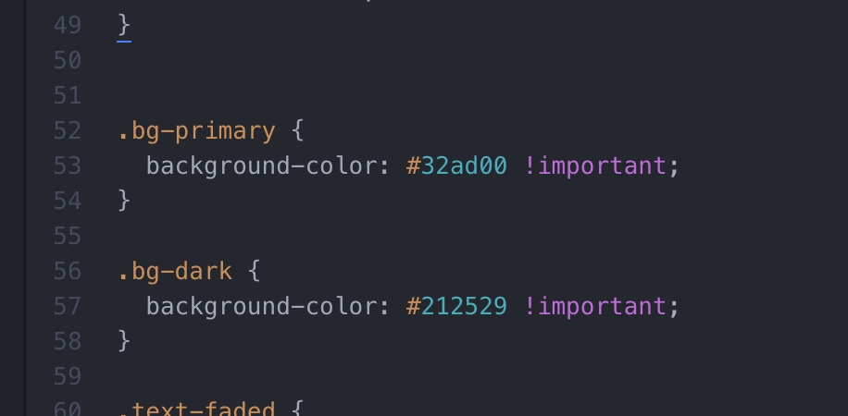

A lot of the colors are duplicated. That is because this theme was built with a CSS preprocessor. The best way to make global changes is to use find and replace in atom.

Open up the Find in Buffer option:

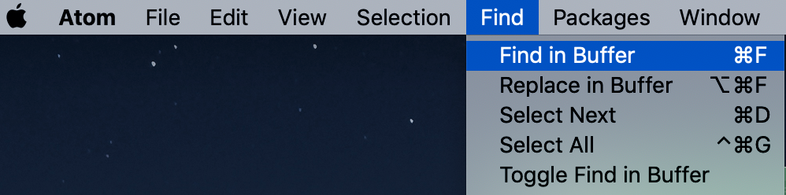

If you don’t like the green #32ad00 color, copy #32ad00 and paste it in the find box. Then paste the hex number of your new color in the replace box. It will change the .bg-primary color and all other class instances that use that same value. If you don’t want to change them all, you can do them one by one.

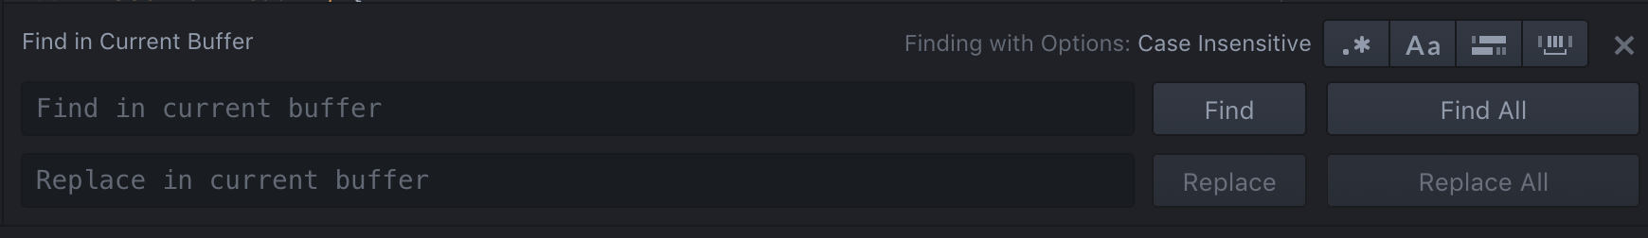

The header image is controlled via css. It is not an html img tag.

If you want to change the image, you need to go to line 186 in the creative.css file:
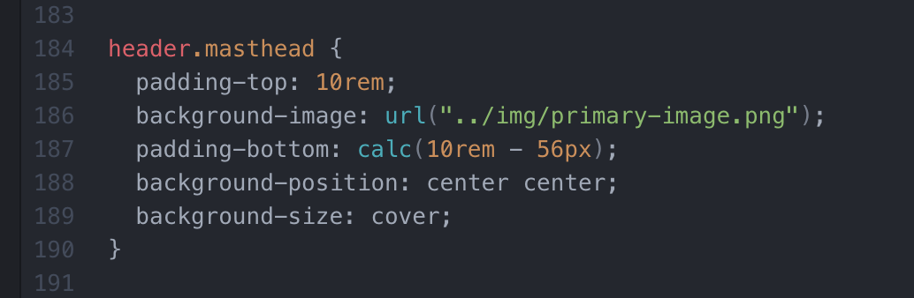

But you must also put your image in the img folder. Name it something relatable to the image. Make sure the file name exactly matches the name in line 186.
