1. Create a database. Save the database as “Library_catalog”
2. Add the following three tables (Books, Patrons, Transactions) to the database. Use the listed Field names and Data Types from the following images for each table. Include the primary key field as shown. For each date data type use a short date and show the date picker for dates in the data view (this requires you to make a change in the field properties).
Books Table
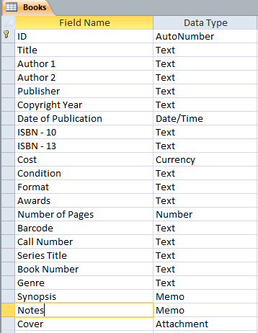

Patrons Table
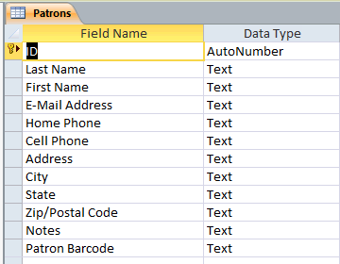

Transactions
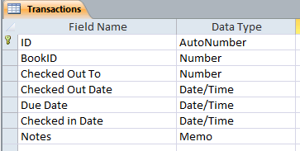

3. Enter the information in each field in datasheet view using the information below.
Patrons
Patrons
ID | Last Name | First Name | E-Mail Address | Home Phone | Cell Phone | Address | City | State | Zip/Postal Code | Notes | Patron Barcode
2 | Johnson | Andrew | andrew@nomail.com | (419)-881-5698 | (419)-728-9999 | 5698 Smith Rd. | Chapel Hill | NC | 27514 |  | DZXBJ
3 | Horowitz | Lorie | horowitz@nomail.com | (888)-654-1234 | (888)-987-6543 | 9856 Game St. | Durham | NC | 27512 |  | DGHYH

Books
Books
ID | Title | Author1 | Author2 | Publisher | Copyright Year | Date of Publication | ISBN - 10 | ISBN - 13 | Cost | Condition | Format | Awards | Number of Pages | Barcode | Call Number | Series Title | Book Number | Genre | Synopsis | Notes | Cover
1 | Stormbreaker | Horowitz, Anthony |  | Puffin Books | 2000 | 2/16/2006 | 0142406112 | 9780142406113 | $7.99 | New | Paper Back | N/A | 234 | 0000000121 | Fic. Hor |  | 01 | Fiction |  |  | 1

4. Use Amazon.com to find five of book titles of your choice to add to the books table. For Barcode, just append incrementally to the barcode number by one. So, for example, your first books barcode would be 0000000122, third 0000000123, etc. For the Cover field, just use 1. Finally, if you don’t have the information for a field on the Amazon record, don’t add it to the table.
5. Checkout three of the books to Andrew Johnson and checkout three of the books to Lorie Horowitz.
6. Create relationships between the tables where appropriate. Ensure that the relationships between the tables are enforcing referential integrity. All relationships will be a 1 to many. Using the lookup wizard create a lookup relationship from the transaction table on the “BookID” field and the “Checked Out To” field for the Book table and the Patron table. Hint: The foreign key of the transactions table is not the labeled the same as the primary key of the Patrons table.
7. Create a form for entering new books and patrons. Use appropriate labels for the form field names and add any additional visual formatting to the form you wish.

8. Create a query that allows you to search on the publisher field in the books table.

9. Create a report using the books table.

10. Email me your database as an attachment.

