Getting Our Feet Wet with SPSS
SESSION ONE
INLS 200
HANDOUT

Instructor: Cathy Zimmer
962-0516, cathy_zimmer@unc.edu

- INTRODUCTION
  - Who am I? Who are you?

  - Overview of Course by Session -- Meet here in 219 David Library Computer Lab
    - Session 1 – Working with SPSS Data Sets and Univariate Analyses
    - Session 2 – Analyses and Output

  - Bring flash drives!!

- DATA – 2012 US General Social Survey (GSS)
  - Other than the US Census, the GSS is the most frequently analyzed source of social science information. Its purpose is to “take the pulse of America” by asking questions about individual attitudes, behavior and attributes of Americans.
  - First survey fielded in 1972 and the 29th survey was fielded in 2012. Fielded every year in the past, but fielded every two years since 1994.
  - Data collected via face-to face interviews that last about 90 minutes by interviewers trained by the National Opinion Research Center at the University of Chicago.
  - The 2012 sample is of English- and Spanish-speaking adults 18 years of age and older who were noninstitutionalized. Multistage area sampling was used to choose the individuals to interview. The final sample size is 1974.
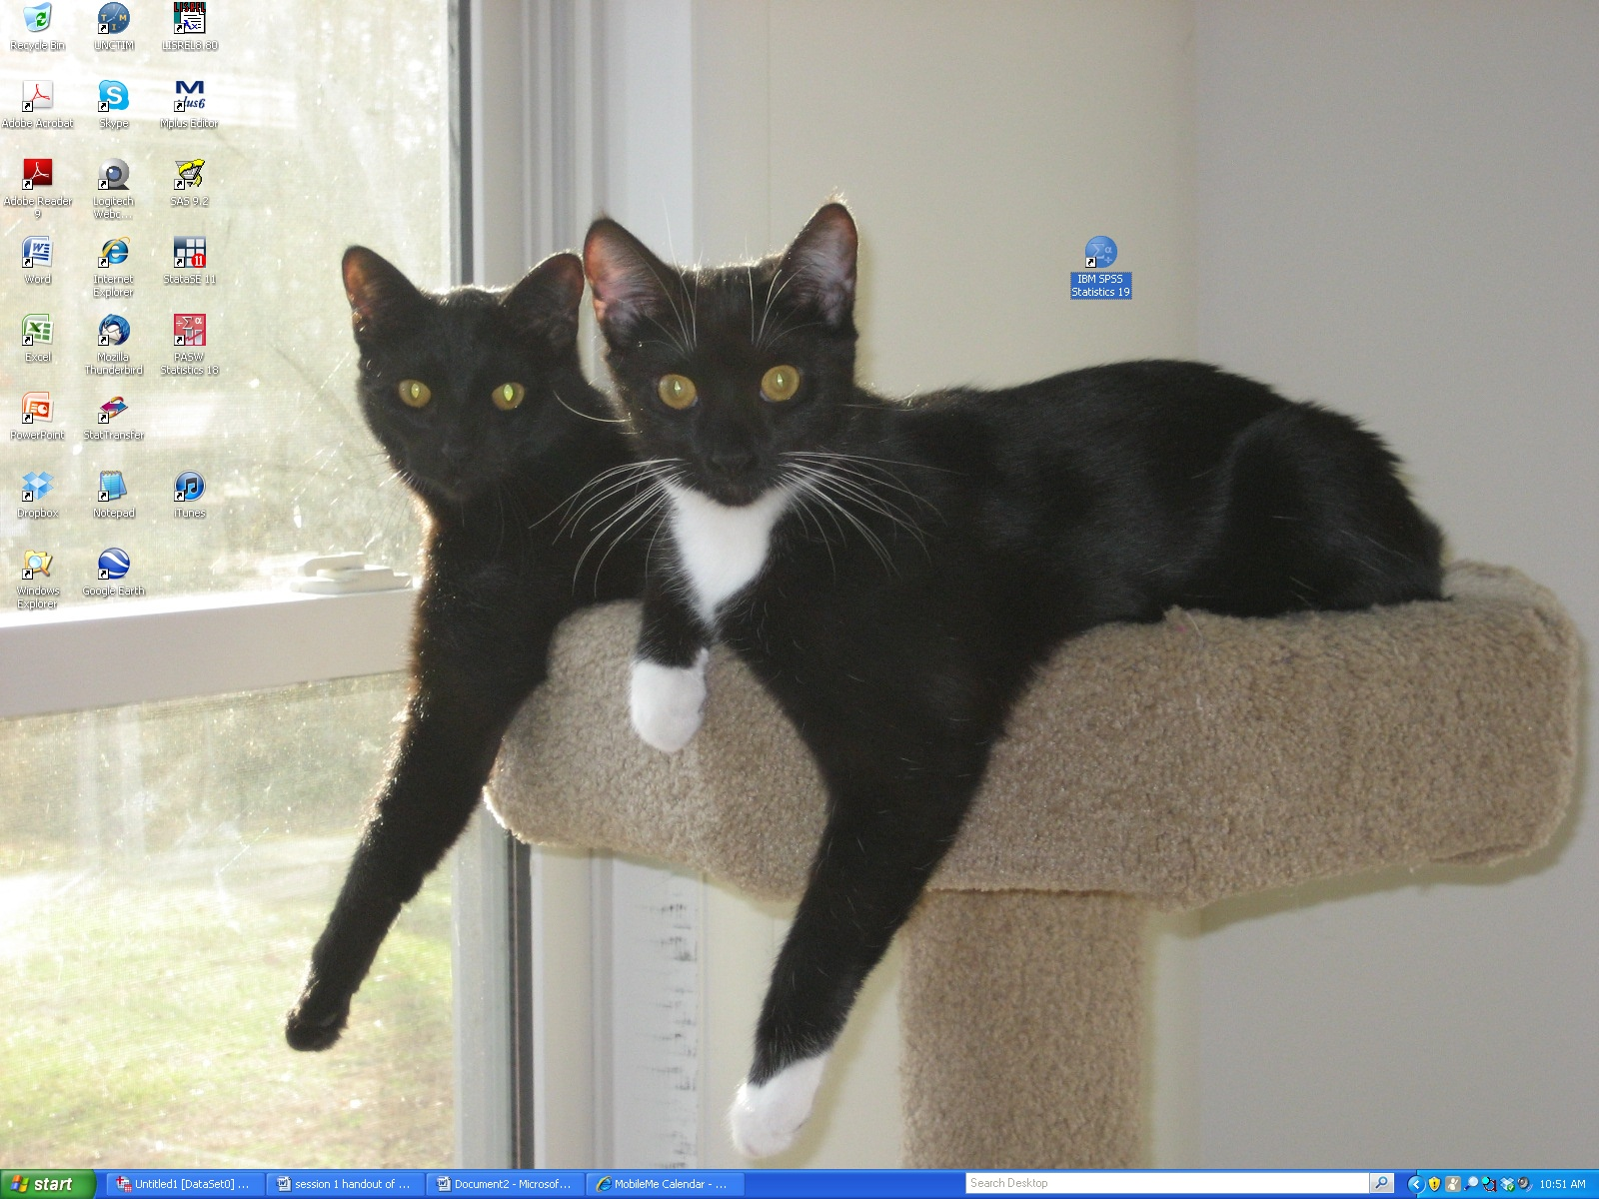
- EXPLORING SPSS
  - Double click SPSS icon to open the program.

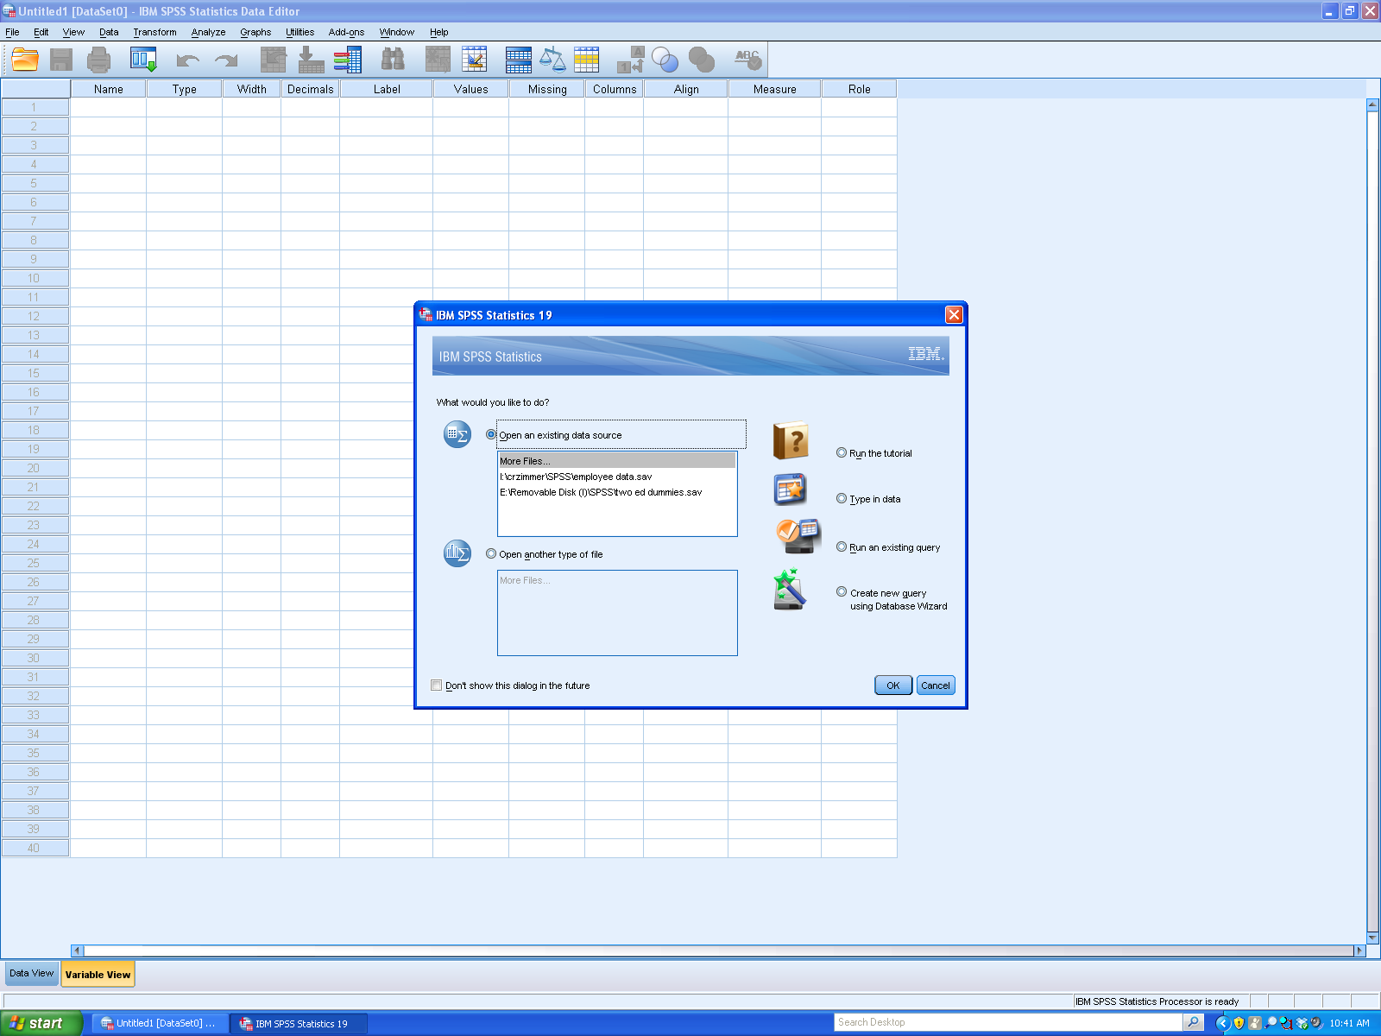
  - Click Cancel to delete the box in the middle of the screen.

  - Look at the screen – this is where data will be.

  - Opening an SPSS data file.
    - Click File
Open
Data -- at the top left of your screen.
    - Find data file: I:\crzimmer\SPSS\gss2012.inls200.sav
    - Double click on the file name – this brings the data into the Data Editor Window.
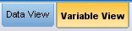
    - Click on Variable View tab at the bottom of your screen.

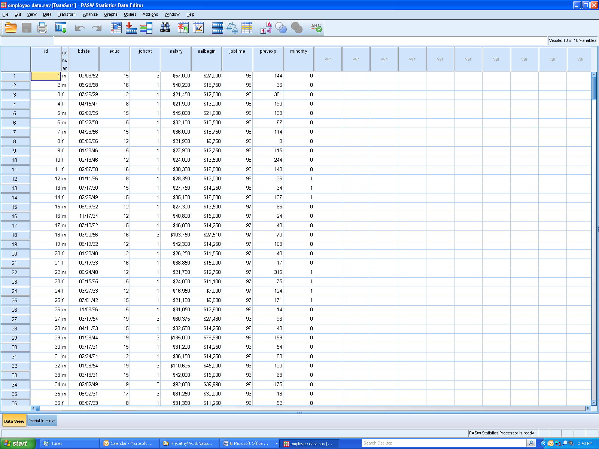
  - Go back to Data View. Look at your variables. Click on the icon below – it shows you the value labels.

  - Saving data on flash drive so you can practice with it.
    - Click File
Save As…
ii) Type in file name, keeping “.sav”. Choose location for file. Click Save.

- WORKING WITH DATA SAVED IN SPSS
  - Deleting cases and/or variables.
    - Using cursor – working with a few variables – age, degree, sex, happy, marital, childs.
    - Using select cases – working with male respondents only.
Click Data
Select Cases…
If condition is satisfied – If…
Put sex into box, click “=1”, Continue. OK.
Run frequency distributions for sex and happy to see effect of selecting cases.

  - Producing a frequency distribution for sex, happy, and marital with bar charts.
Click Analyze
Descriptive Statistics
Frequencies
Charts
Bar Charts
Continue
Move sex, happy and marital into Variable box, click OK.

Note: Try two formats, compare variables OR organize output by variable.

  - Saving output on flash drive so you have a record of your analyses.
    - Click File
Save As…
    - Type in file name, keeping “.spv”. Choose location for file. Click Save.

  - Sorting and splitting files to compare groups.
    - Sorting files.
Click Data
Sort Cases – try sex and age. Look at what happens.

    - Splitting files.
Click Data
Split File – try sex. Then run a frequency on marital. Look at what happens.

Note: Try two choices, compare groups OR organize output by groups.

- ANALYSES
  - Univariate statistics.
    - Frequencies.
Click Analyze
Descriptive Statistics
Frequencies -- let’s look at all the boxes that can be checked and use happy, marital and sex variables.

    - Descriptives.
Click Analyze
Descriptive Statistics
Descriptives -- let’s look at all the boxes that can be checked.
And use age and childs variables.

THANK YOU FOR COMING!
SEE YOU AGAIN ON MARCH 18!

