Syllabus: EBM and the Medical Librarian

Course Identifier:
INLS710.01W.FA14 is approved for 3 academic credits. The course is offered twice a year in the spring and fall semesters. This is an online course available via Sakai. There is one face-to-face class meeting with SILS students to be scheduled within 3 weeks of the start of the class and one web conference with the entire class. This course is offered simultaneously to practicing medical librarians for Medical Library Association CE credit.

Instructor Identifiers:

Connie Schardt
Adjunct Faculty
School of Information and Library Science
University of North Carolina at Chapel Hill
Schardt@email.unc.edu

Angela Myatt
Curriculum Liaison Librarian
UT Health Science Center at San Antonio
Briscoe Library ML 7940
7703 Floyd Curl Drive
San Antonio, TX 78229-3900
Tel, 210-567-2431 (office) Hours: M-F 8:00am to 5.00pm CST
Fax, 210-567-2490
myatta@uthscsa.edu

Target Audience:
The course targets Library Science students interested in working in medical or health sciences libraries.

Course Prerequisites:
This course is designed to be an introduction to the process of Evidence-Based Medicine (EBM) and to the supporting roles and opportunities for medical librarians.

Course Goals and Key Learning Objectives:
- Identify and explain the 6 steps in the practice of EBM
- Identify the parts of a well-built clinical question and use them to formulate a PubMed search strategy
- Identify appropriate EBM resources to answer clinical questions
- Identify and explain the criteria for judging the validity of studies on:
  - Diagnosis
  - Therapy
  - Prognosis
  - Harm/Etiology
  - Systematic Review/Meta-analysis

- Identify and explain the basic statistical terminology used to report the results of randomized controlled trials, diagnostic tests, and systematic reviews
- Identify at least 4 roles for librarians in supporting EBM training and practice for health care professionals

Course Requirements:
For each Module students should:
- Read the course manual
- View the additional recommended material listed in the Sakai Modules
- Complete ALL of the Reviews and Exercises listed at the end of each Module
- Contact both instructors with specific questions about the course material
- Contribute to the class Forums for general comments and questions
- Attend a PubMed training session held at HSL during the first 3 weeks of the course
- Conduct in-depth research on a topic related to evidence-based medicine. The research paper is expected to be a well-thought-out, in-depth exploration of an area of Evidence Based Medicine. Papers should be 10 to 15 pages in length.
Dates:
Dates are set each semester and allow 10 weeks to complete the course. There is a course calendar, which lists deadlines for submitting exercises and the Research paper. An abstract for the research paper is due 4 weeks into the course. The research paper is due 10 weeks after the start of the course.

Grades:
The grade will be based on the students’ completed work and on their participation in the course. The grade will be based on: Contributing to Forums 5%; Course exercises 30%; Final Course Exercise 25%; Research Paper 40%. In grading the paper, the following areas will be taken into consideration:
Depth and quality of content
Is the material original and well developed?
Is the literature search documented and reproducible?
Is there enough content to understand the topic without additional information?
Is the content unique (i.e. not copied from class content)?
Was additional research done to augment the content?
Ease of understanding
Are objectives and audience clearly identified?
Is the project developed in such a way that the point of the project is easily understandable?
Is the language clear and unambiguous?
Are there typos or grammatical errors?
Organization
Is the paper organized in a logical fashion?
Does the order of the content build upon itself?
Authoritativeness of content
Is the content accurate?
Are references appropriate?

Course policies:
Students must attend the PubMed training session. All reviews and exercises must be completed by the deadlines listed in the calendar. Late submissions will lose points. The research paper is due at the end of the 10th week of the course.

Course resources:
All course resources are provided from the Course site in Sakai. Some of the required readings may be requested from the instructors or obtained from the Health Sciences Library eReserves and online collections. No additional textbooks are required.

Honor Code:
There are no special circumstances that have Honor Code consequences.

Time Table:
The following is a sample calendar for when Reviews and Exercises should be submitted:

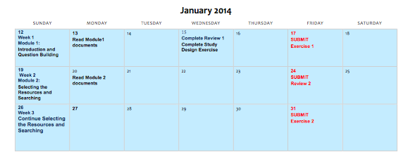

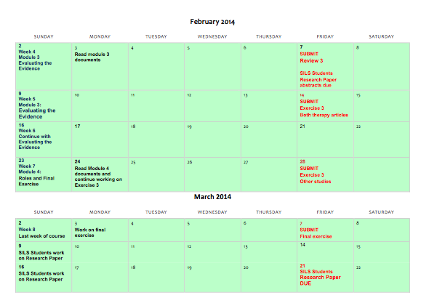

Syllabus Changes:
The instructors reserve the right to make changes to the syllabus, including project due dates and test dates, when unforeseen circumstances occur. These changes will be announced as early as possible so that students can adjust their schedules.

