Searching Academic Search Complete like a pro

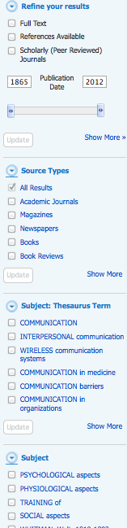
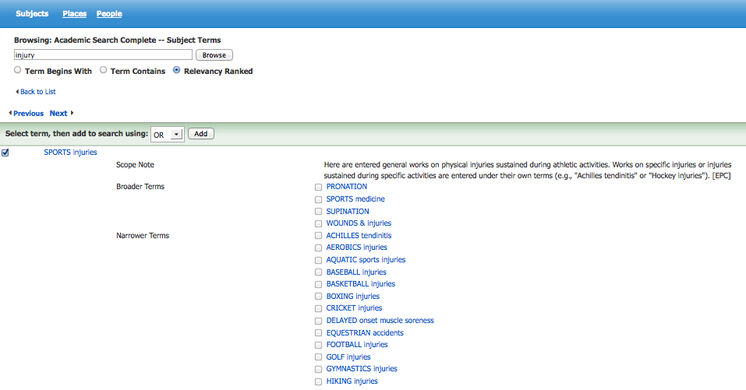
Concept | Definition | Notes
Classification scheme | A method of organization according to a set of pre-established principles, usually characterized by a notation system and a hierarchical structure of relationships among the entities. | Examples: DDC (Dewey Decimal Classification in K-12 & public libraries); LC (Library of Congress Classification used in academic libraries)
Hierarchical scheme | A relationship between or among terms in a controlled vocabulary that depicts broader (generic) to narrower (specific) or whole-part relationships; begins with the words broader term (BT), or narrower term (NT).  Example:  - Social sciences  - Transportation  - Water transportation  - Shipping  - Ocean shipping | SN (scope note): note following a term explaining its coverage, specialized usage, or rules for assigning it.  UF (used for): list of synonyms and alternative spellings  BT (broader term): identifies more broad /generic terms or categories  NT (narrower term): identifies more specific terms or sub-categories  RT (related term): term that is associatively but not hierarchically linked to another term  Jeans  BT Pants  NT Levis  NT Wranglers  UF Dungarees  UF Waist Overalls  RT Denim  RT Overalls
Controlled vocabulary | A standard system of terminology used for coding, classifying, or otherwise uniquely identifying data and information.
Subject heading | A word or phrase, or any combination of words, phrases, and modifiers used to describe the topic of a content object.
Metadata | Data about data  Data that describe the attributes of a resource, characterize its relationships, support its discovery, management, and effective use, and exist in an electronic environment
Facets | A type of metadata that may be applied to resources as an alternative to hierarchical classification | Examples: format (text, image, sound, etc.), availability and location, topics/subjects, etc.

Information need scenario #1

For your communications class you need to find information and research about how and why people reveal (or don’t reveal) information about themselves in Facebook. You may use both scholarly and non-scholarly sources but you will need to cite at least two scholarly articles in your paper.

Steps | List the terms and search actions you try
Topic terms, components, and scope
What subject headings seem appropriate in the database?
Are you selecting a broad subject heading or narrowing down to very specific headings and sub-headings? What seems to work best?
Try combining the subject headings in a few different pairs. What sort of results do you get?
Try refining the search results using one or more facets
How many articles look useful?
What are the best two articles you find? Why are they the best?

Information need scenario #2

For your sports psychology class you want to write a paper on different techniques or strategies that may help motivate athletes and prevent burnout. You may opt to focus on a particular sport or exercise in general. You may use both scholarly and non-scholarly sources but you will need to cite at least two scholarly articles in your paper.

Steps | List the terms and search actions you try
Topic terms, components, and scope
What subject headings seem appropriate in the database?
Are you selecting a broad subject heading or narrowing down to very specific headings and sub-headings? What seems to work best?
Try combining the subject headings in a few different pairs. What sort of results do you get?
Try refining the search results using one or more facets
How many articles look useful?
What are the best two articles you find? Why are they the best?

