Shadowplay: Archival and Cultural Perspectives of Delivering Music Online

INTRODUCTION
Contrary to popular perceptions of the Wild West, modern historians of the American frontier note that many westering pioneers in the 19th century wanted desperately to retain the trappings of the eastern, Victorian age civilization they were escaping. This was difficult to achieve in any real sense – many had thrown the better portion of their belongings out the back of the wagon in order to negotiate rugged terrain and save the oxen, while the rigors of frontier life taxed Victorian niceties. Nevertheless, although artifacts of respectability and civilization littered the migrant trail west, re-creating the east in the new western context proved an abiding goal, and was achieved with varying degrees of success.

So appear the ironies of delivering digital archival media online. Even as we throw bytes out the back of our virtual wagons we want what’s left at the end of the trip to give us a fair resemblance of what we started out with. The prosperity of the digital frontier lies in freeing information from physical constraint, but its price is the continuing challenge of better representation of the original. A digital copy will never be more than a shadow of its physical analogue, regardless of technological advance. How good, then, does this shadow have to be, to accurately, reliably, authentically represent the artifact that is our object? The answer, echoing around the next corner up ahead, seems to be: as good as it can be.

Certainly this is the approach for digitally preserving physical objects such as photographs or sound tapes. But for less apparently esoteric purposes, such as the listening copy of a recording, the answer is, initially, not as clear, and approaches vary. One rarely hears debate over reference copy quality especially regarding sound files, and seldom is the question pondered, “What is the critical mass at which a song delivered online attains authenticity for purposes of study or appreciation?” Although most sound and music archivists are in all probability taxing their resources just attending to preservation and migration of their recordings, this question becomes more compelling as use of online archives grows. If the original sound artifact remains locked in the archive cupboard, and if a master copy is rarely pulled except for migration or duplication purposes, the digital reference or listening copy becomes the de facto cultural artifact as music repositories with online collections make the claim, “This is what the music sounds like.”

This presents an obvious problem as sound and music repositories increasingly provide online access to both non-profit archival and non-unique commercial collections: If listening copy quality is not rigorously attended to, the classes taught, papers written, and cultural interpretations made from these primary sources are jeopardized. How much time and how many resources, then, should archives and repositories give to creating listening copies? Again, the answer appears to be something along the lines of: as much as they can give. However, unlike digitizing for preservation, where the digital sound object often remains within the archive and may be independent of popular listening formats, archivists must take into account limitations of online technology, and even client patience, when devising their methods of efficiently delivering listening copies to users via the spectrum of bandwidths, CPU speeds, and browsers. The result is a digital copy made to be intentionally different from but still mirror its source. That is, while shedding massive quantities of bytes so listener technology can bear its weight, the slimmed-down copy needs to be good enough to convey the cultural message inherent in the master file.

This paper analyzes the “listening copies” provided by several types of online music repositories, to address the question, What challenges do online music providers face in delivering their particular type of cultural material, and how are they meeting these challenges? The discussion and case studies will be informed by archival concepts of quality, including selection and uniqueness of materials, authenticity, and patron trust and expectations, as these vary across systems and especially between academic repositories and their commercial counterparts.

TECHNICAL HISTORY OF A LISTENING REVOLUTION
In discussing the technical standards of sound delivered online, it may be helpful to review some of the basics of digital sound technology and especially its evolution in online environments over the last several years.

Many of the same principles that apply to digital imaging also apply to digital sound. For both, a measure of resolution is accompanied by bit-depth, also known as word length. Where in imaging pixels per inch define resolution, in digital “sampling” of sound the measure of resolution is Kilohertz (or sound wave frequency) per second. Where greater bit depth in imaging allows for a larger color palette and therefore greater color precision in the digital scan, so in sampling greater bit depth allows for a larger spectrum of tones and therefore greater tonal precision in the digital sample.

The advent of the compact disc in the early 1980s set the first widely held standard in digital audio, with a sampling rate of 44.1Khz and a bit depth of 16 bits (or two bytes). The CD offered extended playtime, greater clarity than LPs or tapes when played on most consumer equipment, and a seemingly unlimited number of plays. CDs changed the way music was both recorded and listened to, and according to some not for the better. Audiophiles accustomed to high-end analogue setups in fact called foul early on, as the digital spectrum allowable by CDs clipped out what they considered hear-able chunks of sound, harmonics and nuances not picked up at 44.1/16. Sound archivists, already hard-edged audiophiles with a sense of historical mission, continued to preserve to tape.

Fifteen years on, digital technology capable of rendering analogue sound into digital had grown considerably stronger and become tremendously cheaper. A basic consumer computer with a merely decent soundcard could generate better-than-CD quality copies of analogue sources (typically 48Khz/16-bit), while with some modest investment in a meatier soundcard and extra RAM a home computer could make a .WAV file at 96Khz/24-bit (even if this file couldn’t be rendered onto a playable CD without dumbing it down to a 44.1/16 AIFF file). The .WAV file, the audio equivalent of the .BMP raster image, had become the common currency of digital audio recording.

The drawback of the .WAV file was its size; with a CD-quality 3-minute file taking up around 30,000 megabytes, the format did not lend itself to easy desktop processing or web transfer (especially on a dial-up modem) and thus creators of .WAVs could not easily share them using the internet. MPEG technology, particularly .mp3 technology, mitigated this problem. At work on compression standards for audio visual materials since 1988, by 1992 the Motion Picture Experts Group developed a means of dramatically reducing sound file size. Based on the psychoacoustic principle that humans best hear tones of 2Khz-4Khz (within an overall hearing spectrum of 20Hz to 20Khz), an .mp3 file rendered from an uncompressed source at 128 kilobytes per second (Kbps) reduced an uncompressed audio file by a factor of ten, getting ride of the tonal ranges humans don’t hear so well. This “lossy” compression scheme sliced out audio information from the extreme portions of the audio spectrum, much as the JPEG image rendering system did with pictures, leaving behind what to the human senses might constitute a fair mirror of the original.

The passable audio quality provided by .mp3, especially when compared to other portable sound packages with inherent limitations (e.g., cassette tape), sparked a revolution in the way people listened to recorded music; or, put another way, changed the face of delivering cultural material to audiences. In retrospect the success of .mp3 appears to be serendipity: By the time .mp3 emerged, consumer technology had developed at a pace where it could capably handle the format, and users recognized that digital music could finally be effectively processed on a desktop and online. Audio quality in this context was secondary; convenience was king in the .mp3, much as it had been in the format’s cassette tape predecessors.

Although interests of the recording industry and issues of copyright will not be addressed in this paper, it is significant that .mp3 technology is non-proprietary and that it is the first audio medium that was neither created nor controlled by the recording or broadcasting industry. It is difficult to overstate the significance of the cultural shift that has occurred because of this. In the space of four years audio “file-sharing” via .mp3 has decimated the recording industry, redefined popular perceptions of copyright, and given rise to a whole new business model: online music vendors who believe they can offer both an alternative to the dubious business practices of their traditional recording industry rivals, as well as a convenient way to legally own cheap tunes.

However, the emerging online .mp3 giants are haunted by the populist stance of the lamented Napster mach 1, a file-sharing software of and by the people whose free music swapping service succumbed in 2001 to the legal entanglements of copyright. Vendors like iTunes, legally picking up Napster’s dropped torch in pay-to-download services, are faced with a singular problem. As long as .mp3 was the currency of grassroots users, it could avoid close scrutiny by critics regarding quality standards or best practices. Because users of the service also provided its content, and because Napster was so free it was libertarian, the concept of “standards” was anathema. Less than self-governing, it was little more than controlled chaos. New services delivering online music for pay cannot afford such freedom, when customers demand value.

Held to even higher standards, as is perhaps appropriate, some music libraries and archives have seen fit to use .mp3, as well as other formats, to deliver audio files to academic audiences online. And again, convenience rather than audio quality, the desire to cater to an increasingly online audience, appears to be a major motivating factor (although not always). Here the quality stakes may be a little higher, but as we will see, in the context of online music providers, quality is a matter of perspective, and can be measured in many ways. In assaying quality in the delivery of online music, to see how providers are meeting the challenges of their audiences for worthwhile cultural material, we must take a thoughtful approach that goes beyond simple measurement of the sound technology itself, and even beyond the more complicated measurement of convenience. As important as these factors are, this study of quality extends to selection and uniqueness of the materials in the archive or repository, authenticity of the material as delivered, and the trust and expectations of the client population.

RARE FINDS? SELECTION AND UNIQUENESS
I.
“Archival records are thought above all to be unique, and much of their value is seen as a consequence of this inescapable circumstance.”

It would be folly to summarily treat online music vendors such as Apple’s iTunes (http://www.apple.com/itunes/) as one would the online presence of an academic or archivally-minded music repository like e-Tree’s Live Music Archive (accessed through the Internet Archive, http://www.archive.org/). Marketing dollars, profit-motives, and philosophical differences aside, however, the case for distinction between the two when measuring quality of the “online deliverable” begins to break down, especially once we start speaking of standards such as selection of material and that material’s uniqueness.

Can online music vendors and archives lay claim to uniqueness as traditional archives do, in their promise to provide access to unique materials? It would appear for purposes of discussing what are in effect online versions of listening copies that the answer is no, but the question merits further investigation, since uniqueness of holdings in traditional archives has implied some expertise on the part of archival staff in the content areas of those holdings. For archives, providing unique information to a greater or lesser extent could be a measure of its ability to ably access and/or represent cultural content, as the established “expert” regarding the material. If uniqueness does in fact imply this sort of expertise, then it could have an impact on assessing online music sources that cannot claim uniqueness.

The traditional assumption regarding non-archival sources of cultural information (whether one considers these bookstores, record stores, print shops, galleries, or libraries) is that the materials they hold are not unique (i.e., copies are held elsewhere). Archives on the other hand have often been defined in terms of their uniqueness, their value to the community perceived as a function of preserving and providing access to rare or one-of-a-kind records, selected for their uniqueness, that can speak as surrogates for the people who created them. Uniqueness in an archives is a reassuring affirmation of its documents’ authority and, by association with those documents, the authority of the archive itself. But actually defining the qualities of unique documents was never easy, and according to some is getting harder to do every digital day. For instance, James O’Toole has identified four different meanings of uniqueness and in the process concluded uniqueness may be the straw man of archiving. There is, he says,

a) Physical uniqueness, or the individuality of the artifact containing the information.
b) Uniqueness of information, or the individuality of the content of the artifact.
c) Uniqueness of process & functions, or the individuality of how the information was created.
d) Uniqueness of aggregations of records, or the individuality in which a collection of information or documents is put together.

The trouble with the first two meanings of uniqueness is that identifying the unique object and the unique information in many cases can be quite difficult, and assigning value to them can be quite problematic. For example, in terms of photographic images, is the cultural object of importance the photographic negative or the print? Isn’t it the copy that carries the cultural message, rather than its source? Can something that is inherently not an original be as or more important than that unique object? Sound recordings carry similar issues with some important differences. Many modern recordings, especially after the development of tape and the ability to manipulate it, are often several steps removed from source material. With the exception of live performances recorded with no subsequent editing, modern recordings, often mixed down from multiple takes (not always performed with chronological linearity) and then glued together, cannot be considered mirrors of real events. “Such a recording may well represent a unique assemblage of scattered bits of aural information but…this kind of uniqueness is unconnected to any pre-existing reality. A new, artificial reality has been constructed instead.” The unique cultural object cannot be considered the multi-track tape, or its mixdown, or the master, or the CD copy sitting on the shelf in the record store. These may all have varying degrees of uniqueness, but none of them can claim to have captured an actual performance, and as far as conveying cultural material is concerned, it is the last link in the chain, the CD copy, that may be the most likely candidate for achieving that goal.

The last two aspects of uniqueness are interesting, and may help our interpretation of the concept as applicable to online music providers, if only to an extent. Archives are interested not only in the uniqueness of objects and the information they contain, but how that information was generated, and in what kind of organization the information was then placed. From O’Toole’s perspective, both of these types of uniqueness are doomed because it would be difficult to locate a process or aggregation that did not admit of some unique quality. “In the end, everything differs from everything else, and the presence or absence of uniqueness thus permits us to draw no meaningful distinctions.”

However, for this paper, O’Toole’s suggestion of unique aggregations of records, and the way in which they were created, is meaningful, with a slight adjustment of perspective. There are three major functions or actors that define an archive or repository: 1) document creators or authors; 2) document keepers or archivists; and 3) document audiences, or patrons. If in the realm of online music delivery and downloading we shift the boundaries and consider the provider the document creator, and the user the archive, then there are unique aspects about providers that users may well be interested in. The way in which the providers render their music files, organize them, present them, and restrict them could all be considered unique aspects of music providers and among criteria for their ability to deliver sound and music.

As demonstrated, uniqueness in the context of online music archives and commercial sites doesn’t work as a measurement of quality, since there are few, if any, sites providing sound files not derived from source tapes or otherwise copied. If uniqueness plays a role at all, it is in the way providers bring records together and organize them, which, if we shift perspectives and make the user the archive, might be described as uniqueness of aggregation. Related to this is the principle of selection, a critical aspect of archival quality that speaks to the same kind of expertise implied by a collection’s uniqueness.

II.
Selection in academic and commercial online music archives tends towards one of two sides of a spectrum of choice. At the specialty end, offering fewer choices but greater depth of story, are most of the academic or non-profit archives. The Live Music Archive, part of the Internet Archive and run by eTree, is one example of this type. The spirit behind the Live Music Archive is similar to the one inhabiting the mini-industry that built itself around audience taping of Grateful Dead shows (which the band always allowed, recognizing its value to their reputation). Bands included on the site are selected by recordists who choose to upload concert recordings of performances by bands who themselves very much follow the ethic of the Grateful Dead, both musically and culturally. There are strict rules regarding formats on eTree, the primary directive being that no lossy compression schemes be used in uploading files to the site. This again is an expected outgrowth of the tape trading ethic begun by “jam” band audiences of the 1960s and 70s. Sound quality, as a means of achieving proximity to the performance, has always been of critical importance to these audiences. Files are therefore placed on the archive as .SHN (“shorten”) or .FLAC (Free Lossless Audio Codec) files, and downloading them requires software that can translate these non-lossy formats back into .WAV files playable on a PC. It also requires considerable time – lossless compression files, while smaller than their source .WAVs, are still many times the size of .mp3 equivalents. Because tape traders of this caliber have always been tireless with regard to description, eTree also requires that uploaders record in metadata fields not only pertinent facts of the performance, but the chain of transformations that rendered the sound files to their downloadable state. Selection has therefore been defined by the culture itself, both bands and audience, who follow a shared ethic with regard to musical taste and use. In this model, the archivists are also often the users.

At Southwest Missouri State University, the Max Hunter Folk Song Collection (http://www.smsu.edu/folksong/maxhunter/) archives traditional folk ballads in compressed RealAudio (a proprietary format) and CD-quality AIFF format (the format played by commercial CD players). Selection of songs is not an ongoing process – Max Hunter, a salesman with a tape recorder, collected the songs from 1956 to 1976 as he traveled through the Ozark Mountains, so the collection is discrete and will not continue to grow. Hunter’s decision on what to record became the default selection, and because he recorded traditional songs, many of which are variations on the same tune sung by different singers, the collection conveniently serves scholars studying the development of folk song and the malleability of the form. Its rarity as a web resource has less to do with the uniqueness of its songs than its mere presence online – there simply are not many, if any, comparable web collections that also offer cross-referencing to other collections or folk song transcriptions (such as the Child Ballads). With some songs represented as many as eight times (“Barbara Allen”), the mission of the archive appears implicit in its selection. In this model, the authors, archive, and users are separate, but the specialized nature of the selection of the collection’s songs shows that it is closely aligned with specific needs of folksong scholars.

At the other end of the choice spectrum, offering greater choice but thinner collateral, or context, for those resources, is Apple’s iTunes. Currently the champion of online music vendors (10 million downloads in its first four months alone, before it released its interface for PC), iTunes’ selection policy appears motivated by the pop culture that supports it and its ability to talk artists and record companies into allowing songs to be placed online in their proprietary twist on the .mp3 format. Like a traditional record store chain, iTunes sees its strength in allowing users to select from the broadest possible collection they can put together. In this case, the authors, archive, and users are separate entities, and selection of culturally relevant material is controlled partly by the archive, and partly by the authors or rights holders. Customers do influence selection insofar as they (theoretically) decide what to buy, and therefore influence what is selected and sold, but it could also be argued that as the content manager iTunes ultimately controls user choice.

At the same end of the spectrum with iTunes, although a little more towards the middle, is eMusic, which uses VBR, or variable bit rate .mp3 technology, to provide music to customers. Unlike iTunes, eMusic actually has a stated selection policy (of sorts), which is decidedly mass market but focused on a specific audience: eMusic is the digital music service for discerning music fans, having paved the way for groundbreaking independent artists and labels to digitally distribute and market their music online. Boasting more than 275,000 songs in every genre from 900 of the world's best independent music labels, eMusic is the premier subscription service for independent music. A selection policy aimed to draw listeners of independent music (i.e., music independent of big record labels) distinguishes eMusic from many other online commercial services and in an archival sense adds value to its collection, as eTree does, by letting users know the nature of its collection.

Selection can be revealing in estimating the ability of online music providers to effectively deliver cultural material to audiences. Ideally, selection should function as it does at the Max Hunter Collection, where the mission of the archive is implied in the content it accessions. This is not to say that the other archives mentioned do not achieve their goal, but only at the Max Hunter Collection is the actual cultural content the star of the show, and the focus of the archive’s expertise. At eTree, while the jam band genre naturally fills its vaults, given its community’s tape trading ethic, the story told is less about that genre than it is about the importance of a lossless compression scheme – beyond that requirement, there are no restrictions (outside of copyright) limiting selection for the archives. Many may count this as a strength, but it is possible to read into it a certain lack of control over the direction of the collection. iTunes and eMusic may achieve commercial success, much as a discount department store might, on the strength of policies lacking clear selection standards. Their success as repositories of commercial music may, ironically, depend on an actual disregard for the cultural content of the material they vend.

Uniqueness and selection is a first step in considering the archival qualities of online music providers, and as we have seen, uniqueness is difficult to realize, particularly in digital environments (and may not even be possible, or desirable), while selection can be effectively wielded or ignored to differing effect. The next step, consistently ensuring the authenticity of the material presented, that the sound files users access represent the real deal of (pop) cultural heritage, is a challenge that archives must meet if their reputation is to remain intact.

AUTHENTICITY: WHEN IS ELVIS NOT ELVIS?

I.

In the United Kingdom for the past 25 years, [Elvis] Presley and the Beatles have enjoyed the joint honour of having achieved 17 No. 1 hits. Now, nearly 25 years after his death, and 33 years since The Beatles last reached the top of the British charts, Elvis is the unchallenged king. He has 18 No. 1s. – The Age, June 2002.

Elvis’s 18th hit in the UK was a remix made in 2002 by Tom Holkenborg who, with the Elvis estate’s blessing and using the name JXL, added drum samples, basslines, and more than a minute to the original runtime of Presley’s “A Little Less Conversation.” The song (written by Billy Strange and Scott Davis) was a standout among the typically throwaway tracks he recorded for his movies in the late 1960s, and came from the 1968 film Live a Little, Love a Little. As remixes go, Holkenborg’s treatment of the song was fun, lean and tastefully done. That Elvis should be given some credit for the song along with JXL appears reasonable (and vice versa), and although it may be stretching matters to award Elvis credit for achieving his 18th No. 1 hit, that designation is a measurement of sales and is a reflection of the popularity of the performance or performer, so Elvis might be considered more than a little responsible for the song’s success. But there can be no doubt the song was substantially transformed, and to some criticism (Elvis fans and others noted that the song was already one of his funkiest, and the last thing it needed was a modern 120-beat-per-minute disco interpretation). Furthermore, like remixes of published recordings in general, there are concerns of authenticity regarding original performance or mixes versus performance or mixes added (often many years) after the fact, and of who should be credited for the result. There are also questions of archival and cultural authenticity: what is being presented to audiences as Elvis, versus what is being presented as JXL? What series of transformations did the material undergo? Is there a risk that I could confuse the two if not made aware of their differences, thereby making reasoned assumptions about cultural material that are not valid?

A short tour through iTunes proves that critical questions such as these do in fact test the authenticity, and ultimately the trust, that music archives, whether they are commercial are not, need to cultivate to be successful. iTunes carries the two versions of “A Little Less Conversation,” both of which come from published compilations of Presley’s music. Recognizing the need for metadata of some type to help users access the music and also to act as a surrogate for traditional album liner notes, iTunes does in fact provide some minimal information about the songs they sell, but only as related to the albums from which they came (meaning that songs taken from compilations and rereleases don’t give dates of original song release, and since many albums rereleased on CD don’t provide year of original publication, this can become a real problem). Because JXL’s version of “A Little Less Conversation” was included on one of the most recent compilations of Elvis’s hits (of which there are dozens), Elvis alone is listed as the artist, and there is no mention anywhere of JXL or Tom Holkenborg. Although a nominally sophisticated listener would probably be able to detect the modern sound of JXL’s treatment upon hearing it, the lack of collateral information regarding the song’s context is damaging to iTunes archival reputation and, even if unintentional, deceives the listener. They are selling a song that appears to be something it is not. If it weren’t for the difference in runtime between JXL’s version and the original from the movie that is also available, the user would be unaware on the face of things that any differences existed between the two versions offered for sale.

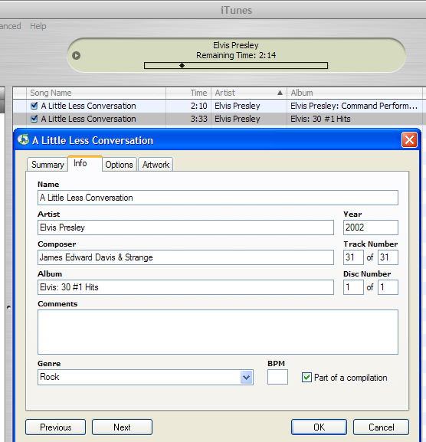
Figure 1. Screen shot of iTunes song information menu for the JXL version of “A Little Less Conversation.”

II.

For a document, speaking per se is not enough. It also must be able to speak reliably….In many cases, this reliability is achieved through fixity….But with newer media…this reliability is achieved not by fixity but by repeatability.

The sort of disconnect seen in the case of iTunes and “A Little Less Conversation,” between the actual content of cultural material and the information provided about that content, is the nightmare of traditional academic archives, but may become more commonplace as the sheer volume of digital files placed online increases. It is this particularly digital character of the files that can potentially jeopardize authenticity of material, because copies can be so easily digitally altered, especially when compared to analogue or “hard” copies. As noted earlier, online musical content is typically copied from original sources or copies of those sources; therefore, the authenticity of the copy in representing the original over time (or repetitions/playbacks of a copy that appears to represent the original) becomes critical. How is this authenticity expressed, how do we know the real deal in a digital environment?

“One possibility would be to maintain audit trails, indicating the series of transformations that has brought a particular document to the desktop. A second possibility would ignore the history of transformations and would instead specify what properties the document in question would have to have to be authentic. This would be akin to using a script or a score to ascertain the authenticity of a performance.” David Levy’s options for assessing authenticity of a copy, either tracking changes made to an object or measuring an object against a master, both have their strengths and weaknesses. In the former method, we must be tracking changes to the right file, that is, changes to a file that has already been authenticated. In the latter, the master we use to authenticate our copy must itself, at some point, be authenticated. The maddening circularity of this chicken/egg dilemma demonstrates the challenges of authenticating digital copies, but in real world terms suggests that a combination of the methods is probably what is most appropriate and feasible, building a sort of good faith due diligence to ensure the greatest possible degree of authenticity.

It is this version of authenticity, in fact, that may be most meaningful. Far from a cleanly defined concept, authenticity is not to be switched on or off, but rather admits of degree, Authenticity of a copy, its “faithfulness” to an original or master, is quite dependent on the needs of the user. “The context of use, in other words, determines which properties of the original must be preserved in the copy.” How can online music archives determine the contexts in which their users utilize downloaded copies of songs? Just as it is difficult to determine uniqueness of a document or collection, user purpose is as varied as individual identity, and ultimately a copy will not be authentic for all purposes.

Authenticity in context is the key to effective evaluation of music providers. All of the providers considered here use some type of metadata, regarding content, formats/systems, or administrative details, to control their files to greater or lesser degree and ensure authenticity. eTree’s Live Music Archive demands extensive content and administrative metadata from members who upload material, to help ensure that their documents are authentic. This kind of claim to authenticity speaks to its audience, who generally come from a tradition of tape trading where documentation of both performance and recording method is of prime concern. There is also a sense of self-policing, and of doing justice to the performers who are the subjects of the tapers/recordists, as the presence of a reviews section, error reporting center, and “Band Policy and Notes” link testify.

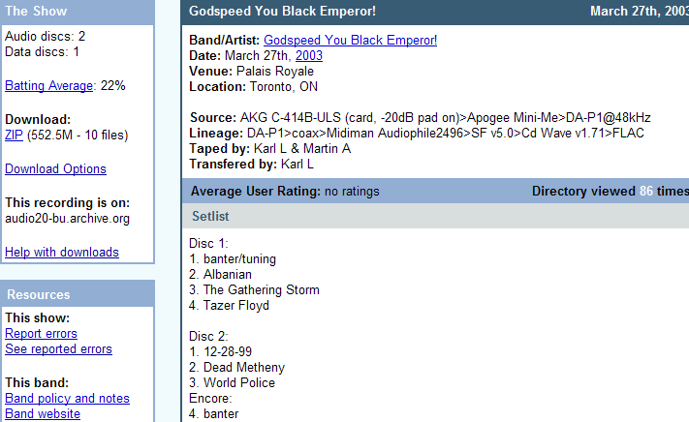
Figure 2. Screen shot of the Live Music Archive's recording information for a performance of the band Godspeed You Black Emperor!

The Max Hunter Folk Music Collection also provides metadata for authentication, as well as some value-added content in the form of song transcriptions (made by Hunter but for our purposes could be considered distinct from the actual recorded song files). In this case the scholarly community is looking for complete information as a measure of authenticity, and transcriptions of the songs can be used to check against the recording content. Depending on the user, copy quality may or may not be a part of the authentication process (although as noted above the collection does offer a CD-quality download), but thorough and accurate information regarding the circumstances of the original recording is key. Any information that Max Hunter collected along with the recording is critical. The metadata that appears to be missing, however, and the collection’s weak spot in regard to authentic copies, is slim administrative information, beyond the very basic details, on how the downloaded files were rendered for online delivery. It is helpful to know whether they were “cleaned up” for presentation purposes, and what systems were used in the process. It is unusual for an archive of this type, definitely concerned with authenticity, not to explicitly provide such information.

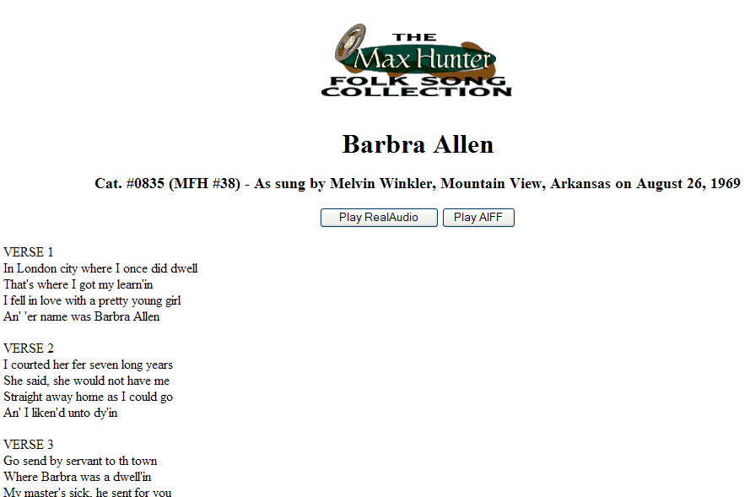
Figure 3. Screen shot of one version of "Barb(a)ra Allen" from the Max Hunter Folk Song Collection.

We have seen the weaknesses of iTunes’s metadata as it regards authenticity, but should also note that for many of its pop culture users, this type of authentication may be unnecessary, outweighed by the benefit of convenience. The other commercial provider we have considered, eMusic, takes some steps in terms of providing a sense of authentic copies. As opposed iTunes, eMusic presents its copies in the context of the original albums, and collectors can therefore be assured of getting complete albums in the same running order as the original release. Additionally, eMusic’s explanation of its VBR .mp3 method, a compression system that maximizes .mp3 bitrate for more efficient downloading, adds to the confidence its users, mostly alternative or independent music fans, have in the system and the authenticity of the copies downloaded.

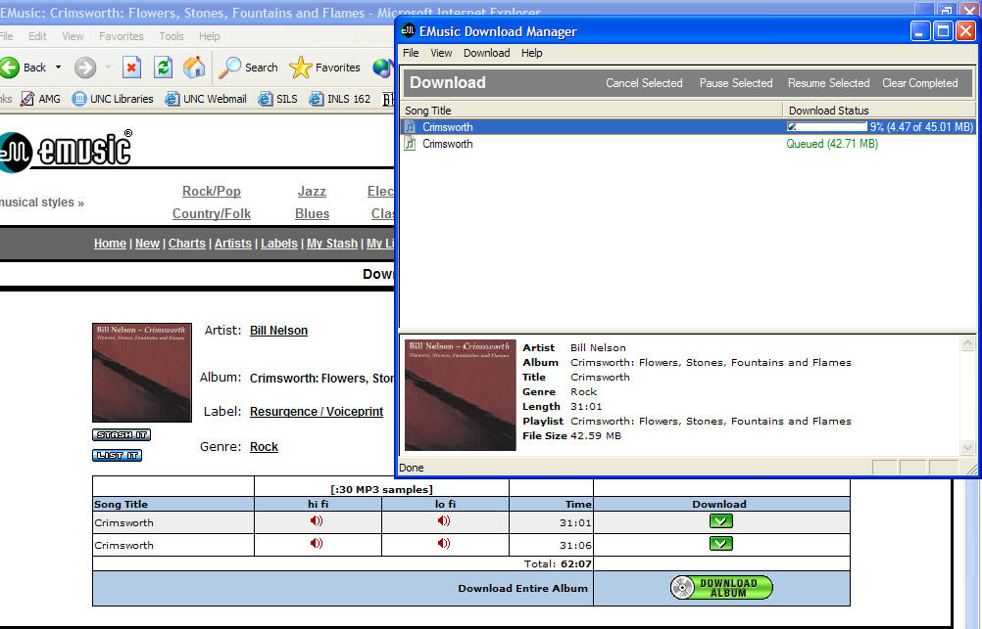
Figure 4. Downloading Bill Nelson's "Crimsworth" album from eMusic. Note the content metadata in the download screen.

Confidence is critical to authenticity, especially if we consider what is authentic in terms of patrons and the context in which they use copies. Another name for confidence is trust, which is the final archival principle considered in assessing how online music providers deliver cultural material.

TRUSTED REPOSITORIES, GREAT EXPECTATIONS

Thus far, libraries, archives, and museums have shown they can create and provide access to digital materials. Users now rely on institutions to provide ongoing development of systems that support long-term access to the materials. Over time, institutions will keep the users’ trust so long as they sustain reliable access to information.

Trust and authenticity are inextricable, and in the digital world are linked by reliability, which answers the question, Will this digital object remain the same over time? Trust in our public institutions is often rooted in documents, the rules that guide officers of the state empowered by those documents to lead our society, but this trust is nourished by time, and the sense that we can rely on our system to perform in a manner to which we have become accustomed. Trust is therefore also grounded in expectation – to what extent we can trust a document depends directly on previous experience with documents of that type and delivered by that source.

By virtue of its youth, the digital environment is one where trust is at best a shaky proposition, but perhaps a more viable notion than authenticity. If in the digital environment one accepts there really are no originals but only copies, “the persistent question is whether a given object X has the same properties as object Y. There is no ‘original’….In such cases, there is no question of authenticity through comparison with other copies; there is only trust or lack of trust in the location and delivery processes and, perhaps, in the archival custodial chain.” Lacking time-proven results, how do repositories and archives in the digital domain generate a sense of trust among its users, and how do we recognize those that are trustworthy? Put succinctly, “a trusted digital repository is one whose mission is to provide reliable, long-term access to managed digital resources to its designated community, now and in the future.” According to the authors of RLG-OCLS’s Trusted Digital Repositories, we can distinguish three levels of trust: how cultural institutions earn trust from their communities (in the case of online music, these would be users at computers with a variety of expectations difficult for the archive to pinpoint, if only because of their facelessness); how cultural institutions trust third-party vendors (we could think of these as record companies or subscription services employed by music libraries); and how users trust the documents provided to them by a repository (i.e., the extent to which online music users trust downloaded files). But we are still left with a nagging question: how is trust developed by institutions who have been digital for such a short period of time, in some cases only a matter of months?

“In the absence of trusted repositories or reliable, proven practices, a program for certification could provide a basis for trustworthiness.” Certification programs, based on organizational feasibility, best practices (if not proven), and compliance with standards such as the Open Archival Information System (OAIS) Reference Model, have been recommended and should be critically considered. Certification programs, while most likely necessary, may be difficult to construct, as best practices in digital environments may depend on the nature of the material digitized (from the perspective of the type of media, e.g. sound, and the content, e.g. music, spoken word, etc.) and are at least partly reliant on user expectations or needs as well as user technologies (for instance, on some user systems some sound files may not even be playable).

The obstacles facing certification programs, however, are not insurmountable, if subsets of standards could be applied depending on the type of archive or repository the institution claims to be. For instance, iTunes might attain certification based on similar, but not identical, standards applied to the Live Music Archive. Why the difference, and wouldn’t this difference destroy any notion of standard, thus nullifying the concept of certification? Yes and no. While achieving certification implies that certain standards have been met, the means of attaining certification, or meeting standards in specific organizational situations, is not an absolute. There are different brands of trust, just as there are differing perceptions of authenticity and uniqueness, that depend both on the source and the user, and therefore certification for trust might also be reasonably expected to have some malleability.

In the case of online music delivery, building trust in users is challenging, especially because, for having such a short history, its past is a checkered one. Issues of copyright have taken down entire systems, and not just populist concerns like Napster, but listening libraries in university settings as well. Trusted online music repositories, that can be relied upon to deliver consistently authentic sound documents not only now but indefinitely into the future, are scarce to non-existent. Commercial sites have specific challenges to contend with, given the profit motive. If a company finds that its online music vending business no longer meets profit goals, as unlikely as that may now seem in the case of iTunes, then in all likelihood that business will close, regardless of its holdings in otherwise out-of-print copies. Academic or non-profit providers fare somewhat better in long-term viability, as they are typically either publicly funded or, as is the case with the Live Music Archive, they may be mirrored at other open archival sites.

What else might provide a surrogate for trust for online music archives? Until trust can be gained through time, there may be only one answer: metadata. Providing users with information about the content and the history of the accessible files, as clearly and completely as possible, appears to be the best hope archives have for establishing trust, regardless if they are non- or for-profit. Telling the user what its holdings are, promising the user they will receive the materials as presented, and then facilitating the user in realizing that promise (as the Live Music Archive does in its step-by-step explanation of how to download and play the files it provides access to), is the best, and perhaps only, method of beginning to build a trusting relationship in a context of delivering cultural material such as music.

CONCLUSION

[Let It Be…Naked] is a valid, entertaining interpretation of the Let it Be sessions. But, contrary to the sticker selling the album, this is not necessarily “Let It Be…as it was meant to be. The band’s cut from the original sessions.”… Though it is still faithful to much of the feel of Let it Be, the presentation of Naked, including the slight bits of modern-day editing, reveals that it is revisionist history, not the final word. Which doesn’t hurt it as a record – these are great songs, after all – but it is a bit disappointing that this long-awaited project wasn’t executed with a little more care and respect for the historical record.

Thirty-four years after its recording session, and 33 years following its release as an album none of the Beatles had particularly much to do with, Let It Be was shorn of the post-production gloss added by Phil Spector, taken out of the original context in which it was released (songs were re-ordered and studio banter deleted), remixed for sound quality, then re-released under a modified title. As its sound quality was celebrated, its other revisions were not treated so kindly – Paul McCartney was accused of taking unreasonable control of the Beatles legacy, as the project was under his auspices, but there was perhaps more a sense of disappointment that the original cultural experience of Let It Be was not left intact.

The circumstances of Let It Be, both in its original and revised released versions, is a textbook of problems associated with assessing uniqueness, authenticity, and trust, and informs a discussion about the transmission of cultural material online. In its first incarnation it was a document whose source was the Beatles but whose creators after-the-fact were third parties not typically associated with the Beatles, producers, engineers, and filmmakers charged with creating a soundtrack album out of session tapes abandoned by a group beginning to fall apart. Of all the Beatles albums, Let It Be is considered their one “unfinished” work. It is also often believed to be the last album they recorded, although it is not – it was recorded before, but released after, Abbey Road. Because there is tremendous confusion about what Let It Be actually is, or was (it was even originally entitled Get Back, an acetate of which was played on a New York radio station before any release of the songs), deciding what sort of cultural meaning it has becomes muddled. What is the original? What is the copy? Which has greater importance?

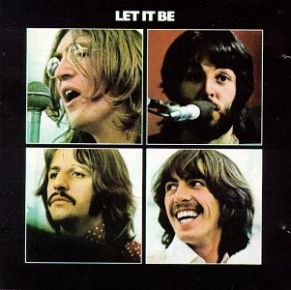 | 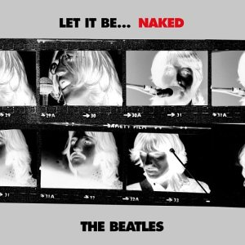
Figure 5. The Beatles’ Let It Be, in its original state (left) and “Naked.”

Almost tongue-in-cheek, the cover of the new version seems to taunt listeners with these questions, and echoes James O’Toole’s comments regarding the photographic negative and its relationship to the print. It is clear that the album originally released as Let It Be in May 1970 represented for over three decades part of the canon of a group commonly considered one of the great cultural touchstones of modern western civilization. To deny it considerable historical significance would therefore be folly. But to deny Let It Be…Naked to exist as a valid partner of the original would also be folly, and for very archival reasons. In the first place, for the creators of the source material who survive, the project was worthwhile – they envisioned an organization to the material and put it in that order, potential objections of the deceased John Lennon and George Harrison notwithstanding. This is not Elvis vs. JXL, this is the Beatles 1969 vs. the Beatles 2003. Secondly, it is a project done with disclosure, the facts of the circumstances surrounding the material are not hidden from view. In this case, altering a copy, or making an alternate version, of a cultural treasure creates rather than destroys; because the high profile of the Let It Be...Naked project created a type of cultural metadata written by pop culture historians and reviewers, we have gained another perspective on pop history, while retaining what we already know.

Let it Be…Naked provides an object lesson in the way alteration of cultural materials should occur. Of course, with the Beatles, every move regarding their catalogue is thoroughly monitored, but one might be able to say the same of Elvis, and as we have seen, distinguishing the original from an altered version of “A Little Less Conversation” proved problematic in the case of iTunes, an online provider of popular media. Would the Beatles, who like several other giants of pop music have been slow to turn their catalogue over to an internet music provider (e.g. Led Zeppelin and Metallica have cited issues of quality and the protection of their artistic legacies), fare any better in an online environment; would a third party be able to distinguish between Let It Be and Let It Be...Naked, and be disciplined enough to pass this information on to its clientele? Additionally, if we understand that online information providers, particularly those dealing in media like music and sound, can in good faith provide certifiable quality and metadata and still come up short because user systems may be unable to handle the documents as intended, then how do we even begin to approach our original question: Are digital music providers able to reliably deliver accurate cultural representations of source material online, and if so how are they meeting the challenges presented by this environment? The answer might be a qualified yes if we attend to the definitions and issues of traditional archivy, and demand from an online archive what might also be reasonably demanded from a traditional one. Uniqueness, authenticity, reliability and trust, however, yield somewhat upon close inspection, admit of relative definition, and so we have seen that many times the questions we have asked can be answered in terms of user need, technical capability, or archival purpose, and with the understanding that what we are typically dealing with in an online environment is a copy of a source, a surrogate for a voice.

The Library of Congress makes 96Khz/24-bit digital masters, and two service copies, one at CD quality and the other in .mp3 format. Carl Fleischhauer, “Audio and Video Preservation Reformatting: A Library of Congress Perspective.” Paper delivered at the Preservation Conference: Digital Technology vs. Analog Technology. March 27, 2003, p.4 (print-friendly version). http://www.archives.gov/preservation/conferences/papers_2003/fleischauer.html
As mentioned in the above note, 96.1KHz/24-bit sampling is the Library of Congress standard for master copies. Most original sources don’t exceed 15 KHz, and the theoretical rule of thumb in digitization of sound is to sample at twice that. Since industry standard is 44.1Khz/16-bit for CDs, even low-end consumer software can effectively digitize analogue originals, at least in theory. However, audio engineers in archives prefer to preserve at 96.1Khz/24-bit (and some even advocate going to 192Khz/24-bit) as a stop-gap, to cover operator mistakes, to ensure harmonic capture, and in case future technology allows for more efficient rendering. Fleischhauer, p.3.
Geoff Nicholson, “MP3 Explained: A Beginner’s Guide,” Shareware Music Machine News, March 1999 (http://www.hitsquad.com/smm/news/9903_109/). See the Moving Pictures Expert Group homepage for greater detail on MPEG technology. http://www.chiariglione.org/mpeg/index.htm.
Amy Harmon, “What Price Music?” New York Times October 12, 2003.
In fact, it should be noted that Napster and its progeny, such as KaZaa, allowed unregulated trading of not only .mp3 files, but other software formats and programs as well.
For an excellent discussion of perceptions of value of online products in general, see Steve Smith, “The Free Lunch is Over: Online Content Subscriptions on the Rise,” EContent, 25 no.2 (2002). The real story of this article is its demonstration that just last year the “experts” were predicting that Napster had ruined any chance of online music delivery ever being a viable revenue generator.
James O’Toole, “On the Idea of Uniqueness.” American Archivist 57 (Fall) 1994, 633.
Peter Hirtle believes this is an asset that archives could bank on. Peter B. Hirtle, “Archives or Assets?” From an address at the 67th annual meeting of the Society of American Archivists in Los Angeles on Aug. 21, 2003, pp. 11-12. http://www.archivists.org/governance/presidential/hirtle.asp.
David M. Levy, “Where’s Waldo? Reflections on Copies and Authenticity in a Digital Environment.” In Abbey Smith, ed., Authenticity in a Digital Environment. Washington: Council on Library and Information Resources, 2000, p. 25.
In discussing uniqueness, it’s also helpful to think of “sameness.” David Levy has suggested that there are two types of sameness: 1) the very same thing; and 2) things of the same type. In the age of digital copies, information contained within documents, rather than their containers (the physical or digital documents themselves), are of the same type if they share certain properties, and in this context uniqueness is irrelevant if the user cares nothing about the information’s container but rather the information itself. Uniqueness tenuously survives as we ask the question, What properties are then considered of a type? Levy says “Determination of which properties matter are made in the context of purpose and use,” meaning that uniqueness may very well be in the eye of the beholder. Levy, p. 26.
O’Toole, pp. 637-39.
Ibid., p. 651.
Ibid., p. 654.
Ibid., p. 657.
The issue of sound files digitally born online is an interesting one but cannot be addressed here. As a purely digital object, however, it would be difficult to think of such a file remaining unique.
Harmon.
EMusic Fact Sheet, December 2003 (http://www.emusic.com/about/facts.html).
Bruce Elder, “A little less conversation has Western world talking,” The Age, June 29, 2002 (http://www.theage.com.au/articles/2002/06/28/1023864656845.html).
Note also the composer information is wrong, with the composers’ names incorrect and incomplete.
Levy, p. 25.
Ibid., p. 29.
Ibid., p. 30. Clifford Lynch echoes this in his adjoining article from the same piece in which Levy’s article appears, couching the concept in terms trust (discussed in further detail below). “Virtually all determination of authenticity or integrity in the digital environment ultimately depends on trust. We verify the sources of claims about digital objects or, more generally, claims about sets of digital objects and other claims, and on the basis of that source, assign a level of belief or trust to the claims. As a second, more intellectual form of analysis, we can consider the consistency of claims, and then further consider these claims in light of other contextual knowledge and common sense.” Clifford Lynch, “Authenticity and Integrity in the Digital Environment: An Exploratory Analysis of the Central Role of Trust.” In Abbey Smith, ed., Authenticity in a Digital Environment. Washington: Council on Library and Information Resources, 2000, p. 46.
Ibid., p. 26.
As Levy notes, “The source…does not and cannot fully specify the properties of the things it is used to make. There is a division of responsibility between the source and the environment in which it operates.” Levy, p. 28.
iTunes will often be able to offer only portions of albums, so that song context is lost.
Trusted Digital Repositories: Attributes and Responsibilities, an RLG-OCLC Report. Mountain View, CA: Research Libraries Group, 2002, p. 9.
Luciana Duranti has distinguished between the authenticity of a document and its reliability, where reliability is a measurement of the authoritative processes by which a document is created (i.e., were standardized processes followed in its creation?), and authenticity is measured by a document’s own physical ability to show what it is claimed to be, that reliable processes were followed in its creation. However, for our purposes here, where we are speaking of the ongoing reliability of a digital copy to remain available and identical over a term of repeated uses, the temporal quality of reliability, especially as related to trust, is emphasized. Luciana Duranti, “Reliability and Authenticity: the Concepts and Their Implications.” Archivaria 39 (Spring 1995): 5-10.
Lynch, p. 41.
Ibid, p. 37.
Ibid., p. 9.
Trusted Repositories, p. 10.
Ibid., p. 13.
? Lynch, p. 36.
A music service developed out of MIT’s was squashed by Vivendi/Universal music group after less than a week in existence. John Schwartz, “Music-sharing Service at M.I.T. Is Shut Down,” New York Times. November 3, 2003.
Paul Conway has expanded on this concept of trust in commercial settings, especially as connected to the academic publisher Elsevier, in his lectures on trust and its relation to economics, Digital Archival Repositories and the Open Archival Information System, University of North Carolina at Chapel Hill, November and December 2003. It is also worthwhile to consider that users in commercial environments may view trust as part of what they’re paying for: they trust the content because they’re paying for it. This suggests Peter Hirtle’s argument that non-profit archives can charge as much as the market will bear for duplication, in effect ethically selling their archives based on their expertise and copy quality, something certainly demonstrated by eTree and the Max Hunter Folk Song Collection. Hirtle, pp. 11-12.
Stephen Thomas Erlewine, review of The Beatles, “Let It Be…Naked,” All Music Guide. December 2003 (www.allmusic.com).

